Introduction:
In this assignment, three types of definitions will be provided to readers to build a common understanding of the subject and provide basic clarity without previous knowledge. The objective is to define the term ‘The Global Positioning System (GPS)’, and explain its functionality and significance to my writing team members, using parenthetical, sentence and expanded definitions.

Parenthetical Definition:
The Global Positioning System (GPS), has become a vital part of our lives that helps us navigate to anywhere we need to go, from smart phones to aircrafts.
Sentence Definition:
GPS is a global navigation system that provides real-time geological coordinates, velocity information for users. It relies on a network of satellites orbiting Earth, crisscrossing the sky at all times during the day, therefore its capable of broadcasting information at any given time and place. (Stanley)
Expanded Definition:
- What is GPS?
GPS is a three-part navigation system using satellites, ground stations and user devices to provide synchronized location, time and velocity information. Satellites in the sky are constantly broadcasting their orbital position and time information with radio signal. That signal is received by ground stations, then processed in a user device to provide users location information. (Team, 2020)
- How does it actually locate users?
The process of pinpointing a user’ location is based on simple mathematical calculations, which uses overlapping regions to find a common, intersecting area. To visualize this, imagine the satellite has a flashlight, when it shines on the ground it can only see a circle of light. Since a user device only gives information about the distance from a satellite, a single satellite cannot locate the device as it could be anywhere within the ‘light circle’ area. (See Fig. 1)
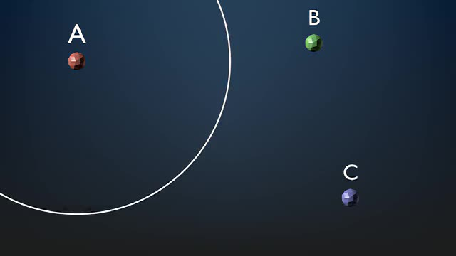
Figure 1: a single circle from satellite ‘A’
Now having a second satellite, it creates a second circle that intersect with the first one, and the user’s location is narrowed down to area where the two circle intersects. (See Fig. 2)
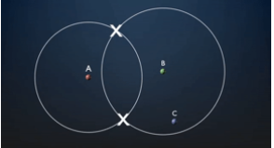
Figure 2: two circles from satellite ‘A’ and ‘B’
Finally, a third satellite will pinpoint the user’s location, because there will only be one point at the intersection of all three circles. (See Fig. 3)
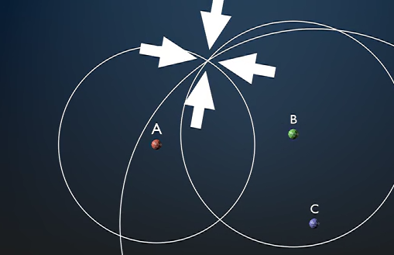
Figure 3: three circles intersection at exactly one point
- What field can GPS be used?
GPS has become an accurate and reliable tool for businesses and organizations who need precise positioning service. “Internet Companies, scientists, pilots, boat captains, and workers in mining and agriculture, are just some of the people who use GPS on a daily basis for work.” GPS is also a core perspective in military usage worldwide. It has changed the nature of battlefield. (Team, 2020)
- How accurate is GPS?
GPS technology nowadays has become so advanced that it can determine your location within a 100 to 50 feet accuracy. For military users, the signals will be more powerful, and secured, pinpointing to within 30 centimeters. Yet some factors can hinder its accuracy, such as large obstructions, atmosphere. (Stanley)

References
Ong, Sandy. “How Does Your GPS Know Where You Are? - Scienceline.” Scienceline, 2 May 2016, scienceline.org/2016/05/how-does-your-gps-know-where-you-are/. Accessed 8 June 2022.
Stanley, Morgan. “GPS | National Geographic Society.” Nationalgeographic.org, 2022, education.nationalgeographic.org/resource/gps. Accessed 8 June 2022.
Team, Geotab. “What Is GPS?” Geotab, Geotab, 22 May 2020, www.geotab.com/blog/what-is-gps/. Accessed 8 June 2022.
What Is GPS and How Does It Work? 2021, novatel.com/support/knowledge-and-learning/what-is-gps-gnss. Accessed 8 June 2022.

