A Feasibility Report
Adopting Postural awareness Techniques to minimize injuries at a General Dental practice in downtown calgary

For: Dr. Rempel and Method Dental Staff

By: Samantha Teeple

Submitted: July 22/22

Table of Contents

Introduction---------------------------------------------------------------------------1

Definition, Description, Background----------------------------------------------------------------------------1

Purpose of this report and audience---------------------------------------------------------------------------1

Method of inquiry--------------------------------------------------------------------------------------------------2

Limitation of studies-----------------------------------------------------------------------------------------------2

Scope of inquiry-----------------------------------------------------------------------------------------------------2

Epidemiology of MSDs---------------------------------------------------------------------------------------------3

Conclusion of inquiry-----------------------------------------------------------------------------------------------4

Collected Data------------------------------------------------------------------------4

Why do dental clinicians suffer from a higher incidence of occupational MSDs?-----------4

Working conditions--------------------------------------------------------------------------------------------------5

What causes these MSDs?-------------------------------------------------------------------------------5

Physical demands of clinical role---------------------------------------------------------------------------------6

Improper ergonomics-----------------------------------------------------------------------------------------------7

Repetitive strain------------------------------------------------------------------------------------------------------7

Time constraints/ Scheduling Concerns------------------------------------------------------------------------8

Clients with physical impairments-------------------------------------------------------------------------------8

What are the most common MSDs?------------------------------------------------------------------9

Occupational hazards---------------------------------------------------------------------------------------------10

Holding postures for long periods of time-------------------------------------------------------------------10

Improper use of dental equipment----------------------------------------------------------------------------10

Causes of premature exist from the program---------------------------------------------------------------11

Injuries contributing to long-term disabilities---------------------------------------------------------------11

How can we prevent MSD’s for dental professionals?------------------------------------------11

Postural awareness techniques---------------------------------------------------------------------------------12

Loupes----------------------------------------------------------------------------------------------------------------12

Speciality chairs-----------------------------------------------------------------------------------------------------13

Would adoption of postural awareness techniques reduce MSDs?--------------------------13

Feasbility of cost----------------------------------------------------------------------------------------------------13

Employee training cost/scheduling of time------------------------------------------------------------------14

Employee acceptance--------------------------------------------------------------------------------------------14

Longer employee retention-------------------------------------------------------------------------------------15

Conclusion----------------------------------------------------------------------------15

Summary of findings-------------------------------------------------------------------------------------15

Recommendations---------------------------------------------------------------------------------------16

Works Cited--------------------------------------------------------------------------17

Introduction

Definition, Description, Background
Dental office personnel are at increased risk for musculoskeletal disorders (MSDs) and pain. MSDs are a prevalent occupational hazard associated with dental office personnel that usually requires time off from work or an early exit from the profession (Lietz et al). Yearly there is a 78% prevalence of MSDs in these workers, with some conditions being acute and others chronic with a higher propensity for the latter (Lietz et al).
These MSDs are common in the neck, shoulders, lower back, upper back, and hands/wrists (Ayatollahi et al; Bedi et al; Lietz et al). These injuries are more prevalent due to the posturing of dental office staff throughout dental procedures, where they adopt awkward body positions, use repetitive movements, carry-out treatments for a long duration and use instruments that cause constant vibrations (Ayatollahi et al; Bedi et al; Lietz et al).

Purpose of the Report and Intended Audience
My goal is to identify why dental office personnel report high incidences of musculoskeletal disorders, examine the causal relationships of injuries and determine prevention strategies for workers.
With dental office personnel, dentists, dental hygienists, dental assistants, and managers to assess feasibility of the inclusion of postural awareness techniques to minimize daily pain and long-term injuries for a downtown Calgary Alberta general dental practice.

Method of Inquiry
My primary data resource will include a survey of dental office staff about MSDs currently or in the past with on-site observations of bodily positioning without photos due to client confidentiality, including photos from texts to simulate and assess bodily positioning in average daily treatment.
Secondary sources will include three publications: one meta-analysis, one systematic review, and one article by the dental research journal on MSDs and prevention.

Limitations of Studies
Primary Study limitations include a small sample pool selected to complete the survey. Data represents a downtown Calgary Alberta general dental practice but is limited to this practice with a proportionally middle to older age bracket and dental auxiliary staff are more proportional then dentist representation.
Secondary data sources included a systematic review, meta-analysis, and cross-sectional study. Within these papers the limitations included a lack of longitudinal follow-up for ensuring lasting ergonomic interventions to prevent MSDs long term and operator biases in completing survey data.
Combination of both studies lack consideration of the multifactorial nature of MSDs and that one intervention is only a piece of the complexity of dental injury precention.
Scope of Inquiry
To assess the feasibility of incorporating postural awareness techniques to minimize workplace injuries. I investigated five areas of study:
- Why do dental personnel suffer much higher incidences of workplace musculoskeletal disorders and pains?
- What causes these MSDs?
- What are the most common MSD injuries?
- How can we prevent MSDs for dental personnel?
- Would adoption of postural awareness techniques help prevent MSD’s?

Epidemiology of MSDs
From primary data sources a survey was conducted at a dental office in downtown Calgary Alberta. The extracted data depicted that 85% of survey respondents regularly, monthly or daily, experience occupational related bodily fatigue which overtime can lead to MSD injuries. 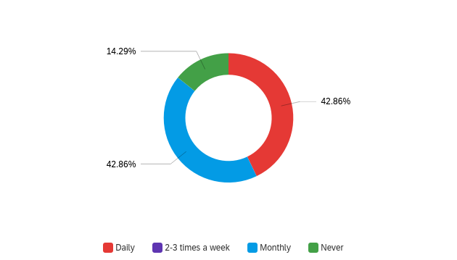
Figure 1 Teeple
From the secondary data source of a systematic literature review documented 78% of dental professionals reported at least one MSD injury annually (Lietz et al). This huge percentage of congruently aligned primary and secondary sources indicates the severity of MSD injuries in the dental occupation and makes ergonomic intervention necessary.
Conclusion of Inquiry
MSDs are prevalent in dental occupations to a much higher degree then other types of work. In this report the assessment of dental clinicians having a higher occurance of MSDs, common causes and types of MSDs, and three different ergonomic interventions were assessed for feasibility of incorporation into a dental office in downtown Calgary. To prevent the early onset of MSDs in dental professionals’ speciality dental chairs, loupes, and postural awareness techniques were assessed as ergonomic interventions based on available literature. The most feasible is to adopt the inclusion of postural awareness techniques. These postural techniques include varying sitting and standing, watching the alignment of the back to prevent curving, adjusting the dental chair ergonomically, avoiding constant postures, proper client positioning in the dental chair, and ensuring feet are parallel to the floor, and preventing twisting of the torso (Bedi et al).
Collected Data
Why do Dental Clinicians Suffer from a Higher Incidences of Workplace MSD’s?

Working Conditions
Dental clinicians work is not only precise but involves motions that are repetitive with awkward and strenuous bodily positioning held for long periods of time while working.
Conclusively in all secondary research, data attributed that improper bodily positioning, bodily straining, and repetitive movements as the primary source of both short and long-term MSDs (Ayatollahi et al; Bedi et al; Lietz et al).
Dental clinicians are subject as are other health care positions to a much higher prevalence of occupational injuries due to the extreme variances in working posture being held for long periods and the repetitive movements from daily clinical work.
What Causes these MSD’s?
Research data consistently contributes awkward and improper bodily positioning and repetitive movements as the most common sources of MSD’s to dental clinicians with recommendations on mitigation consistent throughout the literature (Ayatollahi et al; Bedi et al; Lietz et al).
- Sitting for long periods-unsupported lumbar region, feet not placed evenly on floor, sitting flat, legs together or crossed
- Torso flexion-moving the body “trunk” or torso in a twisting motion, curved back, awkward positioning
- Unsupported posturing-arms up in the air, torso off back rest, major wrist flexion, legs together or crossed, head way out over shoulders
These are very common dental occupational scenarios that illuminate the risk factors and describe the propensity in which dental professionals are at risk of injuries.
Physical Demands of Clinical Role
While each clinical dental role is similar variances in nature of specific occupation changes the susceptibility to MSD locations. In secondary data collection, research data indicates parallels this susceptibility of MSD’s based on clinical role held:
Dentists:
Back pain more predominantly lower back pain and in those with back pain an increased prevalence of shoulder and neck pain. Also noted is hand and wrist injuries although lower back pain is leading for dentists (Ayatollahi et al; Lietz et al).
Dental Hygienists:
Hand and wrist injuries are the most predominate MSD for hygienists who use repetitive wrist motions to complete their work. A high prevalence, more than 50% of hygienists, display symptoms of carpel tunnel as an MSD throughout their career (Ayatollahi et al).
Dental Assistants:
No specific data was attributed to the profession of dental assisting although with the same awkward bodily positioning, holding positions for long periods of time, and repetitive movements they would have similar susceptibility.
Improper Ergonomics
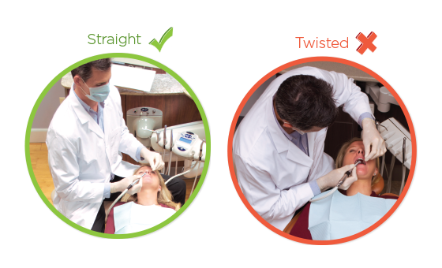
Ergonomics is the practice of proper physical alignment in a work setting to prevent long term injuries by definition it is the designing and arranging of things people use to allow for efficient and safe interaction (Parker, 1). Within the dental field MSDs are very common due to improper ergonomics and increasingly more prevalent in theory application.

Repetitive Strain
Figure 2 Pelton and Crane
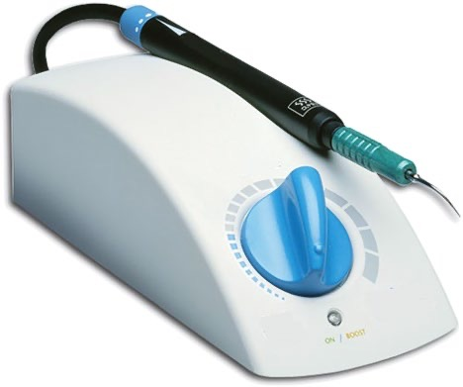
Repetitive movements over long periods of time increase dental providers risk for carpel tunnel and pain associated. In dental hygienists there is a higher propensity then in dentists to have this time of MSD more then 50% of dental hygienists will experience this in their working career (Bedi et al). To decrease repetitive movements for hygienists using ultrasonic scalers can minimize the time of manual scaling to aid in injury prevention (Parker).
Figure 3 Pelton and Crane

Time Constraints/Scheduling Concerns
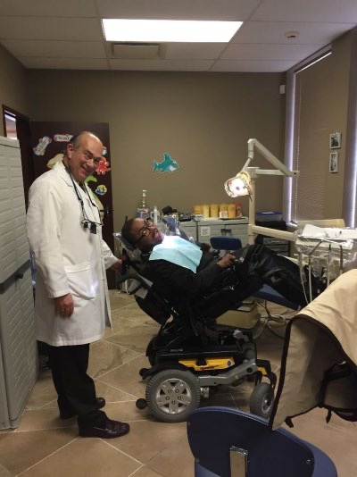
Scheduling is often very tight in a dental clinic with no down time in between client care. This can cause not enough preparation time for clients who require more attention such as those with physical disabilities to ensure proper positioning for clinical care. This factor is to be consider in office acceptance of postural awareness techniques as initially more time will be needed to adopt proper positioning of the client and operator.
Figure 4 Parker

Clients with Physical Impairments
These individuals may have accessibility issues where transferring them from their mobile device to the dental chair is not possible.
These cases can compromise ergonomics as inability to sit ideally is not possible and with scheduling time constraints a dental provider will likely compromise their own positioning.
In this case ensuring comfortable positioning for clients and operators is crucial to maintaining ergonomic practice (Parker).
What are the most Common MSD’s?
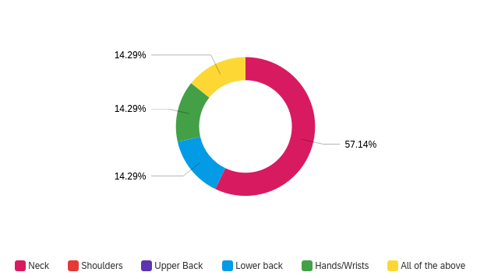
As per primary data sources the most common injury within a downtown Calgary Alberta general dental practice is neck pain.
Figure 5 Teeple, Survey respondents list their most common sources of pain from work

Secondary sources indicate lower back pain as the primary MSD for dentists and wrists as the primary MSD for dental hygienists. MSD’s that are also mentioned upper back and shoulders, as potential dental related occupational MSDs.
Occupational Hazards
Needle stick injuries is the top occupational injury to prevent in the dental workforce with MSDs following closely behind (Ayatollahi et al). Due to the nature of dental clinicians roles variances in sitting, standing, unsupported positions, excessive twisting of the torso, and unideal spine curvature all comprise the occupational hazard of MSDs.
Holding Postures for Long Periods of Time
Dental operators have a small area to work in and often use adaptative body positions to gain access to or for better view of the oral cavity. This can increase a rounding of the spine, cause unsupported positions like holding up arms for long periods and increase twisting of the body trunk into strange positions for field of view (Ayatollahi et al; Bedi et al; Lietz et al).
Improper use of Dental Equipment
Dental equipment and dental clinicians need to work together for safe interaction which is the field of ergonomics. Selection of appropriate tools with proper use of supported holds, use of Cavitron (powered scaling tool), proper alignment of both clinician and client chairs to facilitate the clinician in supported bodily positioning to decrease injuries. Proper adjustments of current equipment can increase ergonomic practice. Similarly selecting instruments that are lightweight and have varied textures and grips can decrease hand/wrsit MSDs (Lietz et al).
Causes of Premature Exist from the Profession
Long term MSD injuries caused by repetitive strains and awkward or unsupported bodily positioning can result in early exist from the occupation. Due to the increased propensity of wear on clinicians these injuries can “force” a clinician to leave the profession with an inability to practice or making lateral shifts in clinician to educator or other roles can be seen to maximize longevity.
Injuries Contributing to Long-Term Disability
- Repetitive strains
- Unsupported postures
- Awkward posturing held for greater then 30 mins
- Improper ergonomic practices
- Client positioning
How can we Prevent MSD’s for Dental Personnel?
Both primary and secondary sources identify the following as ideal methodologies for the minimization of MSDs in dental practices.
Postural Awareness Techniques
Postural awareness techniques are one form of ergonomic practice that has a low cost to initiate versus other ergonomic considerations, requiring operator training, constant awareness and modification of current habits (Ayatollahi et al; Bedi et al; Lietz et al).
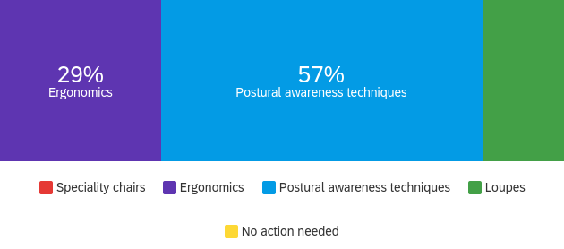
Figure 6 Teeple, Survey respondents indicate the ideal way to prevent MSD’s
Loupes
Utilization of these magnifications can allow operators to carry a constant neutral body position while completing client care. By using loupes providers are more likely to stay in a proper working posture and less likely to hold awkward positioning as their working distance is pre-established on magnification selection and therefore will not need to increase range of view by holding unsupported postures. This is a gold standard in personal ergonomic practice but uncommon on a large scale as it carries a high cost per provider fee for a company to invest in (Lietz et al).
Speciality Chairs
Ergonomically designed chairs to promote an ideal working posture that is supportive in the lumbar to prevent bodily rotations and excessive twisting of the torso. These chairs usually are a waterfall design that encourages operators to sit on an angle versus flat to allow for ideal foot and hip placement under clients. Some of these ergonomic chairs also have arm rests to stabilize and support the arms and decrease the amount of wrist flexion. However, in secondary studies evidence of ergonomic chairs as interventions were only positive in conjunction with use of magnification loupes (Lietz et al).
Would Adoption of Postural Awareness Techniques Prevent MSD’s?
Feasibility of Cost
There is some variance in cost of onsite ergonomic training with anywhere between $200-$550 being the average cost for a group setting. The higher cost typically includes individual analysis and reports on ergonomic positioning.
Potentially providers will not require any additional time in their schedule to incorporate their bodily awareness techniques but may take time at the beginning of the day to ensure equipment is set up with flexibility to accommodate variances in client positioning.
Employee Training Cost/Scheduling of Time
As the employee training costs requires two things:
- Time out of the schedule for training (no production or billing at that time)
- Cost of group training
Accommodations could be made to complete the training on a lunch break or after work paid for with continuing education (CE) credits for completion to minimize costs during the schedule. The cost of the group training is typically $200-$550 for in office training.
Other considerations include taking online ergonomic and postural awareness CE to incorporate within the office with a cost of $20-$40/person.
Employee Acceptance
As indicated in figure 5, the primary data source indicated that ergonomics and postural awareness techniques (a branch of ergonomic practice) as the best choice in preventing occupational MSDs. For this specific office in downtown Calgary dental clinicians already propose this as an ideal strategy for mitigation of injuries.
Longer Employee Retention
Engaging in employee longevity not only aids in the reduction of MSDs but increase provider morale and happiness to stay in the workplace free from injuries and displays a workplace that invests in employee health and stays current with occupational health and safety guidelines.
Conclusion
Summary of Findings
Both primary and secondary data sources indicate a high prevalence of MSDs in the dental clinical setting. Although dynamic in its etiology MSDs do have clearly established interventions for prevention that include:
- Loupes
- Speciality Dental Chairs
- Postural Awareness Techniques
With loupes and postural awareness technique incorporation being the most researched and likely to create lasting change. Loupes is the most widely accepted option through research to create the greatest change but has a high cost associated with adoption. Primary data respondents selected postural awareness technique incorporation or ergonomics as the best way to minimize injuries in the workplace indicating a better rate of acceptance to this method of prevention.
Recommendations
- Hire ergonomic specialist to assess each provider and teach postural awareness techniques specified to the providers needs
- Block time off the schedule at the end of the day for assessments and training of postural awareness techniques and ergonomic interventions
- Follow-up on providers with assessments in 6 months and 1 year to determine long-term acceptance and incorporation

Works Cited
- Ardekani, AliMellat, et al. “Occupational Hazards to Dental Staff.” Dental Research Journal, vol. 9, no. 1, 2012, p. 2., https://doi.org/10.4103/1735-3327.92919.
- Bedi, H.S, et al. “Evaluation of Musculoskeletal Disorders in Dentists and Application of DMAIC Technique to Improve the Ergonomics at Dental Clinics and Meta-Analysis of Literature.” JOURNAL OF CLINICAL AND DIAGNOSTIC RESEARCH, 2015, https://doi.org/10.7860/jcdr/2015/14041.6126.
- Bestsale. “Ergonomics in Dentistry Correct Posture Vector Image on VectorStock.” VectorStock, 27 Mar. 2018, https://www.vectorstock.com/royalty-free-vector/ergonomics-in-dentistry-correct-posture-vector-20491259.
- “Ergonomics.” Pelton and Crane, 20 Nov. 2020, https://www.peltonandcrane.com/en-us/ergonomics.
- “Feasibility of Carrying out an Ergonomics Intervention Study to ... - HSE.” HSE.GOV.UK, https://www.hse.gov.uk/research/rrpdf/rr626.pdf.
- Lannon, John, and Laura Gurak. “Formal Analytical Reports.” Technical Communication Fifteenth Edition , Pearson , pp. 489–529.
- Lietz, Janna, et al. “Prevention of Musculoskeletal Diseases and Pain among Dental Professionals through Ergonomic Interventions: A Systematic Literature Review.” International Journal of Environmental Research and Public Health, vol. 17, no. 10, 2020, p. 3482., https://doi.org/10.3390/ijerph17103482.
- Parker, Susan S. Ergonomics in the Dental Office. Wiley Blackwell, 2022.

