Improving Check-in Procedures at the North Delta Recreation Centre

for
Carmen Gonzalez
Director of Delta Parks and Recreation

by
Harvey Dhaliwal
English 301 Student

July 25, 2022

Table of Contents

Introduction 1
Background 1
Statement of Problems 1
Method of Research 2
Body Section 2
Queuing System 2
Inefficiencies 2
Survey Data 3
Questionnaire Data 4
Wristbands 4
Related Issues 4
Survey Data 5
Questionnaire Data 6
Recommendations 7
Suggestions to Improve Queueing 7
Suggestions for Wristband Alternatives 7
Conclusion 8
Works Cited 9

Figures and Tables

Figure 1: Question 5: How satisfied are you with the current line-up system? 3
Figure 2: Question 7: How comfortable are the wristbands? 5
Figure 3: Question 8: How easy are the wristbands to apply and remove? 6

Introduction

Background
The North Delta Recreation Centre is a large, recently expanded multi-purpose recreation facility located in North Delta, British Columbia. It features a hockey rink, curling rink, weight room, gymnasium, and outdoor pool. Each day, many residents visit the North Delta Recreation Centre and are required to complete a face-to-face check-in procedure with a facility employee. This procedure involves first waiting in a queue for an available attendant, scanning your facility card, and receiving your wristband. This is a standard process which pass holders, new registrants, and drop in visitors must complete.

Statement of Problems
Although the facility has recently renovated its online program sign-up process, the check-in process could be improved. Firstly, all individuals are required to wait in the same line-up regardless of their needs. For example, a person who holds a monthly pass and simply needs to scan in is forced to wait behind someone who wants to learn more about the available programs. This can cause unnecessary delays during busy periods.
The second problem is the use of plastic wristbands to identify all visitors. While many facilities and fitness centres no longer use wristbands, North Delta Recreation Centre continues to enforce them. The colour and pattern of the wristband varies daily, to ensure that the visitor has paid for that specific day. This system creates unnecessary waste and environmental harm considering the bands are single use. The use of plastic wristbands also creates added difficulty for those with limited finger and hand dexterity. They are cumbersome to put on as they require two hands and can only be sized once. Individuals on the autism spectrum, children, and seniors may struggle to wear them comfortably and without individualized support.

Method of Research
A facility user survey was conducted to poll user experiences with the current system and their attitudes towards proposed changes. The survey was distributed through North Delta Community Corner, a Facebook page for North Delta residents. The survey received a total of thirty-five responses. Additionally, an email questionnaire was sent to the Director of Parks and Recreation Carmen Gonzalez to learn more about the current process and organizational limitations. Finally, online research was conducted to investigate the impact of plastic waste on the environment.
Body

Queuing System
Currently, the North Delta Recreation Centre operates using a single line multiple server system. During slower times, a single operator is tasked with all check-in related duties. This includes answering questions, checking users in, and taking payment.

Inefficiencies
The current single line up system creates inefficiencies as queued visitors are forced to wait in the same line regardless of their needs. When there is only a single operator on staff, a passholder who simply needs to scan in may need to wait for an extended period behind an individual who has lengthy program-related questions. This can result in poor user satisfaction and unnecessary wait times.

Survey Data
Of those who responded, 64.7% identified themselves as drop-in visitors rather than passholders. Evidently, there are a significant number of people who fall into either of these categories and would benefit from a more personalized approach to check-in. Further, the mean time that respondents waited in line on average was 4.14 minutes. This value appears to be quite high, especially considering that 35.3% of respondents are passholders and should simply need to scan their cards to enter. Finally, as illustrated in Figure 1, the most common response when asked to rate satisfaction with the current lineup system was “somewhat unsatisfied”. The data shows that users are not satisfied with the current system, and changes to resolve the current inefficiencies would be valuable.

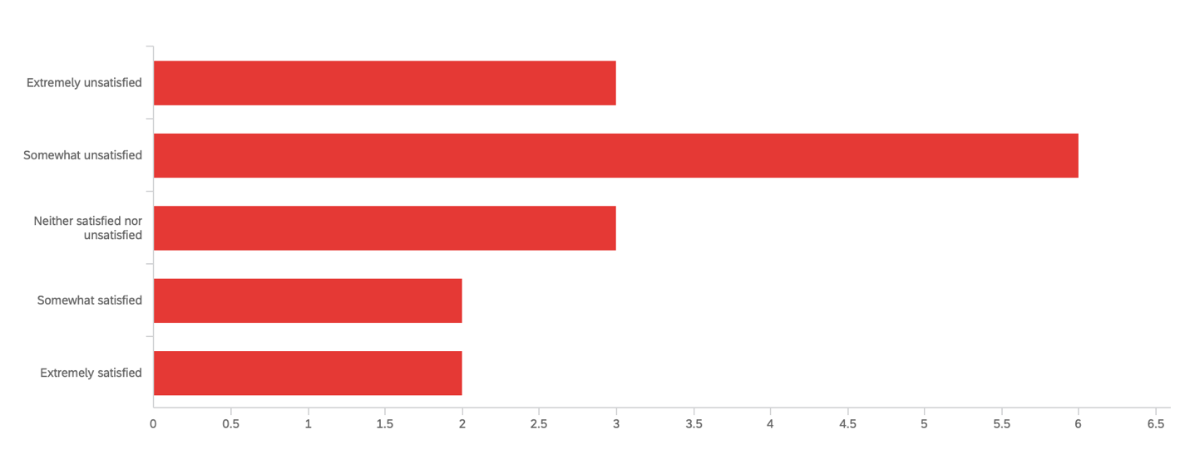

Figure 1. Question 5: How satisfied are you with the current line-up system?

Barriers to Change/Questionnaire Data - waiting for questionnaire responses

Wristbands
The use of plastic wristbands to identify facility users is mandatory for all visitors and is one of the check-in steps. The bands vary in pattern daily, and different bands are used for certain types of pass-holders. For example, users who hold a pass for the weight room only wear a specially marked wristband.

Related Issues
Using plastic wristbands creates two main issues. The first is user comfort and satisfaction, and the second is environmental harm. Based on personal experience, I have found the wristbands to be cumbersome to apply and often uncomfortable during my workout. For example, the wristbands can get in the way when playing basketball or lifting weights.

The second issue is environmental harm, with plastic waste being a well-known cause for concern. Researchers have estimated that in 2010 alone, plastic waste contributions from coastal countries totalled approximately 99.5 million metric tonnes (Jambeck et al. 770). Further, it is estimated that up to 4.6% of this total plastic waste ended up in oceans, with the amount expected to rise by 2025 (Jambeck et al. 770). Reducing plastic waste is essential to ensure the health of our environment. Considering the number of users visiting the recreation centre each day, there are a large amount of wristbands that end up as waste. Further, there are no clearly marked receptacles for disposing of wristbands in the facility.

Survey Data
In terms of survey questions relating to wristband comfort and ease of use, user opinions vary. As described in Figure 2, 25% of respondents rated the wristbands as “extremely comfortable” while 6.25% rated them “very uncomfortable”. Similarly, 6.25% of respondents answered “somewhat comfortable” while 25% answered “somewhat uncomfortable”. The most popular rating was “neither comfortable or uncomfortable” at 37.5%. Considering the data, there exists a sizable proportion of respondents who find the wristbands at least somewhat uncomfortable.

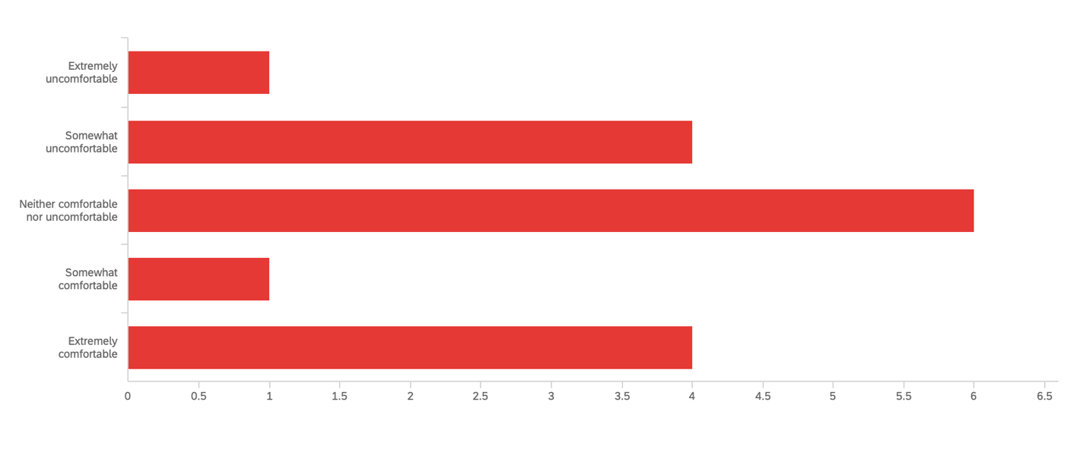
Figure 2. Question 7: How comfortable are the wristbands?

As seen in Figure 3, the responses to the question polling ease of application and removal of the wristbands exhibited a perfect bell curve. While 13.3% of respondents answered “extremely difficult” or “extremely easy”, 20% answered “somewhat difficult” or “somewhat easy”. Finally, 33.3% answered “neither easy nor difficult”. This pattern shows that while some are satisfied with the ease of using wristbands, a significant number of people are not.

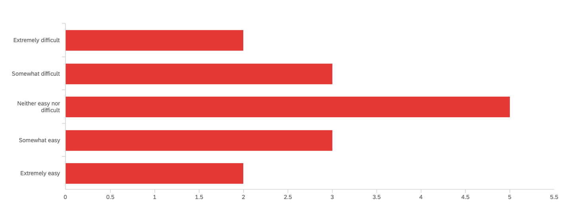
Figure 3. Question 8: How easy are the wristbands to apply and remove?

The most common method of disposing the wristbands was in the garbage rather than recycling, with 100% of respondents selecting this option. In terms of support for alternatives to wristbands 43.75% respondents answered “somewhat agree”, while 37.5% chose “neither agree nor disagree” and 18.75% selected “somewhat disagree”. These results show that while there may be some hesitation to change, most respondents would not be opposed to alternatives.

Barriers to Change/Questionnaire Data - waiting for questionnaire responses

Suggestions to Improve Queueing
One suggestion that can improve queueing efficiency is creating an express line for passholders who simply need to scan their cards. This express line could be operational during peak hours when there are extra staff available to manage customer inflow. Implementing this solution would eliminate the inconvenience of passholders having to wait behind individuals who may have lengthy questions or would like to sign up for a program. From a facility standpoint, the assets needed to implement this change (scanners, staff) already exist so no new investment would need to be made.

Suggestions for Wristband Alternatives
Considering the environmental issues and inconveniences related to wristband use, I propose a solution which eliminates wristbands. Currently, all facility users must have an identification card which electronically stores their information. This includes their photo, address, and any passes that they hold. This information is already available to employees when users scan their cards and is an integral part of the proposed solution. The steps are outlined as follows:
- User enters the facility
  - If they have questions, want to register for a program, or want to pay for drop-in they can join the normal line up.
  - If they already hold a pass and simply need to scan in, they can enter the express line and scan their card. A front desk employee can verify their photo and existence of a prepaid pass.
- User enters specific area (ex. arena, weight room, gymnasium)
  - Each area of the facility generally has at least one staff member overseeing the activity. This staff member can be tasked with scanning user cards with handheld scanners to verify their eligibility for that specific program or area.
  - Once verified, the user can partake in their activity of choice. If they would like to visit a different area, they would simply scan in again at that point of entry.

This approach to user identification would eliminate the need for wristbands, thereby lessening the facility’s environmental impacts and improving user experience. The facility would also save on the cost of purchasing and storing the wristbands. The investments associated with this shift would be the handheld scanners and computers which can display the card information. A laptop or tablet would be sufficient, depending on how the facilities computer systems are structured. In the long run, this initial investment would result in net savings as no wristbands would need to be purchased again.
Conclusion

The main concerns this report seeks to address are the lineup inefficiencies and wristband use. Based on survey data, a sizable number of users are not satisfied with the current system and would not oppose change. The main proposed solutions are the implementation of an express entry line and elimination of wristbands in favour of an electronic system.

Works Cited

Jambeck, Jenna R., et al. "Plastic Waste Inputs from Land into the Ocean." Science (American Association for the Advancement of Science), vol. 347, no. 6223, 2015, pp. 768-771. https://www.jstor.org/stable/24746131

