Improving App Usability of Seoul Bike for Foreigners in Seoul, South Korea

Submitted to Yang Jae-young, Head of Seoul Bike App Operation Team

July 22, 2022

By Jeemin Kim, ENGL 301 Student

Abstract

Letter of Transmittal

Table of Contents

I. INTRODUCTION

A. Background on Seoul Public Bike system

B. Purpose of this report

C. Method of data collection

II. DATA SECTION

A. Language availability

B. Registration and payment

C. Studies and comparison of similar bike-sharing services

III. CONCLUSION

A. Summary and interpretation of findings

B. Recommendations for improving Seoul Public Bike system for foreigners

IV. Works Cited

V. Appendix

I. INTRODUCTION

1. Background on Seoul Bike

Seoul Bike, also commonly known as Ttareungyi, is a public bicycle rental service implemented in 2015 by the Seoul Metropolitan Government. The system aims to resolve ongoing environmental issues including congestion, air pollution, and increasing oil prices in the capital of South Korea (“Seoul Public Bike”).

Seoul Bike is an unmanned system – thus bikes can be rented at rental stations that are located in both busy business districts and residential areas. These stations include popular pedestrian areas, subway entrances/exits, bus stops, residential complexes, public offices, schools, and banks (“Seoul Public Bike”). Users can rent and return bicycles at any rental station.

In order to rent a bike from the rental station, users must download the Seoul Bike app. The service can only be used after purchasing a pass. The rates vary according to period of use and rental time. To buy a season pass, registration is required. Non-members including foreign visitors can purchase a one-day pass. One-day passes for foreign travelers can also be purchased at the Seoul Bike website.

1. Purpose of this report

Seoul Public Bike extends its service to foreigners residing in Seoul. However, the app that is used to rent the bikes is extremely difficult to use for non-Korean speakers. The app currently offers an option for foreign tourists but the app is only partially translated to English. The registration and payment processes make it difficult for foreigners who do not have a Korean phone number or pre-approved international credit card to use the system.

As South Korea becomes more globalized, there is a need to acknowledge the inconveniences that non-Korean speakers face daily and accommodate their needs. The purpose of this report is to clarify the difficulties of using the app for Seoul Public Bike as a foreigner and present suggestions that could help resolve the issues.

1. Method of data collection

Interviews with a university student, English instructor, and a long-term tourist were conducted to understand issues regarding the app’s usability. The three interviewees are all foreigners and/or non-Korean speakers who have experienced the rental service. Secondary sources include information released from the Seoul Metropolitan Government and peer-reviewed journal articles on similar public bike-sharing services such as Bixi Montréal.

II. DATA SECTION

1. Language availability

Many complaints on the Seoul Bike app are related to language availability issues. The Seoul Bike app is currently offered in Korean and English. However, even if the phone user’s preferred language is set to a language English, the app is not automatically translated. In the app, there is no option to choose the user’s preferred language. The app is translated to English for users who choose the “Foreigner” option from the starting screen (see Figure 1).

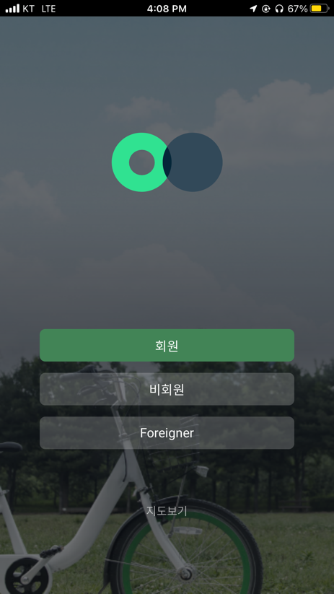

Figure 1. Screenshots of the Seoul Bike App. From left to right, each shows the login screen, list of nearby rental stations, and map of the rental stations.

Even after selecting the “Foreigner” option, the app is only partially translated to English. Upon selecting the “Foreigner” option, the app shows a list of nearby rental stations. “Favorites” or “Recently used” is only available for members. On the map, places are written in English in addition to Korean, but the buttons switch back to Korean.

One interviewee, a university student studying in Seoul, explained the difficulties she experienced due to the language barrier while using the app.

“The translation is incomplete - I always need to get help from a Korean friend because I cannot read what is written on the screen. I can’t copy the text and use an app to translate it either. I remember the process taking so long I don’t really bother renting it anymore, especially when I’m alone.”

Another interviewee, who is working in Seoul as an English instructor, expressed the inconvenience of not being able to get a season pass as a foreigner.

“It seems like the “Foreigner” option is only meant for travelers who are staying in Seoul for a short period of time. I wanted to use Seoul Bike because it’s extremely affordable if you buy a season pass, but the “Foreigner” option only lets you get hourly or daily passes.”

Foreigners residing in Seoul are able to register as long as they have a Residence Card issued by the Immigration Office, Korean phone number and Korean credit card. However, the app is not translated in this case, so users are required to read and understand Korean in order to use the service.

1. Registration and payment

As mentioned in the introduction, Seoul Bike offers varying passes depending on period of use and rental time (see Figure 2).



Figure 2. Seoul Bike's rental passes and fees (Source: Seoul Public Bike)

In order to purchase a season pass, the user must register to be a member. The user’s name, resident registration number and phone number is required for registration. A Korean phone number is required for a verification code, which is used to confirm one’s identity.

As the interviewee mentioned above, the “Foreigner” option on the app seems to consider only foreign tourists who are traveling for a short period of time. Foreign tourists who are staying long-term but do not hold a residence card, a Korean phone number, and/or a Korean credit card are only able to get daily passes, even if they are able to communicate in Korean on a basic level. An interviewee who is traveling in Seoul for long-term expressed the inconvenience of not being able to purchase a seasonal pass.

“I came to Seoul during the summer to visit some of my relatives living here. I saw a lot of people ride the green bikes, so I wanted to rent one myself to get around places. A friend told me I’d only need to pay KRW 5,000 to rent bikes for a month, but I learned later that I couldn’t get a season pass because I didn’t have a Korean phone or credit card. I’m not sure if I would want to pay for a daily pass every time I’d rent a bike, since I would only be taking a short trip.”

The payment process was another issue highlighted during one of the interviews. The university student interviewee expressed that the payment process was relatively complicated compared to other bike-sharing services they used in the past.

“I have to click through about five different pages to rent a bike. It’s not a major problem, but I do think of it as an inconvenience because I know a lot of other apps where you’d only need to put your card information and that’s it.”

Figure 3. Screenshots of payment process

1. Studies and comparison of similar bike-sharing services

Bixi Montréal, operated in Montréal, Canada, is North America’s first public bike rental service launched in 2009. According to Aju Daily, Seoul Metropolitan government benchmarked this service (Kim, 2022) before fully implementing its own bike-sharing service in 2015. One main difference between Bixi and Seoul Bike is the business model. While Seoul Bike is non-profit (i.e. publicy owned and operated), Bixi is publicly owned and operated by a contractor (Shaheen et al., 2013).

One difference between Bixi Montréal and Seoul Bike is the developer or company in charge of the software behind the bike-sharing system. While Seoul Bike is developed and managed by the Seoul Metropolitan government, Bixi was created using the technology provided by 8D Technologies, a private company that was in charge developed the entire technological platform behind the BIXI system (Swedberg, 2008).

*(More information + interview responses to be added)*

III. CONCLUSION *(More to be added)*

1. Summary and interpretation of findings

Although Seoul Bike is a widely used bike-sharing service in Seoul, many foreigners still experience difficulties using the app because of its insufficient translation and inconvenient registration/payment process. The only way to access the service in English is to select the “Foreigner” option. Even then, the app is not translated sufficiently and switches back to Korean time to time. The “Foreigner” option also only allows for daily passes instead of the more affordable seasonal passes. To purchase a season pass, one must register to be a member, which requires a residence card, Korean phone number and Korean credit card.

1. Recommendations for improving Seoul Bike system for foreigners

Works Cited

Kim, Joo-heon. “Seoul's Public Bike Rental Service Becomes Popular Public Transport System.” AJU Business Daily, 27 Apr. 2022, https://www.ajudaily.com/view/20220427094305098.

“Seoul Public Bike.” *Official Website of the Seoul Metropolitan Government*, http://english.seoul.go.kr/service/movement/seoul-public-bike/1-seoul-public-bike/.

Shaheen, Susan A., et al. “Public Bikesharing in North America.” *Transportation Research Record: Journal of the Transportation Research Board*, vol. 2387, no. 1, 2013, pp. 83–92., https://doi.org/10.3141/2387-10.

Swedberg, Claire. “Montreal RFID-Enabled Bike Project Picks up Speed.” RFID JOURNAL, 17 July 2008, https://www.rfidjournal.com/montreal-rfid-enabled-bike-project-picks-up-speed.

Appendix I. In-depth Interview Questions

Introduction:

I am an undergraduate student at UBC working on a project for ENGL 301. The purpose of this interview is to obtain primary data for analyzing issues that non-Korean speakers and foreigners experience using the public bike rental system, Seoul Public Bike. This interview will serve the ultimate purpose of providing recommendations for improving the app experience for non-Korean speakers and foreigners visiting or residing in Seoul. Your responses are voluntary and anonymous. Thank you for taking the time to respond to this interview.

1. General

* How often do you use the Seoul Public Bike service?
* When and how did you first use the service?
* What are your overall impressions of the app?
* How would you rate the overall experience?

1. Language availability

* What is your primary language?
* What is your level of fluency in Korean? English?
* Do you think the app is sufficiently translated?
  + If not, which parts need translation?

1. Registration and payment system

* What is the registration process and payment system like? Was your experience positive or negative?
  + If it was negative, did you experience any difficulties while trying to register or pay for the service?
* Do you know any other similar businesses that offers a simpler registration or payment system? How would you compare it to Seoul Public Bike?

1. Wrap-up

* How satisfied are you with the service?
  + If the service was unsatisfying, what could be improved in this service or app?