Report on Increasing Community Oral Hygiene Programs
for Individuals with Special Needs

For
Janice Harrington, Alberta’s Health Advocate & Mental Health Patient Advocate
Dr. Tobias Meiszinger, President of Alberta Dental Foundation

By
Rida Irshad, ENGL 301 student

Instructor: Dr Erika Paterson
22 June 2022

Table of Contents

- Letter of Transmission – 3
- Abstract – 4
- Introduction – 5
- Report – 6
- Appendix – 10
- Conclusion – 11
- References – 12

Introduction
-Background information on preventive dentistry
People with special educational needs are those who have long-term physical, psychological, intellectual, or behavioral difficulties that may affect their equal, full, and effective participation in social activities (Díez-Palomar et al., 2021). [current available number of programs available]. The purpose of this report is to assess the feasibility of developing community programs specifically tailored to individuals with SHCNs. The report includes research completed through surveys and interviews of both dental professionals as well as individuals with SHCNs and their care givers. Primary data was collected using a survey questionnaire of nine questions that was distributed via the UBC survey tool and the participants responses were collected anonymously. A total of twenty-two participants completed the survey of which fourteen were in the dental profession and eight that had personal relations with SHCNs individuals. Working as a dental hygienist, secondary data was collected through in-person interview questions that took place in the dental clinic with both dental professionals as well as care takers or chosen demographic themselves. Interviewing both sides provided a broader understanding of challenges, demand, and perspective for this research. It also gave light to the issue and the gap in our knowledge as a society. To assess the feasibility of developing community programs specifically tailored to individuals with SHCNs, the following topics were researched:

- Current availability of community programs available for those with SHCNs.
- Demand for oral hygiene programs for this group of people.
- Current level of knowledge regarding oral hygiene care for individuals with SHCNs and their care givers.
- Impact will these community oral hygiene programs have on the selected population’s oral and overall health.

Data Collected

- Barrier to dental care for individuals with SHCNs
- Higher risk of oral health diseases
- Dexterity issues
- Level of dependency
- Diet concerns in relation to oral health
- Medications and its effects on oral health

- Demographic of voluntary participants for primary data source

Demographic | Count
Dental Professional | 14
Individual with SHCNs | 0
Care provider of individual with SHCNs | 8

Figure 1: Demographic of voluntary participants for survey

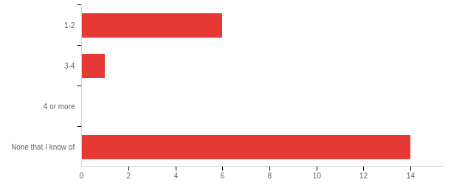
- Level of knowledge of programs available for SHCNs
Figure 2: Data for awareness of current programs for all participants
- Awareness of current programs available among dental professionals
- Awareness of current programs available among the chosen demographic
- Availability of current programs
- Demand for need of new programs

- Impact of community dental programs for individuals with SHCNs
- Effect of oral health on overall health
- Cost effectiveness of preventive dentistry versus restorative dentistry
- Anxiety due to dental procedures
- Lack of dental care due to anxiety
- Knowledge on different tools available for home care

- Satisfaction with current program availability
- From dental professionals
- From the chosen demographic and their care givers

Conclusion

- Summary and interpretation of the research findings
- Recommendations and final thoughts
-need for more community programs is highly recommended given the results of the research. Most participants are unaware of the limited community programs available but show demand for more oral hygiene community programs. Individuals including some dental professionals are unaware of all available tools to help with home care for SHCNs individuals. This further shows the gap in knowledge not only in this community but as well in the dental community.

References:
da Rosa SV, Moysés SM, Theis LC, Soares RC, Moysés ST, Werneck RI, et al. Barriers in access to dental services hindering the treatment of people with disabilities: a systemic review. Int J Dent. [Internet]. 2020 [cited 2022 Jun 20]; 2020:1-17. https://doi.org/10.1155/2020/9074618

Díez-Palomar, J., Ocampo Castillo, M., Pascual, A., & Oliver, E. (2021). Adults With Special Educational Needs Participating in Interactive Learning Environments in Adult Education: Educational, Social, and Personal Improvements. A Case Study. https://doi.org/10.3389/fpsyg.2021.662867

