Determining the New Office Plan for OP Media Group

Presented to:
Mark Yelic,
OP Media Group president

Prepared by:
Dale Miller,
ENGL301 student at UBC

July 22, 2022

Table of Contents
I. LETTER OF TRANSMISSION 3

II. ABSTRACT 3

III. INTRODUCTION
A. Situation Summary 4
B. Report Purpose 4
C. Methods 5

IV. RESULTS
A. Summary of Office Options
1. Renewing current space
2. Reducing current office size
3. Finding a new space
4. Cancelling office lease
B. Impact Study
1. Employee survey
2. Management interviews

V. CONCLUSION
A. Summary
B. Recommendations

VI. APPENDIX
A. Interview Questions
B. Survey Questions

VII. REFERENCES

LETTER OF TRANSMISSION
TKTKTKTK

ABSTRACT
TKTKTKTK

INTRODUCTION
OP Media Group is a publishing company with 15 full-time and dozens of contract and freelance employees. They have an office in downtown Vancouver with workstations for 15 people. Like most businesses in Canada, OP Media Group went completely remote in 2019, and since the beginning of 2022 have been functioning largely as a hybrid work environment with approximately eight people on site each day, depending on their work schedule.
OP Media Group’s office lease expires at the end of 2022, and the company needs to decide whether to renew the lease for the current space, seek to get a space with reduced capacity, or get rid of the office altogether. Some implications of this problem are the monthly rental costs to OP Media Group, staff safety, staff productivity, and staff satisfaction.
The purpose of this report is to present all the relevant information required to decide on a best course of action. Using information from the data sources, it will summarise the options, interpret the findings, and make a recommendation. To help determine the correct course of action, this report will examine costs associated with renewing, reducing, and getting rid of the current office space, as well as impacts on employee safety, productivity, and satisfaction.
Ten out of a possible fifteen OP Media employees responded to a short survey designed to analyze employee perception of working from home, the office, and a hybrid work environment, including questions on productivity, safety, and flexibility. Interviews were conducted with two OP Media managers to get more information on the office space options, as well as their preferences and other considerations.

RESULTS
Summary of Office Options
Four options were identified and examined in interviews with OP Media Group management staff member, Arran Yates (Yates). They are as follows:

- Renewing the Current Space: OP Media Group is currently renting a 3,000 square foot office space at 1166 Alberni Street at a cost of $12,000 per month, or $720,000. This space has workstations for 15 people, plus a board room, kitchen, and reception area. The building owners are willing to renew the contract for another five years at the same rate, providing there is no change to the layout of the space.

- Reducing Current Office Size: Inquiries have been made with the building owners on reducing the size of the current office space. The business in the office beside OP Media’s has expressed a desire to increase the size of their current space by approximately 1,000 square feet, which would reduce OP Media’s space by the same amount. This would leave OP Media with approximately 2,000 square feet, which could be arranged to accommodate approximately 10 workstations, depending on layout. It would also allow for a small meeting space and two private offices with lockable doors. The cost to renovate both office spaces will be around $60,000 split between the two businesses, and will take one month to complete, during which time only two or three people will have space to work in the office. The new cost of the space will be $8,000 per month plus the $30,000 that will be spread over the five-year lease, totalling $510,000.

- Finding a New Space: There are several options in the area for offices in the 2,000 to 3,000 foot range, with rents ranging from $8,500 to $15,000 per month. An office move would represent a significant cost in employee productivity and time, and also approximately $100,000 in moving, office improvement, and equipment costs.

- Cancelling the Office Lease: The final option is to not renew the current lease and get rid of the office all together. This would require leasing a storage unit at a cost of $1,000 per month, but would represent a significant savings in costs for rent. All work and meetings and would have to be conducted remotely, and the company controller would need to store boxes of records in their home office.

Impact Study
Employee Survey: The results of the employee survey (Figure 1) show that the majority of respondents preferred a hybrid work environment, where they could pick and choose which days to come into the office and felt more productive as a result (Figure 2).
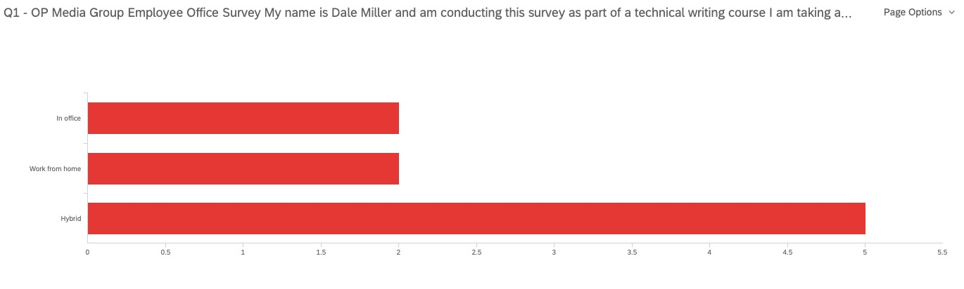
Figure 1. Employee preferences on in office, from home and hybrid work environments.

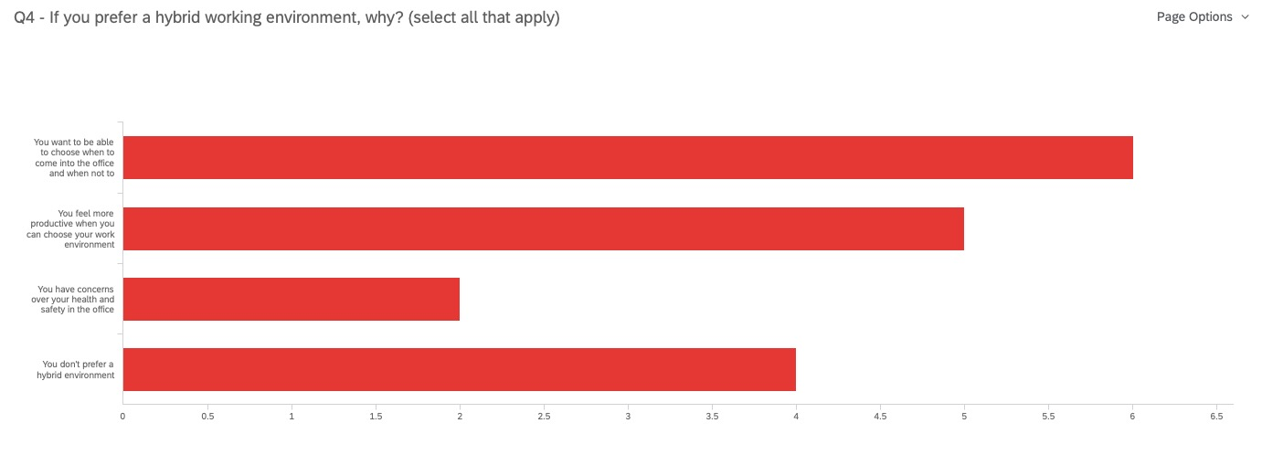
Figure 2. Employees who prefer hybrid want to choose where they work and feel more productive with the option.
The majority of employee respondents also said that they come into the office between one and three days per week, with only two respondents coming in for five days (Figure 3). Coincidentally, only three out of ten respondents said that they would require their own desk in a hybrid work environment, with the rest claiming they would be happy to share a desk with others (Figure 4).
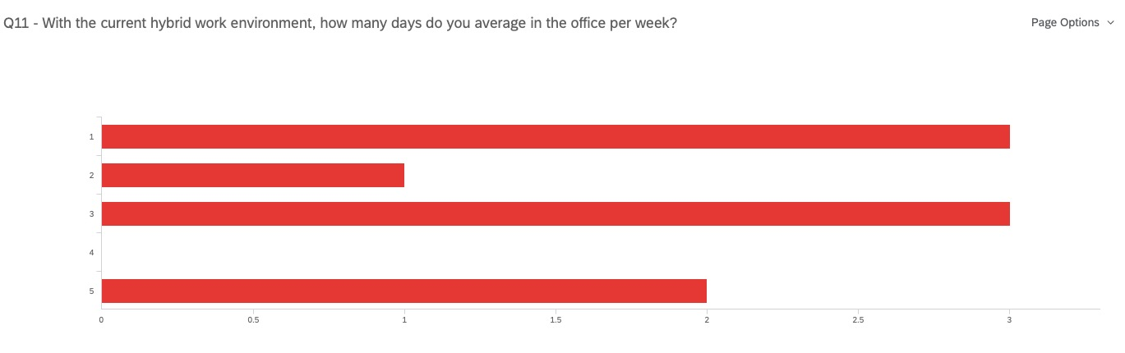
Figure 3. Eight out of ten respondents claim they work out of the office an average of one to three days per week.
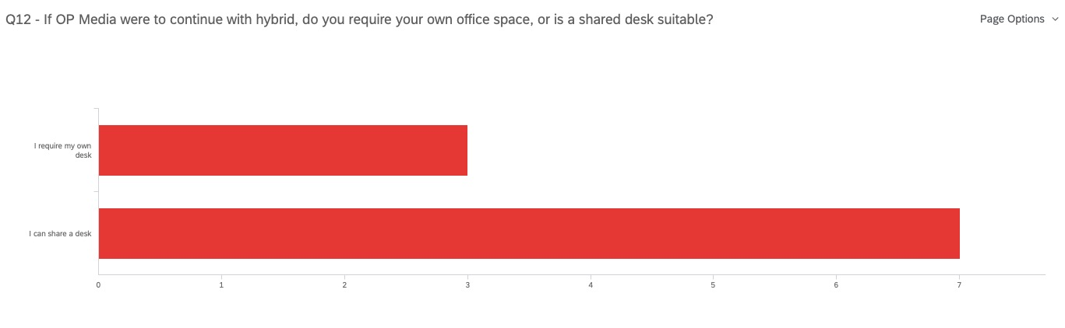
Figure 4. Seven out of ten respondents say they are happy to share a desk in a hybrid work environment.
Overall, the survey results show that most OP Media Group employees are happy with the current hybrid work environment, and would be happy to use a shared desk for the one to three days they come in per week.

Management Interviews: The management interviews found that their first priority was employee safety and satisfaction, with costs and productivity being secondary considerations (Miller). Arran Yates expressed that one of his direct reports was very uncomfortable with coming into the office for COVID safety reasons, and preferred to work from home unless they were required for a meeting. Another one of his reports said that they preferred working from the office for productivity reasons, but didn’t mind being flexible (Yates). One of Desiree’s direct reports stated that they required a lockable office for confidentiality reasons, and preferred to work in the office 100 percent of the time. They had no concerns over safety (Miller).
Overall, management felt that most employees were satisfied with the hybrid work environment, but having an option for people to work in the office, either occasionally or permanently, was important. Additionally, both managers expressed a desire to reduce month-to-month costs associated with rent, and were frustrated by the fact that the current office space is only half utilized during the current hybrid work arrangement.

CONCLUSION
Summary
Analysing the findings of both the employee survey and manager interviews, it is clear that continuing with a hybrid work environment is the preferred option. Not only is it the preference of the majority of the employees, but those who prefer to work in the office only can be accommodated in a hybrid work environment by setting up desks for their exclusive use. From a management perspective, a hybrid work environment allows the company to prioritize employee safety and satisfaction while reducing costs and maintaining productivity. With these results in mind we can examine each of the office options:
1. Renewing the Current Space: With a total cost of $720,000 over five years, this is potentially the most expensive option but it is also the easiest as it wouldn’t require any renovations or a move. This option would also allow OP Media employees to either work from home or the office without worrying if they would have an open desk to work at.

2. Reducing Current Office Size: With a total cost of $510,000 over a five-year lease, this option would save OP Media Group approximately $210,000 while allowing the employees the flexibility to either work from home or the office. The potential downsides to this option are the disruption of office life during the renovations, and the increased complication of scheduling desk use during busy periods.

3. Finding a New Space: This option has the potential to equal both of the previous options in terms of cost, but once you consider the costs associated with moving, it could also potentially cost much more. Furthermore, there would be significant disruption to business during the move, and there would be the additional complications of a change in address for a publishing company that relies on mail for much of its business.

4. Cancelling the Office Lease: While this is by far the least expensive option, representing a savings of approximately $720,000 over five years, both the survey and interview results suggest it would not be a popular option with the employees.

Recommendations
This report recommends OP Media Group continue with the hybrid work environment it has used since the beginning of 2022 and seek to have the size of its current office reduced to 2,000 square feet. While planning the layout, OP Media should be sure to include at least three offices with lockable doors, and at least five additional workstations. They should also seek to maintain the kitchen and a small private meeting space to counter for the loss of offices.
This will allow the company to decrease the amount of rent it pays each month (for a savings of $210,000), offer its employees flexibility for when they are sick or when they need to collaborate with others, and allow employees to choose whether they want to work in the office or not, which should increase staff satisfaction.
As the COVID-19 pandemic continues to change the way companies do business, OP Media Group should adapt to this new reality by taking advantage of their upcoming lease renewal and creating a new office space that meets its needs moving forward.

APPENDIX

Interview Questions
1. Could you please provide an overview of the process, costs and considerations for the following office options:
a. renewing current space
b. reducing current office size
c. finding a new space
d. cancelling office lease all together
2. Are there any options that we missed? If so, what are they?
3. Does OP Media management have a preferred option? If so, why?
4. What are OP Media’s overall considerations while choosing an office plan?
5. What are OP Media’s priorities when considering office options?
6. Is there anything else we should consider for our report?

Survey Questions
1. Please select your preferred office environment:
-In office
-Work from home
-hybrid

2. If you prefer in-office, why? (select all that apply)
-You like the social aspect
-You feel more productive
-You don't have a space to work at in your home
-You need to be in the office to carry out your job
-You don't prefer in-office

3. If you prefer working from home, why? (select all that apply)
-You feel more productive at home
-You have space at home for work
-You can carry out your job completely from home
-You have concerns over your health and safety in the office
-You don't prefer working from home

4. If you prefer a hybrid working environment, why? (select all that apply)
-You want to be able to choose when to come into the office and when not to
-You feel more productive when you can choose your work environment
-You have concerns over your health and safety in the office
-You don't prefer a hybrid environment

5. If you were required to work in an environment that isn't your preference, would that impact your ability to continue working for OP Media Group?
-Yes
-No

6. Please rank where you feel the most productive (1 being the most productive)
-Working from home
-Working from the office
-Working both at home and the office, depending on tasks
-It makes no difference

7. Please rank where you feel the most safe (1 being the most safe)
-Working from home
-Working from the office
-Working from both at home and the office, depending on tasks
-It makes no difference

8. How satisfied were you with OP media's previous in-office only arrangement?
-Very satisfied
-Satisfied
-Neutral
-Not satisfied
-Very dissatisfied

9. How satisfied were you with OP media's previous work-from-home only arrangement?
-Very satisfied
-Satisfied
-Neutral
-Not satisfied
-Very dissatisfied

10. How satisfied are you with OP media's current hybrid-only arrangement?
-Very satisfied
-Satisfied
-Neutral
-Not satisfied
-Very dissatisfied

11. With the current hybrid work environment, how many days do you average in the office per week?
-1
-2
-3
-4
-5

12. If OP Media were to continue with hybrid, do you require your own office space, or is a shared desk suitable?
-I require my own desk
-I can share a desk

REFERENCES
Miller, Desiree. Interview. Conducted by Dale Miller. July 17, 2022.
Yates, Arran. Interview. Conducted by Dale Miller. July 18, 2022.

