University of British Columbia
English 301-Technical Communications
Professor: Erika Paterson
Assignment 2.3 Formal Report Draft

Determining Cause, Impact and a Possible Solution of Expensive Student Housing at UBC
Presented by: Dennis Tianxiang Deng, ENGL 301 student
To: Mr. Andrew Parr, associate Vice-President, Student Housing and Community Services (SHCS) at UBC.

Table of Contents

I. ABSTRACT 2

II. INTRODUCTION 3
Problem 3
Intervention 4
Comparison 4
Proposed Outcomes 5
Research Methods 6

III. DATA COLLECTION 7
Survey Questionnaire for Participants 7
Researcher Observations 7
Participants’ Perception 8
Results Comparison 8
Presentation of Research Results 8

IV. CONCLUSION 9
Summary of Research 9
Recommendations 9

VI. Literature Cited 10
VII. Appendices 11
Appendix A. Survey Questionnaire 12

I. Abstract
Canada as one of the world’s top study destinations is growing painfully exorbitant to live in. Across provinces, students who seek for rental housing have reported an increasing number of horror stories of finding a livable place to rent in Canada due to a rising housing crisis. Housing affordability is a huge challenge for our region and for UBC. Providing affordable housing is an important part of student wellbeing and recruiting and retaining faculty and staff. UBC’s “Housing Action Plan”, which includes targets and goals for affordable housing projects and programs, is part of the university’s overall strategy to solve the affordability challenge and sustainability issues. The report aims to uncover whether there are potential room for more improvements to bring down student’s cost of living and provide more housing options.

II. Introduction

Background
Student Housing affordability is one of the most challenging issues students face nowadays, both financially and emotionally. Living on campus has become more expensive every year, yet housing fees charged by the university have become a necessary source of revenue, now more than ever. Many students nowadays demand a housing fee reduction.

Definition of housing affordability
Affordable housing for the purpose of this report is defined as housing one can afford to rent, lease, or purchase without having to spend more than 30% of pre-tax household income on housing costs (including rent or mortgage, strata fees and property taxes).

Statement of Problem
The rise for housing at UBC is increasing, in part because the demand to live in residence at UBC has greatly exceeded the number of vacancies. and in part because UBC has put in a wide range of new expenses that require funding. Heavy investments were made in online education support, training, and systems for faculty, teaching assistants, and students' financial aid. These additional costs coupled with marked declines in revenues of UBC ancillary services (such as housing and residences, conferences), as well as the ongoing expenses related to energy consumption and food services, have put the university in a challenging financial position, it is, therefore, a difficult and complex issue both for students and the university.
Student Housing and Community Services (SHCS) has built a significant inventory of housing on campus and will continue to play an important role in providing a range of housing options for faculty, staff and students. The University is, however, faced with a number of considerations which limit its role in the provision of housing.
- Metro Vancouver’s Rising Real Estate Values: Our university locates next to some of the most beautiful as well as most expensive living area, this indicates that students and staff will have to face longer commutes to find more affordable housing options. Land values are surpassing significantly than incomes, affecting all businesses and residents in the region. Even with recent softening of prices in Greater Vancouver, the affordability challenges remain. (“Housing Action Plan”)

- UBC’s Reserved Land: Upon the establishment of UBC, the government offered a fair amount of land endowment to be used for future research and teaching expansions. Therefore, the use of this limited land asset needs to be meticulous and sustainable, balancing the needs of today and future generations. (“Housing Action Plan”)

Purpose of Report
Student Housing and Community at UBC Services have considerable power to take action. Firstly, there is a great need to acquire more land (or capacity) for affordable housing. The school can reach out to several parties (local government, and commercial housing entities) for potential cooperation where more housing is available to accommodate students. Such as building University-affiliated student apartments or houses that allow students to live off-campus without sacrificing the best parts of the college experience. Secondly, UBC should also enforce sustainable power consumption measures. It has come to many students’ attention that many UBC residence buildings do not have a programmable thermostat, where unnecessary heating or cooling occurs on a frequent basis. Lights are constantly left on in empty rooms. I believe being energy efficient can reduce the cost of living as well.

Scope of Inquiry
To address the complex issues of renting affordability and how it affects student housing, I will pursue five areas of inquiry:
- Perspectives of students living/renting at UBC
- A Review of the changes/differences in the recent years
- Why is it hard to cut down the price for students and the school?
- Potential housing acquisitions and development
- Other tools to curb rental prices

Research Methods
For the purpose of generating this report a surveying method was conducted, providing all student participants a questionnaire regarding the issue being address above. It was reiterated to the participants include residents at UBC, including staff and students who have knowledge and experience in school living. I provided a short survey that took no longer than 5 minutes to complete. The questionnaire was distributed via email and published on the internet to individuals. The responses to the questionnaire were completely voluntary and anonymous. I have received 37 responses. The responses to the questionnaire from the participants were sufficient to generate the report, however, any supplementary information that helped in the writing were gathered through web research on Google by referencing statistical data and quoting relatable articles.

III. Data Collection
Survey Questionnaire for Participants
During the past few weeks, I have been interested in observing the participants of my research. To gain a sense of student demand for and preferences for housing at UBC, 23 responses were received and were analyzed to provide descriptive information regarding housing satisfaction and decision.
(Refer to Appendix A)
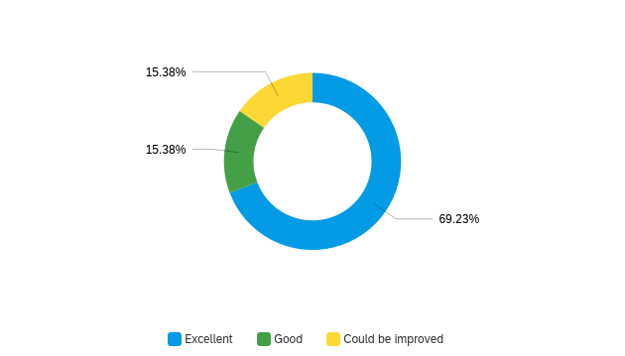
Figure 1
Figure 2
84% of respondents believe that living on campus more very convenient than living outside.
Only 30% students think it is easy to find a place to live.

Key Finding 1 – High cost with high level of satisfaction
Survey data indicates that the majority of student residents living on campus would agree that it is expensive to live in residence, yet proximity to school also becomes an advantage that affects housing decision.
Despite this, anecdotal information gathered from other institutional sources reveals that the cost of meal plan option to students is a source of frustration for many students. Therefore, organizers should take this into consideration. “The meal plan itself has been the subject of student complaint since the beginning of the year and we can attribute the negativity that surrounds our meal plan specifically in threefold: price, transparency and quality. (Michouris, 2017)

Key Finding 2 – Housing Availability is tight
Understanding availability for dormitory is critical to planning student residences.
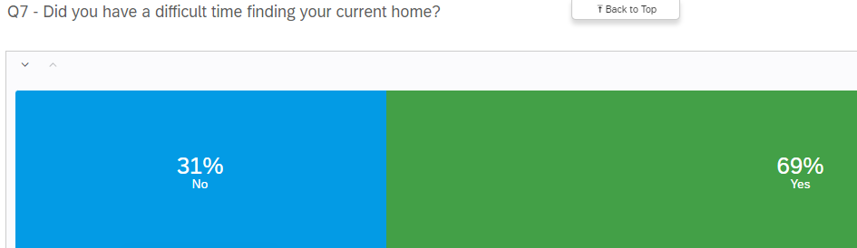
Figure 3

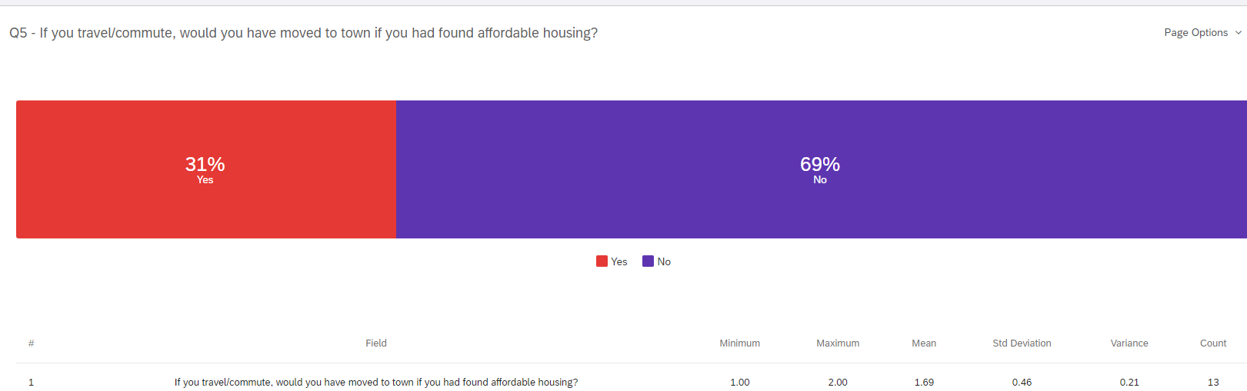
Figure 4
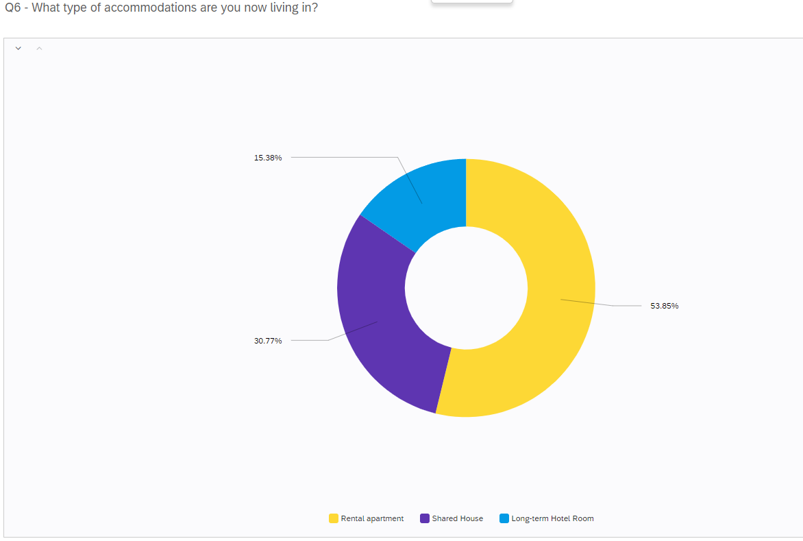
Figure 5
Data from survey participants suggests that individual living units in an apartment is the most preferred arrangement over other rooms, and nearly 70% students find hard to get place to live.

IV. Conclusion

Summary of Research
The surveys utilized for this study were designed to grasp the level of satisfaction for student housing at UBC in conjunction with identifying factors that may influence a student’s housing decision.

Despite the fact that the overall response rate is relatively small, the results does indicate insightful information. Therefore, to assist organizers in the Student Housing and Community Services (SHCS) at UBC, based on the information I collected, certain aspects below should be considered:

- Individual living units are the most demanded room type as well as least available, therefore it can also put pressure on the price. Cost and proximity to campus plays a significant role in current and prospective student’s housing decisions.
- Despite this, data gathered from other research shows that the price of some meal plans are too high

Proposed Solution
Student Housing and Community at UBC Services have considerable power to take action.
Firstly, there is a great need to acquire more land (or capacity) for affordable housing. The school can reach out to several parties (local government, and commercial housing entities) for potential cooperation where more housing is available to accommodate students. Such as building University-affiliated student apartments or houses that allow students to live off-campus without sacrificing the best parts of the college experience.
Secondly, UBC should also enforce sustainable power consumption measures. It has come to many students’ attention that many UBC residence buildings do not have a programmable thermostat, where unnecessary heating or cooling occurs on a frequent basis. Lights are constantly left on in empty rooms. I believe being energy efficient can reduce the cost of living as well.

V. Literature Cited
“Corporate Reports & Plans | BC Housing.” Bchousing.org, 2022, www.bchousing.org/about/corporate-reports-plans. Accessed 27 July 2022.
“Housing Action Plan.” Hr.ubc.ca, 2012, hr.ubc.ca/working-ubc/housing-and-relocation-services/finding-housing/housing-action-plan. Accessed 27 July 2022.
Housing Survey Data Analysis.
Michouris, Masha. “Sign the Petition.” Change.org, 2017, www.change.org/p/ubc-change-for-the-ubc-mandatory-meal-plan-and-dining-halls. Accessed 27 July 2022.

VI. Appendices

Appendix A. Survey Questionnaire
Introduction
I am a UBC student participating in a technical writing course. This survey aims to collect primary data for a formal report concerned with the cost of living on UBC campus. The finished report will be presented to Andrew Parr, the acting Associate Vice-President, Student Housing and Community Services (SHCS) at UBC. The data gathered from this survey will be used to prepare recommendations for decreasing the cost of living and improving the housing situation on campus. The survey should take 5 minutes, and your responses are voluntary and anonymous. Your participation is appreciated.

Q1
In general, housing on campus is:
- Easily affordable
- Affordable
- Costly
- Too costly

Q2
In general, social activities while living on campus are:
- Excellent
- Good
- Could be improved

Q3
In general, living on campus is
- A lot more convenient then living off-campus
- More convenient as living off-campus
- As convenient as living off-campus

Q4
Do you you think students living on campus do better academically?
- Yes
- No
- It's not related to where you live

Q5
If you travel/commute, would you have moved to town if you had found affordable housing?
- Yes
- No

Q6
What type of accommodations are you now living in?
- Rental apartment
- Shared House
- Long-term Hotel Room

Q7
Did you have a difficult time finding your current home?
- Yes
- No

Q8
Is living on campus cheaper than living off campus?
- Yes
- No

