Recommendations to Improve Community Engagement in Bedok Public Library

for
Ms. Raneetha d/o Rajaratnam
Director of programmes and services
National Library Board (NLB)

by
Anushka Nair
ENGL 301 Student
University of British Columbia

July 2022
Table of Contents
Abstract 3
Introduction 4
Background on the impact of COVID-19 on the library system in Singapore 4
Purpose of this report 4
Description of data sources 5
Scope of this inquiry 5
Data Section 7
Community Programmes 7
Issues with community programmes post-pandemic 7
Results of the survey taken by community members 7
New Features and Additions to the library 10
Results of the survey taken by community members 10
Results of an in-depth interview with Ms. Raneetha d/o Rajaratnam 11
Conclusion 13
Summary and overall interpretation of findings 13
Recommendations 14
References 15

Abstract

- Add abstract

Introduction
The National Library Board has a network of 27 public libraries that are conveniently located across Singapore. In 2020, the National Library Board saw COVID-19 causing significant disruptions to their physical operations and spaces (National Library Board). In April of that year, NLB’s libraries and archives were temporarily closed for five months as Singapore entered a nationwide circuit breaker. This came just after the country experienced a severe spike in local COVID-19 transmission cases.

Background on the impact of COVID-19 on the library system in Singapore
Over the past few years, public libraries have significantly suffered due to the reduction of visitors and community engagement because of the COVID-19 pandemic and the subsequent budget cuts. In 2021, all Singaporean public libraries were forced to reduce their capacity to 25%, limit visits to 1 or 2 hours and shut down all additional services (like cafes) and community programs in order to adhere to the strict COVID-19 measures imposed by the government. The overall number of visitors reduced from 26.7 million in 2019 to 9.06 million. This has led to the inevitable shutdown of important community programmes, with the number of pre-pandemic programmes being 27,000 to the current number of programmes lying around only 6000 (National Library Board).

Purpose of this report
Library-based community programs are opportunities to support lifelong learning. They serve residents of all ages and income levels. They serve a community's diversity through engaging entertainment, enrichment, and opportunities to encounter new ideas and learn new skills. Reduced visitorship threatens the survival of the library itself. Libraries help boost local economies and offer safe refuges for the underserved and poor. The purpose of this report is to:
- provide recommendations, based on feedback from Bedok community members and employees of Bedok Library employees, to improve community engagement in libraries
- To gauge the interests and opinions of Bedok Community members regarding library-run community programmes and features present in the library

Description of data sources
The primary data sources in this report will include surveys distributed to members of the Bedok community in order to assess their interests as well as an interview with a high-level employee of the National Library Board, to get a better understanding of the challenges they are facing. The secondary sources in this report will include annual reports provided by the National Library Board as well as studies and publications on the issues that Singaporean libraries are facing in the post-pandemic economy.

Scope of this inquiry
To assess the feasibility of the proposed solution, the following areas of inquiry, with the specific branch of Bedok Public Library in mind, will be pursued:
- What are the current programmes that are running?
- Which programmes (in the past or currently running) are the most popular amongst community members?
- Can the most popular programmes be adapted for a digital platform?
- What kind of programmes do community members prefer in the post-pandemic world?
- Are community members open to engagement programmes hosted online?
- Is it feasible to improve the additional services (such as cafes, etc.) provided in Bedok Public Library?
- Is it possible to implement a digital learning zone in Bedok Public Library?

.

Data Section
The data can be divided into two sections. The first is survey results from Bedok community members on current and future community programs that the Bedok Public Library runs. The secondary data in this subsection is based on the issues that community programmes are facing due to the COVID-19 pandemic.

The second section is based on new features and additions to the Bedok Public Library. This includes results from the survey taken by community members asking their opinions on what new features they would like to see at the library. There is also a short interview with Ms. Raneetha d/o Rajaratnam, director of programmes and services for the National Library Board (NLB).

Community Programmes

Issues with community programmes post-pandemic
- Secondary data

Results of the survey taken by community members
The responses to the survey regarding community programmes are given below:
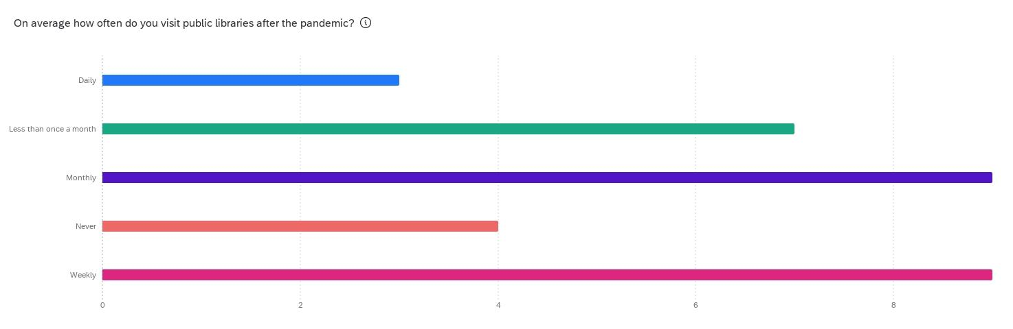
Fig 1. Results of Question 1 of the Community Programme survey

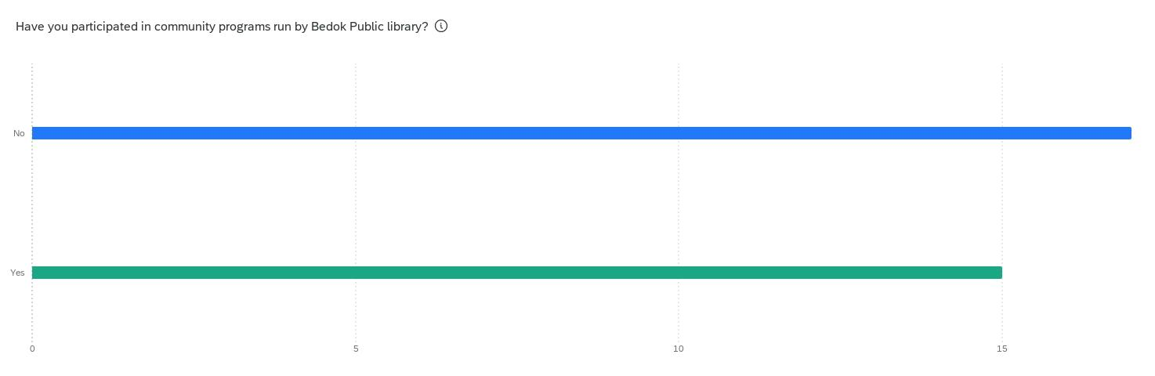

Fig 2. Results of Question 2 of the Community Programme survey

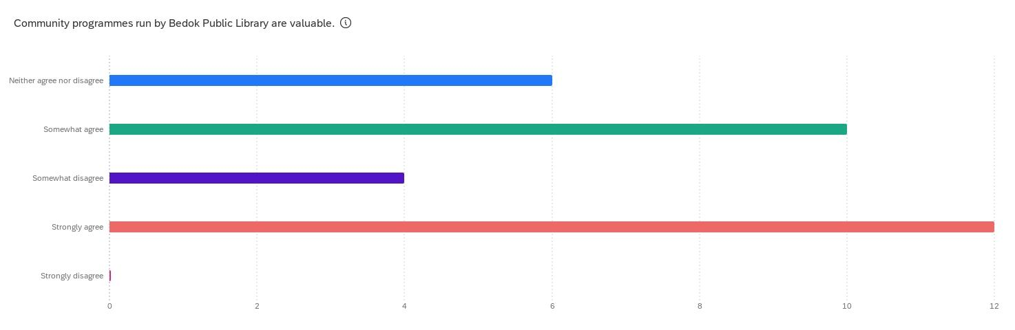
Fig 3. Results of Question 3 of the Community Programme survey
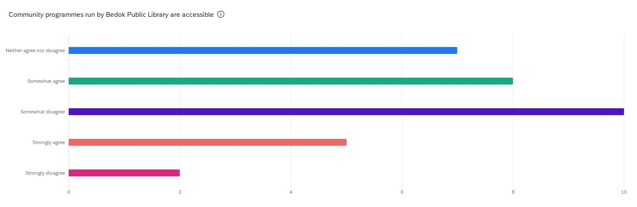
Fig 4. Results of Question 4 of the Community Programme survey

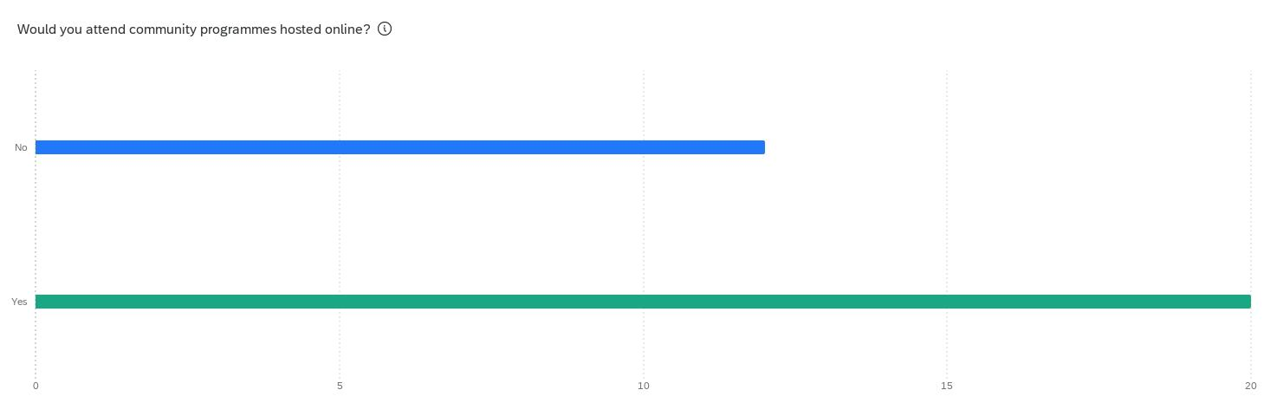
Fig 5. Results of Question 5 of the Community Programme survey

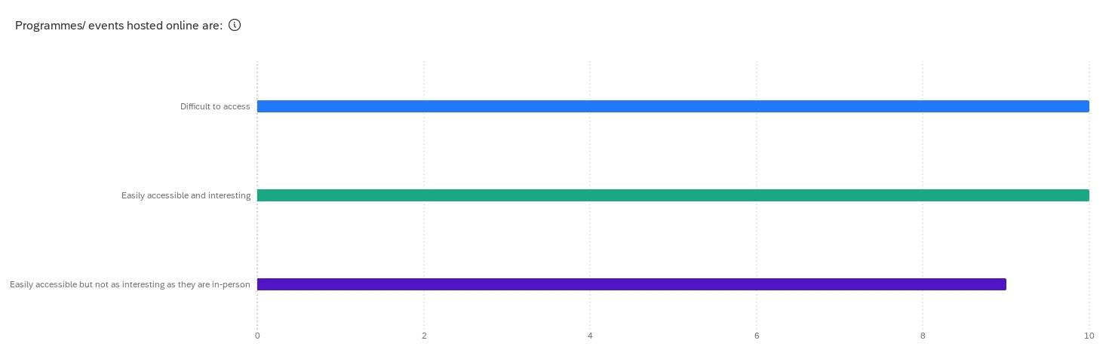
Fig 6. Results of Question 6 of the Community Programme survey

For the last question (question 7) titled “What kind of programmes do you want to see in Bedok Public libraries (Online or In-person)?”, the responses can be arranged into five broad categories. These categories are:
- Film-based events such as screening, technical history, etc.
- Programmes that help senior citizens learn more about technology/educational workshops for seniors
- Storytelling programmes for young children
- History/History of Singapore-based programmes
- Anything digital/online based

New Features and Additions to the library

Results of the survey taken by community members
- Primary data

Results of an in-depth interview with Ms. Raneetha d/o Rajaratnam
Below is the transcript of the interview conducted with the director of programmes and services for the National Library Board (NLB):

Q: What are the current challenges being faced by libraries in Singapore due to the pandemic?
A: We had to shut down all our branches for nearly five months. Even after we re-opened, the libraries were either working at reduced capacity or reduced hours. During this time, we were solely dependent on our digital resources, however, we noticed that our digital side had not been as developed or robust as we would like them to be. So our focus has been on re-vamping this side. In doing so our in-person facilities and programmes have taken a back seat, but as we slowly get back to normal we have realized how important in-person facilities are, especially for our senior population.

Q: What are the current programmes that are running after the pandemic?
A: Some of the programmes that are running are:
- An exhibition detailing our journey in Singapore’s ever-changing landscape
- We are currently calling on citizens of Singapore to come in and share their pandemic experiences in order to archive and chronicle this historic event
- We have career workshops for young adults/adults
- We have science and sustainability programs for teens

Q: Can the most popular programmes be adapted for a digital platform to suit the post-pandemic world?
A: One hundred percent! Like I said before, this has been our main focus for the past few months, since the beginning of 2022. People are currently more comfortable with everything being online and so we want to keep up with the interests of these times.

Q: Is it feasible to improve the additional services/facilities (such as cafes, etc.) provided in Bedok Public Library?
A: Yes, we are focusing on updating our facilities/services across all branches as they were untouched for quite some time during the pandemic.

Q: Is it feasible to add any services/facilities (such as cafes, etc.) to the Bedok Public Library?
A: In the short run, no. This is due to COVID-related budget cuts and the fact that any renovation would cause libraries to close for a couple of months at a time. However, if we are looking at five, or ten years in the future, I believe new services such as cafes can be implemented in Bedok Public Library. Any new addition is not currently a big priority as we are trying to maintain and update our existing facilities/services.

Q: Is it possible to implement a digital learning zone in Bedok Public Library
A: I believe so! This is an interesting idea and falls in line with our efforts to digitize even more into the future. With so many technological advances, this seems like an attainable and relevant goal.

Conclusion

Summary and overall interpretation of findings

For the survey regarding community programmes, there were a total of 32 responses. Below is a summary of these responses:
- Nearly 52% of responses indicated that they had not attended any of the community programmes hosted by Bedok Public Library.
- However, 40% of the responses indicated that they strongly believe that the community programs are valuable.
- 30% of the responses note that community programmes that are currently hosted are not easily accessible.
- The majority (nearly 55%) would attend online programs/ events and 30% believe that online events/programmes are interesting and easily accessible.
- 31% stated that online events/ programmes are difficult to access.
- Meanwhile, 28% believed that while online programmes/events are easily accessible, they are not as interesting as they would be in-person.

Looking at this data, it is clear that community programmes need improvement. People in the community want online programmes. However, hosting online programmes or events is not without its challenges as the National Libray Board will have to ensure that people of all ages can easily understand how to access these events and they need to be interesting enough to captivate the audience so that the attendance numbers do not fall.

- Add summary + interpretation of facilities/services survey

Recommendations
One possible solution is to create an omnichannel (engagement approach in which a company gives access to their products, offers, and support services to customers on all platforms, and devices) learning marketplace platform so that learning can take place both digitally and physically. This would include improving digital facilities offered by the NLB, including the mobile app, and ensuring that library spaces are open for work and learning. (National Library Board)

References
​​​​National Library Board. (2021). National Library Board Annual Report 2020 / 2021. Singapore: National Library Board. Retrieved from https://www.nlb.gov.sg/Portals/0/Docs/AnnualReports/2020/(PDF-A)%20NLB%20Annual%20Report%20FY2020.pdf

National Library Board. (2020). National Library Board Annual Report 2019/2020. Singapore: National Library Board. Retrieved from https://www.nlb.gov.sg/Portals/0/Docs/AnnualReports/2019/NLBFY2019AnnualReport(PDF-A).pdf?ver=yfH7PoBTw3tR5LoHxdyL9Q%3d%3d

