Implementing an Electronic Queuing System in the UBC Birdcoop Fitness Centre
Prepared for Darren Stolz, Facility & Equipment Coordinator of UBC Recreation Centre
July 22, 2022
Prepared by Chris Jung
eunhocj@student.ubc.ca

Table Of Contents

Introduction 3
Background 3
Statement of Problem 3
Purpose of Report 4
Scope of Inquiry 4
Data Sources 5

Data Section 6
Cause 1: Popular Gym Equipment in Birdcoop Fitness Centre 6
Cause 2: Changes in the Number of Visitors After the COVID Restriction Was Lifted 7
Problem 1: Amount of Time Spent Waiting for Equipment 7
Problem 2: Conflicts Between Users Caused by Ambiguous Waiting System 8
Solution: Electronic Queuing System Using a UBC Card 9
Electronic ID Checking System Using a UBC Card in the UBC 9
Components and Process of the Proposed Electronic Queuing System 9
Expected Advantages of Using an Electronic Queuing System Using a UBC Card TBD
Installation Plan 10
Card Reader 10
Software Development 11
Budget 11

Conclusion TBD
Summary of Findings TBD
Recommendations TBD
Reference TBD

Introduction

Background
The UBC Recreation Centre plays a significant role in many UBC students’ lives. It helps the students strengthen their physical health and boost their mental health as well during the intensive study period at UBC. As the COVID restriction is being eased, more students visit UBC Recreation Centre, especially the Birdcoop Fitness Centre which is known for its weightlifting equipment. However, the increase in the number of visitors to Birdcoop Fitness Centre causes a shortage of popular gym equipment such as squat racks, bench racks, and lifting platforms. Thus, more users of the gym have to wait for an uncertain amount of time standing next to the equipment before using popular equipment.

Statement of Problem
There are currently four bench racks, five squat racks, and six lifting platforms in Birdcoop. It may seem that they are a lot, but the demand for them is also very high as these three kinds of gym equipment are used for five core exercises in weightlifting (Bench Press, Squat, Deadlifting, Overhead Press, and Barbell Row). Although waiting for the popular equipment in Birdcoop Fitness Centre has become more frequent, there is no systemic way of queueing for equipment at the gym. The traditional way of waiting for equipment is just to stand near the equipment until the current user finishes exercising with the equipment. This way of queueing wastes users’ time spent in the gym by making them stay at one spot not being able to exercise. Also, this way of waiting creates conflicts between users because it is often not clear who started to wait first or how many people are waiting to use the equipment.

Purpose of Report
This report aims to provide an accurate analysis of the current issues with the waiting system in Birdcoop Fitness Centre and to propose an electronic queuing system as a feasible solution to resolve the problem. (_{Add} help readers make decisions? )

Scope of Inquiry
This report investigates the following eight questions to precisely investigate the current problem and provide an effective solution to it:
- How many people are having difficulties caused by the current waiting system in Birdcoop Fitness Centre?
- How much time can be saved for each student approximately by not waiting near the equipment when they want to wait for it?
- What are the kinds of equipment in Birdcoop that are most popular but short in supply?
- What is the average/appropriate using time of the popular equipment in Birdcoop?
- How much would it cost to implement the entire electronic queuing system?
- How many gym users agree with implementing a new electronic queuing system?

Data Sources

Survey
The primary data source of this report is the actual experiences of the users of the gym. Thirty-five users of Birdcoop Fitness Centre responded to an anonymous online survey designed to analyze the demand and waiting for the gym equipment as well as gauge interest in a potential electronic queuing solution. The survey consists of the following eight questions:
- On average, how many days do you exercise at the UBC Birdcoop Fitness Centre in a week?
- On average, how much time do you spend in one visit to Birdcoop Fitness Centre?
- Please select gym equipment that you most frequently use (up to 3 kinds)
- Have you ever waited for gym equipment in Birdcoop Fitness Centre?
- (If the response from Q4 is “yes”) On average, how much time do you spend waiting for gym equipment in one visit to Birdcoop Fitness Centre?
- (If the response from Q4 is “yes”) Please select the gym equipment that you most frequently wait for (up to 3 kinds).
- Have you ever experienced or watched a conflict caused by waiting for equipment between users of Birdcoop Fitness Centre?
- Do you agree with implementing an electronic queuing system for popular gym equipment in Birdcoop Fitness Centre?
- Please enter the reason for your answer for Q8

Interview
An interview with the staff who has been working as a staff of Birdcoop Fitness Centre for the last 23 months was also conducted to get answers to the following two questions:
- Was there any change in the number of visitors to the gym after the COVID restriction was lifted compared to before?
- Have you ever witnessed or resolved conflicts between users caused by waiting for gym equipment?

Others: Observation & Web Search
As secondary data sources, long-term observations of the Birdcoop Fitness Centre by the writer, an active user of the Gym, were included in the report. Also, some data was collected online to calculate an accurate budget for the implementation of an electronic queuing system.

Data Section

Popular Gym Equipment in Birdcoop Fitness Centre
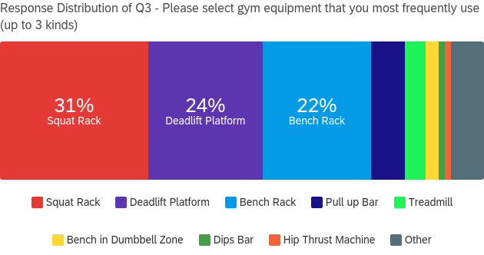
Figure 1. Result of Survey – Q3
Figure 1. shows that squat rack, deadlift platform, and bench rack are by far the three most frequently used types of gym equipment in Birdcoop Fitness Centre. This implies that many users visit Birdcoop Fitness Centre to use its facility specialized in weightlifting.
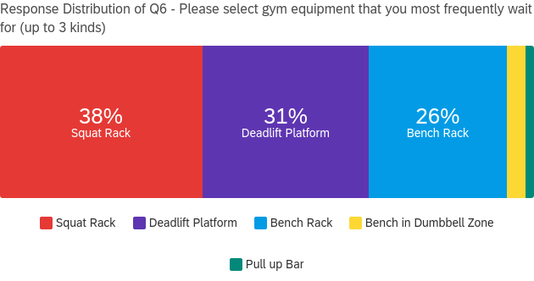
Figure 2. Result of Survey – Q6
Figure 2. strikingly shows that squat rack, deadlift platform, and bench rack are the gym facilities that are not just popular but that are most waited for in the gym as well. Combining the two results, it is shown that the demands for the three kinds of gym equipment are much higher than the capacity of the gym. This high demand over the capacity for those three kinds of facilities causes the users to spend more time waiting in the gym.

Increasing Number of Visitors to Birdcoop Fitness Centre
After the COVID restriction was lifted, more people are visiting the Birdcoop Fitness Centre to enjoy the gym which was not easy to do during the COVID period. From the interview conducted with a staff of Birdcoop Fitness Centre, the interviewee answered that “The number of visitors to the gym approximately doubled during the peak time of the day after COVID restriction was lifted.” This response also complies with the fact that there is always a line to enter the gym during peak time (from 5 pm to 7 pm) but the maximum capacity of the gym was increased to 75 people from 30 people at the same time after the COVID restriction was relieved.

Amount of Time Spent Waiting for Equipment
In the current waiting system in the gym, users should stay near the equipment they want to use until it becomes available. Someone else may take the equipment if the original waiter is not there at the moment it becomes available. Thus, most of the time waiting for equipment is purely wasted standing nearby it unless the waiters luckily have another exercise to do with equipment near the one they wait for.
Average time spent in Birdcoop Fitness Centre
1) Average time spent in the gym per visit | 73.8 mins
2) Average time spent waiting per visit | 11.2 mins
3) Percentage of time spent waiting per visit | 15.2%
4) Average number of visits per week | 3.1 times
5) Average wasted time per week | 34.7 mins
Table 1. Summary of time spent in Birdcoop Fitness Centre
Table 1. is the summary of users’ time spent and wasted in the gym calculated from the responses from Q1), Q2), and Q3) of the survey. It turned out that about 15% of users’ time was wasted while waiting for the gym equipment they want to use in the Birdcoop Fitness Centre. Also, when converted into the time spent per week, about 35 minutes on average was wasted just waiting for gym equipment every week by each user. This is a huge loss both for the gym and for the users of the gym. To put it another way, Birdcoop Fitness Centre can increase its capacity up to about 15% by reducing the users’ time spent waiting. In terms of users’ benefits, they can save about 35 minutes every week by effectively managing the time wasted waiting in the gym.

Conflicts Between Users Caused by Ambiguous Waiting System
Wasted time in the gym is not the only problem caused by the current waiting system. The traditional waiting system also brings unnecessary conflicts between users of Birdcoop Fitness Centre. The current waiting system does not record anything about the waiting. Thus, it is not clear how many people are waiting for certain equipment, who started the waiting first, or how long the current user of the equipment is using it. This ambiguity of the waiting often causes trouble among users especially when the gym is filled with people at its peak time. For example, one common conflict between two waiters is caused because the order of waiting is not clear. From the survey conducted with the users, about 57.7% of respondents answered that they have experienced or watched a conflict between users caused by waiting for gym equipment in Birdcoop Fitness Centre. Since any conflict between users can negatively affect many other users’ experiences in the gym, this kind of conflict should be prevented. Also, the staff of the gym in the interview responded that he “frequently witnesses conflicts caused by waiting for gym equipment, and this kind of conflict comprises about 80% of all human-caused troubles in the gym.”. For this reason, it is necessary to introduce a clear queuing system to prevent this kind of unnecessary trouble in Birdcoop Fitness Centre.

Solution: an Electronic Queuing System Using a UBC Card

Electronic ID Checking System Using a UBC Card in the UBC
In the UBC, one can easily verify their identity electronically using a UBC card by simply tapping the card on a card reader. The process of electronic identification using a UBC card is very simple. The card reader reads a unique id stored in the card, sends the scanned id to a computer, and the computer finally verifies the id by comparing the id with the information stored in the online UBC system. This electronic identification is widely used to enter restricted areas in the UBC including Birdcoop Fitness Centre. As all users of the gym possess a UBC card, an electronic waiting system in the gym can be created just by replacing the last step with putting the user onto a queuing system.

Components and Process of the Proposed Electronic Queuing System
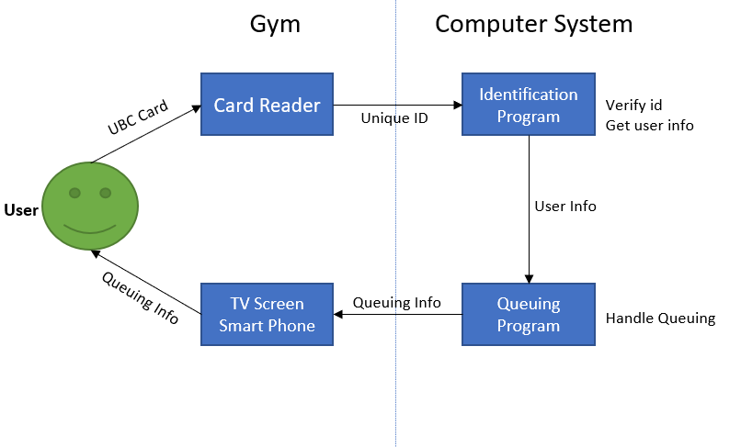
Figure 3. Process of the Electronic Queuing System
The proposed electronic queuing system is comprised of four major components: Card reader, identification program, queuing program, and display. Among the four components, only extra card readers and a queueing program are required to be installed as the other two components already exist in the gym.
The process of the system is very similar to other identification processes used on the UBC campus. Figure 3. shows a simple visualization of the process. Each piece of equipment has a designated card reader on one side of the gym. When a user taps their UBC card on the reader, it reads the user id stored in the card and sends it to the computer in the gym. The computer has an identification program used to identify people entering the gym. From the identification program, the PC gets the user information and sends the user information to the queuing program. The queueing program handles everything related to queuing including enqueuing, dequeuing, and sending queuing information to the TV screen in the gym or to the user’s smartphone. Finally, users can check the status of queuing from their smartphone or TV screens installed in the gym.

Installation Plan

Card Reader
Fifteen new card readers are required to implement the proposed queuing system to designate one reader for one piece of equipment. The readers are fixed on the wall near the equipment they are designated for. The standard card reader used on the UBC campus iCLASS SE R10 model manufactured by HID. When it is privately bought, one piece of the device costs 110 dollars, but this cost can be saved if there are available card readers in UBC Recreation Centre.

Software Development
The system requires an original application to manage the queueing for fifteen pieces of equipment in the gym. However, the level of difficulty is quite low as the logic for queueing systems is well-known. From the perspective of a 4th-year student in Computer Science (the proposer of this report), about 20 hours of programming by an entry-level programmer would be sufficient to develop a working software for this system.

Budget
Assuming that there is no available card reader in the UBC Recreation Centre, a maximum of 1,650 dollars is required to purchase 15 new card readers. There would not be extra expenses to install the device as the installation of standard UBC card readers can be done by the UBC Facility and Maintenance Department. The average salary of entry-level software developers in Vancouver is about 33.6 dollars per hour. Based on this number the software development can be done within approximately 700 dollars of budget. To sum up, the entire cost of implementing the proposed electronic queuing system is estimated at about 2,350 dollars.

