Feasibility Analysis for the AMS to Create a Newsletter for Improving Awareness of Library Resources for Career Opportunities for UBC Students at the Surrey City Centre Library

For
Michael Prost
Student Services Manager of the
AMS

By
Benson Lin
ENGL 301 Student

Table of Contents
I. Introduction 3
A. Information about Resources Available at the Public Libraries for Career development and Job Searching 3
B. Information about Resources that UBC Provides for Job Searching 3
C. Purpose of this Report 4
D. Description of Data Sources and Methods 4
E. Scope of this Inquiry 5
II. Body 5
A. Detailed Overview of Resources Available at the Surrey City Centre Library 5
1. Books, Access to Wifi, Access to Online Learning Platforms 5
2. Events at the Library 6
B. Discussion of the Collected Data 6
C. Proposed Solution 11
III. Conclusion 11

I. Introduction

A. Information about Resources Available at the Public Libraries for Career development and Job Searching

Most people’s first thought about the library is that it is a place where you can only find books or is a place for children to explore literature. However, it contains a wealth of knowledge with resources other than books. Many people go to the library to access Wifi to study, read the newspaper, and to learn about various subjects, such as language, history, science, business, and practical guides. The library is a meeting place for people to interact with their community and a place to participate in various clubs for various interests. There are various events that aim to teach people practical skills in computer basics, language practice, career training and employment information sessions. These events can be hosted in different languages depending on the community they are serving. For example, the Richmond library has events in Mandarin and the Surrey library offers events in Punjabi. Public libraries provide free resources for the community to meet, and learn and are underutilized by students as they are unaware of the many resources that are available.

B. Information about Resources that UBC Provides for Job Searching

UBC provides many resources for career and skill development. On the Student Services website, there are pages about events and workshops, access to LinkedIn Learning, an online job board and other career resources. There are also pages that provide sample resumes and cover letters, and provide best practices for interviews. There are also external links to other useful websites and sources for all topics about career development. UBC also hosts events for career advising, interview preparation, and career fairs. UBC provides students with many resources for career development and job searching, but students who do not live on campus may not be able to attend certain events due to their location or schedule so having more opportunities closer to where they live can help.

C. Purpose of this Report

The purpose of this report is to determine the feasibility for the AMS to create a newsletter for UBC students to increase awareness of local library resources that are related to career advancements and job searching. With increased awareness of public library resources, UBC students will have more resources and support that will help them gain the skills to find jobs in a competitive job market. I believe that public library resources that are located closer to students will help students who live outside of campus the most. These resources can reduce stress and anxiety that come from job searching which can lead to higher student satisfaction and allow them to better focus on their studies.

D. Description of Data Sources and Methods

Seven UBC students responded to a short survey to determine what the current needs of students are for career related resources, what resources students are aware of at the library, and how many students are seeking a new job or are contemplating changing careers. Observations were made at the Surrey City Centre library to discover the available resources and the placement of advertising for said resources. An analysis of the survey and the observations at the library were made to determine the feasibility of the proposed newsletter.

E. Scope of this Inquiry

To assess the feasibility of a newsletter to increase awareness of library resources, I created a list of questions.
- What are the current needs of people for career related resources?
- How many people are aware of library resources besides books and dvds?
- How many people are currently seeking a new job or are contemplating changing careers?
- What career related programs are in place at the library?
- What is the current attendance at career related events hosted at the library?

II. Body

A. Detailed Overview of Resources Available at the Surrey City Centre Library

1. Books, Access to Wifi, Access to Online Learning Platforms

From my observations at the Surrey City Centre Library, I have found a bulletin board that advertises employment aid right next to the entrance. The bulletin board contains flyers for job fairs, tutoring for reading, writing, and math, and free programs that will provide aid in finding a job. There was an information board that advertised free Wifi, a large collection of O’Reilly ebooks, and electronic resources in French for various topics. Next to the help desk, there were brochures that provide information about employment and income, education/ESL, and events occurring at the library. Access to LinkedIn Learning is available on the Surrey Libraries website. To access the learning platform, one needs a library card and library cards are easily obtainable by bringing a valid piece of identification.

2. Events at the Library

Upon exploring the Surrey Library website, I found that several events related to employment or starting a business were available until the end of 2022. One of the events is an information session provided by staff from Work BC Job Centre about employment counseling, skills training, wage subsidy and other useful topics relevant for job seekers. Also, there is an online information session about how to start up a business or gain business knowledge. This program is presented in partnership with S.U.C.C.E.S.S BC and offers one on one assistance to individuals seeking business coaching, mentorship, networking, and shadowing. The Surrey Library system has multiple events related to employment that are readily available and are helpful for UBC students.

B. Discussion of the Collected Data

The survey results appear to support that a newsletter would be beneficial for students. The first question on the survey asks how prepared students feel for a job interview. A majority of the students feel at least somewhat prepared. Additional opportunities for interview practice from library events or other online resources would help students feel more prepared and comfortable when it comes to interviewing.

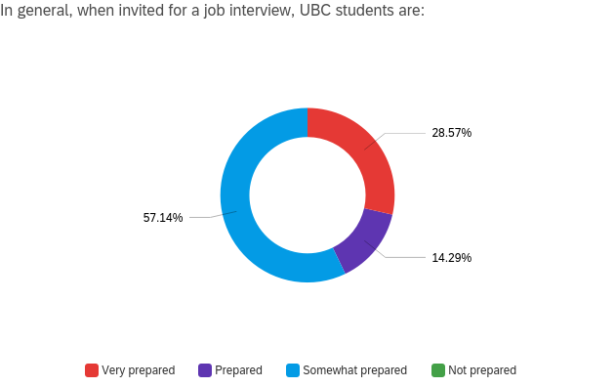
Figure 1. Results from Survey Question #1

More than half of the students responded that they either rarely or never use the public library for assistance with job searching and application packages. This reflects the results obtained from a question asking students to type in the resources that they know are available at the library. Students mainly responded with books, computers, and printers. Only one student had a response that included resume writing assistance and tutoring. This indicates that students are not aware of the career related resources that are available at the library and therefore do not use public libraries for job search assistance.

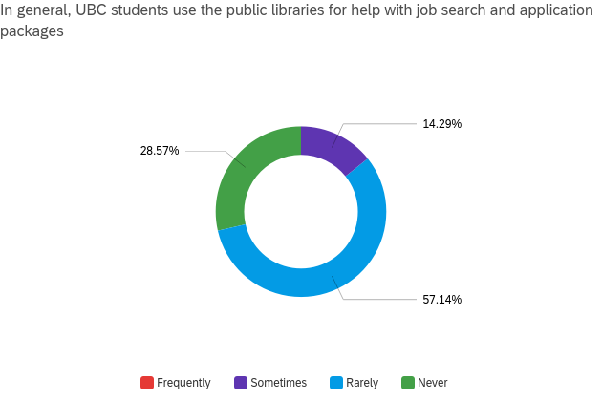
Figure 2. Results from Survey Question #2

Over 50% of students find writing resumes and cover letters difficult and over 70% indicated that finding a new job is difficult. A large portion of students responded with feelings of difficulty in these two responses which indicates that additional career resources would help students feel more comfortable with writing resumes and cover letters.

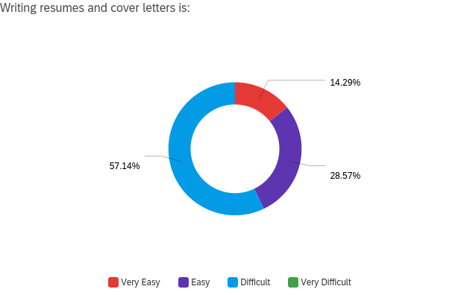
Figure 3. Results from Survey Question #4

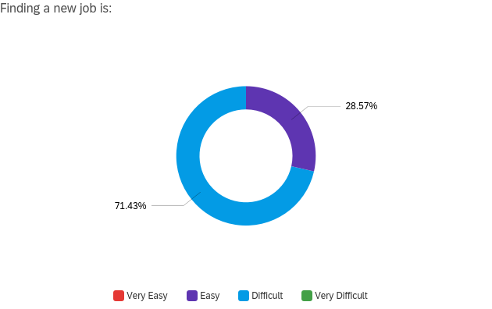
Figure 4. Results from Survey Question #5

The last two survey questions suggest that having additional career resources would be helpful as a large portion of students are either seeking new jobs or are interested in changing careers.

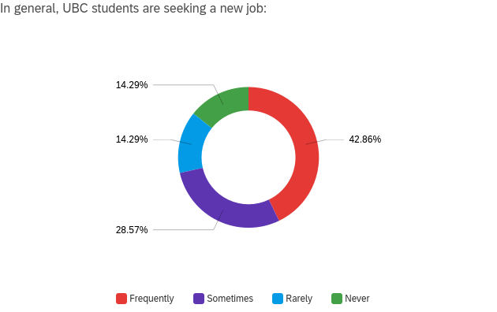
Figure 5. Results from Survey Question #6
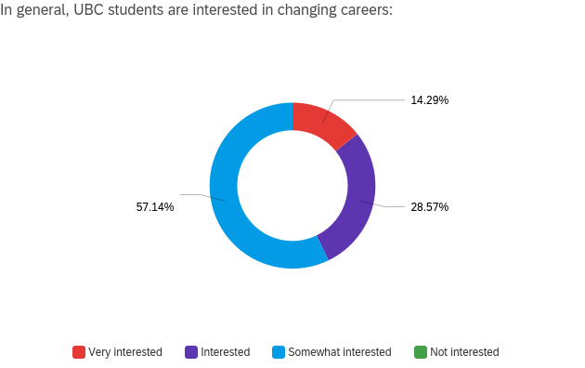
Figure 6. Results from Survey Question #7

C. Proposed Solution

From the results of the survey, it appears that students would benefit from having access to additional career related resources. The observations from the library indicate that relevant resources are readily available for free to students. A newsletter from the AMS would serve students actively looking for jobs and or contemplating a career change. I believe that the newsletter would need to be sent out at the beginning of the semester so that students can become aware of the library resources. Students can find time to seek out these resources. The newsletter could contain links to the career resources pages on the Surrey Library website, highlight some resources such as free access to LinkedIn Learning and present upcoming career related events being hosted at the Surrey City Centre branch.

III. Conclusion

As the job landscape evolves, students will need to learn new skills to keep up with the changing requirements that employers are looking for. The public library system has the resources to help students become lifelong learners and advance their career or transition to a new career. The AMS can provide help to students who are actively looking for jobs or contemplating career changes by providing a newsletter at the beginning of the semester to introduce students to the resources available at the public library. With these resources, students will have better outcomes in interviews, job searching and will help increase student satisfaction.

