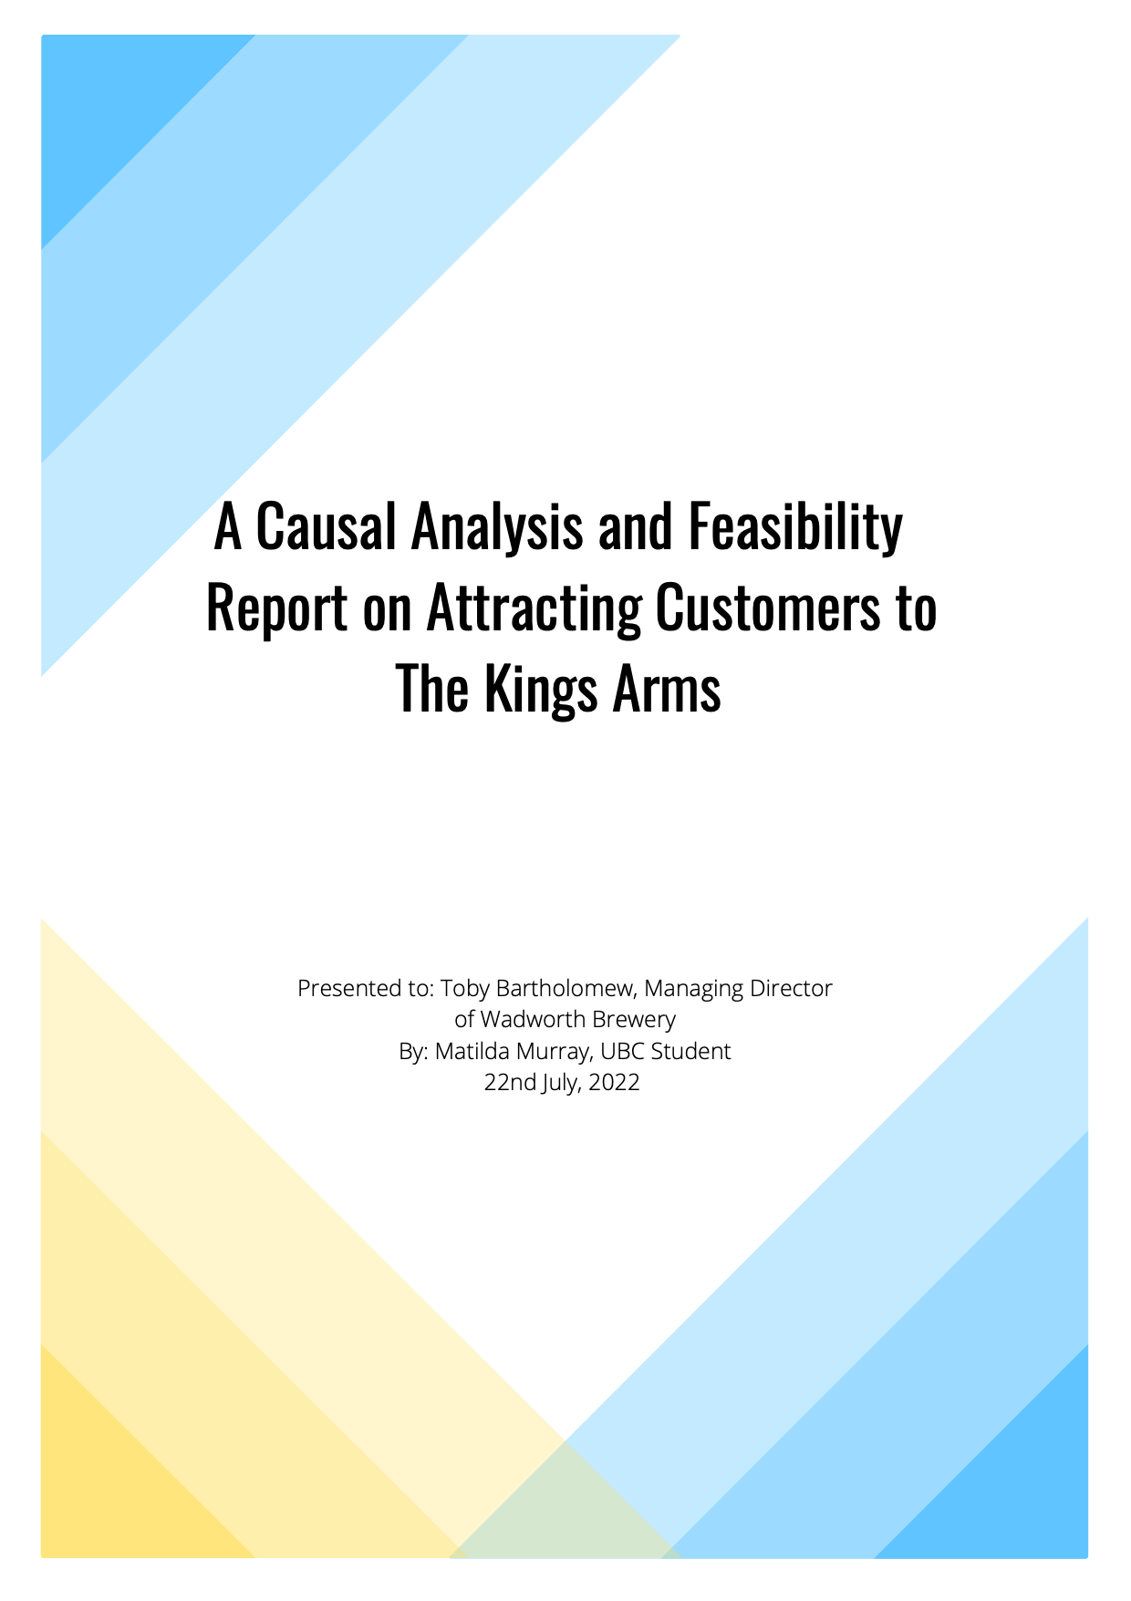
Table of Contents
Introduction - - - - - - - - - - - - - - - - - - - - - - - - - - - - - - - - - - - - - - - - - - - - - 2
Background on The Kings Arms - - - - - - - - - - - - - - - - - - - - - - - - - - - - - - - - - - - - - - - - - 2
Issue and Purpose of Report - - - - - - - - - - - - - - - - - - - - - - - - - - - - - - - - - - - - - - - - - - - - 2
Methods of Inquiry - - - - - - - - - - - - - - - - - - - - - - - - - - - - - - - - - - - - - - - - - - - - - - - - - - 3
Scope of Investigation - - - - - - - - - - - - - - - - - - - - - - - - - - - - - - - - - - - - - - - - - - - - - - - - 3

Data Section - - - - - - - - - - - - - - - - - - - - - - - - - - - - - - - - - - - - - - - - - - - - - 4
Amount of Customers at The Kings Arms - - - - - - - - - - - - - - - - - - - - - - - - - - - - - - - - - - 4
Amount of Customers at The Golden Lion and White Horse - - - - - - - - - - - - - - - - - - - - - - 5
Comparison and Analysis of Customer Amounts - - - - - - - - - - - - - - - - - - - - - - - - - - - - - - 5
Interview Findings - - - - - - - - - - - - - - - - - - - - - - - - - - - - - - - - - - - - - - - - - - - - - - - - - - 6
Summary and Analysis of Interview Findings - - - - - - - - - - - - - - - - - - - - - - - - - - - - - - - - 9
Survey Findings on Enjoyment of A Pub - - - - - - - - - - - - - - - - - - - - - - - - - - - - - - - - - - - 9
Summary and Analysis of Enjoyment Findings - - - - - - - - - - - - - - - - - - - - - - - - - - - - - - - 10
Survey Findings on Beer Garden Opinions - - - - - - - - - - - - - - - - - - - - - - - - - - - - - - - - - -10
Summary and Analysis of Findings on Beer Gardens - - - - - - - - - - - - - - - - - - - - - - - - - - - 11
Estimated Cost of Refurbishment - - - - - - - - - - - - - - - - - - - - - - - - - - - - - - - - - - - - - - - - 12
Feasibility Assessment - - - - - - - - - - - - - - - - - - - - - - - - - - - - - - - - - - - - - - - - - - - - - - - 13

Conclusion - - - - - - - - - - - - - - - - - - - - - - - - - - - - - - - - - - - - - - - - - - - - - -13
Summary of Investigative Findings - - - - - - - - - - - - - - - - - - - - - - - - - - - - - - - - - - - - - - - 13
Recommendations - - - - - - - - - - - - - - - - - - - - - - - - - - - - - - - - - - - - - - - - - - - - - - - - - - - - - - - - 14

Works Cited - - - - - - - - - - - - - - - - - - - - - - - - - - - - - - - - - - - - - - - - - - - - 15
Introduction

Background:
The Kings Arms is a pub in the London borough of Fulham, owned by Wadworth brewery. The Kings Arms is a spacious pub boasting a max capacity of 250 people and a fully stocked bar with 20 different beers and six different ales on tap. The pub also has seven 54-inch TVs throughout the space to allow for visibility from all angles and a small beer garden.
Furthermore, the pub has a beautiful kitchen and pizza oven staffed by three talented chefs who serve lunch, dinner and nibbles daily. Located a 15-minute walk from Fulham Football Club stadium, Craven cottage, The Kings Arms is lucky enough to be one of the closest pubs to the stadium and thus garners significant business from football fans on match days. Workers from offices such as Clarion Events, Maxgo Business Solutions, Fuse Venture Partners and Parallel Consulting would come by for the lunchtime specials or after-work drinks.
Issue and Purpose:
The pandemic hit the hospitality industry hard. Like other pubs and restaurants, The Kings Arms was forced to close for a significant time due to lockdown measures. Once reopened, they were forced to operate at a reduced capacity meaning that The Kings Arms couldn't significantly profit from major events such as the Euros. Furthermore, the office workers were forced to work from home, even after the UK lifted some lockdown measures. Moreover, many football matches had to be cancelled due to the pandemic. The pandemic has meant that profits have stagnated for the past few years. The UK lifted COVID-19 restrictions on 19th July 2021, meaning that The Kings Arms was allowed to operate at max capacity and with no restrictions. However, The Kings Arms is still struggling with the lack of customers.
Meanwhile, nearby pubs such as The Golden Lion and The White Horse are thriving with London's social scene reopening. The issue is that whilst the rest of London has reopened, nearby offices have chosen to remain permanently remote or implement a hybrid system. Thus, The Kings Arms has lost most of its customers and, therefore, its’ income. This report investigates why pubs such as The Golden Lion and The White Horse thrive in a post-pandemic London whilst The Kings Arms is still struggling. From the findings in this report, one can implement a solution to attract customers to The Kings Arms.
Methods:
Near identical surveys were conducted at The Kings Arms, The White Horse and the Golden Lion. Seventy-four customers completed the survey. The surveys were designed to understand better the pubs' customers, such as their age and smoking habits. The surveys also questioned what the customers liked about the pub they were at and their opinions on beer gardens. In addition, some employees at The Kings Arms were interviewed to understand better the workings of the pub and its customer base. Furthermore, secondary research into the demographics of Fulham was undertaken. Finally, a rough estimate of the cost of refurbishing the beer garden was conducted from contractor quotes and DIY websites to assess the plan's feasibility better.

Scope:
To determine the feasibility of remodelling the King's Arms, I will investigate these five elements:
- What do our current customers want?
- What draws customers to other more popular pubs?
- What is the cost of remodelling?
- what are the demographics of the area, e.g. average income, age?
- Can other changes be implemented, such as changing the food or drinks menu?

Data Section
Amount of Customers:
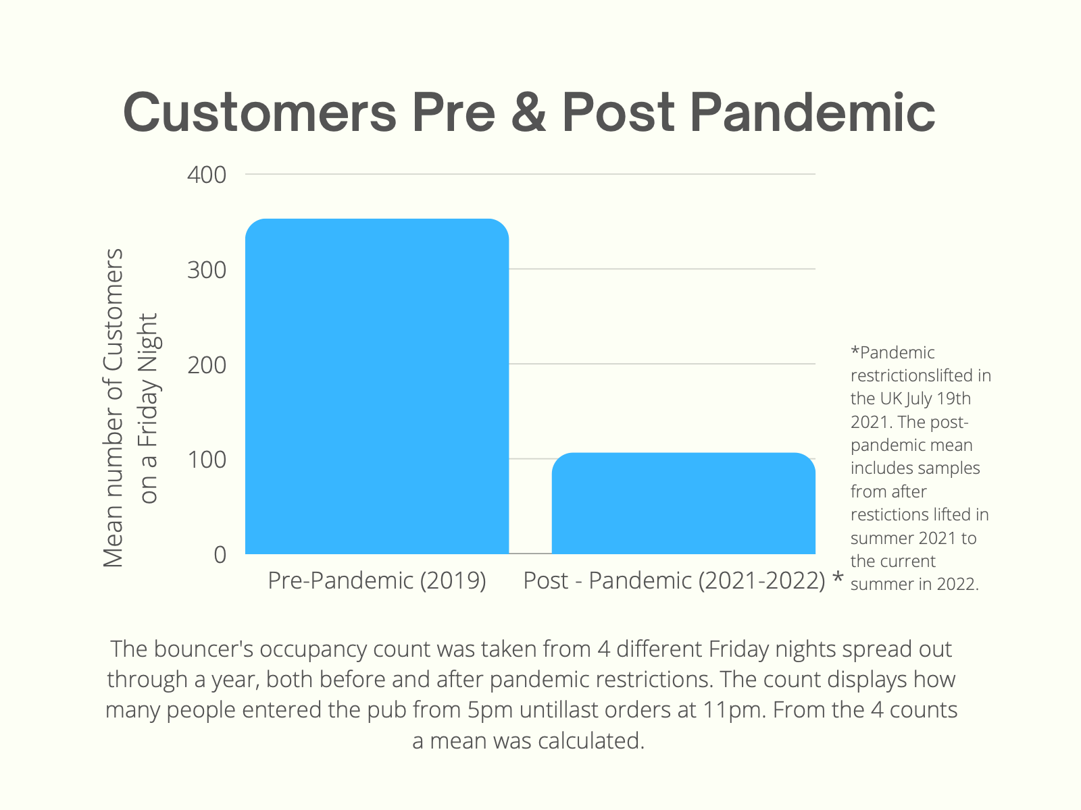
The Kings Arms:
Figure 1: A graph comparing pre and post-pandemic customer amounts.

The data shows that pre-pandemic, an average Friday night would have about 300 customers. Since lifting COVID-19 restrictions, an average Friday night now sees about 100 customers. The data shows that despite lifting restrictions, Kings Arms has been unable to revert back to its pre-pandemic occupancy.

The Golden Lion and White Horse:
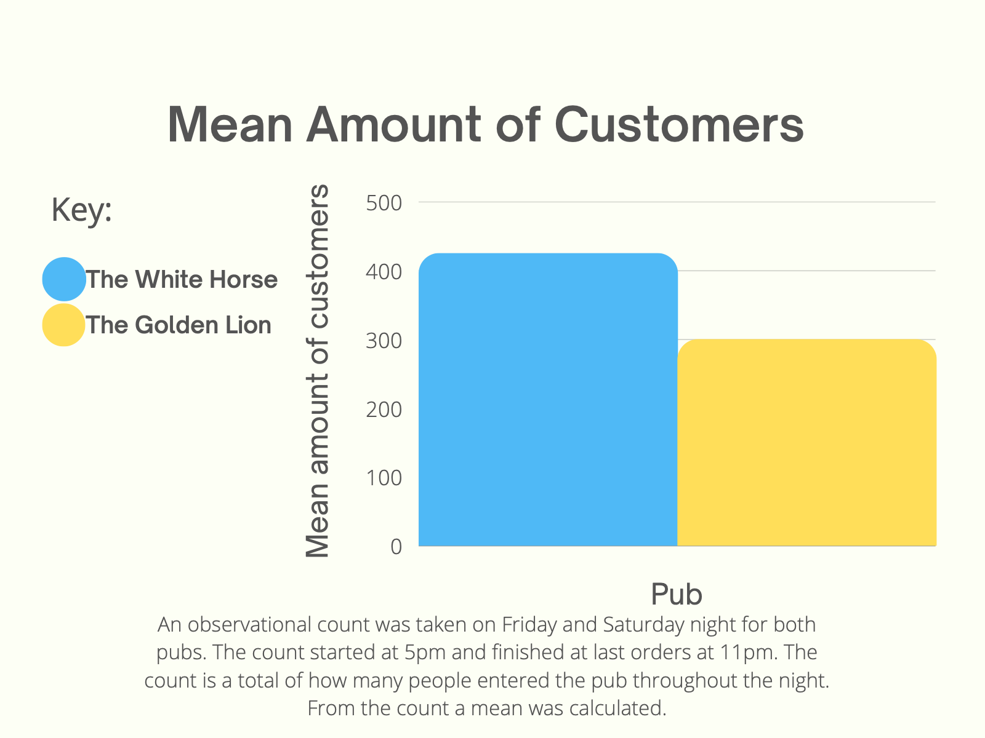
Figure 2: A graph showing average amount of customers in a night at other pubs (Post-pandemic)

Pubs such as The White Horse and The Golden Lion are seeing an average of about 300 to 400 people a night, even in post-pandemic conditions; this is a stark comparison to The Kings Arms. The White Horse and The Golden Lion are all within walking distance of The Kings Arms, with The Golden Lion being just 100 m down the road, yet they continue to thrive. Thus, it would be inconceivable to blame The Kings Arms' location for their lack of customers and it must be due to another reason. The data shows that pubs are capable of thriving post-pandemic, and the pandemic cannot be entity blamed for The Kings Arms lack of success.
Interview Findings:
Interviews were anonymously conducted with three long term employees at The Kings Arms. Here are the most useful answers to some of the questions asked:

1. What kind of customers did you typically serve before the pandemic?
"The lunchtime crowd was usually people from the offices. We would get big groups of 15 or more at a time. They would come for a sandwich or a wrap from the lunchtime menu. We would typically make about £750 in just two hours. The office workers would then come back in the evening for a drink or two.”

"At lunchtime, we got a lot of office workers coming in, except on Sundays when families were coming for the Sunday roast special. The evenings are typically filled with office workers again, as they usually came in to have a couple of drinks after work."
2. Before the pandemic how busy would you get in the evenings, especially on the weekends?
"Friday evenings were always packed. The pub would be filled with office workers. They would celebrate the end of the week, typically racking up huge tabs on the company card. I think many companies used Friday night drinks at The Kings Arms to help boost morale."

"Saturdays are reasonably busy, but Friday evenings are always packed with office workers. But, the really hectic days were when Fulham had a match. The pub would be filled wall-to-wall with hundreds of football hooligans or demanding pints. It would be endless hours of non-stop pulling pints. You couldn't even stop to wipe the beer dripping down your arms. It was chaos but such a great adrenaline rush. We could easily make 10K on a match day.”

3. What kind of customers are you typically serving post-pandemic?
"We are serving a strange array of customers now since we reopened. We still see a handful of regulars, usually families and the elderly, who come in for their Sunday Roast, but we don't see the offices as much."

"We have been serving quite a few young people. We've had to check a lot of IDs recently. The beer garden at The Golden Lion closes at 9:30 due to the neighbours complaining about the noise. So the youngsters from The Golden Lion will have to come to us and cram into our garden, which doesn't close until 11:30. It's the only time we really get a surge of people."
4. Post-pandemic how busy would you get in the evenings, especially on the weekends?
"We really don't get busy on weekends anymore. Sometimes it's so dead we have to close early as it's just not profitable to stay open. Match days are also quieter now. I think many other fans are worried about catching COVID, so they would rather stay at home and watch the game."

"The only time we get busy is about 9:30 on weekdays when The Golden Lion closes their beer garden early, and all the young people come over. The Golden Lion's beer garden is lovely as they re-did it a few years ago. I think that's why people typically go there first. We've had a few people arrange events or parties, but they always cancel because someone has Covid."
5. What do you think the cause is for the decline of customers is?
"It's clearly because there are no Office workers anymore; many probably won't return. The few who have come in have explained that they are implementing a hybrid model and only have to come in Tuesday through Thursday. Some only had to come into the office once a week."

"I spoke to someone from Clarion, and they're working remotely from now on. It's cheaper than renting an office space, and they're not the only office to implement the system. Many are enjoying working from home, so I think companies have compromised and implemented a hybrid method. So I blame the lack of customers on there being no office workers about"
6. Do you think there are any changes that can be made to the pub that can help it recover?
“I’m not sure. The only people who seem to be going out are young people, lots of university students and young professionals, most under 30. The younger ones seem to enjoy the beer garden, but it's looking a little grubby and weathered. It hasn't had any TLC since we first opened years ago, it could probably do with a good clean, but it’s impossible to properly clean that deck.”
"Maybe start advertising again? Instagram has been kind of neglected since the pandemic hit. The floorboards in the garden could do with being redone; they're starting to rot, and one of the wooden benches has broken too. It's honestly becoming a bit of a safety hazard."

Investigators interviewed three long-term Kings Arms employees. Their answers show the significance of not having the office workers around anymore and how significant a source of income they were for The Kings Arms. The lack of customers is due to the office workers working from home. However, all the employees noted that they would often get a surge of young customers on weekday nights when The Golden Lion would close its beer garden early due to noise pollution laws. The Kings Arms is not subject to the same laws as they do not neighbour residential homes, so the garden can stay open until closing time. Thus, it would be logical to take advantage of the situation and make the beer garden more alluring.
Survey findings:
Pub customers were asked how much they enjoyed their experience on a scale of 1 to 10, with ten being the most enjoyable.

- The mean enjoyability for The Kings Arms was 5.91, dramatically different from The Golden Lion and The White Horse, who had a combined mean of 8.20. Thus, one can ascertain that people at The Golden Lion and White horse enjoyed themselves more than customers at The Kings Arms.

- When Pub goers were asked what they enjoyed at the pub, the top two most favoured answers for The Kings Arms were:
- The prices (31.37%)
- The drinks (17.65%)

- Customers at The Golden Lion and The White Horse were also asked the same question, with the most popular answers being:
- The prices (20.29%)
- The beer garden (23.19%)
- The two least popular answers for what customers found enjoyable at The Kings Arms were:
- The beer garden (3.92%)
- The music (3.93%)
- While the two least popular answers for The Golden Lion and The White Horse were:
- The friendly employees (7.25%)
- The music (5.07%)

The survey findings suggest that The Golden Lion and White horse customers enjoyed themselves more due to the beer gardens the pubs possess. The beer garden was the significant difference in survey findings between The Kings Arms and other nearby pubs, both The White Horse and The Golden Lion also offered competitive prices, good drinks and similar music. When the major difference between survey findings is the beer garden it can be assumed that a beer garden is a deciding factor in a pub’s popularity and enjoyability.

The correlation of enjoyment and a beer garden is also backed by the survey. Most customers agreed that having a pub with a beer garden is relatively important:
- 86.96% of customers at The Kings Arms said having a beer garden was moderately to extremely important.
- 76.09% of customers at The Golden Lion and The White Horse said having a beer garden was moderately to extremely important.
The Kings Arms also has a beer garden. However, when questioned about the appearance of The Kings Arms' beer garden, the answers were often negative, with the most common responses being that the space was:
- Small (28.57%)
- Dirty (19.64%)
- Rundown (19.64%)

In comparison, the response to the beer gardens at The Golden Lion and The White Horse was largely positive, the most common answers being that the area was:
- Well maintained (22.86%)
- Big (18.10%)
- Beautiful (16.19%)
The evidence speaks for itself in that having a beer garden is vital and many consider it to be an essential element of a pub. However, the evidence suggests that simply having a beer garden is not enough. What truly attracts customers and makes a pub experience more enjoyable is the appearance of the beer garden. Customers prefer a pub that has a beer garden that is beautiful, well maintained and clean. The popularity of The White Horse and The Golden Lion also suggests that a beer garden not only ensures optimum customer satisfaction, but also attracts more customers.

Demographics:
What is notable from the survey findings is that The Golden Lion and The White Horse possessed a larger proportion of individuals under 30 than The Kings Arms. Paired with the survey findings mentioned in the survey findings section suggests that an attractive and well-maintained beer garden is alluring to younger customers.
The Kings Arms must cater towards younger individuals. The office workers were often commuters and not local to Fulham, and statistics show that Fulham has 32% more individuals in their 20s than the regional average (The Move Market). When a considerable portion of Fulham's people are under 30, and employees note that only young people are going out, The Kings Arms must adapt to cater to a younger customer base.

Estimated Cost of Beer Garden Refurbishment:
The Kings Arms beer garden is undoubtedly run down, as the survey shows. Employees also noted that the decking was "starting to rot and one of the wooden benches has broken", and another also suggested that it could do with a refurbishment.
Item | Quantity | Total estimated cost
Removal of rotting deck and Replacement with pavement |  | £6000
Paving Slabs | 54 SQM worth | £986.58 - £3330.18
Pressure washer Cleaning service | 1 Time | £200
Picnic Benches | 4 | £672-£920
Tables | 7 | £315-£770
Chairs | 14 | £1680-1820
Plants, outdoor cushions and decor |  | £1000
 | Total | £10,853 - £13,840

Figure 3: A table showing the estimated costs and total of refurbishing the beer garden.

The total is a rough estimate, the estimated costs were based on quotes from contractors: LW Renovations, Sigma Construction and E&S Building Contractors. Estimates for paving slabs, garden furniture and outdoor decor were estimated basted off prices at DIY shops such as B&Q and Wicks. The cost of pressure washing was based off two quotes from Jet Wash Drives LTD and PS Power Washing. There is some variation of the total cost, as this is dependent on what kind of furniture and decor is bought.

Feasibility assessment:
When at optimum working capacity The Kings Arms can easily make £10,000 in a weekend. When full of customers again The Kings Arms would be able to repay the cost of of the refurbishment in a matter of weeks. Wadworth owns more than a 150 pubs and hotels across Southern England. Moreover, a significant income is made from selling specialty ales and beers. Between these two major sources of incomes, it is entirely feasible that roughly £10,000 can be spent on The Kings Arms’ beer garden.

Conclusion

From the investigation, it was found that:
- A lack of customers at The Kings Arms was due to office workers no longer being in the area.
- Customers preferred other nearby pubs due to that bit of garden.
- Customers did not enjoy The Kings Arms beer cup garden as much as the other two pubs as it was considered "rundown" and "dirty".
- The White Horse and The Golden Lion had more customers under 30.
- It is presumed that younger customers appreciate the beer garden more.
- Fulham is comprised of more individuals in their 20s than the regional average.
- The cost of refurbishment would be approximately 10K.

Recommendations:
- It is recommended that the beer garden at The Kings Arms be refurbished to look well maintained and inviting like other nearby pubs. Renovating the beer garden would attract more customers, especially those under 30 who are enjoying their post-pandemic freedom.
- Another recommendation is that the pub begins opening the skylight and all three double doors again to create a more open space in lieu of being unable to expand the beer garden.
- Once refurbished, it is recommended that a focus is put on advertising, particularly on Instagram, to reach out to your customers and inform people of the update of the beer garden.

Works Cited:
How old are the people living in Hammersmith and Fulham 007D - Addison, Hammersmith and Fulham? The Move Market. (n.d.). Retrieved July 21, 2022, from https://themovemarket.com/area/age/addison-hammersmith-and-fulham/hammersmith-and-fulham-007d

