A Proposal to Install Air Conditioning in the UBC Chemistry Building

For Ken Macfarlane
Director of Finance and Operations, UBC Chemistry

By Ethan Fung
UBC Chemistry student, ENGL 301 student
University of British Columbia

July 22, 2022
Table of Contents

- Introduction – Pg. 3
  - Methods and Scope – Pg. 4
  - Significance – Pg. 5

- Results – Pg. 6
  - Analysis of Survey – Installing air conditioning in the chemistry building – Pg. 6
    - Opinions on updating the UBC chemistry building – Pg. 6
    - Opinions on hot/cold days in the chemistry building – Pg. 6
    - Opinions on where air conditioning should be available – Pg. 8
    - Budgeting for air conditioning – Pg. 8
  - Analysis of Survey – Temperature sensitive reactions and solvents – Pg. 9
    - Properties of temperature sensitive solvents – Pg. 9
    - Quantities of temperature sensitive solvents kept in UBC labs – Pg.10
    - Fire safety cabinets – Pg.11
    - Temperature sensitive results/experiments – Pg. 12
  - Analysis of Survey – Climate change – Pg. 13
  - Cost of installing and maintaining air conditioning in the chemistry building – Pg. 14
    - Air conditioning the whole chemistry building – Pg. 14
    - Air conditioning just the labs of the chemistry building – Pg. 15

- Conclusion – Pg. 17
  - Summary of findings – Pg. 17
  - Expected outcome – Pg. 17
  - Works Cited – Pg. 19

Introduction

Since 1925, the University of British Columbia (UBC) chemistry building has stood strong and firm in the heart of UBC’s Vancouver campus. Its classic design mesmerizes students, staff, and visitors alike with many calling it an UBC historical landmark. The history and significance of the building has caused UBC to act defensively when suggestions about rebuilding or remodelling arise even though there are serious issues concerning the building’s age and design. One serious issue is the lack of temperature control within the building. Currently there is no air conditioning and the heating in the building can be untrustworthy.
Recently global warming has exposed the chemistry building’s lack of air conditioning. Global warming refers to the global increase in temperature due primarily to the burning of fossil fuels [1]. The effects of global warming are far reaching, severe, and include a rise in frequency of extreme weather events [1]. Such events were felt in July 2021 where the temperature on many days were at an all time high in British Columbia, Canada [2]. This created a very uncomfortable working environment for chemists required to wear a variety of personal protective equipment including lab coats, pants, and gloves. Additionally, there are many flammable, volatile, and poisonous solvents that are kept in large quantities in the chemistry building. At normal temperatures this is not a problem however high temperatures can turn these solvents into a very serious threat to worker safety. Overall, in a building full of volatile/flammable chemicals, temperature sensitive reactions, and fully dressed chemists, the implementation of air conditioning should be a top priority for UBC chemistry.

Methods and Scope
This report investigates the feasibility of installing air conditioning in the UBC chemistry building using surveys and online research. Questions related to the following topics were investigated:
- What are your opinions on global warming?
- Are there flammable/volatile solvents in your lab?
- Are there temperature sensitive reactions in your lab?
- What are your thoughts on installing air conditioning in the UBC chemistry building?
- How large is the UBC chemistry building?
- How much would it cost to fund air conditioning in the UBC chemistry building?
Questions relating to the first four topics were released as three different online surveys and sent to various students, faculty, and staff of UBC chemistry through email and social media platforms. A total of 77 responses were received. The surveys assessed the necessity of air conditioning in the chemistry building.
Questions relating to the fifth and sixth topics were investigated through online research and some physical measurements. The HVACDirect website was consulted for the price, size, and cooling capacity of different air conditioners. Additionally, the same website was used to determine the cost of installation and maintenance. To find the size of the chemistry building, physical measurements were taken of three different labs. These measurements were used as a standard to estimate the total size of the labs. Furthermore, different documents published by UBC were consulted. These documents contain the square footage of the five different buildings that make up the chemistry building. These values were added to give a rough estimate of the size of the entire building. From there, all the information was combined to give the total cost of providing UBC chemistry with air conditioning.
Significance
In an era where the climate is changing due to factors such as global warming, measures must be put in place to protect the students, staff, and faculty of UBC chemistry. The installation of air conditioning can benefit the residents of the chemistry building in three ways:
- It would increase the safety of the building by mitigating hazards imposed by high temperatures
- It would increase the comfortability of the building
- It would ensure the reproducibility of temperature sensitive results
The time to act and install air conditioning in the UBC chemistry building is now.

- Results
Analysis of Survey – Air conditioning in the chemistry building
Opinions on updating the UBC chemistry building
The students, staff, and faculty of UBC chemistry agree that air conditioning would be a great addition to the chemistry building. Results from the survey showed that most of the respondents feel that the chemistry building needs an update (Figure 1A). Furthermore, 52% of respondents believe that air conditioning in the chemistry building is a necessary addition while 48% believe that air conditioning would be a great addition but not necessary (Figure 1B).
A
B
n = 25
n = 25
Figure 1.
Opinions on hot/cold days in the chemistry building
Of the two temperatures extremes, most participants agreed that hot days in the chemistry are uncomfortable while cold days are comfortable (Figure 2A&B). This reflects the ineffectiveness of coping mechanisms during hot days and the effectiveness of layering clothes on cold days. When asked, most participants deemed fans and cold drinks as minimally effective or not effective methods to remain cool on hot days (Figure 3A&B). On the other hand, layering clothes was found to be effective or somewhat effective to remain warm on cold days (Figure 3C)
Figure 2.
B
A
n = 25
n = 25
B
A
n = 25
n = 25
Figure 3.
C

n = 25

Opinions on where air conditioning should be available
If air conditioning were to be installed in the chemistry building, there is a general consensus that the whole building should be cooled. However, participants were in favour of some parts of the building having air conditioning over others. In first place was labs, then classrooms, then common areas, then hallways, and finally offices in last place (Figure 4). These results were expected as labs house all the dangerous chemicals that can become a treat to worker safety under certain temperatures. In addition, chemists in a lab must be fully covered due to safety regulations so they cannot dress appropriately for hot weather.

Figure 4.
n = 25
Budgeting for air conditioning
To receive air conditioning in the chemistry building, a portion of UBC chemistry’s budget must be allocated to the upkeep, installation, and maintenance of air conditioning. All respondents of the survey reported that it was reasonable to grant a certain amount of UBC chemistry’s budget to air conditioning (Figure 5A). In addition, 84% of participants agreed that they would be in favour of sacrificing some department funded events or awards to receive air conditioning (Figure 5B).

Figure 5.
n = 25
n = 25

Analysis of Survey – Temperature sensitive reactions and solvents
Properties of temperature sensitive solvents
Many solvents commonly used in chemistry labs can become extremely hazardous to worker safety under certain temperatures. These solvents are classified as volatile, flammable low-boiling point solvents and some are carcinogenic. Four temperature sensitive solvents were examined in this study, three of them were low boiling point solvents while one was a high freezing point solvent. The four solvents were dicloromethane (DCM), diethyl ether, pentane, and dimethyl sulfoxide (DMSO). The physical properties of these solvents were obtained through Sigma Aldrich – a popular chemical supplier and can be seen in Table 1 [3,4,5,6].
Table 1.
Solvent | DCM | Diethyl Ether | Pentane | DMSO
Boiling point (⁰C) | 40 | 34 | 35 | Freezing point = 19 ⁰C
Flammable | No | Yes | Yes | Yes
Peroxidizable | No | Yes | No | No
Carcinogenic/Toxic | Yes | Yes (Mildly) | Yes | No
Volatile/explosive | Yes | Yes (If peroxides form) | No | No

Quantities of temperature sensitive solvents kept in UBC labs
Survey results show that there are more than 1L of temperature-sensitive solvent in each lab. DCM is the most common solvent with every participant claiming that there is at least 1L of DCM in their lab. In addition, 10 out of 16 participants claimed that they had over 12L of DCM while 15 participants claimed they had 4-12L of DCM (Figure 7). This is frightening news as DCM has a boiling point of 40 ⁰C and is very volatile and carcinogenic (Table 1). Worker safety could be jeopardised if large volumes of DCM are kept together on very hot days. While other temperature-sensitive solvents such as diethyl ether, pentanes, and dimethyl sulfoxide are not as commonly available compared to DCM, they still can pose as a threat to worker safety (Figure 7). A majority of labs do not contain pentanes as hexanes provide a safer alternative and have a higher boiling point. However, many labs still contain a 1-4L of diethyl ether which is a common solvent used for recrystallization experiments (Figure 7). Diethyl ether is peroxidizable meaning that it can degrade into dangerous explosive peroxides when exposed to the atmosphere [7]. This degradation process is sped up in the presence of heat or light [7]. The final solvent examined was DMSO, a high freezing point solvent which has caused problems for chemists during heating malfunctions in the chemistry building. Even though DMSO does not present a direct threat to worker safety it can ruin experiments by freezing at 19 ⁰C or below. Results from the survey show that most labs contain at least 1L of DMSO (Figure 7).

n = 26

Figure 7.
Fire safety cabinets
By regulations imposed by the safety team at UBC chemistry, all flammable solvents must be stored in a designated fire safety cabinet. Results from the survey show that most labs are following the rules with 20 out of 26 participants claiming that all flammable solvents are kept in a fire safety cabinet while 6 participants claim that most flammable solvents are kept in fire safety cabinets (Figure 8). Although these results seem promising in preventing the chemistry building from burning down during a very hot day, most chemists don’t consider the solvents used to wash glassware such as acetone and ethanol. As the fire safety cabinets are usually stocked full of more dangerous chemicals, acetone and ethanol bottles are usually left on the counter or on a shelf and can cause a fire if ignited. Therefore, if someone left a flammable low-boiling point solvent out by accident and it caught fire on a hot day, a chain reaction could occur with acetone/ethanol and burn the whole lab down. Air conditioning would mitigate this event entirely.

Figure 8.
n = 26

Temperature sensitive results/experiments
Most chemists in UBC chemistry believe that varying temperature could affect the results of their experiments (Figure 9). For example, some reactions may only occur or are optimized at a certain temperature. This is concerning as irreproducible results could warrant academic misconduct. To avoid this, a consistent temperature can be maintained if air conditioning is installed in the chemistry building.

Figure 9.
n = 26

Analysis of Survey – Climate change

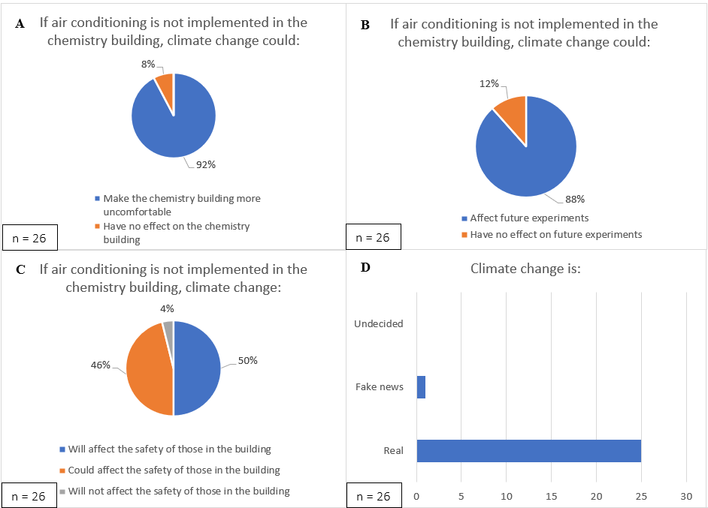
The chemists of UBC chemistry believe that if nothing is done to counter climate change the safety of workers, future experiments, and comfortability in the chemistry building could be jeopardized (Figure 10A&B&C). An overwhelming number of participants believe that climate change is real and will have a large impact on our future (Figure 10D&E). Furthermore, most participants predict that climate change is going to get worse (Figure 10F). These fears are backed up by primary research done by climate change experts [8]. Air conditioning is the most effective and efficient way to counter climate change in the chemistry building and should be implemented immediately.
F
E
n = 26
n = 26
Figure 10.

Cost of installing and maintaining air conditioning in the UBC chemistry building
Air conditioning the whole chemistry building
From the survey data above, it is clear that the chemists of UBC believe that air conditioning would be a beneficial addition to the chemistry building. The main issue is the cost of installation and maintenance. Published UBC documents were used to gauge the size of the entire UBC building while physical measurements were taken of 3 different labs to estimate the size of the chemistry labs. It was found that the area of the chemistry building was 364,870 square feet [9,10]. As the height of the building is not publicly available an estimate of 50 feet was used to give volume of the chemistry building at 18,243,500 cubic feet. To find the price of air conditioning, the website of a common air conditioner provider – HCAVDirect was used [11]. The most powerful air conditioner on the website which is the Daikin 25 Ton 400,000 BTU Light Commercial 11.4 IEER Gas/Electric Packaged Unit was used as the standard for pricing [11]. According to an online air conditioning calculator, 17 of these air conditioning units would be needed to cool the entire UBC chemistry building [12]. As each unit costs $28,200 the price of installing air conditioning in the chemistry building would be $477,252.44 [11]. Maintenance of air conditioning will also cost UBC chemistry an estimated $90,000 a month. The calculation used to obtain this value is shown in Figure 11.
$$2,000kW*\frac{\$0.061}{kWh}=\frac{\$122}{h}*\frac{24h}{day}=\frac{\$2928}{day}*\frac{30days}{month}=\$87840/month+additonal fees and cleaning \sim \$90000/month$$
Figure 11.
The value of 2000 kW was obtained from [12] and the value of $0.061/kWh is BC Hydro’s rate for institutions [13].
Air conditioning just the labs of the chemistry building
A more cost-efficient way to air condition the chemistry building is to provide air conditioning to only the labs. The size of all the labs in the chemistry building were estimated to be approximately 75,000 square feet in area and 10 feet in height. As a result, only 5 Daikin 25 Ton 400,000 BTU Light Commercial 11.4 IEER Gas/Electric Packaged Units are needed to air condition all the labs [12]. This would cost UBC chemistry $140,440 for installation and approximately $26,000 per month for maintenance (Figure 12) [11]. As labs contain all the hazardous chemicals as well as chemists that are required to wear multiple layers for safety, air conditioning just the labs becomes a viable, cost-efficient alternative that UBC chemistry should explore.
$$513.69kW*\frac{\$0.061}{kWh}=\frac{\$31.386}{h}*\frac{24h}{day}=\frac{\$753.275}{day}*\frac{30days}{month}=\frac{\$22,598.25}{month}+addtional fees and cleaning \sim \$26,000$$
Figure 12.
The value of 513.69 kW was obtained from [12] and the value of $0.061/kWh is BC Hydro’s rate for institutions [13].

- Conclusion
Summary of findings
The staff and students of the UBC chemistry building strongly believe that air conditioning should be installed in the chemistry building. This study found that many labs contain low-boiling point solvents such as DCM, diethyl ether, or pentanes which become dangerous during extremely hot days. When asked about temperature-sensitive experiments, 12% of respondents said that varying temperatures will affect their experiments with another 69% said that they were unsure. The safety and hard work of UBC chemists should not be jeopardized due to extreme temperatures. Also, results indicate that many workers feel uncomfortable during hot days in the chemistry building with fans and cold drinks being inefficient in keeping cool. Most participants believe that climate change will worsen in the years to come causing an increase in severity and frequency of extreme weather events. To prepare for this air conditioning needs to be installed. The cost of installing and maintaining air conditioning may be great at $477,252.5 and $90,000/month respectively. However, there is no amount of money that can be put on the value of a chemist’s safety, comfortability, and results. To prove this most participants in the study said that they would sacrifice department funded events/awards in favour of air conditioning. Also, this report provides a cheaper alternative that still mitigates the issues mentioned previously by providing only the labs with air conditioning. The cost of installation and maintenance would be $140,440 and $26,000/month respectively which is a reasonable amount for air conditioning. The time to act is now!
Expected outcome
If air conditioning is installed in the chemistry building, general worker comfortability and safety are expected to increase. This will lead to a general increase in worker satisfaction and may lead to an increase in recruitment to UBC chemistry. Most importantly, the lives and work of UBC chemists will be protected during extreme weather events in the future.

Works Cited
    - Climate change. Student Energy Climate Change Influence. (n.d.). Retrieved July 15, 2022, from https://studentenergy.org/influencer/climate-change/?gclid=CjwKCAjwoMSWBhAdEiwAVJ2ndpkAiWEqjsM22dBBVQ54i1Fka7trT9MTYhoP-BGw5u7RSFCMWX_4NxoCT_4QAvD_BwE
    - Vancouver - highest temperature for each year. Vancouver BC Highest Temperature Each Year - Current Results. (n.d.). Retrieved July 8, 2022, from https://www.currentresults.com/Yearly-Weather/Canada/BC/Vancouver/extreme-annual-vancouver-high-temperature.php
    - Dichloromethane. Dichloromethane - Methylene chloride, Dichloromethane. (n.d.). Retrieved July 8, 2022, from https://www.sigmaaldrich.com/CA/en/substance/dichloromethane849375092
    - Dimethyl sulfoxide. Dimethyl sulfoxide - DMSO, Dimethyl sulfoxide. (n.d.). Retrieved July 8, 2022, from https://www.sigmaaldrich.com/CA/en/substance/dimethylsulfoxide781367685
    - Diethyl ether. Diethyl ether - Ethyl ether, Ether. (n.d.). Retrieved July 18, 2022, from https://www.sigmaaldrich.com/CA/en/substance/diethylether741260297
    - Pentane anhydrous, = 99 109-66-0. anhydrous, = 99 109-66-0. (n.d.). Retrieved July 18, 2022, from https://www.sigmaaldrich.com/CA/en/product/sial/236705
    - Laboratory Safety Manual - Chapter 13: Safe handling of peroxidizable compounds. University of North Carolina at Chapel Hill - Knowledge Base. (2022, July 4). Retrieved July 18, 2022, from https://policies.unc.edu/TDClient/2833/Portal/KB/ArticleDet?ID=132025
    - Climate change. Student Energy Climate Change Influence. (n.d.). Retrieved July 15, 2022, from https://studentenergy.org/influencer/climate-change/?gclid=CjwKCAjwoMSWBhAdEiwAVJ2ndpkAiWEqjsM22dBBVQ54i1Fka7trT9MTYhoP-BGw5u7RSFCMWX_4NxoCT_4QAvD_BwE
    - Chemistry Laboratory Complex. UBC Facilities: Infrastructure Development. (n.d.). Retrieved July 19, 2022, from https://infrastructuredevelopment.ubc.ca/projects/undergraduate-chemistry-teaching-labs-chemistry-physics-research-labs/
    - Reneehalle, •. (2019, December 22). Sustainable heritage case studies. Retrieved July 19, 2022, from https://sustainableheritagecasestudies.ca/2019/12/22/renewing-ubcs-historic-campus/
    - Commercial Rooftop AC units for sale. HVACDirect.com. (n.d.). Retrieved July 19, 2022, from https://hvacdirect.com/commercial-hvac-equipment/commercial-rooftop-units.html?p=5
    - Home. Calculator.net: Free Online Calculators - Math, Fitness, Finance, Science. (n.d.). Retrieved July 19, 2022, from https://www.calculator.net/btu-calculator.html
    - General Service Business Rates. BC Hydro - Power smart. (n.d.). Retrieved July 19, 2022, from https://app.bchydro.com/accounts-billing/rates-energy-use/electricity-rates/business-rates.html#:~:text=for%20remaining%20kW.-,Energy%20Charge,per%20kWh%20for%20remaining%20kWh.

