University of British Columbia

Improving the Understanding of Waste Sorting at the University Of British Columbia Okanagan

Prepared for:
Sayra Gorgani, President, Innovate Design Sustain
Campus Waste Initiatives Team Lead, Innovate, Design, Sustain

Samantha Krieg
ENGL 301: Technical Writing
Dr. Erika Paterson
2022/07/25

Table of Contents
Introduction 1
Background Information 1
Statement of Problem 2
Proposed Solutions 2
Working Definitions 4
Methodology 4
Surveys 4
Informational Interview 5
Literature Review 6
Regulation, Standard, and Policy Review 7
Feasibility and Comparison Analysis 7
Collected Data 8
Waste Stream Contamination 8
Efficacy of Proposed Initiatives 10
Feasibility of Proposed Initiatives 12
Feasibility and Comparison Analysis Results 13
Conclusion 13
Summary of Findings 13
Recommendations 14
Works Cited 15
Appendix A: Innovate, Design Sustain Campus Waste Initiatives Survey Questions 17
Appendix B: July 2022 UBCO Student Survey 18
Appendix C: Informational Interview Questions 19

List of Figures
Figure 1: Example of an automated waste sorting bin with an AI-Based system (Greenwalt). 4
Figure 2: The first survey question assessed students’ opinion on the ease of sorting waste at UBCO, with five representing ‘very easy’, three representing ‘moderately easy’, and one representing ‘not at all easy’. 9
Figure 3: The second survey question assessed students’ likelihood to sort waste at UBCO, with five representing ‘very likely’, three representing ‘moderately likely’, and one representing ‘not at all likely’. 10
Figure 4: The third survey question assessed students’ opinion on waste sorting at UBCO, with five representing ‘very effective’, three representing ‘moderately effective’, and one representing ‘not at all effective’. 10
Figure 5: The fourth survey question which gathered the respondent’s opinion on the efficacy of the proposed initiatives. 12
Figure 6: The final survey question which gathered the respondent’s opinion the feasibility of the proposed initiatives. 13

List of Tables
Table 1: Proposed Initiatives to Improve the Understanding of Waste Sorting at the University of British Columbia Okanagan. 3
Table 2: Ranking of the Efficacy of the Proposed Initiatives. 11
Table 3: Ranking of the Feasibility of the Proposed Initiatives. 12

List of Acronyms
UBCO |  | University of British Columbia Okanagan
CWI |  | Campus Waste Initiatives
IDS |  | Innovate, Design, Sustain

Introduction

Background Information
By 2030, the University of British Columbia Okanagan has commited to reducing the waste sent from campus to landfills by 50% per capita, compared to 2020 (Armer). However, recent waste audits have shown that the diversion waste streams on campus have a significant amount of contamination (Mackintosh, 12-22; Green Step Solutions Inc., 31-36). Contamination is the presence of unaccepted or mis-categorized materials in a waste stream. In diversion waste streams, it presents significant problems in diverting waste from landfills (Lyndsey). If there is considerable contamination in the diversion waste stream, all of it is sent to a landfill instead of being repurposed, recycled, or disposed of properly (Thoden van Velzen et al., 16). In addition, the presence of waste materials that could otherwise be recycled or repurposed in the garbage stream contributes to the expansion of landfills, which is a growing concern globally (Zelenika, 1-2). In 2022, contamination levels at UBCO reached up to 38% in diversion waste streams and 88% in the garbage stream (Green Step Solutions, 16-30). Reducing the significant waste stream contamination on campus is crucial to meeting the 2030 waste diversion set by UBCO.
A waste management audits done in 2018 and 2022 identified limited awareness of waste sorting practises as a key concern (Green Step Solutions Inc., 31-36; Mackintosh, 28-32). The results of a survey conducted by Innovate, Design, Sustain (IDS) in 2022 supported this finding by highlighting the lack of knowledge of proper waste sorting on campus (Gupta et al., 5-7). Thus, improving the understanding of waste sorting practices at UBCO is crucial to reducing significant contamination.

As the only sustainability focused student organization at UBCO, Innovate, Design, Sustain (IDS) understands the importance of meeting the sustainability targets set out by the university. The IDS Campus Waste Initiatives (CWI) teams experience with similar projects and their close relationship with the UBCO Facilities Management and Sustainability Office proves their authority to act on the recommendations outlined in this report (Gupta et al., 1-7; Armer).

Statement of Problem
Diversion waste streams at the University of British Columbia Okanagan have a significant amount of contamination (Green Step Solutions Inc., 16-30). The presence of contaminants in diversion waste streams can prevent the materials from being repurposed, recycled, or disposed of properly (Thoden van Velzen et al., 16). Moreover, approximately 88% of waste found in the garbage stream could be redirected to diversion waste streams, eliminating its build-up in landfills (Green Step Solutions Inc., 30). The lack of understanding of waste sorting best practices at UBCO is a primary reason for the contamination (Gupta et al., 5-7; Green Step Solutions Inc., 31-36). Therefore, immediate changes are required to meet the IDS CWI team’s goal of improving waste diversion on campus and reaching UBCO’s target of a 50% reduction in waste per capita by 2030 (Gupta et al., 1-2; Green Step Solutions Inc., 8). Implementing feasible and effective initiatives to improve the understanding of waste sorting at the University of British Columbia Okanagan is vital to reducing waste stream contamination.

Proposed Solutions
Based on a literature review and survey conducted in the spring of 2022 by IDS, this report proposes six initiatives to improve the understanding of waste management at the University of British Columbia Okanagan. The initiatives are intended to be launched on campus between 2022 to 2024 by the IDS CWI team with the assistance of the UBCO Sustainability Office and Facilities Management departments. The proposed solutions and a plan for their implementation is listed in Table 1.
Table 1: Proposed Initiatives to Improve the Understanding of Waste Sorting at the University of British Columbia Okanagan.
Proposed Initiatives | Description | Plan for Implementation
Educational Seminars and Events | Free seminars or events that teach students, faculty, and staff how to properly sort waste, waste diversion, and about the impacts of waste stream contamination. | Hosted by the IDS CWI team.
Improved signage near waste bins | Revising and standardizing the existing signage for clarity, accessibility, and potential to be interpreted quickly. | Designed by the IDS CWI team and implemented with the assistance of the UBCO Sustainability Office and Facilities Management.
Waste bins with automated sorting | Replacing existing waste receptacles with waste bins that automatically sort all waste thrown into them into the appropriate waste stream using and AI-based system. An example of this technology is shown in Figure 1. | Designed and prototyped by the IDS CWI team and implemented with the assistance of the UBCO Sustainability Office and Facilities Management. Pilot automated bins funded by the UBCO Innovation, Entrepreneurship & Impact Fund (Faculty of Applied Science School of Engineering).
Educational signage around campus | To remind students, faculty, and staff of how to properly sort waste and about the impacts of waste stream contamination. | Designed by the IDS CWI team and implemented with the assistance of the UBCO Sustainability Office and Facilities Management.
Incentives for participation, achievement, or contribution | Incentives awarded to students, faculty, and staff who contribute to proper waste sorting on campus based on a point system. | Managed as a joint effort from the IDS CWI team, the Sustainability Office, and Facilities Management
Changing the colour coding system of the UBCO waste bins to match to provincial standard | Change mixed paper recycling to yellow, all other recycling to blue, and compost to green. | Designed by the IDS CWI team and implemented with the assistance of the UBCO Sustainability Office and Facilities Management.

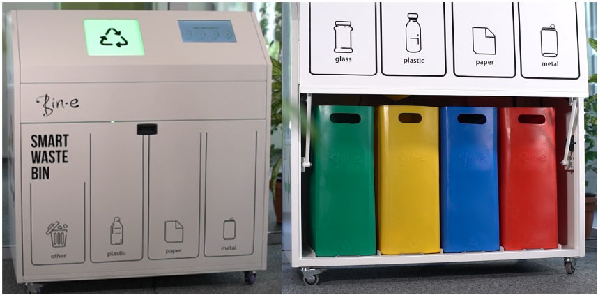
Figure 1: Example of an automated waste sorting bin with an AI-Based system (Greenwalt).

Working Definitions
Diversion Waste Stream: all waste streams that divert materials from landfills through recovery or recycling.
Waste Stream: “flows of a specific waste from its source through to recovery, recycling, or disposal” (Bourguignon).
Contamination: the presence of unaccepted or mis-categorized materials in a waste stream.
Waste Diversion: the redirection of waste from landfills through repurposing or alternative methods of disposal.

Methodology

Surveys
In the spring of 2022, the IDS Campus Waste Initiatives team surveyed UBCO students, faculty, and staff. The survey assessed the waste management and sorting knowledge, habits, and interest among the population (Gupta et al., 2-5). Findings showed that participants were willing to put in the effort necessary to sort waste properly but often lacked the knowledge or resources required (Gupta et al., 4-7). The results from the spring 2022 survey helped establish the proposed initiatives to improve waste sorting at UBCO by determining the areas of greatest concern. Questions from the IDS CWI survey are shown in Appendix A.
Eleven UBCO students responded to a voluntary and anonymous online survey conducted from July 16 to 21, 2022. As one of the primary data sources for the analysis, the survey quantified student’s opinions of the feasibility and efficacy of the proposed initiatives to improve the understanding of waste sorting in campus. In addition, it assessed respondent’s interest in sorting waste and opinions on waste management on campus. This survey continued the survey done by the CWI team in the spring of 2022, focusing on the potential impacts of the proposed initiatives. Time and resource constraints limited the population surveyed to UBCO students; thus, it gathered no information from the campus faculty and staff. Students account for nearly 80% of the population of the Okanagan campus (University of British Columbia), and therefore their opinion of the proposed initiatives is crucial to successful implementation. The survey questions are shown in Appendix B.

Informational Interview
On July 5, 2022, an informational interview was conducted with Jamie Armer, the Manager of Custodial and Waste Services at UBCO. The interview served as one of the primary data sources for the feasibility and comparison analysis. The responses established background information about waste contamination on campus, past and ongoing efforts to improve waste sorting, and the regulations surrounding waste management (Armer). Furthermore, they provided an understanding of the likelihood of the UBCO administration approving the implementation of the proposed solutions (Armer). Appendix C includes the questions asked during the informational interview.

Literature Review
A literature review served as a secondary method of data collection for this report. The information gathered helped to establish the proposed initiatives to improve the understanding of waste sorting at UBCO. The recommendations included in the waste audits conducted on campus in 2018 and 2022 (Mackintosh, 28-32; Green Step Solutions Inc., 31-35) were considered. The following suggestions were incorporated into the proposed initiatives based on their presumed feasibility, efficacy, and compatibility with ongoing efforts on campus (Armer):
- Standardise UBC waste sorting colours with provincial sorting colours (Green Step Solutions Inc., 33).
- Add messaging to increase source-separation (Green Step Solutions Inc., 33).
- Create a short sustainability course (Green Step Solutions Inc., 33).
- Add “no plastic bags,” (plus other problem materials) messaging (Green Step Solutions Inc., 33).
- Standardize outdoor bins with similar signage to indoor sorting stations (Green Step Solutions Inc., 33).
- Create a Sustainability course (Mackintosh, 31).
- Encourage or host a competition between residence buildings to see who can recycle better. Add a prize as incentive (Mackintosh, 32).
The information gathered during the literature review also provided supported evidence for the feasibility and comparison analysis of the solutions. Robinson stated that initiatives to reduce waste stream contamination are most effective when they are kept simple, communicate a specific propose, and focus on benefits (21). In addition, convenience was prioritized based on the analysis of DiGiacomo et al. (311), which showed that the likelihood of waste being sorted correlates to how easy it is to execute. Finally, the study conducted at the University of British Columbia Vancouver campus conducted by Zelenika et al. found that standardized and clear signage is crucial for proper waste sorting (43-44).

Regulation, Standard, and Policy Review
Waste contamination regulations, standards and policies were researched as part of the feasibility analysis. It was found that the limitations on contamination at UBCO are determined by the companies contracted to manage and collect the waste; Cascades Canada ULC and Waste Management Canada. The standards set by these companies vary depending on the need of the contract holder and are not shared publicly. Thus, a comprehensive regulation review was not included in the scope of the feasibility analysis.

Feasibility and Comparison Analysis
A feasibility and comparison analysis was conducted using the information gathered from the July 2022 survey, informational interview, and literature review. The main purpose was to determine which of the proposed initiatives have the greatest potential to improve the understanding of waste sorting and would be the easiest to implement at UBCO. The results of the analysis were used to establish the recommendations outlined in this report, to provide the IDS CWI team a starting point for their implementation.
The analysis focused on two primary categories: efficacy and feasibility. The efficacy of the proposed initiatives was based on their potential to improve the understanding of was sorting at the University of British Columbia Okanagan. Feasibility was assessed based on the initiatives ease of implementation. A high-level approximation of the cost was considered as part of the feasibility during the informational interview (Armer) but not during the survey.

Collected Data

Waste Stream Contamination
Information about waste stream contamination at UBCO was gathered using an informational interview with Jamie Armer, head of UBCO Facilities Management and the July 2022 survey.
The informational interview gathered information on waste sorting at UBCO, including ongoing efforts to improve it, areas of concern, and contributing factors. UBCO is currently implementing the following initiatives to reduce waste stream contamination (Armer):
- Educational talks at incoming student onboarding events
- Regular audits of the waste management program
- Working with a waste management company that video records waste sorting and reviewing the results in monthly meetings
- Volunteer waste sorting assistants on campus
Areas of concern and factors that contribute to a lack of understanding of waste sorting identified during the interview with Jamie Armer include:
- Inconsistent signage
- Unintelligible signage; language barriers and cultural divide
- Inconsistent use of colour coding between regions
- Mismatched sizes of receptacles
- A lack out a clear explanation during the onboarding to the university; teaching first years must be improved
The first half of the July 2022 student survey collected the respondent’s opinion on waste sorting on campus. It can be seen from Figure 2 that none of the respondents found it very easy to sort waste on campus. The majority found sorting waste on campus to be not at all or moderately easy, indicating a need for better communication and education. Over 45% of the population surveyed (5/11) indicated that they are very likely to sort their waste (Figure 3). Figure 4 shows the third survey question, which assess students’ overall opinion of waste sorting on campus. The results in the figure illustrate that the population surveyed have low to moderate confidence in the efficacy of the existing waste sorting at UBCO. The results of the July 2022 survey identify a need to improve the understanding of waste management on campus and are supported by the findings of Gupta et al. (5-7) in their spring 2022 survey of students, faculty, and staff.
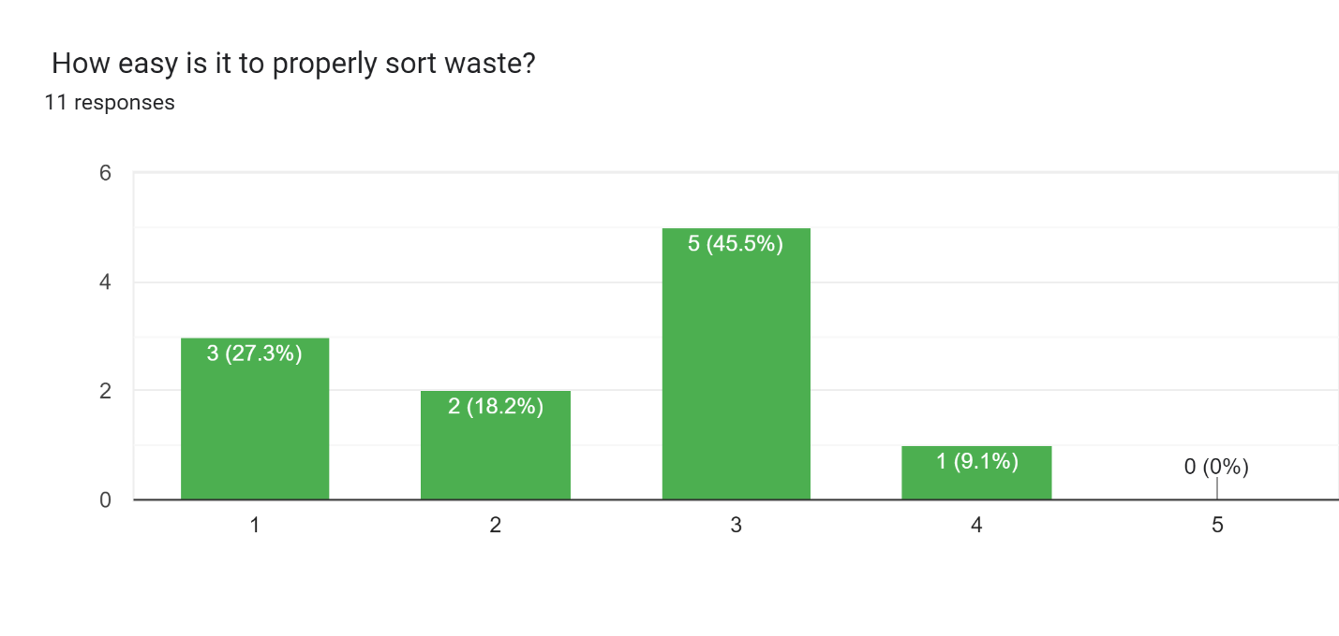
Figure 2: The first survey question assessed students’ opinion on the ease of sorting waste at UBCO, with five representing ‘very easy’, three representing ‘moderately easy’, and one representing ‘not at all easy’.
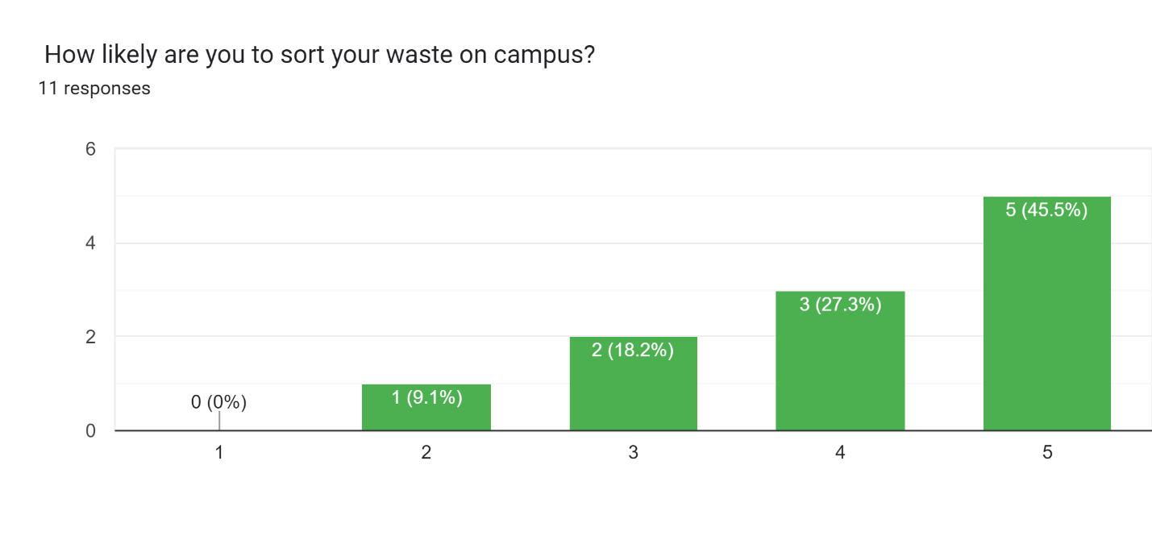
Figure 3: The second survey question assessed students’ likelihood to sort waste at UBCO, with five representing ‘very likely’, three representing ‘moderately likely’, and one representing ‘not at all likely’.
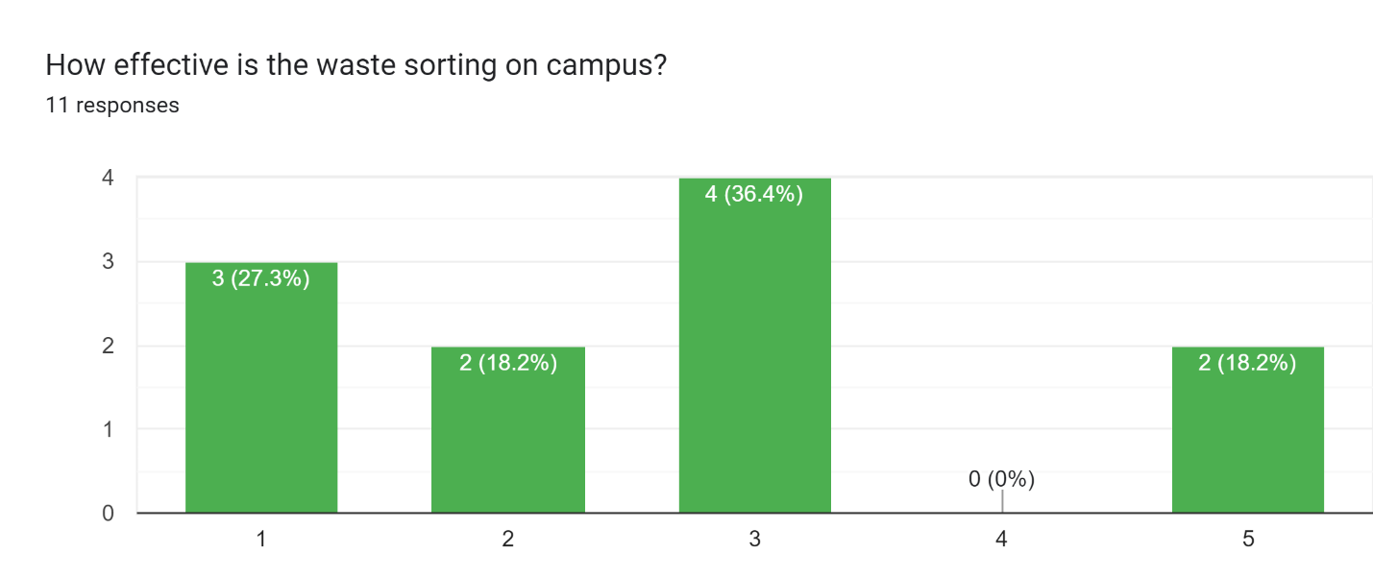
Figure 4: The third survey question assessed students’ opinion on waste sorting at UBCO, with five representing ‘very effective’, three representing ‘moderately effective’, and one representing ‘not at all effective’.

Efficacy of Proposed Initiatives
The efficacy of the proposed initiatives was based on their potential to improve the understanding of was sorting at the University of British Columbia Okanagan. The convenience and accessibility of a solution was found to be correlated with its efficacy, which is supported by the findings of DiGiacomo et al. (310-311).
Table 2 ranks the proposed intitiatives in terms of efficacy based on the results of the informational interview (Armer) and the July 2022 UBCO student survey.
Table 2: Ranking of the Efficacy of the Proposed Initiatives.
Proposed Initiatives | Ranking Based on Survey (Figure 5) | Raking Based on Informational Interview (Armer)
Educational Seminars and Events
Improved signage near waste bins
Waste bins with automated sorting
Educational signage around campus
Incentives for participation, achievement, or contribution
Changing the colour coding system of the UBCO waste bins to match to provincial standard

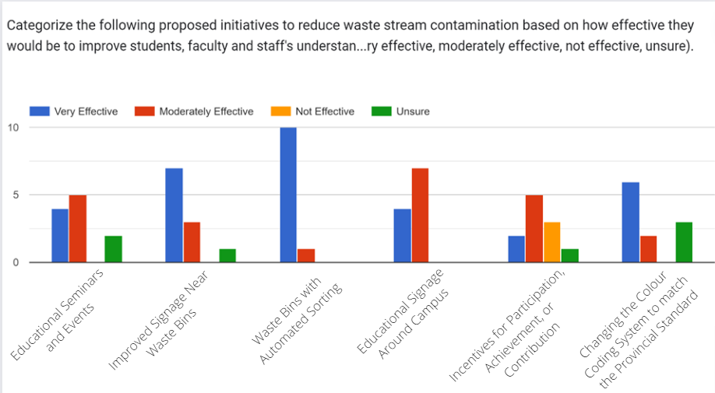
Figure 5: The fourth survey question which gathered the respondent’s opinion on the efficacy of the proposed initiatives.

Feasibility of Proposed Initiatives
Table 3 ranks the proposed intitiatives in terms of feasibility based on the results of the informational interview (Armer) and the July 2022 UBCO student survey.
Table 3: Ranking of the Feasibility of the Proposed Initiatives.
Proposed Initiatives | Ranking Based on Survey (Figure 6) | Raking Based on Informational Interview (Armer)
Educational Seminars and Events
Improved signage near waste bins
Waste bins with automated sorting
Educational signage around campus
Incentives for participation, achievement, or contribution
Changing the colour coding system of the UBCO waste bins to match to provincial standard

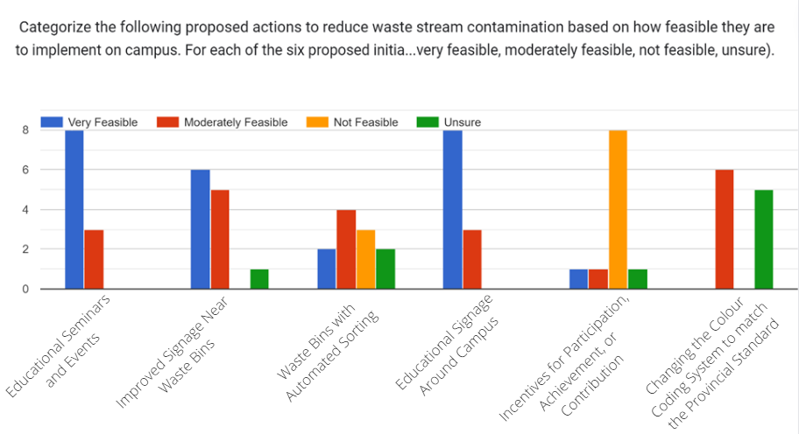
Figure 6: The final survey question which gathered the respondent’s opinion the feasibility of the proposed initiatives.

Feasibility and Comparison Analysis Results
The feasibility and comparison analysis established the initiatives to improve the understanding of waste sorting on campus that the IDS CWI team should prioritize.

Conclusion

Summary of Findings
Improving the understanding of waste sorting at the University of British Columbia Okanagan is vital to reducing waste stream contamination, thus increasing the amount of waste diverted from landfills.

Recommendations
Based on the findings of the surveys, informational interview, and literature review, the following initiatives to improve understanding of waste sorting at the University of British Columbia are recommended:
- Educational seminars and events; within one year.
- Educational signage; within one year.
- Improved signage near waste bins; within two years.
- Begin planning for waste bins with automated sorting for new buildings on campus and identify high traffic locations with severe contamination for pilot locations; within five years.

Works Cited
Amer, Jamie. Personal Interview. 5 July 2022.
Bourguignon, Didier. Understanding waste streams: Treatment of specific waste. European Parliamentary Research Service. Jul. 2015. Web. Jun. 2022. www.europarl.europa.eu/EPRS/EPRS-Briefing-564398-Understanding-waste-streams-FINAL.pdf
DiGiacomo, Alessandra, et al. “Convenience Improves Composting and Recycling Rates in High-Density Residential Buildings.” Journal of Environmental Planning and Management, vol. 61, no. 2, 2017, pp. 309–31. Crossref, doi.org/10.1080/09640568.2017.1305332.
Faculty of Applied Science School of Engineering. “Innovation, Entrepreneurship and Impact Fund.” The University of British Columbia Okanagan, engineering.ok.ubc.ca/student-resources/innovation-and-impact-dean-fund. Accessed 23 July 2022.
Green Step Solutions Inc. “UBC Okanagan waste audit.” May 2022. Report.
Gupta, Aruhndathi, et al. “IDS Campus Waste Survey Summary.” 3 Jul. 2022. Report.
Mackintosh, Andrea. “UBC Okanagan waste audit.” Nov. 2018. Green Step Solutions Inc., Kelowna. Report.
Lyndsey. “What Happens to My Recycling: A Closer Look.” Recycle BC, 19 May 2020, recyclebc.ca/what-happens-to-my-recycling-blog.
Robinson, Susan. “The Changing Waste Stream.” 2014. www.epa.gov/sites/default/files/2015-09/documents/changng_wste_stream.pdf
Thoden van Velzen, Ulphard E., Molenveld, Karin, Brouwer, Marieke, Van der Zee, Maarten, Smeding, Ingeborg. Issue paper: Recycling of different waste streams. Wageningen Food & Biobased Research, 2021. doi.org/10.18174/555442
University of British Columbia. “Facts and Figures - UBC's Okanagan Campus.” The University of British Columbia Okanagan, 27 May 2022, ok.ubc.ca/about/facts-and-figures.
Zelenika, Ivana, et al. “Toward Zero Waste Events: Reducing Contamination in Waste Streams With Volunteer Assistance.” Waste Management, vol. 76, 2018, pp. 39–45. Crossref, doi.org/10.1016/j.wasman.2018.03.030.

Appendix A: Innovate, Design Sustain Campus Waste Initiatives Survey Questions

Appendix B: July 2022 UBCO Student Survey

Appendix C: Informational Interview Questions

