Proposal for Improved Ingredient and Allergen Labelling
at UBC AMS Food Establishments

For
Mohan Vishwa
Senior Manager of Food & Beverage at the UBC AMS

By
Jessica Lan Barlescu
ENGL 301 Student

July 21st 2022

Table of Contents

- Introduction
  - Background information on the UBC AMS
  - Statement and overview of problem
  - Purpose of this report
  - Brief description of data sources and methods
- Data Section
  - Analysis of current labelling practices
  - Survey data from UBC Students
  - Research regarding diets, allergens, and food labelling practices
- Conclusion
  - Summary and interpretation of findings
  - Limitations
  - Recommendations to improve food labelling practices
- Works Cited
- Appendix

Abstract

I. Introduction

A. Background information on the UBC AMS

The Alma Mater Society of the University of British Columbia, also referred to as the AMS, is UBC Vancouver’s Student Union. The AMS has been operating since 1915, and its purpose is to hold UBC and the government accountable to the students. The UBC AMS is completely run by elected student leaders, dedicated staff, and volunteers, and it solely exists to serve UBC Vancouver students (“The AMS”). There are currently 8 food establishments in the AMS Student Nest, however not all the menus and items have clear labels of what is contained in each product.

B. Statement and Overview of the Problem

Not all food establishments in the AMS Student Nest have clear indications of whether a certain food product for sale contain common allergens or ingredients that an individual would want to avoid due to ethical or health-related reasons. Although some food establishments have signs indicating if a particular item is vegan, vegetarian, or gluten-free, these labelling practices are inefficient as it does not indicate if other common allergens are used as ingredients, such as dairy or nuts. This can lead to confusion and if ingested, an allergic reaction. During peak meal hours, food establishments inside the AMS Student Nest can become incredibly busy and crowded. This makes it difficult to approach staff simply to ask if a certain item contains a common allergen or ingredient you are purposely trying to avoid. Furthermore, not all staff are aware of exactly what ingredients are used in a certain food product. This makes the straightforward task of choosing a snack or meal more difficult and may discourage people with dietary restrictions from eating at a particular establishment.

C. Purpose of this Report

The purpose of this report is to provide effective recommendations on why the UBC AMS should implement improved food labelling practices. Additionally, to provide Mohan Vishwa, Senior Manager of Food & Beverage at the UBC AMS, with information regarding current UBC student’s experiences when purchasing food at the UBC Student Nest.

D. Data sources and methods

Primary data sources used for this proposal includes the menus of various AMS food establishments listed on the AMS website. Additionally, a survey that fifteen UBC students responded to, designed to analyze student’s thoughts and experience regarding finding an appropriate meal at the UBC AMS Student Nest. Secondary sources of data include a variety of journal articles and public health reports and statistics regarding food allergies, diets, and food labelling practices.

II. Data Section

A. Analysis of current food labelling practices
Menus for various AMS food establishments can be found online. For example, Honour Roll Sushi, which is owned and operated by the UBC AMS. Their menu is quite extensive; however, it lacks any implementation of ingredient and allergen labelling apart from listing the name of the item (see Figure 1). Although some students may be familiar with the type of cuisine and the commonly used ingredients and cooking methods for each dish, it is not fair to assume that this knowledge is held by all students. If more thorough and considerate food labelling practices were to be added, it would make this food establishment accessible for students with any dietary restrictions.

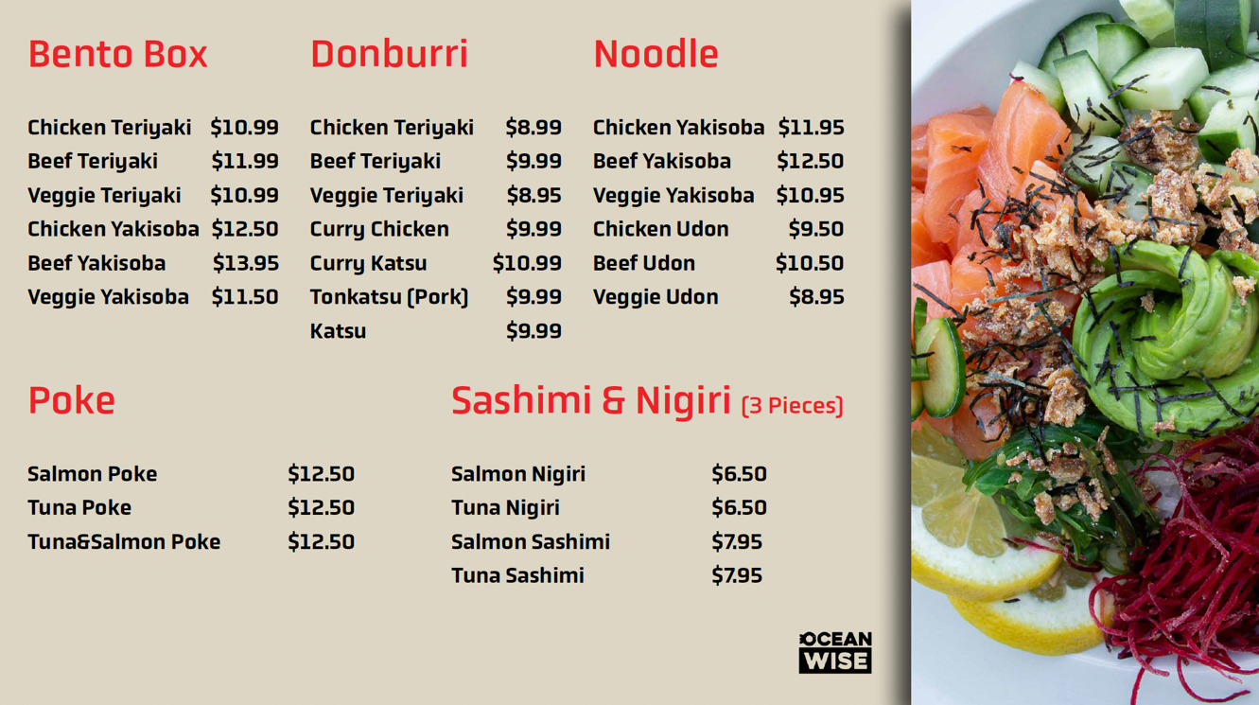
Figure 1. Screenshot of a page of Honour Roll Sushi’s menu listed on the UBC AMS website.

A second example is Blue Chip Café’s sandwich section of their menu. Although there is a vegan option listed indicating it does not contain any products derived from animals, it does not specify if any other options are safe to consume for someone who is vegetarian, or who has a specific allergy to substances such as dairy or eggs. This type of labelling limits the options available for anyone with any dietary restrictions or preferences outside of being strictly vegan. Although some ingredients can be self-explanatory, such as cheese meaning it contains dairy, the lack of information can lead to confusion and be the reason why someone decides to look elsewhere for their meal. Furthermore, it could potentially result in an allergic reaction from an ingredient in their meal which they weren’t aware of, due to this lack of thorough labelling.

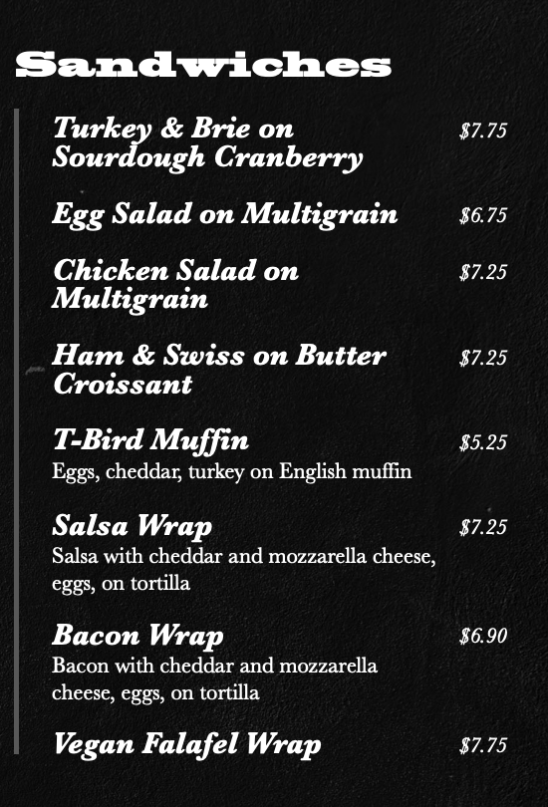
Figure 2. Screenshot of Blue Chip Café’s sandwich menu.

B. Survey data from UBC students
Fifteen UBC students responded to a survey that consisted of 6 multiple choice questions designed to analyze their dietary restrictions or preferences and overall experience when visiting the AMS Student Nest when searching for an appropriate meal. Eight students (53.33%) answered “Yes” to the question “Do you have any dietary restrictions or preferences?” and seven students (46.67%) responded with “No” (see Figure 3).

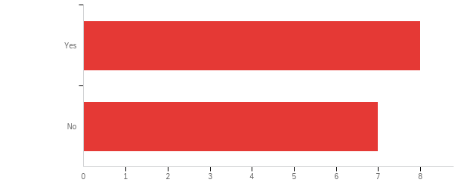
Figure 3: Responses to survey question “Do you have any dietary restrictions or preferences?”

When asked “Have you visited the UBC AMS Student Nest with the intention of buying a snack or meal?” all student responses (100.0%) choose “Yes” indicating that the AMS Student Nest is a popular destination for students when looking to buy a snack or meal (see Figure 4).

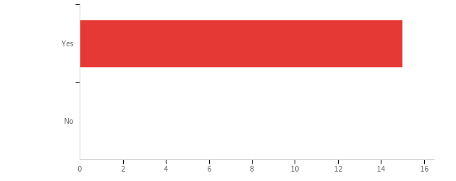
Figure 4: Responses to survey question “Have you visited the UBC AMS Student Nest with the intention of buying a snack or meal?”

When asked to finish the sentence: “Finding an appropriate snack or meal at the UBC AMS Student Nest is:” there was a significant amount of variation in answers, with “Sometimes difficult and inconvenient” being the most popular answer chosen by seven (46.67%) respondents (see Figure 5).

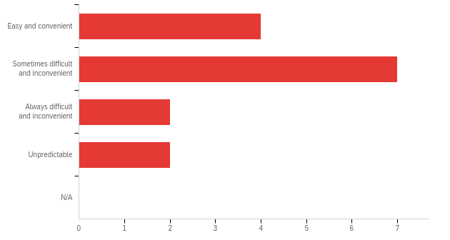
Figure 5. Responses to the question “Finding an appropriate snack or meal at the UBC AMS Student Nest is:”

When asked “How would you rank the current ingredient and allergen labelling practices at food establishments at the UBC AMS Student Nest? (1 being excellent, 5 being poor).” The most popular response was 3, chosen by eight (53.33%) students (see Figure 6).

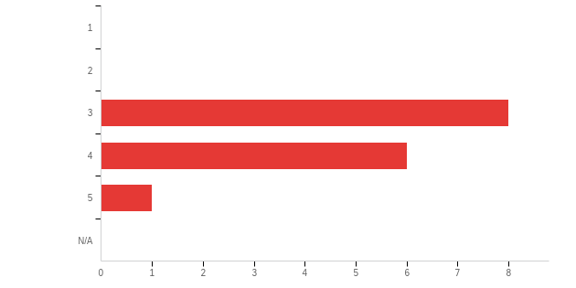
Figure 6. Responses to the question “How would you rank the current ingredient and allergen labelling practices at food establishments at the UBC AMS Student Nest? (1 being excellent, 5 being poor).”

When asked to complete the sentence “Finding out if a food product at the AMS Student Nest contains a certain ingredient is:” the most popular response was “Sometimes difficult and inconvenient” chosen by seven (46.67%) students (see Figure 7).

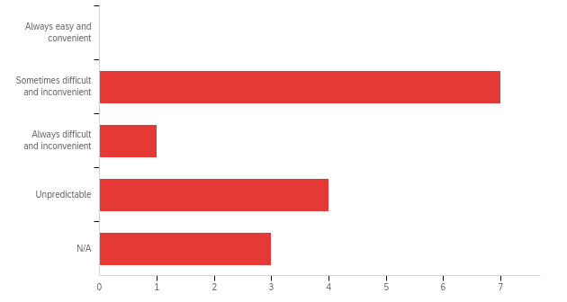
Figure 7. Responses to the question “Finding out if a food product at the AMS Student Nest contains a certain ingredient is:”

Lastly, the final question asked “If the UBC AMS Student Nest implemented improved labelling on food products, how would it affect your frequency of visitation?” Eight (53.33%) responses choose “Increase frequency” and seven students (46.67%) chose “Not affect frequency.”

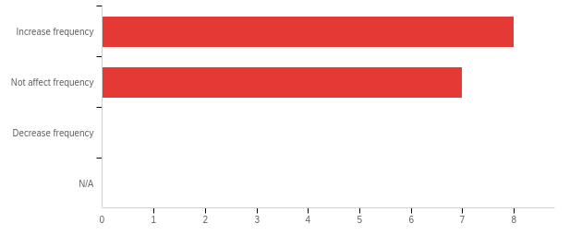
Figure 8. Responses to the question “If the UBC AMS Student Nest implemented improved labelling on food products, how would it affect your frequency of visitation?”

C. Research regarding diets, allergens, and food labelling practices

Research has found the prevalence of self-reported food allergy to be 9.3% in Canada in 2016 (Clarke et al. 1428). Among this 9.3%, a few of the highest common food allergens are milk (2.6%), shellfish (1.9%), and tree nuts (1.8%) (Clarke et al. 1429). Heath Canada and the Canadian Food Inspection Agency (CFIA) have identified key substances most frequently associated with food allergies and allergic-type reactions, which are often referred to as priority food allergens (“Common Food Allergens”). These include eggs, milk, mustard, peanuts, crustaceans and molluscs, fish, sesame, soy, sulphites, tree nuts, and wheat and triticale (“Common Food Allergens”). In 2015, approximately 5% of Canadians reported adhering to a plant-based dietary practice, which includes vegan, vegetarian, pescetarian and red meat excluder diets (Valdes et al. 782). In terms of food labelling practices, one study found that necessary components for effective food allergen labels include: bold fonts, differing font colours, box frames, warning statements, front labels, and additions of potential allergens (Se-young et al. 519).

III. Conclusion

A. Summary and interpretation of findings

The AMS Student Nest is a popular destination for students during mealtime. Both students who have dietary restrictions and preferences, and students who do not, visit the AMS Student Nest with the intention of purchasing a meal or snack that is safe for them to consume. However, this is not always a convenient task. The current ingredient and allergen labelling practices at the AMS Student Nest leaves students who have any dietary restrictions with few options. Furthermore, the survey data shows that finding out if a food product contains a certain ingredient is rather complicated and inconvenient.

B. Limitations

A major limitation of this proposal is the small sample size of UBC students who completed the survey, which was used as a primary data source. The results from this small sample size cannot be generalized to the entire population of UBC students, however it does provide us with some details regarding the experience of current UBC students.

C. Recommendations

Based on the responses from the survey distributed among UBC students, and the research presented earlier, there is an apparent need for improved ingredient and allergen labelling at food establishments inside the AMS Student Nest. There should be a clear label indicating if a food product for sale contains a common allergen, instead of simply listing an item as vegan, or gluten-free to accommodate all types of diets and food allergies. This would allow both students with dietary restrictions and those without to be able to find a meal easily and conveniently.

Works Cited

