1234 Apple Street
Richmond, BC

August 2nd, 2022

Dr. Adrian Dix
Health Minister of BC

Dear Mr. Dix,
I have attached my report: Determining the Impact of Mental Health in a Post-Pandemic Society. This report addresses the challenges that have arisen from COVID-19 and how employees experience stress inside and outside of the workplace.

I hope you can draw conclusions from this report to help implement health programs for British Columbians. Considering how much time is spent in the workplace, it should be a place where we can truly feel our best.

I thoroughly enjoyed completing this report and investigation and will take these findings with me throughout my career. If you have any questions at all, please contact me at juanita_kwok@hotmail.com.

Sincerely,
Juanita Kwok
Juanita Kwok

Determining the Impact of Mental Health in the Workplace in a Post-Pandemic Society

For Adrian Dix
Health Minister of British Columbia

By Juanita Kwok
ENGL 301 Student
University of British Columbia

Aug 2, 2022

Table of Contents
Abstract 4
I. Introduction 5
A. Background and Definitions 5
B. Purpose of the Report and Intended Audience 6
C. Method of Inquiry 7
D. Scope of the Inquiry 7
II. Collected Data 8
A. Survey Findings from Corporate Individuals 9
1. Definition 9
2. Findings 9
B. 11 Ways to Prevent Employee Burnout by Oracle 14
1. Findings 14
III. Conclusion 14
A. Summary and Overall Interpretation of Findings 14
B. Recommendations 15
IV. Works Cited 16

Abstract

The COVID-19 pandemic has been around for over two years now but the impacts it has had on our workplace and culture may be everlasting. While it was recommended to stay home as much as possible, what were the drawbacks experienced from remote work? Taking a closer look at employee’s experiences with burnout and stressors they hadn’t experienced before will give a better understanding for what needs to be improved . While it is a challenging and vast topic to research, this report covers the tip of the iceberg in mental health challenges in the workplace.

This topic is worthwhile as it affects many workers directly and organizations indirectly through lost productivity, diminishing employee morale, and low workplace culture. While there is not one simple way to find a solution as this problem can arise in many forms, the bigger agenda is providing fulsome resources for employees to feel engaged and supported in their workplace.

Introduction

Background and Definitions
On March 11, 2020, the World Health Organization (WHO) declared the coronavirus (COVID-19) outbreak a global pandemic. Since then, the workplace and mental wellbeing of corporate employees have evolved drastically. The change from a standard five-day work week in office to a new “work from home” concept created an imbalance between the average worker’s personal and professional life. The pandemic meant that it was difficult to distinguish work life from home life, employees were working longer hours, and had minimal face-to-face interaction with their colleagues. This fundamental shift in workplace culture contributed to a variety of catalysts that would shape the “burnout-centred” workplace environment we see today.
Recognizing the importance of human interaction and connection is vital to an organization’s success and to prevent feelings of burnout. The WHO has formally declared burnout as a work-related syndrome. Burnout syndrome results from chronic workplace stress that has not been managed. This results in energy depletion or exhaustion; increased mental distance from one’s job and ultimately reduces professional efficacy (World Health Organization, 2019).
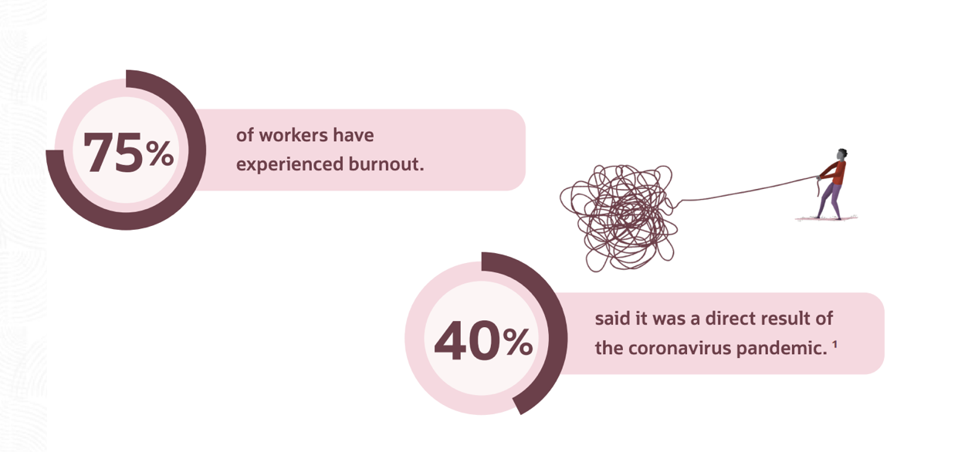
Figure 1: Workers experiencing burnout and correlation with coronavirus
In every four workers, three of them have experienced burnout before or are currently experiencing it now. Four out of ten individuals have attributed this as a direct result from COVID-19. This sets the precedence for the report as it is clearly a big topic that needs to be addressed for the long-term health of employees around the world.

Purpose of the Report and Intended Audience
The primary purpose of my report is to address the growing concerns of mental health challenges due to the inaccessibility of work-life balance measures. COVID-19 has altered the lives of working individuals dramatically with the introduction of online communications within teams, social distancing, and limited events. The need for human interaction has been compromised and employees are feeling its effects with burnout in their work and personal life. My goal is to evaluate the repercussions of the pandemic on an employee’s mental health and what improvements can be made to address the growing concern.

Method of Inquiry
The primary data was collected by conducting personal interviews with employees in various industries, creating an in-depth survey, and examining statistical data sources. This will give my research first-hand experience from individuals as well as an anonymous platform to answer to share insights they may not be comfortable with publicly. The survey’s primary objective is to analyze the mental health initiatives and resources provided by employers and establish patterns of workplace stressors. 25 individuals working in a corporate setting partook in this survey and the findings will be presented in this report. Statistical data gives numerical insights to trends over the years and can be further interpreted to form a conclusion. The secondary sources I plan to use are recent publications on mental health in the workplace and a review of an e-book published by Oracle titled “11 Ways to Prevent Employee Burnout”.

Scope of the Inquiry

In order to access the feasibility of how COVID-19 has shaped mental health and performance in the workplace, I plan to pursue the following five areas of inquiry:
- Employees’ personal experiences with how their life has changed since the onset of the COVID-19 pandemic
- Employee experiences with burnout and the associated impact
- How often do employees participate in activities outside of work?
- What can employers do to improve employee morale and productivity?
- How is office workplace culture shifting and what trends do we see for the future?
Due to the long-lasting effects of COVID-19 and the direct/indirect implications it has caused, there are considerable challenges that British Columbians are facing. These are problems that are likely not talked about, and many deem to be insignificant or just another part of life.
With more employees continuing to work from home, the disconnect amongst colleagues increases as well as the loss of essential human interaction. There is a strong need to implement programs that will improve the livelihood and productivity for employees while giving them the freedom to work from where they want. Burnout affects many people and can be detrimental for workplace culture.
As for myself, I have been working in a corporate setting for over three years. During this time, I have experienced the typical week in office, five days a week. I have also experienced two years of working from home full time and how that can negatively impact your mental health. Currently, I work a hybrid work model with alternating days in person and remote. I have also taken multiple human resources classes at UBC focused on what makes an effective, engaging, and fulfilled workplace.

Collected Data

Survey Findings from Corporate Individuals

Definition

A five-question survey was developed to assess the stress levels of individuals working in a corporate setting. These questions’ intention were to understand how stress is perceived after the pandemic, the level of support provided from their employer, and the number of hours dedicated to personal time. The last question gave respondents an opportunity to make suggestions on how their workplace could improve mental health initiatives.

Findings

- What is your age?
Figure 2: Age
Most individuals who took this survey are in the 26-30 and the 31-35 age group, representing the “Millennial” generation. In a study by the American Psychological Association (APA), “Gen Xers’ and Millennials’ stress differentials — the difference between each generation’s average personal stress level and their average perceived healthy stress level — are higher than Matures and Boomers” (American Psychological Association). The study defines Millennials at ages 18-32 and Gen Xers’ as 33-46 years old. Another statistic found that “almost 6 in 10 Millennials (58%) consider stress management to be important, but only one-third (32 percent) think they are excellent or very good at it” (American Psychological Association). In summary, the survey shows that Millennials comprise a significant majority of the workforce. Meanwhile, results from the APA demonstrate that many Millennials find stress management important. Thus, one should focus on the demands of a significant majority of the workforce.
In another survey conducted by Lhasa OMS, the three highest contributors to Millennials experiencing burnout are career-related: finances and debt, work tension, and finding the right work-life balance (Elmers, 2022). While each person will inevitably experience stress in their lifetime, 78% of respondents in this survey state they are more stressed than previous generations, attributing this to higher debt, a more competitive labour market, and the cost of living (specifically healthcare) increasing (Elmers, 2022).

Figure 3: Overall stress level in the workplace after pandemic

In this question, 16 out of 25 respondents (64%) reported that the level of overall stress in the workplace has either increased or increased significantly. This can be attributed to multiple factors because of COVID-19; longer working hours, boundaries of work and home being blurred together, and other obligations such as family. In a study done on negative impact of long working hours on mental health in young populations, the correlation is clear. “An excessive workload increases workers’ fatigue and thereby negatively affects the subjective perceptions of health. In addition, anxiety and depression are more common in the group working long hours.” (Park, 2020)

Figure 4: Mental health program access in workplace

The respondents were asked whether their access to mental health programs at work are good, sufficient, needs improving or does not exist. Ten out of 25 respondents are satisfied with the programs currently offered or it exceeds their expectations. The remaining 15 out of 25 respondents believe their workplace needs to do more to address the growing concerns of burnout and stress. Four out of 25 respondents do not have access to mental health programs at their work currently, this is more common in start-ups or companies that do not have the funding and/or resources to implement mental health initiatives.

Figure 5: Hours per week dedicated to personal activities outside of work
Respondents are asked how many hours outside of work per week are dedicated to personal activities. Examples include hobbies, extra-curriculars, volunteer, etc. The survey showed out of the 25 respondents, eight people do not get any time to do personal activities. Another eleven get just 1 to 3 hours of personal time per week. According to the Department of Health and Human Services, the exercise guidelines for healthy adults is at least 150 minutes of moderate exercise per week (Mayo Clinic, 2022). The data recommends at least two and a half hours of exercise alone per week. However, majority of respondents do not have the luxury to dedicate such time for their health.

The fifth and final question of the survey: “What are your suggestions on how your current company could improve the mental health of their employees?” Respondents’ answers differed below:

- Provide a fitness subscription for employees to a local gym
- 4- day work week to motivate employees to finish their work more efficiently
- Complete regular check-ins with the HR department to assess programs
- Present flexible working hours/ work where you work best
- Increase mental health programs in benefit package

11 Ways to Prevent Employee Burnout by Oracle

Findings
According to a study conducted by Oracle and Future Workplace, 21% of respondents view dealing with burnout as their biggest challenge of working remotely. To counter this, many organizations have implemented new technology to reduce the overall workload and 27% of respondents believe this automation of tasks have improved their mental health. However, 76% of employees would like to see more initiatives from their employer (Oracle, 2021). From the employer standpoint, it is critical to address feelings of burnout as it can lead to productivity loss, high turnover rates, low engagement, and poor health (Oracle, 2021).

Conclusion

Summary and Overall Interpretation of Findings

During the pandemic, many deep-rooted issues came to light and thankfully, mental health is now talked about more than ever. Despite this, there are many people still struggling at work trying to maintain a balanced lifestyle while growing their career. This gives an opportunity to explore additional resources and support for employees to achieve this all while boosting employee productivity and morale.

Recommendations
Providing adequate employee resources and counseling services act as a good starting point. Beyond that, employees are looking for sustainable workplaces that give proper work life balance and tools to help them succeed. This involves a culture shift as well as an awareness campaign from the BC Ministry of Health to create programs and funding to promote a healthy work life.
- Mandate the use of wellness programs in training program and benefits
  - Having access to fitness programs and general counsellor services and giving time during the work week to utilize them
  - Facilitate workshops with co-workers to promote teambuilding and ease any workplace tension while building stronger relationships
- Encourage British Columbians to take time off and “mental health” days
  - In addition to vacation time, having dedicated days where employees do something they enjoy
- Create tools and resources that are readily accessible for all employees

Works Cited

American Psychological Association. (n.d.). Stress in America. Retrieved from https://www.apa.org/news/press/releases/stress/2011/generations.pdf
Elmers, D. (2022). Millennial Burnout: The Top 3 Reasons Why Millennials Are So Stressed. Retrieved from TopResume: https://ca.topresume.com/career-advice/millennial-burnout-reasons
Mayo Clinic. (2022). Healthy Lifestyle Fitness. Retrieved from Mayo Clinic: https://www.mayoclinic.org/healthy-lifestyle/fitness/expert-answers/exercise/faq-20057916#:~:text=For%20most%20healthy%20adults%2C%20the,of%20moderate%20and%20vigorous%20activity.
Oracle. (2021). 11 ways to prevent employee burnout. Retrieved from https://www.oracle.com/a/ocom/docs/11-ways-to-prevent-employee-burnout.pdf
Park, S. (2020, 08 04). The negative impact of long working hours on mental health in young Korean workers. Retrieved from Plos One: https://journals.plos.org/plosone/article?id=10.1371/journal.pone.0236931#pone.0236931.ref010
World Health Organization. (2019, 05 28). Burn-out an "occupational phenomenon": International Classification of Diseases. Retrieved from World Health Organization: https://www.who.int/news/item/28-05-2019-burn-out-an-occupational-phenomenon-international-classification-of-diseases

