Improving Road Safety in the West Vancouver Residential Area:
A Formal Report

For
Mr. Mark Sager
The Mayor of West Vancouver
and
Councilors of the West Vancouver Council

By Gareth Yuen
ENGL 301 Student
University of British Columbia
Vancouver, BC

March 25, 2023

Table of Contents

INTRODUCTION…………………………………………………………………………………………3
- Definition of road safety and road safety hazards .....………………………………………3
- The speed limit law in Canada and Stevens Drive in West Vancouver ………….………...3
- Background of speed cameras ……………………………………………………………...3
- Purpose….…………………………………………………………………………………..4
- Scope of inquiry ……………………………………………………………………………4
- Methods …………………………………………………………………………………….4
DATA SECTION…………………………………………………………………………………………..5
Evaluation of primary data
- Survey data expectations……………………………………………………………………5
- Survey data analysis………………………………………………………………………...5
- Survey data conclusion and findings………………………………………………………11
Evaluation of secondary data
- Article on the effectiveness of speed cameras……………………………………………..12
- Article on the public attitude and opinion towards speed cameras ………………………..12
PROPOSED SOLUTIONS AND FEASIBILITY DISCUSSION. ……………………………………13
- Improving road safety in the West Vancouver residential area………………………...…..13
- Alternative methods to improve road safety………………………………………..………13
CONCLUSION……………………………………………………………………..……………………..14
WORKS CITED…………………………………………………………………………………………..15

INTRODUCTION
Definition of road safety and road safety hazards

Road safety can be defined as measures and strategies put in place by the government or taught and encouraged by driving lessons to keep all road users safe. For example, wear a seat belt, drive attentively, use turn signals, and check for blind spots before turning. Simple measures and strategies that can enhance road safety for all road users. Moreover, the government has laws and programs to ensure road safety, such as speed limits, anti-driving under the influence campaigns, and intersection safety camera programs for Canada (Public Safety Canada). All intend to prevent or minimize the risk of accidents, injuries, and fatalities for all road users.

In contrast, road safety hazards are elements or potential sources that cause harm to road users, varying in different forms, such as speeding, distractions, slippery roads due to weather conditions, poor visibility, and poor vehicle conditions. Road safety hazards exist everywhere; even if they are not predictable and observable instantly, they may or may not be prevented, such as weather conditions and visibility issues. However, hazards such as speeding, distractions, and vehicle conditions can be prevented depending on every road user (Road safety at work).

The speed limit law in Canada and Stevens Drive in West Vancouver

In 1903, Canada established a road safety law considering the safety of pedestrians and other motorists with a top speed of 24km/h in urban areas and 48km/h in rural areas. Over time, as motor vehicles and roads improved due to technological advances, Canada established a national maximum speed limit of 100km/h for all provinces in the 1970s (Government of Ontario). However, the national speed was banished in the 1990s, as respective provinces and municipalities could set their speed limits instead. Thus, in West Vancouver, the speed limit for most residential streets is 30 km/hr, while major arterial roads are 50 km/hr, including Stevens Drive (City of Vancouver). However, Steven Drive is a road that connects with a school zone and a golf course crossing; while the school zone is adjacent to the road and has a regular school zone speed limit of 30km/h, students can be seen walking and crossing the road without a proper crossroad, where cars tend to speed.

Background of speed cameras

Speed camera was pioneered by a Dutch rally driver named Maurice Gastsonides in 1958 to capture lap times. Thus, being inspired by Gastonides, the original speed camera was referred to as the “Gastsometer,” a radar-based system that could measure the speed of a vehicle and capture a photo of the vehicle automatically (Sensys Gasto Group). Since then, different variations have been invented following this concept, such as laser-based and infrared cameras that detect speed. Today in Canada, provinces such as British Columbia and Quebec also implanted speed camera programs to monitor traffic in high-risk areas, such as school zones.

Purpose

Due to many interdependent factors, collision-related injuries and loss of life continue to roam all of Canada, where road safety remains a significant public health concern. In 2020, the social cost of Canadian motor vehicle collisions was estimated at $35,979.49 in $2010 million (Transport Canada). More importantly, speeding was one of the leading causes of crash fatalities in the U.S. from 2009 to 2018, associated with 26% to 31% of crash fatalities annually (NHTSA). Making speeding one of the top three leading causes of road accidents. Thus, solving the speeding problem would be a good start in improving public road safety.

Moreover, as mentioned above, the speed limit of the West Vancouver major arterial roads is 50km/hr, yet cars can be observed going above the speed limit by 20 to 40 km/hr through the observations of radar speed signs. With the limited vision and narrow spacing on the road, it is unsafe for all users who share the road, especially children, cyclists, and pedestrians, who are more prone to suffer lethal injuries in car accidents. Moreover, while there are radar speed signs around West Vancouver to remind drivers of their speed, speeding drivers tend to ignore them, rendering the radar speed signs useless. Which could endanger public and road safety as the speed limits are not being followed and enforced. Thus, this paper aims to provide an alternative solution to the speeding problem as a precaution against accidents.

Scope of inquiry
To evaluate how to improve the road safety of West Vancouver in terms of effectively enforcing the speed limit, I propose six questions:
- How effective are the radar speed signs on Stevens Drive in West Vancouver?
- Is there a speeding problem, and should it be a concern?
- How effective will the camera be once people learn of its location and coverage?
- Would there be a violation of privacy concerns?
- How much should the speeding fine be?
- Would West Vancouver residents support the installation of speed cameras?

Methods
The primary source will be the data collected from online surveys targeted at West Vancouver residents based on the six questions proposed. The survey will be distributed through online platforms such as Facebook and Instagram for broader data collection. Surveys will also be conducted in person at the West Vancouver Community Center. However, since West Vancouver is most likely unfamiliar with the concept of speed cameras, it would be beneficial to explain to them what a speed camera is during the survey for effective data collection. Moreover, residents outside of West Vancouver can also participate in the survey to increase the sample size, as this road safety concern is applicable everywhere.
The secondary source will be the research and references from news reports and articles about speed cameras, analyzing their effectiveness with data collected from the utilization of speed cameras. Moreover, an extensive research based in British Colombia that investigates the public’s opinion towards speed cameras will also be referenced. Solutions will then be presented considering the recorded responses collected from the survey and data researched from the article. The data will then be cross-referenced to provide a sound and valid argument and solution for solving the speeding problem.

DATA SECTION

Survey data expectations

The primary source of data is collected through surveys distributed online and in person at the West Vancouver Community center. This survey aims to investigate the public’s opinion and attitude toward the issue of speeding and speed cameras with the assumptions:

there is a speeding problem in West Vancouver.

The speeding problem is recognized as a concern because the radar speed signs in Stevens Drive are not effective enough.

The mistrust towards radar speed signs will result in positive feedback for installing speed cameras.

A total of 28 responses were recorded, but only 25 were valid, as those three were empty responses due to an online technical issue. Therefore, the valid results are sorted into 11 questions and analyzed as follows:

Survey data analysis
Q1 - Is speeding a public road safety hazard? (Figure 1)

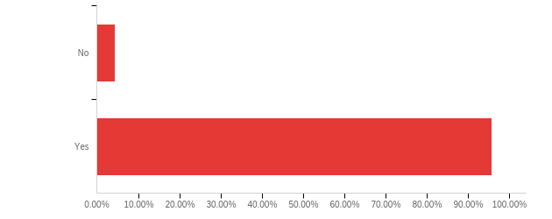
Upon being asked, “is speeding a public safety hazard?” Over 90% of respondents recognized speeding as a public safety hazard, representing the negative public consensus and opinion towards speeding. This result contributes to building the argument for speeding being a problem in west Vancouver as speeding is a public safety hazard.

Q2 - Is there a speeding problem in West Vancouver? (Figure 2)
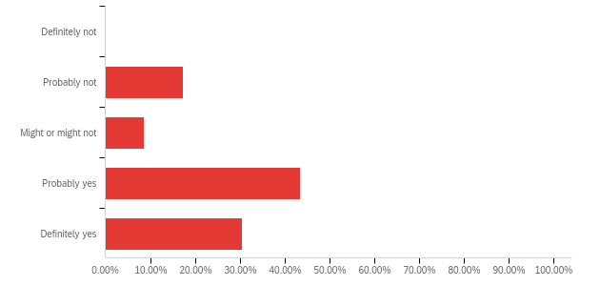
Over 70% of respondents gave positive feedback regarding our initial assumption by recognizing the existence of a speeding problem in West Vancouver, showing a recognizable speeding problem in West Vancouver. Thus, assumption one is proven correct upon combining the results in questions one and two, as respondents recognize speeding both as a public safety hazard and it occurs in West Vancouver.

Q3 - Are you familiar with Stevens Drive in West Vancouver? (Figure 3)
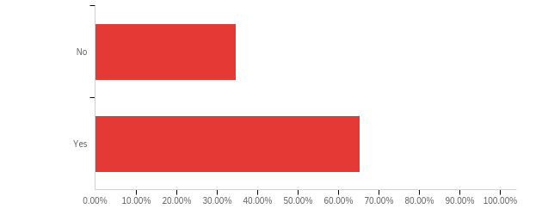
This question is purposed for the demographics of respondents, and over 65% of respondents responded yes to being familiar with Stevens Drive, stating that they are all possible road users of Steven Drive. Therefore, making their recognition of West Vancouver has speeding problems valid.

Q4 - Are you aware of the existence of radar speed signs and their purpose in Stevens Drive? (Figure 4)
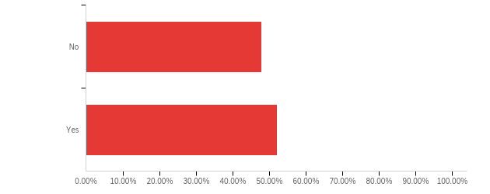
Combining with the results of question 3, where over 65% of respondents are familiar with Stevens Drive, the percentage ratio of almost 50% of respondents saying no reflected that there are people who are not aware of the existence and purpose of radar speed signs on Stevens Drive even if they are familiar with Steven Drive, indicating the lack of recognition for radar speed signs and their usefulness.
Q5 - Are the radar speed signs useful in terms of warning motorist in lowering their speed for road safety? (Figure 5)
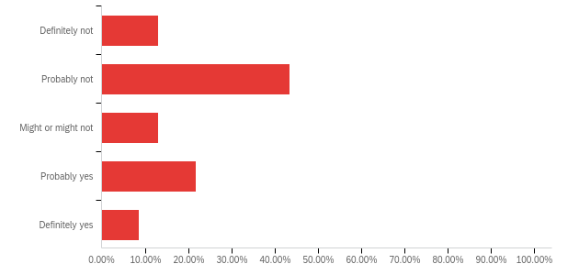
Over 50% of respondents leaned towards radar speed signs being ineffective in warning speeding motorists. In comparison, only 30% leaned towards them being effective, representing the doubt about the effectiveness of radar sign signs in reducing the occurrence of speeding.

Q6 - Do you know what a speed camera is? (A speed camera is a camera that can automatically take a picture of a car that is exceeding the indicated speed limit for law enforcements) (Figure 6)
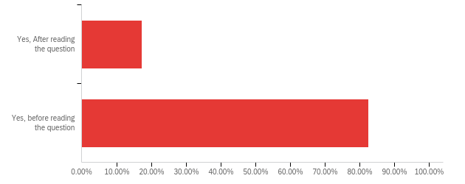
Question 6 was created to give respondents the necessary information about speed cameras so that they are qualified to answer the upcoming questions. In addition, the aim of question 6 is also to find out what the recognition of speed cameras would be since there is no speed camera in Vancouver.
The assumption here is that people will only be familiar with it after reading the description provided. However, results showed that over 80% of the respondents knew what a seed camera was before this question, representing the public acknowledgment of speed cameras.
Q7 - Can speed camera discourage speeding? (Figure 7)
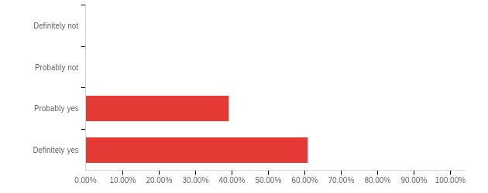
For question 7, 100% of respondents reacted positively to our assumption that speed cameras can discourage speeding, as it is logical to think that if a motorist knows they will be fined for speeding, they will not speed unless there is a reasonable emergency to justify breaking the law of speed limits. Because being fined for speeding is a great negative punishment.

Q8 - Will people only slow down to avoid speed cameras but continues to speed otherwise? (Figure 8)
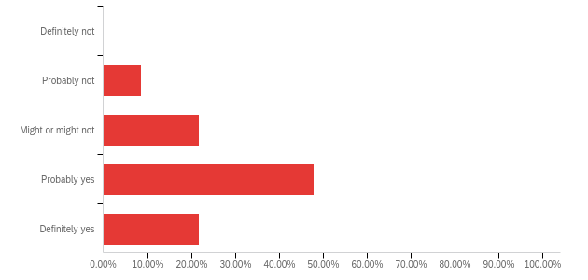
Question 8 is aimed at the criminal nature or, perhaps, the human nature aspect of abiding by the law. Those who abide by the law would not speed or do so if there were police patrols around. The result of having almost 70% leaning towards people will evade speed cameras and continue to speed collides with the assumption that those who intend to break the law to speed will do so whenever they can, contributing to the limitations of speed cameras, as it is out of the speed camera's control and intended purpose.
Q9 - Do you think a speed camera will be a violation to privacy? (Figure 9)
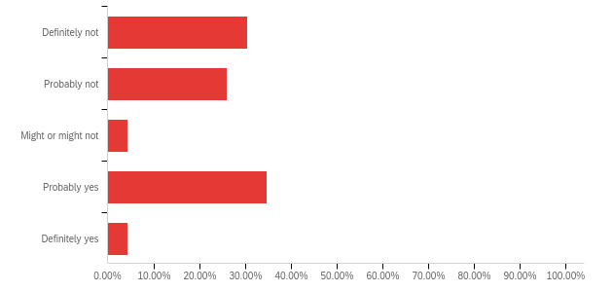
Privacy has always been a concern and especially in the digital information era. As technology advances, it also constrains people's freedom in the name of security. For example, there are security cameras to monitor public places. Whereas agencies and companies can track and monitor online activities, making privacy a worrisome concern for people nowadays. Thus, it is within the expectation that respondents might think speed cameras will constitute an invasion of privacy, as machines will monitor their driving behavior constantly. However, the results show that over 55% of respondents lean towards speed cameras not being a violation of privacy, which is a surprising factor. However, the reasoning from respondents can also be seen in question 11, and it is understandable that unless a speed camera violates a homeowner's privacy directly, it will not be an invasion of privacy.
Q10 - How much should the fine be if a motorist is caught speeding by a speed camera? (Figure 10)
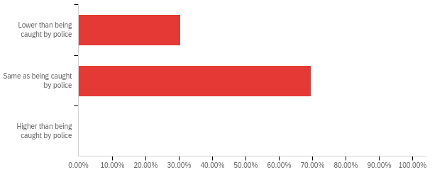
Question 10 aims to discover the cost-effectiveness of speed cameras, as speed cameras will be using funds and taxation money to install. Since a speed camera can operate every day and night, it can catch speeding motorists most often than police patrols and speed traps. Our assumption for the result is that most respondents will agree that the fine should be the same value whether speeding motorists are caught by camera or police, as there should not be a difference in punishment upon being caught violating the law. However, the result of having over 30% of respondents thinking the fine should be lower is interesting, as they appear to think being caught by police in person deserves a higher fine than being caught by a camera. Possibly, they thought that the camera should act as a warning or precaution to speeding drivers instead of acting as a punishment, or they valid the interaction experience better at discouraging future speedings.
Q11 - Would you support the installation of speed cameras in West Vancouver to prevent speeding and why?
Since question 11 is not a multiple-choice question, there is no chart to represent the answers. However, upon calculating the response manually, over 85% answered in favor of installing speed cameras.

The responses can be concluded as follows:

- Installing speed cameras can act as a better warning to speeding drivers than radar speed signs, which can protect drivers and pedestrians.
- Installing speed cameras to prevent speeding can represent the government’s concern.
- Installing speed cameras can stop some from speeding, if not all, which can still improve road safety in terms of speeding.
- Installation of speed cameras should only be permissible in public and does not invade the privacy of nearby homeowners of West Vancouver.
- Installation of speed cameras should only be permitted if the budget is within reason.
- The installation of speed cameras can catch unaware speeding drivers and teach them a lesson, which can also act as a deterrent in their driving future.

The summary of the remaining 15% of respondents who said no can be concluded as follows:

- They do not see people speeding around, so it is unnecessary.
- They do not think speed cameras will be helpful if speeding drivers continue to speed out of the range of speed cameras.

The results and answers show a positive attitude towards installing speed cameras under the right circumstances, as most respondents agree that speed cameras are more valuable than radar speed signs in reducing the instances of speeding.

Survey data conclusion and findings

The survey data reflected a positive attitude and opinion toward installing speed cameras. Hence, the initial assumption of:

there is a speeding problem in West Vancouver

The speeding problem is recognized as a concern because the radar speed signs in Stevens Drive are not effective enough

The mistrust towards radar speed signs will result in positive feedback for installing speed cameras

Have all obtained a positive result, proving the assumptions correct. Providing a favorable support towards speed cameras, which can be used to solve the speeding problem in West Vancouver and improve road safety. The next section will be the analysis of the research articles on the effectiveness of speed cameras and public opinion toward them for data cross-referencing.

Articles on the effectiveness of speed cameras

Stephane Hess conducted an "analysis of the effects of speed limit enforcement cameras: differentiation by road type and catchment area" to determine how effective speed cameras are. Hess presented that in the “250-m range, the average effect of the installation of a SLEC is a drop in (weighted) injury accident numbers by an astounding 45.74%; corresponding figures for the 500-, 1,000-, and 2,000-m ranges are reductions by 41.30%, 31.62%, and 20.86%.” Showcasing the effectiveness of speed cameras upon installation by calculating the reduction in accidents. Similarily, Mountain, L. J., W. M. Hirst, and M. J. Maher’s "costing lives or saving lives: a detailed evaluation of the impact of speed cameras" concluded that speed cameras are effective in reducing speed. They suggested that “the mean speed at the sites prior to the cameras was 33mph, with 64% of vehicles exceeding the speed limit” and is marginally higher than the UK national average for cars on 30 mph roads. However, after the installation of cameras, “all measures of speed fell: mean speeds by an average of 4.4mph and 85th percentile speeds by 5.9mph. There was also a 35% reduction in the percentage exceeding the speed limit.” Both studies supported the effectiveness of speed cameras.

In addition, Haojie Li, Daniel J. Graham, and Arnab Majumdar did a study in 2013 that included a dozen of similar studies with similar positive results in favor of speed cameras, especially when the referenced studies are based across the globe—demonstrating the effectiveness of speed cameras on a global scale, indicating that it is effective in reducing speed and accidents regardless of culture.

Articles on the public attitude and opinion towards speed cameras
In 2022, Beaton published a paper about the "critical elements of public acceptance and support for automated speed enforcement in British Columbia, Canada," which includes the public opinion on speed cameras and more. Upon analyzing the data, Beaton found that the most approved method of speed enforcement are traditional police enforcement with 88% approval and fixed speed cameras in school and playground zones with 82% approval. While, speed on green intersection cameras received 68% approval and fixed speed cameras outside school and playground zones received 67% approval. Representing the importance of conditions and location, as that can make the public approval or disapprove speed cameras.
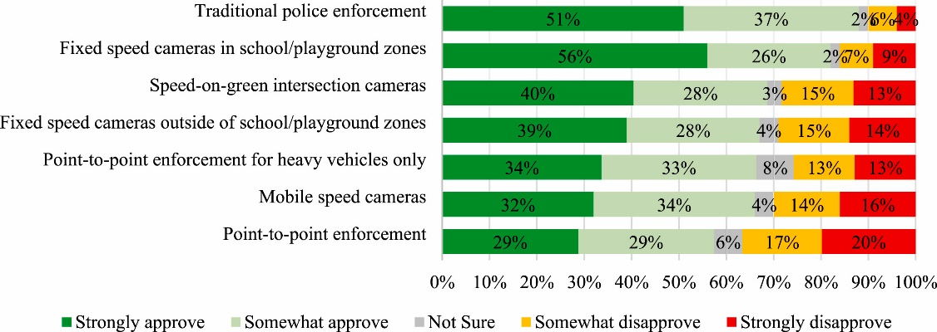
Source: Beaton, M. D., et al. "Critical Elements of Public Acceptance and Support for Automated Speed Enforcement in British Columbia, Canada." Journal of Transport & Health, vol. 26, 2022. Fig 1.
According to Beaton, the four main factors related to automatic speed enforcement were “choosing the location of cameras based on crashes and road injuries,” “learning that it could decrease collisions,” “learning about possible reductions to car insurance costs,” and, “giving drivers a well-advertised ‘grace’ allowance of 5–10% above the speed limit before issuing a ticket.” While other factors included “the government reporting the results of ASE in terms of speed, crash, and injury reductions,” “having highly visible signs that warn drivers of an upcoming ASE camera to allow drivers to adjust their speed accordingly,” and “having a chance to nominate places in their communities for ASE.” Moreover, other studies has also concluded that locations and conditions are an important faction for the public’s approval towards speed cameras, such as Frank Douma’s "identifying issues related to deployment of automated speed enforcement” that was based on a public survey conducted in in Minnesota and Dawn Royal’s National Survey of Distracted and Drowsy Driving Attitudes and Behavior that is based in the United States. Suggesting that speed camera is often approved in North America under the right conditions, such as location and statistics, because road safety is an important concern, and speed cameras can further reduces accident risk stemmed from speeding.

PROPOSED SOLUTIONS AND FEASIBILITY DISCUSSION
Improving road safety in West Vancouver residential area

With speeding being recognized as a public road safety hazard (figure 1) and speeding being a problem in West Vancouver (figure 2), it is evident that there is a need to address the problem of speeding as the radar speed signs have exhausted their usefulness in terms of warning speeding motorists (figure 5). In order to solve the speeding problem in West Vancouver, speed cameras would be a great solution as it is proven to be highly effective by numerous studies that were based across the globe to reduce speed and the occurrence of accidents. Although speed cameras are assumed to be ineffective towards vehicles outside range (figure 8), it is irrefutable that they are effective within range, as suggested by the studies presented above. Which, if installed in high-risk locations, can significantly lower the chance of accidents occurring due to speed, making speed cameras valuable just from the covered area. Furthermore, as examined in this survey and the study by Beaton, British Columbians support installing speed cameras in high-risk locations and school zones, as they believe it is very reasonable to protect those areas for various reasons. Likewise, protecting residential areas in West Vancouver, such as Stevens Drive, with a school zone and golf course crossings, would be reasonable. Thus, with all the studies supporting the effectiveness of speed cameras, it is evident that they can solve or ease the speeding problem and improve road safety in West Vancouver.

Alternative methods to improve road safety
Community engagement can be a powerful tool for improving road safety. Many believe proper education is the best way to solve problems in this world, as knowledge is power. For example, proper knowledge about the risk and dangers of speeding could discourage speeding from fear of doing what is wrong instead of being punished. For example, Mothers Against Drunk Driving is a “provincial anti-drinking and driving groups started to appear in Canada in the early 1980’s. The early pioneers were victims/survivors who wanted to educate the Canadian public about the human tragedies caused by impaired drivers.” Their intention is “to create a national network of victims/survivors and concerned citizens working to stop impaired driving and to support victims/survivors of this violent crime,” (MADD Canada) which is an example of community engagement, and it can help improve road safety by spreading awareness.

Conclusion
This formal report started with the aim to improve road safety in the West Vancouver residential area, especially Stevens Drive, where speeding can be considered normality as the radar speed signs are not effective enough to make speeding drivers slow down due to the lack of consequences from breaking the law. While police speed traps can hugely discourage speeding, police cannot set up a speed trap or patrol constantly to catch speeding drivers, but a speed camera can. Along with extensive studies and surveys covering the effectiveness of speed cameras and the public’s opinion towards them. Even though the speeding camera has its limitations, it is undeniable that reducing speed and accidents is very beneficial to public health and safety, even for small coverage, as lives are priceless. Thus, with the support of this report, a speed camera could be a viable option for solving the speeding problem in West Vancouver.

Works Cited
Beaton, M. D., et al. "Critical Elements of Public Acceptance and Support for Automated Speed Enforcement in British Columbia, Canada." Journal of Transport & Health, vol. 26, 2022, pp. 101461.
Douma, Frank, et al. "Identifying issues related to deployment of automated speed enforcement." (2012).
City of Vancouver. “Signs, signals, and regulations.” City of Vancouver. 2023. https://vancouver.ca/streets-transportation/signs-signals-regulations.aspx#:~:text=Speed%20limits,-Unless%20otherwise%20posted&text=City%20roads%3A%2050%20km%2Fh,Street%20bikeways%3A%2030%20km%2Fh
Government of Ontario, Ministry of Transportation. "History of Ministry of transportation." Ontario.ca. https://www.ontario.ca/page/ministry-transportation#1960s
Hess, Stephane. "Analysis of the effects of speed limit enforcement cameras: Differentiation by road type and catchment area." Transportation research record 1865.1 (2004): 28-34.
Li, Haojie, Daniel J. Graham, and Arnab Majumdar. "The impacts of speed cameras on road accidents: An application of propensity score matching methods." Accident Analysis & Prevention 60 (2013): 148-157.
Mountain, L. J., W. M. Hirst, and M. J. Maher. "Costing lives or saving lives: a detailed evaluation of the impact of speed cameras." Traffic, Engineering and Control 45.8 (2004): 280-287.
MADD Canada. “MADD Canada’s History.” Madd. 2023. https://madd.ca/pages/about-us/what-we-do/history-and-impact/
NHTSA’s National Center for Statistics and Analysis. Traffic Safety Facts: 2018 Data. Report No. DOT HS 812 981. National Highway Traffic Safety Administration, Washington, DC, 2020.
Public Safety Canada. “National Impaired Driving Prevention Week.” Canada.ca. 2023. https://www.canada.ca/en/public-safety-canada/campaigns/national-impaired-driving-prevention-week.html
Royal, Dawn. National Survey of Distracted and Drowsy Driving Attitudes and Behavior: 2002: Volume 1: Findings. No. DOT-HS-809-566. United States. National Highway Traffic Safety Administration. Office of Research and Traffic Records, 2003.
Road Safety At Work. “Hazard Identification and Risk Assessment.” Road safety at work. 2023. https://roadsafetyatwork.ca/resource/tool-kit/hazard-identification-and-risk-assessment/#:~:text=A%20road%20safety%20hazard%20is,employer's%20health%20and%20safety%20responsibilities.
Sensys Gasto Group. “Our Heritage.” Sensys Gatso Group. 2023 https://www.sensysgatso.com/about/our-heritage
Transport Canada. “2020 statistics on the social costs of collisions in Canada” Government of Canada. 2023. https://tc.canada.ca/en/road-transportation/statistics-data/statistics-data-road-safety/2020-statistics-social-costs-collisions-canada

