Increasing Distance Education at the University of British Columbia

for
Dr. Clare Haru Crowston
Dean of Arts
University of British Columbia
Vancouver, British Columbia

by
Amy McCoan
ENGL 301 Student
University of British Columbia
April 12, 2023

TABLE OF CONTENTS
- ABSTRACT……………………………………………………………………………….1
- INTRODUCTION…………………………………………………………………………2
- Definition of Distance Education and Class Formats
- Background of University Rankings and Commute Times
- Purpose and Intended Audience
- Data Sources and Method of Inquiry
- Scope of Inquiry
- DATA COLLECTED
  - Analysis of Current Class Formats Offered at UBC
  - Analysis of Student Surveys
  - Analysis of Professor Feedback
  - Literature Review and Feasibility Discussion
    - Benefits of Improving Distance Education
    - Feasibility of Increasing Distance Education
- CONCLUSION
  - Summary of Findings
  - Recommendations
    - Assess Topic Suitability
    - Cost Analysis Report
    - Professor Professional Development
    - Creativity in Changing Current Courses
- APPENDICES
  - Student Survey Questions
  - Professor Interview Questions
  - Dean of Arts Interview Questions
- REFERENCES
TABLE OF FIGURES

- ABSTRACT
- INTRODUCTION
  - Definition of Distance Education and Class Formats
For this report, distance education will only refer to:
• Online: “instructor supported with real-time classes” (UBC 2023).
• Asynchronous: “instructor supported (UBC, 2023).
• Hybrid classes: “classroom + online” (UBC, 2023).
Online classes are those taught solely online via Zoom where classes are usually not recorded for replay, making attendance mandatory on predetermined dates and times (UBC, 2023). Asynchronous classes refer to online courses taught either via Zoom sessions that are recorded or pre-recorded videos where students can watch the replay at their convenience (UBC, 2023). Finally, hybrid classes include both in-person attendance and online learning (UBC, 2023). These definitions will be used interchangeably throughout the report. Currently, most courses offered at UBC are listed as in-person. Students are required to be in class at a specified time and date, and attendance often counts as part of a participation grade.
  - Background of University Rankings, Commute Time, and Employed Students
According to Times Higher Education, the University of British Columbia (UBC) currently ranks second in Canada and 40th worldwide (UBC’s Institutional Ranking, 2023). To earn rankings universities are heavily evaluated on their teaching environment, research, and research influence (The Higher Education, 2022). To continue research and ensure its influence, there must also be a conducive teaching environment. Having adequate time to study will lead students to maintain high-grade averages that lead to post-graduate work. For those students who live outside of campus and downtown Vancouver, this can be challenging.
Located on the Point Grey Peninsula, UBC had an average daytime student population of 42,550 (table 1.2, transportation status report, 2021), in the fall of 2021. It was reported that student made 131, 200 (consisting of personal vehicles and transit) (Transportation Status Report, 2021) of average weekday trips to campus. 51% of the these trips were made on transit, and 48% on personal vehicles (Transportation Status Report, 2021). These statistics suggest that nearly all students spend some time commuting to campus. The travel time from downtown Vancouver on transit is approximately 1 hour return daily (Google Maps). However, for those students living in Port Coquitlam, Surrey, or Squamish for example, the commute is often up to 4 hours a day. At a full-time (in-person class) course load, this is up to 20 hours of commute time per week, and adds to 300 hours over the semester; valuable time that could be spent studying.
Employment is also assessed as a factor of time constraints interfering with studies.
Since the COVID-19 pandemic, inflation has driven up the cost of housing, food, utilities, and tuition. With Vancouver rated as the second most expensive city in Canada (Nairn, 2022), it follows that 20% of undergraduate students worry they will not be able to continue attending UBC (Turdy, 2022). Students who work a part-time job (20hrs/week) are in the same time-constraint position as their commuting counterparts. Increasing the flexibility of online course choices for these students may encourage them to continue at UBC.
  - Purpose and Intended Audience
The purpose of this report is to assess the demand, feasibility, and potential impact of increasing online, hybrid, and asynchronous classes for the student who commute more than two hours to campus daily or who are employed. The results are analyzed, compared to, and supported by current research, and recommendations are made on how to offer the best distance education for the University of British Columbia. The primary audience for this report is the Dean of Arts at UBC, Dr. Clare Haru Crowston. The secondary audience consists of Dr. Erika Patterson, Professor of ENGL 301.
  - Data Sources and Method of Inquiry
Primary research for this report consisted of a voluntary and anonymous student survey that assessed how commute time impacts students’ feelings, actions, and decisions toward distance education at UBC. The survey, designed on Qualtrics, consisted of ten multiple-choice questions and took approximately two minutes to complete. The survey was distributed on the Piazza discussion board for PSYC 365 and on a Facebook group called “The University of British Columbia (UBC) – Class of 2027”. Fifteen students responded to the survey. Results were analyzed and compared against the current UBC class offerings and literature. Interviews were conducted with two PSYC professors: Dr. Rebecca Todd and Brandon Tomm to assess the pros and cons of offering distance classes versus in-person classes. These interviews consisted of three short questions (see Appendix). The Dean of Arts, Dr. Clare Haru Crowston, was emailed similar interview questions (see Appendix) to assess the pros and cons and cost benefits: no response was received. Secondary research methods included a literature review to support and guide recommendations and inform background research. A complete assessment of the number of online, hybrid, and asynchronous classes offered in the PSYC department for the Winter 2022 and Summer 2023 semesters, was accomplished to support recommendations.
  - Scope of Inquiry
These are seven main points of inquiry.
- How great is the demand for increasing the availability of online classes?
- Would students take more classes if they did not have to commute?
- Do students who commute or work value or desire an on-campus experience?
- Do students feel like they would get higher grades and more life satisfaction from taking online classes and not commuting?
- What are the pros and cons of teaching distance versus in-person classes?
- How many classes are currently offered as distance education at UBC?
- What is the cost of creating more online lectures and labs?
- COLLECTED DATA
  - Analysis of Current Class Formats Offered at UBC
Over the Winter 2022 and Summer 2023 semesters combined, UBC offered 174 in-person classes (82%) and 37 DE classes (18%) in the Psychology department. These excluded the thesis, work placement, directed studies, and practicums.
  - Analysis of Student Surveys
Demographics (age, commute time and employment status) were obtained.
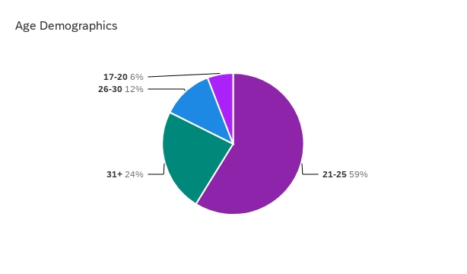
Figure 1. Age Demographics
Figure 1 indicates that most students (59%) were between the ages of 21-25 years, 12% were over 31, and only 6% were between 17-20. Roundtrip commute times to campus and employment status were also obtained (Figure 2).
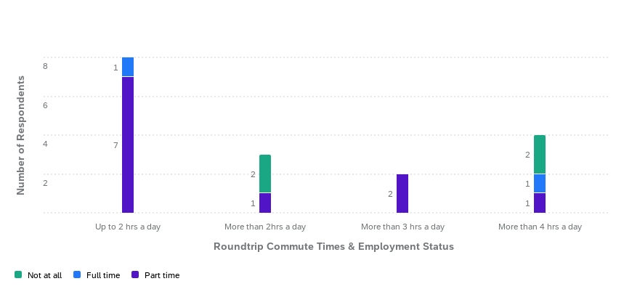
Figure 2. Commute Times to Campus and Employment Status
Figure 2 illustrates that most students only commute up to 2 hours a day however, 88% of them worked part-time jobs. Nine students commuted more than 2 hours a day, out of which 5 were employed in either full or part-time work. The effect of time in transit on studying, was measured (Fig 3; Fig 4).
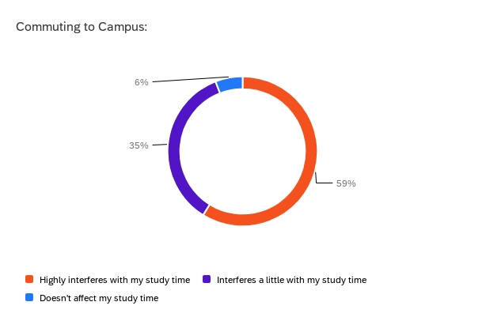
Figure 3. Students Feelings That Commuting Interfered with Study Time
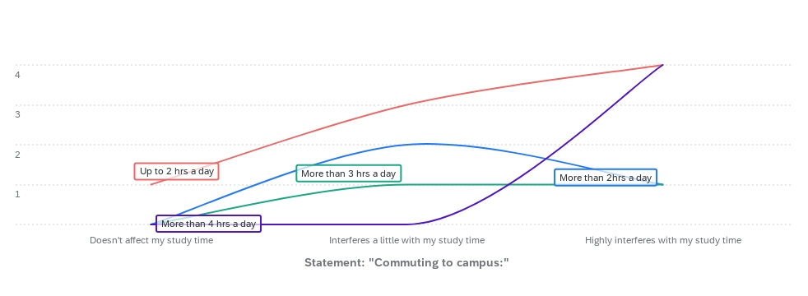
Figure 4. How Many Hours Students Commute in Relation to the Level of Study Time Interference
94% of students felt that, to some degree, commuting interfered with their study time (Fig 3). Students agreed that UBC did not offer enough DE (Fig 5.)
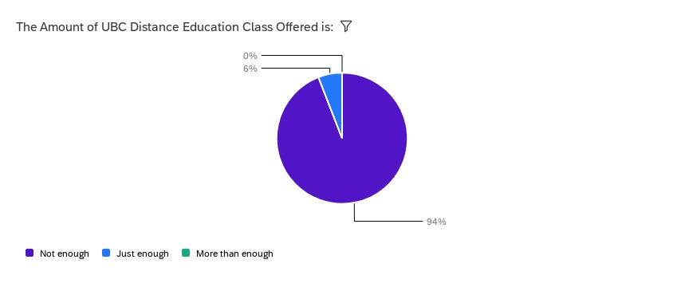
Figure 5. Students Did Not Feel That UBC Offered Enough Online/Hybrid Classes
94% of students found that UBC did not offer enough online/hybrid classes and felt that their GPA and mental health would be positively impacted by the increased availability of online courses (Fig. 6; Fig. 7).
Figure 6. Students’ Predication of Impact on GPA by Taking More DE
Figure 6 illustrates that 94% of respondents believe the opportunity to take more classes would increase their GPA. Students' projection about their mental health was assessed in relation to doing their degree over online courses.
Figure 7. Students' Prediction of Impact on Mental Health by Taking More DE

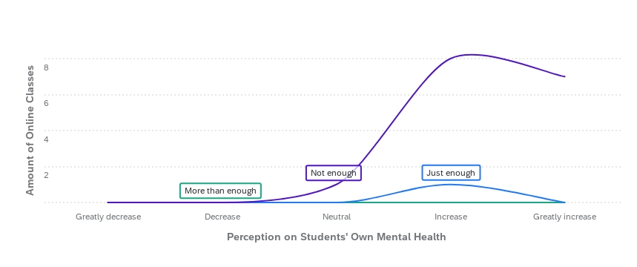
Figure 8. Relationship Between the Amount of Current DE and Mental Health Predictions
94% of respondents believed their mental health and life satisfaction would increase significantly if they could take online classes (Fig.7). In that 94%, 14 out of 15 agreed that UBC did not offer enough DE classes (Fig. 8). The decision to enroll into a partial or full-time course load was also measured (Fig. 9).
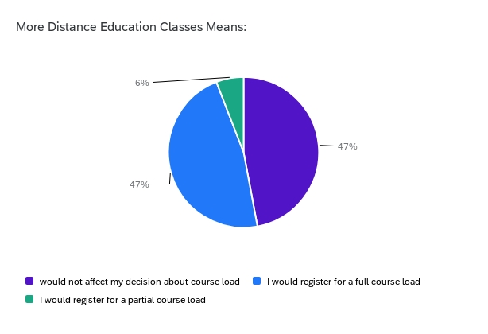
Figure 9. The Influence of Availability of DE on Course Load
Interestingly, only 47% of students reported they would register for a full course load. Another 47% said it would not affect their decision about course load and only 6% chose to register for a partial course load. It is unclear whether registering for a partial course load would be an increase or a decrease of credits for those students. Lastly, UBC prides itself on delivering social campus activities and an interactive campus experience. It is possible that this is an argument for the higher ratio of in-person classes on offer. Assuming that survey respondents are not living on campus or working when not studying, the importance of the campus experience was measured (Fig. 10).
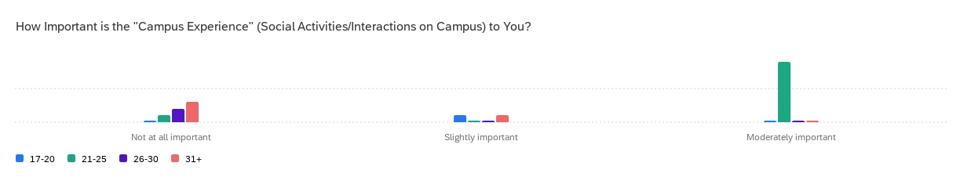
Figure 10. The Importance of UBC “Campus Experience” by Age Group
The “campus experience” was deemed moderately important by 9 students between 21-25 years of age. Only 2 responded as feeling it to be slightly important and 4 not at all important. No respondents chose “Greatly Important” or “Exceedingly Important” therefore they were excluded from the figure.
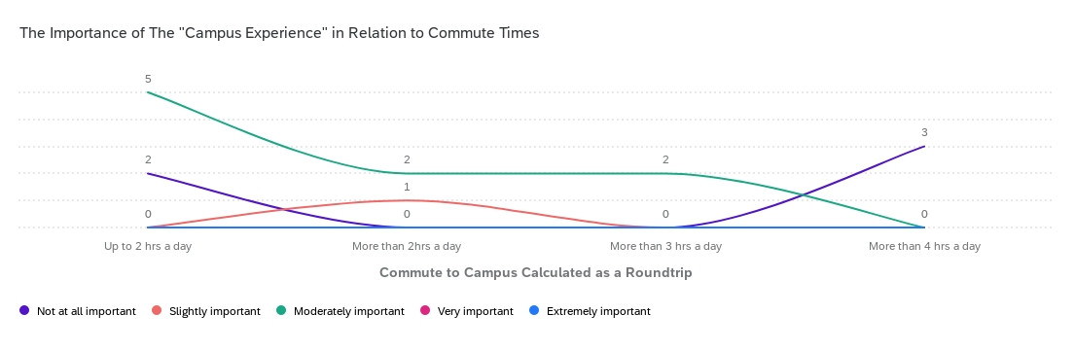
Figure 11. The Importance of the UBC "Campus Experience" in Relation to Commute Times
5 out of the 9 students in Fig. 11 that found the “campus experience” to be moderately important commuted under 2 hours to campus, whereas the other 4 transited above 2 hours. In contrast, all those who traveled more than 4 hours away did not feel that being on campus was important.
  - Analysis of Professor Feedback
Professor Rebecca Todd (PYSC 365) was interviewed over email and Professor Brandon Tomm (PSYC 309) over Zoom. Dr. Todd teaches her classes in a hybrid format with a split in-person recorded lecture (posted after class) and pre-recorded lectures with the option of an in-class discussion on those days. Professor Tomm’s class is entirely in-person with no live streaming or recorded postings. Mr. Tomm did post two pre-recorded lectures, one when he was sick and the other on a Midterm test day instead of making students come back for class.
Both professors agreed that providing in-person classes was valuable for getting to know students, discussing course topics, and real-time feedback on lecture material. Professor Tomm championed the in-person format over online classes. He reported that preparation was shorter, taking only half an hour for the in-person lectures and 10 hours for recording them. He cited feeling anxious about logistical and technical issues for teaching the lecture over Zoom, which led to recording it instead. Regarding students’ performance in class, he reported a 2% grade average drop on the midterm post the two recorded lectures, which he says has not occurred in his previous in-person classes. Professor Tomm could not comment on the morale and well-being of students as he has not taught an online class and therefore had no basis for comparison.
Dr. Todd reports having made her pre-recorded lectures during COVID when she had more time. She described enjoying a hybrid format as it gave rise to the voluntary discussion classes but also noted that it could be a con for students who prefer a “live lecture with a designated room and few distractions”. Conversely to Mr. Tomm, Dr. Todd found that students generally did much better on online exams however, she acknowledged that the chance of cheating is much higher. Lastly, when asked about student morale Dr. Todd said this was a “mixed bag”. Overall, students seemed to thrive more in-person, but some students enjoyed the flexibility and convenience of online classes, and the online format can provide relief for those suffering from social anxiety.
  - Literature Review and Feasibility Discussion
    - Benefits of Improving Distance Education
UBC has offered distance education since 1917 (UBC Distance Learning, 2023). The long and rich history UBC holds with remote education experience shone in 2020 when the COVID-19 pandemic forced all classes to be offered online. Many professors turned their lectures into pre-recorded videos for asynchronous viewing, lectured on Zoom, and, used Panopto to live stream their classes; as a result, the foundation for online learning was been built. A systematic review and meta-analysis completed by Pei and Wu (2019) concluded that online learning was as beneficial as in-person learning. Cavanaugh, Jacquemin, and Junker (2022) added that switching to online classes positively affected GPA overall, however, noted that this was dependent on the class topic (eg: engineering versus medicine). Assumably more dedicated time and flexibility to study the course material would increase the grade percentage average (GPA) which is conducive for students continuing onward to post-graduate work and research. By valuing the students’ time, they may be more inclined to stay at UBC and rate their overall experience even higher. Castro and Tumibay (2021) summarize it best by stating “from the student perspective, the convenience of online learning is particularly valuable to adults with multiple responsibilities and highly scheduled lives; thus, online learning can be a help to workforce development, helping adults to return to school and complete additional education that otherwise could not fit into their daily routines. From an institutional perspective, online modalities allow colleges to offer additional courses or course sections to their students, increasing student access to required courses” (p. 1383).
The other benefit of improving the remote education experience is improving students’ mental health and well-being. Committing so much time to travelling and working and therefore not studying is stressful. Mental health inevitably suffers in those students who strive to do very well but feel like they cannot. Decreasing stress leads to greater health outcomes (Canadian Mental Health Association, 2023), more focused study time, and ultimately more satisfied students. By increasing the availability of distance education, students would feel optimistic about their grades and classes, leading them to rate their classroom experience positively. As a result, UBC would continue to be evaluated well in the teaching environment category.
    - Feasibility of Increasing Distance Education
UBC has already laid a strong foundation upon which to start expanding the distance education program, however, a cost analysis report would be beneficial to assess the most useful allocation of finances and resources in supporting this venture. To make distance education more robust, Meyer and McNeal (2011) suggest utilizing these three pillars:
1) Using low-cost technology (PowerPoint, pre-recorded lectures, self-paced modules, etc.) to maximise finances and diversify the online format.
2) Employing teaching assistants to support class interactions, facilitate class discussions, and grade assignments and tests.
3) Utilizing group work, group discussions, and including abundant communication with the student and between faculty to improve learning.
University students have less time to attend in-person classes and could benefit from the increased flexibility that distance education can offer. To stay competitive post-COVID, UBC needs to be prepared to keep up with the demand for online teaching and empower the professors to feel equipped to teach online courses (Rapana, Botturi, Goodyear, Guardia, & Koole, 2020).
- CONCLUSION
  - Summary of Findings
UBC offers far more in-person classes than online/hybrid/asynchronous class formats. Nearly all the students who travelled to campus, or were employed agreed that UBC did not offer enough online classes and that commuting interfered with studying. Students also predicted that their mental health, well-being, and GPA would all increase if they could take more courses online. Those respondents who lived closer to campus valued the “campus experience” more than those who travelled from further away. The professors fundamentally agreed on the value of student interaction and discussion in-person, however, disagreed on GPA test results and the time commitment to the preparation of course material. There were pros and cons to the impact on students’ well-being for both in-person and online formats. No comment can be made on the cost-benefit of increasing distance education.
  - Recommendations
Below are several recommendations for how to improve the distance education program.
- Assess Topic Suitability
As not all topics are suitable for an online format, piloting a study to assess which topics would ensure student success and save time and cost.
- Cost Analysis Report
Once topics are determined as being suitable in an online format, performing a cost analysis to plan the conversion of classes in the most efficient way to save cost in the long run.
- Professor Professional Development
Maintaining a positive classroom experience will rely on ensuring professors have adequate training in the technology required for online courses, successful online pedagogy, and how to prepare effectively for their course setup. Teaching assistants might also benefit from taking some of the same professional development if they are to assist in online courses.
- Creativity in Changing Current Courses
It is imperative that creative thinking influence the final distance education program. Finding resourceful and innovative ways to change the current course format will both be to students' and professors' liking. For example, if changing a 300-student class from in-person to online is too costly, maybe making half of it online would succeed. Lastly, in the course itself, professors ensuring that students have a variety of ways to interact and communicate with each other and faculty will lead to a greater sense of community and learning.

