Hi team,
The objective of the first part of Assignment 1:3 is to define a term using parenthetical, sentence, and expanded definition. The purpose of this exercise is to write for a specific audience based on the audience’s familiarity with the term.
As some of you may know from reading my blog, I am currently working as an Intermediate Human Resources Business Analyst. Although my main role is to support and train our HR system end users, I had been asked to participate in IT projects here and there to test our modified HR system after system upgrades. Business analyst works closely with project manager throughout the life-cycle of a project. A business analyst’s role in a project setting is to gather requirements from stakeholders, identify potential risks, support the testing process and ensure the final product meets the needs of stakeholders. Project manager uses the requirements gathered by business analyst to determine a list of specific project goals, tasks, costs, deliverables and deadlines. The term I would like to introduce to you commonly occurs in projects and is considered a project manager and project team’s worst nightmare.
Term:
Scope creep
Parenthetical Definition:
Scope creep (uncontrolled changes to scope) is one of the most prevalent causes of project failure.
Sentence Definition:
Scope creep is a continuous growth of unauthorized work on top of the agreed-upon work that needs to be accomplished to deliver a product or service. Scope creep is a risk to project because it increases the time, costs and resources needed to complete the project.
Expanded Definition:
Etymology:
Scope creep is a combination of two words: scope and creep. The term “scope” is derived from Greek skopos, which means “aim, target, object of attention” (Harper, 2001). The term “creep” is derived from Proto-Germanic *kreupaną, which means “to twist, to creep” (Harper, 2001). When we combine the meanings of two words, scope creep can read “to twist [the] aim or object of attention”.
Scope change vs scope creep:
Scope change refers to an official change to scope that is agreed upon by project manager, project sponsor and the client. Scope change involves making adjustments not just to scope, but also to project time, costs, and resources needed to complete the project. On the other hand, scope creep refers to slow and unofficial change to scope that is often not documented and lack management and allocation of additional time, cost and resources required to complete the project.
How does scope creep occur?
- Scope creep happens when the project scope is poorly defined. An ambiguous scope leads to further clarification and adjustments to requirements, and may result in expansion of scope.
- Changes to scope need to follow a clear process for evaluation of necessity and allocation of resources. When the project lacks requirements and scope management, the project has a high chance of failure due to lack of time, cost and resources. Some features or changes that are not previously agreed upon in the project scope may only take the developer an hour to do, but it is an hour of developer’s time that should be spent on working toward finishing the defined project scope.
- Project that lacks stakeholder involvement runs the risk of developing scope creep. Without stakeholders to clarify their needs, the project team may end up building features that the client does not need or want.
- Requirements without clear process or product boundaries may lead to fuzzy scope and irrelevant requirements. The lacks of uniformed process for collecting requirements can cause misunderstanding and may leave room for different interpretation of scope.
Visualize the effect of scope creep:
The triple constraint of time, cost, and scope describe the project. Changing one constraint will affect one or both of the other constraints. Imagine we have a blue ball representing scope and a yellow ball representing cost and time, both placed at either end of a balance scale. If the project increases the size of scope, it will also need to increase cost and time to keep the balance. If the project only increase size of scope without increasing cost and time, the project will be out of balance and will likely lead to project failure.
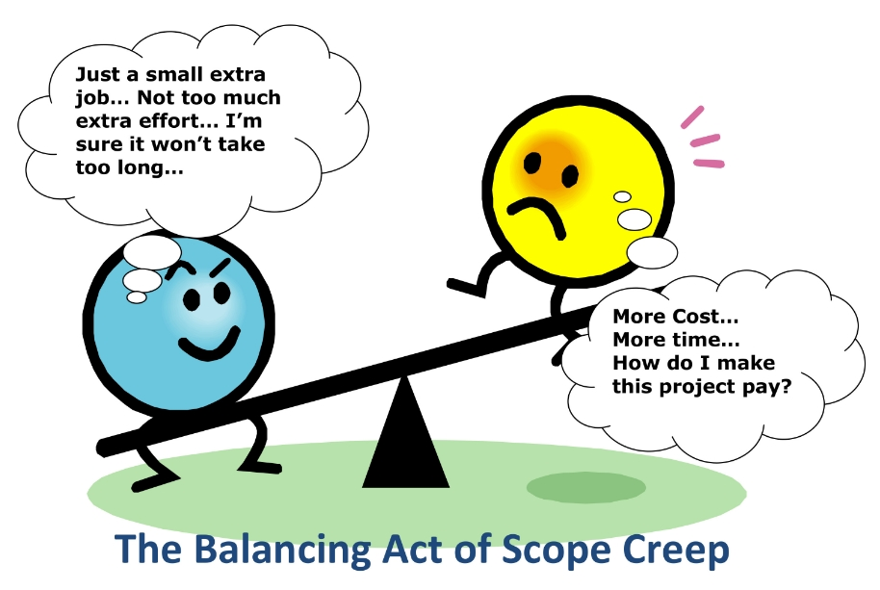
Source: https://blog.ganttpro.com/wp-content/uploads/2017/02/Scope-creep-joke.jpg

References:
Harper, D. (2001). Creep. In Online Etymology Dictionary. Retrieved September 24, 2019, from https://www.etymonline.com/word/creep
Harper, D. (2001). Scope. In Online Etymology Dictionary. Retrieved September 24, 2019, from https://www.etymonline.com/word/scope
Kukhnavets, P. (2017, February 20). How to Avoid Scope Creep In Project Management? Retrieved from https://blog.ganttpro.com/en/project-management-scope-creep-with-real-examples/
Larson, R., & Larson, E. (2009, October 13). Top Five Causes of Scope Creep. Retrieved from https://www.pmi.org/learning/library/top-five-causes-scope-creep-6675
Moses, S. (2018, May 24). Scope Creep in Project Management: Definition, Causes & Solutions. Retrieved from https://www.workamajig.com/blog/scope-creep

