**Extrapolation**

**What is extrapolation?**

Extrapolation is a statistical technique used to expand and predict unknown data. Researchers use this method by examining previously collected data and observing the trends associated with the variables. It allows one to forecast (predict) data; however, predictions cannot be made with extreme certainty.

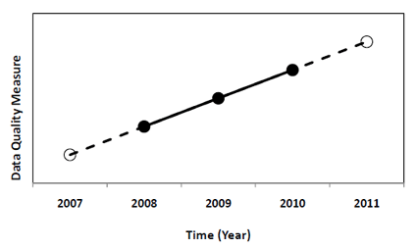

**When should extrapolation be used?**

Extrapolation should primarily be used when data results have been consistently accurate to one another and there are no large fluctuations or data scattering. The more stable the data is, the more reliable data extrapolation will be – although this cannot be guaranteed.

**Cautions and Mistakes**

Extrapolation should only be used to predict data in the short-run. Various unexpected factors can influence data, and therefore should not be used to predict the long run. Extrapolation uncertainty can present false information to scientists and has the potential to create mistakes in future data. Due to the potential mistakes that may arise, extrapolation should be used with extreme caution.

**How is extrapolation used in real life?**

Engineers and marketing analysts within the technology industry constantly use extrapolation to predict the next product that consumers will want – predicting the growth rate of technology. Similarly, scientists observe former growth trends of human populations to forecast future population sizes in various communities and countries.

**Bibliography**

"Biased Sampling and Extrapolation." *Biased Sampling*. N.p., n.d. Web. 19

Jan. 2015.

<https://www.ma.utexas.edu/users/mks/statmistakes/biasedsampling.html>

"Extrapolation: What Is It?" *Statistics How To*. N.p., n.d. Web. 19 Jan. 2015. <http://www.statisticshowto.com/extrapolation/>

"What Is Extrapolation? Definition and Meaning." *BusinessDictionary.com*. N.p., n.d. Web. 19 Jan. 2015. <http://www.businessdictionary.com/definition/extrapolation.html>