Definition

The ENGL 301 assignment requires students to use 3 different ways to define a complex term in our related field of study. By using parenthetical definition, sentence definition and expanded definition for general audience that does not have a deep understanding of the field of study.

Term: Hypersomnolence

**Parenthetical Definitions**

Excessive sleep

**Sentence Definitions.**

Hypersomnolence means excessive sleep during the day or prolonged nighttime sleep. People with this condition may fall asleep during the day at inappropriate times such as at work and school.

**Expanded Definitions.**

The term hypersomnolence can be divided into two words. The word hyper is a prefix meaning having too much of a quality. The second word somnolence means sleepiness.

**Diagnostic Criteria**

The predominant feature is excessive sleepiness for at least 1 month (in acute conditions) or at least 3 months (in persistent conditions) as evidenced by either prolonged sleep episodes or daytime sleep episodes that occur at least 3 times per week.

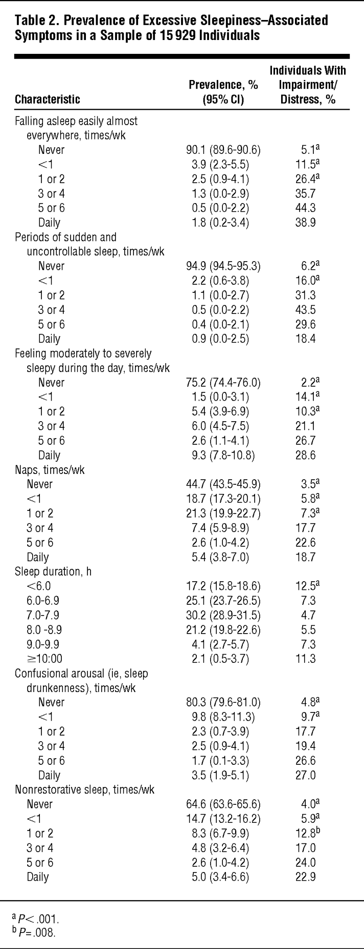

**Treatment:**

Treatment options for hypersomnolence and narcolepsy have usually included education and behavioral modification, as well as stimulant medications such as modafinil, armodafinil, and more potent stimulants such as methylphenidate and amphetamines

Citation

BaHammam, A. S. (2017). hypersomnolence.*Sleep Medicine Clinics, 12*(3), xvii-xvii. doi:10.1016/j.jsmc.2017.06.002

Lee, E. K., & Kazaglis, L. (2015). Hypersomnolence disorders in hypersomnolence disorders in.*Psychiatric Annals, 45*(1), 25. doi:10.3928/00485713-20150106-06

Ohayon MM, Dauvilliers Y, Reynolds CF 3rd, . Operational definitions and algorithms for excessive sleepiness in the general population: implications for DSM-5 nosology. Arch Gen Psychiatry. 2012;69(1):71–79. doi:10.1001/archgenpsychiatry.2011.1240