The term “Lane’s Scale” will be the word that I am going to define in this assignment. The main goal for this post is to give a brief introduction in three types of definitions to those audience with non-technical background and fresh to this term. The situation will be set as a fourth-year university student who is enrolling in environmental science presenting to his juniors in the first year.

Term to be defined: Lane’s Scale

Parenthetical definition: A representative model of fluvial geomorphology.

Sentence definition: The Lane’s scale (also refers to Lane’s balance) is a model introduced from fluvial geomorphology. It applies to describe the balance between the load of water and the sedimentation within a stream system. As well as demonstrating the self-adjusting process (channel aggradation/degradation) that the stream system goes through in order to maintain a balance between the sedimentation and water levels.

Expanded definition:
Lane’s scale (Lane’s balance) is a useful model to study and understand the channel equilibrium. It really tells us a lot about how a stream system will adjust by itself. Whatever you are doing your research in, the river restoration or river engineering field and suchlike, it tells you the fundamental concept about the relationship between water and sediments in a stream system.

History
The model of Lane’s scale first came from the concept of Lane’s relation which was introduced by E. W. Lane in 1955. He introduced the qualitative expression which included the relationship between water discharge, sediment discharge or load, channel slope, and the representative sediment size for a river under a dynamic equilibrium condition (Dust & Wohl, 2011).

Operating Principle
The Lane’s Scale is popular used model in fluvial geomorphology. Fluvial geomorphology is the study of the form and function of streams and the interaction between streams and the landscape around them. ‘Fluvial’ refers to the processes associated with running waters, ‘geo’ refers to earth and ‘morphology’ refers to channel shape (Credit Valley Conservation, 2012). It has been displayed on the Lane’s scale model that on one side we have sediments and water on the other. Sediment is solid material that is moved and deposited in a new location. Sediment can consist of rocks and minerals, as well as the remains of plants and animals (National Geographic Society, 2012). If the sediments side goes down, that will lead to the aggradation to the channel bed. And if the water side goes down, it will lead to the degradation to the channel bed. This is a kind of local reach adjustment.

Visuals
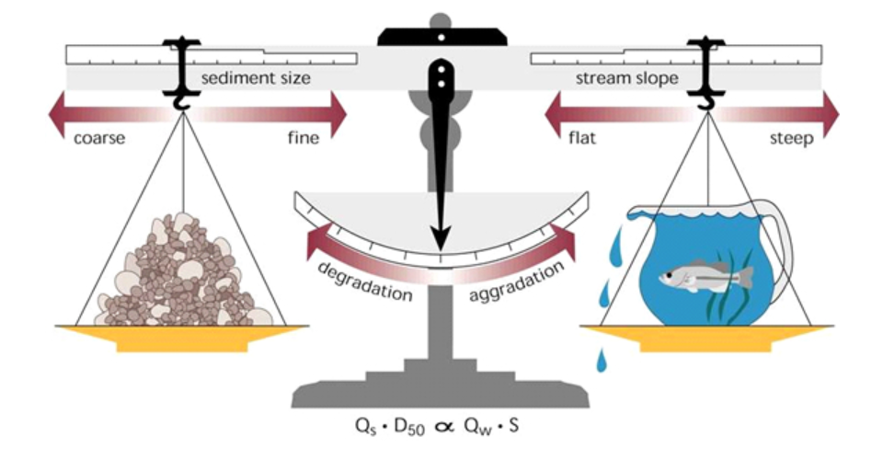
Figure 1. Model of Lane’s Balance (University of Kentucky, 2014)

In terms of water and sediments, the certain amount of water discharge that should happen in equilibrium with the sediment supply and the whole system should be balance. That means river is able to adjust over a period of time by the discharge and sediments which related to the channel geometry. The relative process of how the Lane’s Scale works and their causing elements are explained as below:

Process: Aggradation (deposition)
Causes:
- Coarsening sediment size
- More sediment input
- Less sediment output
- Stream slope decrease
- Water discharge decrease

Process: Degradation (erosion)
Causes:
- Fining sediment size
- Less sediment input
- More sediment output
- Stream slope increase
- Water discharge increase

Examples
The equilibrium is dynamic. For example, in presence of a storm, the level of water input dramatically increases. As illustrated on Lane’s Balance, this would lead to water loss at the bottom of water side as the water in the container is getting flood over. Depending on the water input and loss in a river system, those sides of the balance can go up and down. This is the dynamic equilibrium driven by the hydrology which is first started prior to the runoff process. After that, the runoff from upstream may lead to the channel or bank erosion and landslide input which are going to increase the amount of sediments. If it is unable to get rid of the sediments, then, they will pile up as it reflected on the other side of the balance which makes it goes down, this results in a channel aggradation at the end.

Reference:
Lane, E. W., 1955. The importance of fluvial morphology in hydraulic engineering. Proceedings, American Society of Civil Engineers, No. 745, July.

Dust, D., & Wohl, E. (2011, October 14). Conceptual model for complex river responses using an expanded Lane's relation. Retrieved June 06, 2020, from https://www.sciencedirect.com/science/article/abs/pii/S0169555X11005241

University of Kentucky, Arts &amp; Sciences. (n.d.). Retrieved June 06, 2020, from https://www.as.uky.edu/blogs/jdp/changing-lanes

Chapter 8 - Fluvial Geomorphology. (2013, February 06). Retrieved June 13, 2020, from https://cvc.ca/watershed-science/watershed-monitoring/credit-river-watershed-health-report/chapter-7-fluvial-geomorphology/

National Geographic Society. (2012, October 09). Sediment. Retrieved June 13, 2020, from https://www.nationalgeographic.org/encyclopedia/sediment/

