Dear fellow students,
For assignment 1.3, as instructed in this blog post on the English 301 website, each student is required to choose a relatively complex term in their discipline and write three definitions. The meaning of this word will be clarified to a non-technical audience with increasing level of detail: parenthetical definition, sentence definition and expanded definition.
This assignment will help students appreciate the importance and the role of definitions in technical writing, to understand how audience and purpose indicate the need for definition, to differentiate between the levels of details in definition and to select the right level of detail according to the situation.
The Situation: I am a hypothetical instructor of an introductory Earth and Ocean Sciences course. This course focuses on geomorphology, the study of the physical features of the surface of the earth and their relation to its geological structures. The definitions below are written for non-technical students outside of the Earth and Ocean Sciences field with no technical knowledge or background in this discipline.
Term:
Drumlin
Parenthetical Definition:
Drumlin (a feature of the Earth’s surface that looks like a flipped spoon or a half-buried egg)
Sentence Definition:
Drumlin is an oval or elongated hill, formed under a large moving body of ice and indicate the ice flow direction.
Expanded Definition:
Drumlin is an elongated hill, formed beneath large ice mass (also known as glacier) and is usually asymmetrical with one side steeper than the other, which implies the direction of the flowing glacier above (see Figure 1). It is made up of glacial deposits, which are mixed materials being carried by ice that subsequently got laid down. They are usually found in groups or fields, which comprise of tens to thousands of drumlins.
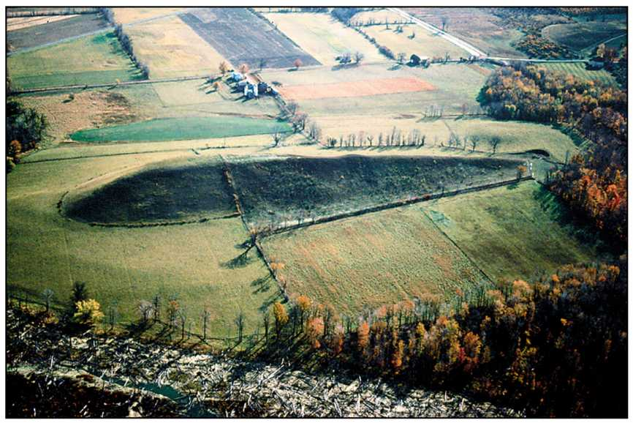
FIGURE 1: Example of a drumlin
- How did its name originate?
First named by H.M. Close in 1897, the name is derived from the Gaelic word druim (a ridge or hill) or droimnín (littlest ridge) as a diminutive.
- What is it made of?
Drumlins are composed of many sediment types and structures. Some drumlins have cores that are made of rock, sand, boulder (a large smooth rock) or laminated clay and covered by till (unsorted glacial sediment). Some can be found with glaciofluvial materials, which are materials that have previously been moved by glacier, got sorted later on and deposited by streams flowing from the meltwater of the ice. Drumlins can also be made of carved bedrock or a mixture of all the above. A common compositional feature among drumlins is the predominent local materials, with transportation distances of a few kilometers or less. Other materials from farther locations, if any, are usually deposited at the very top of the drumlins.
- How is it formed?
Due to the inaccessibility of glacier beds, no observation of an actively-forming drumlin has been recorded. There are two major theories revolving the formation of this feature: erosional theory and depositional theory.
The erosional theory focuses on the processes of removing and transporting materials from one location to another on the Earth's surface. As meltwater from glaciers creeps over a landscape, it scours loose material from that area and transports the material away, at the same time smoothens out the left behind high-resistant feature known as drumlin.
The depositional theory revolves around the successive geological processes of laying down sediment (such as soil, rocks and materials) that has previously been carried by wind, water or ice to a land mass. This theory suggests that some areas may experience a slight change in pressure from the ice above or variation in the material below, which results in increased deposition and creation of drumlins under the glacier.
- How does it resemble or differ from similar glacial features?
Drumlins can be easily confused with eskers. They are both made by glacial processes, both aligned parallel to the ice flow direction but have very distinct features. While drumlins have asymmetric egg-like shape, eskers, in contrast, are long, snake-like hills (see Figure 2).
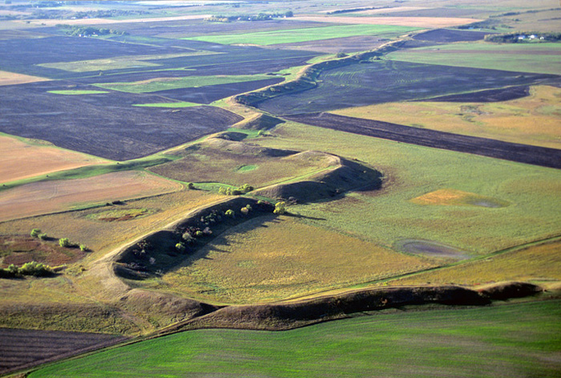
FIGURE 2: An esker near Dahlen, North Dakota
References:
Bean, Tom. “Esker, a sinuous ridge formed by subglacial ice age stream, aerial view near Dahlen, North Dakota”. AGPix. http://www.agpix.com/view_caption.php?image_id=206564&photog=1
“Drumlin”. Wikipedia, 1 Jan. 2019, https://en.wikipedia.org/wiki/Drumlin. Accessed 17 January 2019.
“Drumlins”. The University of Sheffield. https://www.sheffield.ac.uk/drumlins/drumlins. Accessed 17 January 2019.
Hall, Adrian. “Drumlin”. Landforms. http://www.landforms.eu/Lothian/drumlin.htm. Accessed 17 January 2019.
McKinnon, Mika. “Drumlins Are The Easy-To-Identify, Hard-To-Understand Glacial Landform”. Gizmodo, 22 Mar. 2015, https://gizmodo.com/drumlins-are-the-easy-to-identify-mysterious-to-unders-1692890209. Accessed 17 January 2019.
The Editors of Encyclopaedia Britannica. “Drumlin”. Encyclopaedia Britannica, 8 Jun. 2017, https://www.britannica.com/science/drumlin. Accessed 17 January 2019.
Turski, Mark. “Drumlin”. Jupiter Plymouth Education. http://jupiter.plymouth.edu/~sci_ed/Turski/Courses/Earth_Science/Images/4.drumlin.jpg
“What Is the Difference Between a Drumlin and an Esker?”. Reference. https://www.reference.com/science/difference-between-drumlin-esker-c13542f038998622. Accessed 17 January 2019.

