ENHANCING THE PARTICIPATION OF UBC GEOLOGICAL SCIENCES STUDENTS IN THE UBC SCIENCE CO-OP PROGRAM

For
Dr. Javed Iqbal
Program Director of the Science Co-op Program
The University of British Columbia
Vancouver, British Columbia, Canada

By
Thu (Navy) Vo
English 301 99C – Technical Writing
Instructor: Dr. Erika Paterson

March 15th 2019
TABLE OF CONTENT
Table of Contents
INTRODUCTION 3
DATA SECTION 3
THE INDUSTRY’S VIEWS 3
The nature of the job market 3
What makes a new graduate stands out 4
THE STUDENTS’S VIEWS 4
Effectiveness of official/unofficial promotional methods 4
How well students know about the program 5
Main drawbacks of the program 5
How can the program improve 6
CONCLUSION 7
Summary and Overall Interpretation of Findings 7
Recommendations 8
WORK CITED 9

INTRODUCTION
With vast developments in technology, economy and society, the competitive job market has become fiercer than ever for new graduates. Hiring managers consider good academic performance and other aspects such as experience, skills, motivation, maturity, and attitude in a prospective young employee. Co-op Programs are well known to successfully bridge this educational gap by introducing the concept of work placements within post-secondary programs, where students alternate academic terms with working terms within their industry of interest.
The University of British Columbia (UBC) is known for the largest Co-op program in Western Canada. Although the UBC Science Co-op program has been growing steadily, the number of Geological Sciences students take part in the program has been decreasing for the past three consecutive years. The major implications of this problem are two: first, students will struggle to find suitable jobs after graduation; second, there will be a supply shortage of well-trained short- and long-term employees in the industry.
Thirty-nine UBC Geological Sciences students responded to a short survey designed to analyse students’ perception/opinion of the UBC Science Co-op Program as well as gauge interest in a potential attracting solution. In addition, interviews were conducted with two past and current UBC Science Co-op Advisors as well as two Human Resources Advisors in the industry to see what they think about the UBC Science Co-op Program. Based on examination of recent research, surveys and interviews with UBC Geological Sciences students, Co-op Advisors and professional Human Resources Advisors, this report aims to investigate the cause of reduction in Geological Sciences students’ participation in the Co-op Program and provide recommendations to the UBC Science Co-op Office. An analysis
This report covers five major topics: what are the main reasons for Geological Sciences students not to participate in the UBC Science Co-op program, what these students look for in a program that supports gaining working experience, what are the current marketing strategies of the UBC Science Co-op Program and their relative effectiveness, how are these strategies keeping up with the changes in the industry, and what are the employer’s preference when hiring a co-op student or a new graduate.
This report concludes by acknowledging the decrease in participation of Geological Sciences students in the UBC Co-op Program and by recommending immediate and inexpensive solutions to enhance the participation.

DATA SECTION

THE INDUSTRY’S VIEWS
Many Geological Sciences students find employment in industries related to mineral, petroleum, and water resources; either in academia, field/laboratory settings or consulting firms. Two Human Resources (HR) Advisors from a digital solution company in the mining industry and a global engineering consulting firm were interviewed for this project. Both have extensive experience in hiring students from Co-op programs across Canada.

The nature of the job market
The job market for Geological Sciences Co-op students or new graduates greatly depends on the specific industries that they are interested in. The mineral exploration or the mining industry is strongly dependent on external factors outside of the companies such as the fluctuation of the market, commodity prices, investment from clients, etc. It is also a seasonal market – in Canada, there are more opportunities for contract work during the summer when the ice melts and drilling is possible. For other industries such as academia or consulting, the number of job openings are more stable.

What makes a new graduate stands out
When looking to fill positions for new Geological Sciences graduates, apart from relevant educational background, employers have high preference for those with previous Co-op or any related work experience in school. Experienced new graduates are valuable to employers because they are more capable at adjusting to the challenges in a new working environment. These experiences demonstrate that the new graduates’ willingness to work hard and to take on responsibilities. The market is getting extremely competitive, hence, those who can differentiate themselves from others will have a higher chance of getting hired.

THE STUDENTS’S VIEWS
[Thirty-nine UBC Geological Sciences students responded to a short survey designed to analyse students’ perception/opinion of the UBC Science Co-op Program as well as gauge interest in a potential attracting solution.] They spread out from first year to already graduated. When asked about the importance of work experience during post-secondary education, students score an average of 88 with the scale from 0 as not important to 100 as very important.

Effectiveness of official/unofficial promotional methods
All thirty-nine participants in the survey knew about the UBC Science Co-op Program. Most students (74.36%) found out about the program through word of mouth from friends or professors. Official marketing strategies from the UBC Science Co-op Office come second and third, with 41.03% of students hearing about the program through events and 38.46% from the program’s official website. Flyers and posters of the program are not commonly known within the student body (only 20.51%).
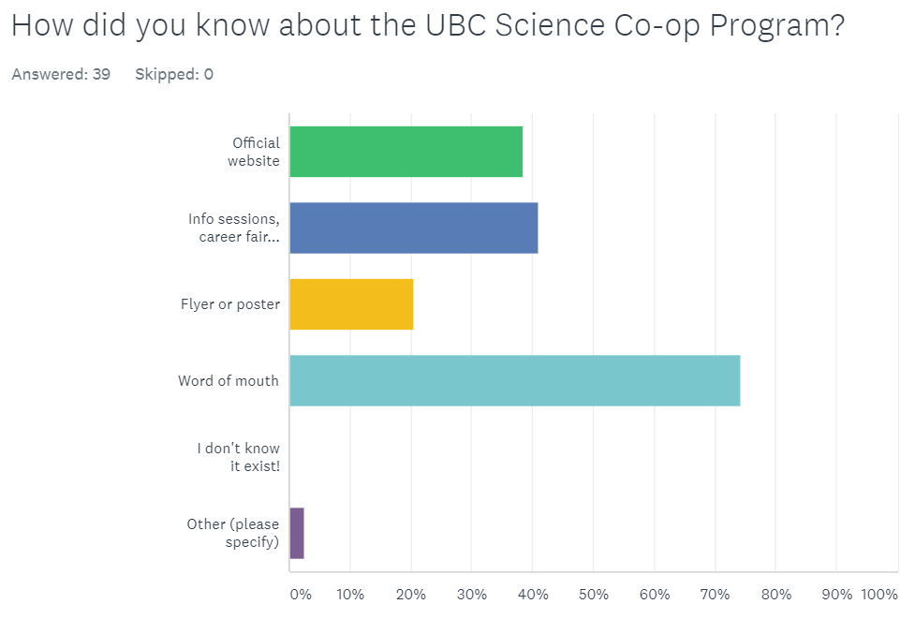
Figure 1. How Geological Sciences students know about the UBC Science Co-op Program
Of all students participated in this survey, 43.59% knew about the program but decided not to join. 35.90% are co-op students, most of them plan to or have finished the program while one fifth of these students plan to or have dropped the program. The rest of the students show interest in the program, but either still waiting for admission, did not qualify or miss the deadline to apply.

How well students know about the program
Thirty-seven participants responded to this survey question. Majority of them, 83.78% and 81.08%, know about the popular benefits of the co-op program: industry experience, networking, career exploration, broad job pool. An equal amount of students (54.05%) know that the UBC Science Co-op Program provides ongoing free supports for their students and has a one-time workshop fee of $251.75 that covers Resume/Cover letter, interview, LinkedIn Profile etc. workshops for the entire program. A very small number of students (16.22%) are aware of the monthly income statistics for Natural Sciences (including Geological Sciences) Co-op Students but more than twice of them (37.84%) know about the ratio of co-op fee vs. monthly income.

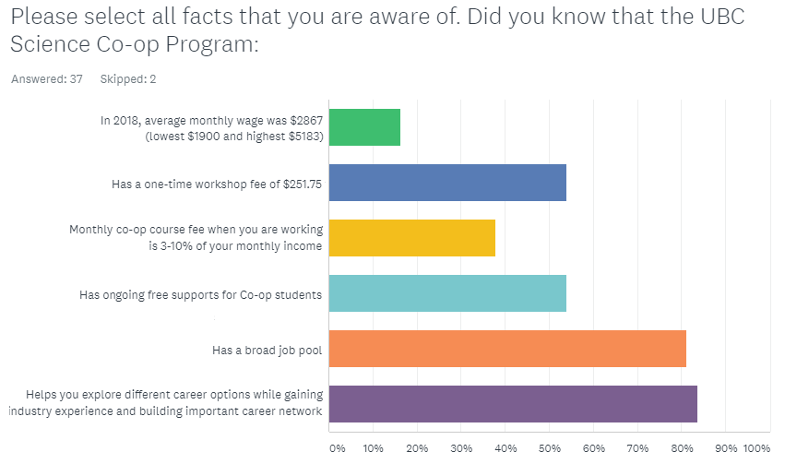
Figure 2. How well Geological Sciences students know about the UBC Science Co-op Program

Main drawbacks of the program
53.85% of the students participated in this survey are concerned about the delay in graduation (at least additional year) if participate in the UBC Science Co-op Program. An equal percentage of 38.46 of students are less interested in the program due to high program fees (placement fees, workshop fees, etc.) and are confident that they can find work experience without the Co-op program. A 30.77% of surveyed students did not like the tight schedule of the Co-op Program. An 17.95% of students (data not shown on graph) did not have any negative experience with this program.
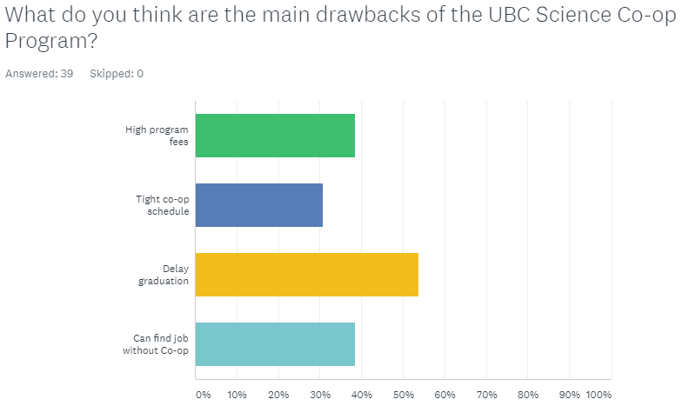
Figure 3. Main drawbacks of the UBC Science Co-op Program

How can the program improve
Most students are concerned about the associated fees and job opportunities in the UBC Science Co-op Program: 71.79% of the students want lower program fees while 64.10% want a wider selection of employers and job placements. Peer mentoring between previous or current Co-op students to new students has a popular vote of 46.15% from the participants. 20.51% of the student body hope to have more workshops and support from the Program. A small number of students mention better timing for information sessions, less selective in choosing students to be in the program, and a more persuasive argument from the co-op office and past students.
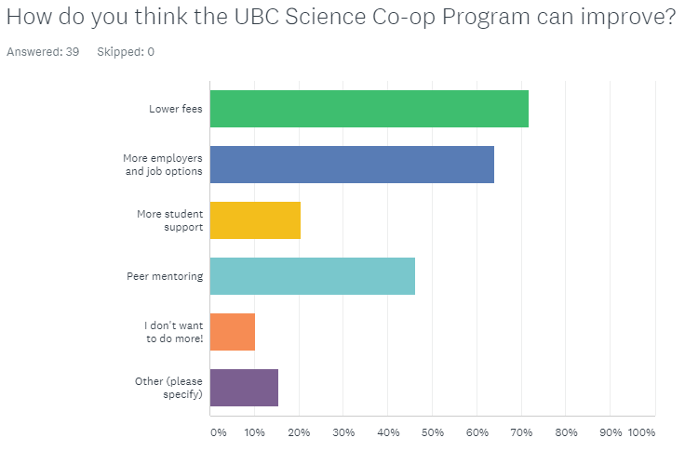
Figure 4. Suggestions for program improvement from Geological Sciences students

CONCLUSION

Summary and Overall Interpretation of Findings
The UBC Science Co-op programs typically adds another year to a students’ degree. More than half of the students when asked are concerned about this delay in graduation and consider it as a drawback to the program. Many reasons can be associated such as financial, parents or peer pressure, or the belief in the positive correlation between on time/fast graduation and less competition in the job market for new graduates. Moreover, almost 40% of students participated in the survey are confident that the student job market is not very competitive, and they can find jobs by themselves. However, the concerns of taking longer time to finish a degree and the confident that they can easily secure job positions in the industry can be incorrect. In fact, without the Co-op program, many students can’t get relevant work experience while in school and many new graduates might need more time than a 16-month co-op program after graduation to land a job related to their field. (research on how long does it take for new grads to secure jobs)
It is becoming increasingly popular for companies in the industry to hire Geological Sciences students through Co-op Programs. All interest students have to apply and pass the interviews with the Co-op Advisors before becoming students in the Co-op Program and getting access to internal Co-op job openings. Hence, the UBC Co-op Program acts as the first layer of screening applicants, which save employers valuable time and effort. Moreover, employers can choose targeted students for specific positions thanks to the Co-op program. Once a job posting is sent to the Co-op office, it will be posted on the right platform to get the suitable and qualified students. Due to all the benefits from the Co-op Program, many employers are choosing to only post short-term job positions for students through the internal Co-op website rather than on their own company websites.
Many Geological Sciences students are unaware of companies in stable industries that are invested in early-preparation of quality new graduates through Co-op programs. For instance, in the environmental or consulting sectors, many employers hire co-op students and train them so that they can be rehired as full-time employees after graduation. This process is ongoing so that employers will have a constant supply of well-trained new graduates. However, many Geological Sciences students at UBC are only aware of industries such as research and mining. These industries’ dependency on external factors such as commodity price or funding hinders the stability of job opportunities for co-op students and new graduates. Students need to be aware that there are more opportunities out there that are not seasonal-dependent or market-dependent.
Geological Sciences students are generally knowledgeable of the UBC Science Co-op Program’s benefits and costs, whether they choose to attend the program or not. Most students when asked know about the broad job pool, chances to explore career options, to gain industry experience and to build professional network, or the ongoing supports that the program offers. However, students are not well aware of the possible salary of Co-op students in this field. This doesn’t mean students don’t focus on the costs associated with the program: more than half of them know about the fees associated with the program while more than one third know about the ratio between co-op course fee and average monthly income. These data have two implications: one, income is not the most important thing for Geological Sciences students and they are more willing to invest into the future through the Co-op program; two, they are more aware of the costs they have to put up front as a Co-op student than what they can possibly be making.
Over 80% of surveyed students agree that the UBC Science Co-op job pool is quite broad but over 60% of them want more employers or a wider variety of job options on the Co-op website. One of the reasons why students want to be part of the program is that they can explore different career options through different job positions or different sub-sectors in the industry. However, many students are not attracted to “imperfect” job postings. These postings usually have some aspects that the students like and that they do not enjoy. For instance, a job opening might not be in the exact field the students want, or it is in a different city far away from home, or it does not sound like something the students are familiar with. It is important that students need to see the values and appreciate all job opportunities. Getting those first “imperfect” jobs not only give them insights into what job they want or do not want in the future but also help them “get one foot into the door” of employers.
Word of mouth has proven to be a double-sworded knife to the UBC Science Co-op program. It is believed to be the most effective way in getting students to know about the program, more effective than the official marketing strategies of the UBC Science Co-op Program. Over 70% students in the survey are aware of the UBC Science Co-op Program through friends or professors. However, over 40% decided not to join despite knowing about the program. This finding has two implications. One, as word of mouth is a much more personal approach than traditional promoting methods, information through this channel is more valued by the audience. However, the information given might not be accurate or more negative than positive (research on how people perceive negative things more clearly than positive). Two, word of mouth can cause inaccurate assumptions of not only the UBC Science Co-op Program but also of the market and the potential employers. Three, even past or current co-op students, who joined for the benefits of the co-op experience, might have spread more negative than positive comments about the program. While 35.90% of the students participated in this survey are past or current co-op students, only 17.95% do not think there is any drawback in the program. In fact, all students participated think that the program can be improved.

Recommendations
The UBC Science Co-op Office need to change the image of the program: focus more on the positive (benefits of the program) and less on the negative (fees associated, time-consuming, etc.). Breaking down the fees into particular, more detailed sub-sections can be helpful. Instead of focusing on the cost, the program can reword it and show it in a more positive way. Explaining to the students the rationale behind this extra year of co-op and how it can save students more time in the long run can be more beneficial. The co-op program can also try to increase students’ awareness in the status of the job market (e.g. which field is ideal to go into this year) or expand their job options (e.g. Geological Sciences students can also do Geotechnical work in consulting firms).
The UBC Science Co-op Program need to better convey to prospective students that admission is not strongly dependent on external factors such as grade, past experiences, skills, or certifications. Instead, the UBC Science Co-op need to emphasize on the internal factors and that they are looking for individuals that stand out and possess valuable unteachable traits, such as hard working, the ability to take initiative, responsibility, etc. If students have these traits, they can utilize the co-op workshops or personal meetings with advisors and will be set for success.
The UBC Science Co-op Program need to show their genuine interest in supporting and helping the student, or in other words, “It’s okay to fail, as long as you want to improve, we are here to help.” It is always ideal to take in brilliant students who almost only need access to the co-op job platform to start excelling in their fields. However, most students are only academically-ready but not working-ready. In particular, students need to learn skills outside of the classroom such as how to ace interviews or how to convey themselves better through application packages. Hence, the UBC Co-op Program should accept the students’ abilities at the time of admission and put more effort in bringing the students up to employable standard.
Having a peer mentoring program between students and more events that incorporate the employers (e.g. industrial mixers) can increase the participation of Geological Sciences co-op students. Peer mentoring is beneficial for both experienced and inexperienced co-op students. For past or senior co-op students, this is a good way of giving back to the program. For new students, hearing direct tips from previous students in the same field can open their eyes and help them better prepared for the co-op journey. To employers, an industrial mixer is a great chance for them to get to know prospective co-op students even before they apply for the job. Students also benefit as they get to know what kind of jobs are out there and what are the culture or the people at prospective companies, which will help them narrow down what they want to do in their co-op program. This will save time for both the employers and the students: the employers can find students that they really like while students are matched to employers or positions they really enjoy.

WORK CITED
(no cited work at the moment)

