1. Signing in to WordPress
Sign in by going to your site URL blogs.ubc.ca/xx or at blogs.ubc.ca and entering your CWL when promted
2. An orientation to the WordPress Dashboard
The WordPress Dashboard is the admin panel for your site. You can edit your site settings, change the look and feel and publish posts and pages in this area. This area is only available to administrators regardless of site-wide privacy settings
To get to the Dashboard from your site hover over the My Sites list, select your site and select Dashboard.
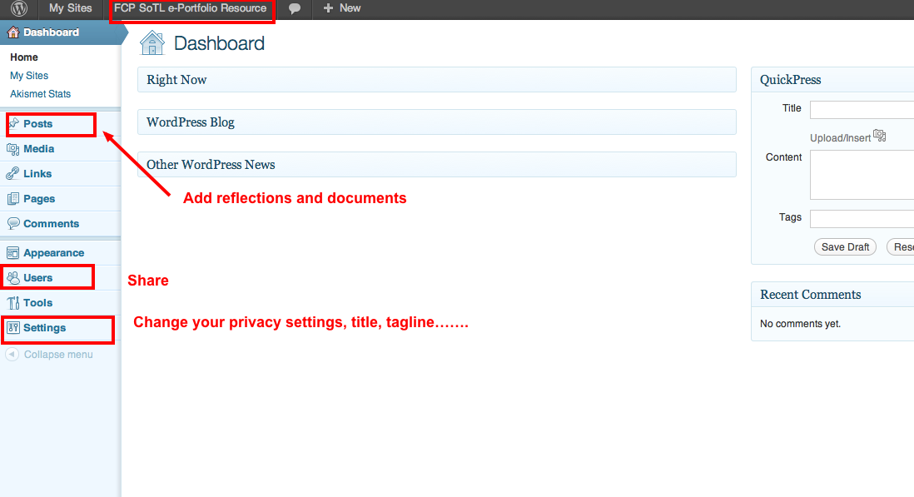

Fig 1: The Dashboard
2. For this e-Portfolio, posts are used as a holder for both your reflections and evidence. You can write reflections in the post body, and upload documents, images, slides and audio to share as evidence.
- From the Dashboard, click Posts on the left-hand menu bar.
- Click the Add New button
- Enter a new short title in the new post and enter text in the large empty box below the title.
- Select a category from the current category list by clicking on the radio button next to it. The categories correspond to the organizational components of your FC SoTL Portfolio.
- Browse the Discussions settings below and either allow or disallow comments on your posting.
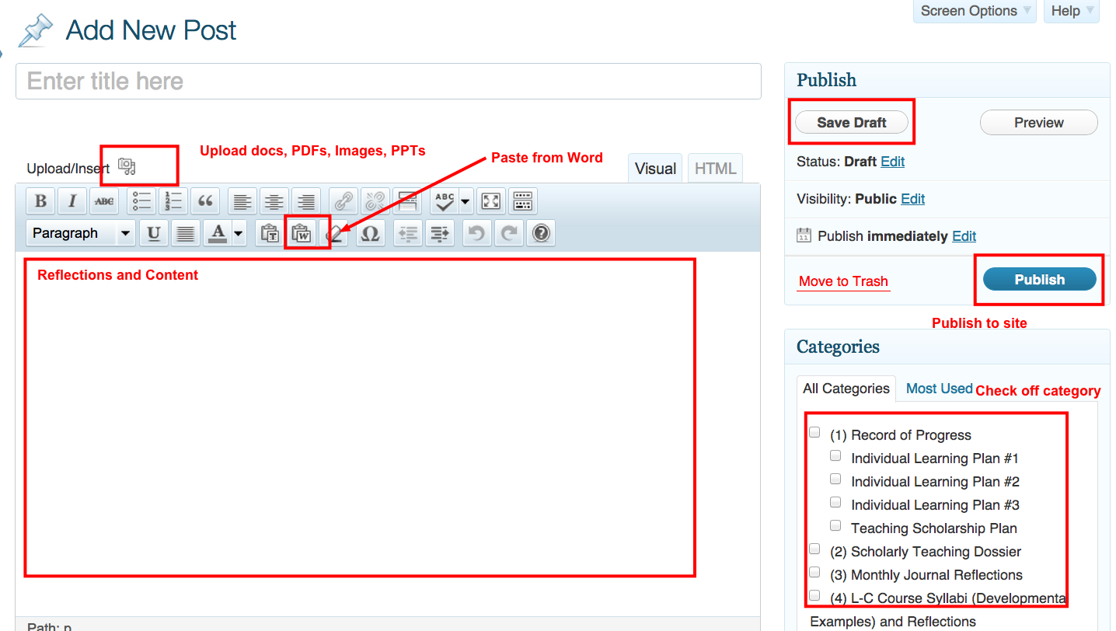
- On the far right, in the Publish settings, click Preview to see your new post, and then click Publish. 'Note: the yellow confirmation at the top of the page. If you click Save Draft the post will be saved to your All Posts areas.

Fig 3. Creating and publishing a post
3. A number of different media formats can be uploaded to WordPress MU including PDFs, Docs, PPTs, and images. This media can be inserted into pages and posts in your site. The following guide will assist you in adding content to your site.
- Create a new page by clicking on Pages in the sidebar
- To add media to a page, scroll to the area above the Formatting Menu and select the Add Media icon
- This will open the uploader. From this screen click on Select Files to upload a file from your computer.
- From your computer click on the image, document or audio file to upload and click Open
- From the screen that appears give the media a title, a caption and description (optional), alternative text (accessibility) and click Insert Into Post. If the file is an image it will appear in their post. If the file is a PowerPoint, PDF or Document it will appear as a hyperlink.
- Add any relevant text and select Update to publish your revised page.
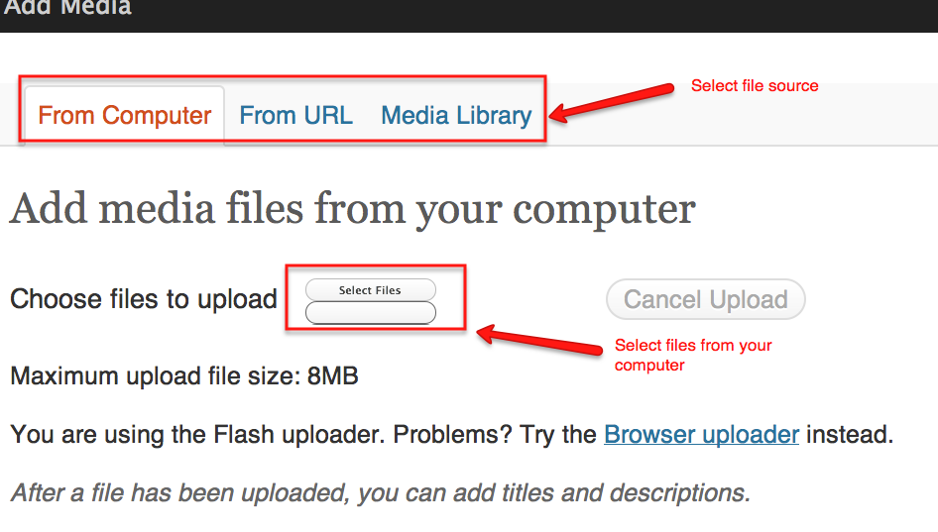

Fig 4: Uploading images and documents to your site

