Understaffing issues of the Richmond Aquatics special needs program

For Brandon Kato, Aquatic supervisor
Of Richmond Aquatics special needs
Program Richmond BC

By Eric Chang
ENGL 301
Dec, 5, 2019

TABLE OF CONTENTS

ABSTRACT…….………………………………………………………..……....………………….#
INTRODUCTION……………………………………………………………..…………………….#
- Description of the Richmond Aquatics special needs program…………………………………………………………………………………….#
- Description of the staffing shortage……………………….………………………………………………………......#
- Description of data sources……………………………………………………………...……………………..#
- Purpose of the report …………………………………………..………………………….……………………....#
- Scope of inquiry …………………………...…………………………………………….…………………...#
DATA SECTION
- Determining the importance of the special needs program……..…………………….#
  - How it contributes to the community ...…………………………………………#
  - Why the program is needed.……………………..…………………………...…#
G. Determining the amount of staff members needed to run the program..……..……..#
- Data from interviews………………………..…………………………………….#
2. Data from surveys………………………………………………………………..#
H. Proposed Solutions for the staffing shortage..……………….………….……………..#
- Providing incentives for volunteer instructors…......…………….…………….#
- Increase marketing for the program….……………………….………………..#
- Increase of Richmond Aquatic staff members…………………………………#

CONCLUSION
I. Summary of findings…………………………………………………………….………..#
J. Recommended solutions…………………………………………………………………#

ABSTRACT (to be completed)

INTRODUCTION
- Description of the special needs program
The Richmond Aquatics special needs program is a two hour swim class that is provided for all children with any form of physical or mental disabilities on Saturdays from 10-12pm at Minoru Aquatics centre in Richmond. The purpose of this program is to create an environment better suited for special needs children to learn swimming as regular swim classes are often times not suited for children with special needs.
- Description of staffing shortage
Due to the continuous increase in the amount of students that want to join the special needs program, the program is almost always short instructors. This is a major issue because in order for special needs children to learn swimming effectively, the ratio between students and instructor should always be 1:1 or 1:2 at worst. Yet this is consistently not the case as instructors are often times forced to teach 4 or even 5 students at a time.
- Description of the data source
The majority of the data for this report will come from primary resources which consist of both interviews and surveys. The interviews will then be conducted on the current staff members of the Richmond Aquatic special needs program as well as the volunteer instructors that took part in the program. The surveys will then be given to all of the students participating in the program currently as well as to their parents. The second source of data for this report will then come from research papers, articles, and reviews.
- Purpose of the report
The purpose of this report is to discover a solution to the problem of the Richmond Aquatics special needs program being constantly understaffed in terms of instructors.
- Scope of Inquiry
This report will cover all members participating in the Richmond Aquatics special needs program .

DATA SECTION
- Determining the importance of the special needs program
- How it contributes to the community
The Richmond Aquatics special needs program is an extremely special program as the main purpose of the program is really just to give back to the community and this is why the Richmond Aquatics special needs program is one of the only aquatics programs that is free of charge. But more important than just being a free program, staff members of the program also work extremely hard to create special events that occur after the swim lessons for the students to participate and further bond with other classmates or instructors.
- Why the program is needed
Teaching special needs children swimming in a regular class setting can be extremely difficult for the instructor as well as the special needs child for numerous reasons. The first reason is that special needs children oftentimes need individualized attention, which is extremely difficult for an instructor to provide consistently when teaching swim classes with 4-8 students. The second reason why special needs children don't learn to swim effectively in a regular group environment is because of the distractions that are present in a group setting. Special needs children learn better in an environment with less distractions, which is not something the instructor can provide in a group setting. The third and most important reason why it is difficult for an instructor to teach a special needs child swimming in a regular class setting is for safety reasons. Special needs children are usually weaker swimmers that needed to be constantly watched in order to prevent them from hurting themselves. In a group setting instructors often times need to work with students individually for short periods of time, which could put the special needs child in danger due to the fact that the instructor would not be able to focus on both students at the same time.

G. Determining the amount of staff members needed to run the program
- Data from interviews
(still being conducted)
- Data from surveys 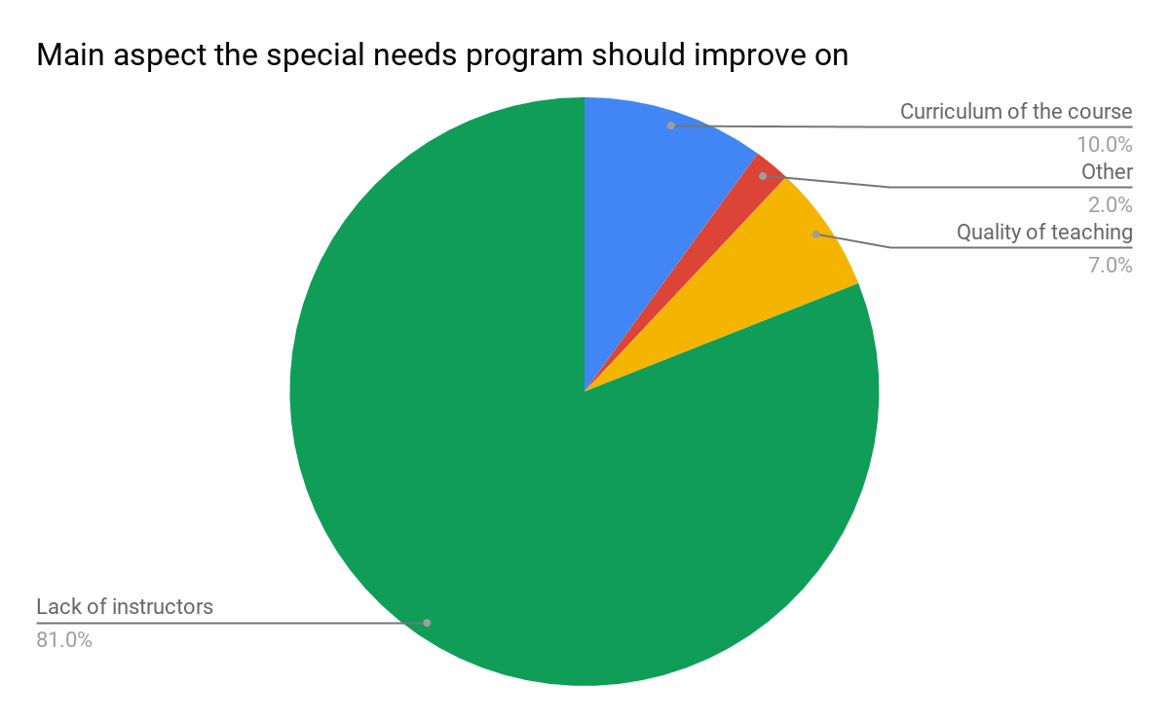
Fig 1. Main aspect of the program to improve on
(Still being worked on)

H. Proposed solution for staffing shortage
- Providing incentives to volunteer instructors
As of right now, out of the total 19 instructors for the program 4 of the instructors are lifeguards that work for the city of Richmond while the other 15 instructors are all volunteer instructors who do this in their spare time. A majority of the volunteer instructors are high school students who are using this program to gain teaching experience in order to apply one day to become a lifeguard. As of right now the program provides no benefit to the volunteer instructors when applying for a lifeguarding job other than teaching experience they gain when teaching the students. A method to attract more people to become volunteer instructors for the program would be to provide the students that enter the program a leg up when applying to become a lifeguard. For example the lifeguard hiring process is split into three sections teaching, physicals, and interviews. For students that teach as volunteer instructors for the special needs program for more than 3 months, they get to skip the teaching section of the hiring process and move straight into physical portion of the testing. This is because the volunteer instructors that join the special needs program will gain tons of experience teaching children to swim which means that this is a skill that they most likely do not need to be tested on.
- Increase marketing of the program
As of right now the only marketing there is for volunteer instructors to join the program is through word of mouth from instructors to students after they complete their certification for Water Safety Instructor. By advertising the position on the Richmond Aquatics website, the program then should be able to find and attract much more volunteer instructors.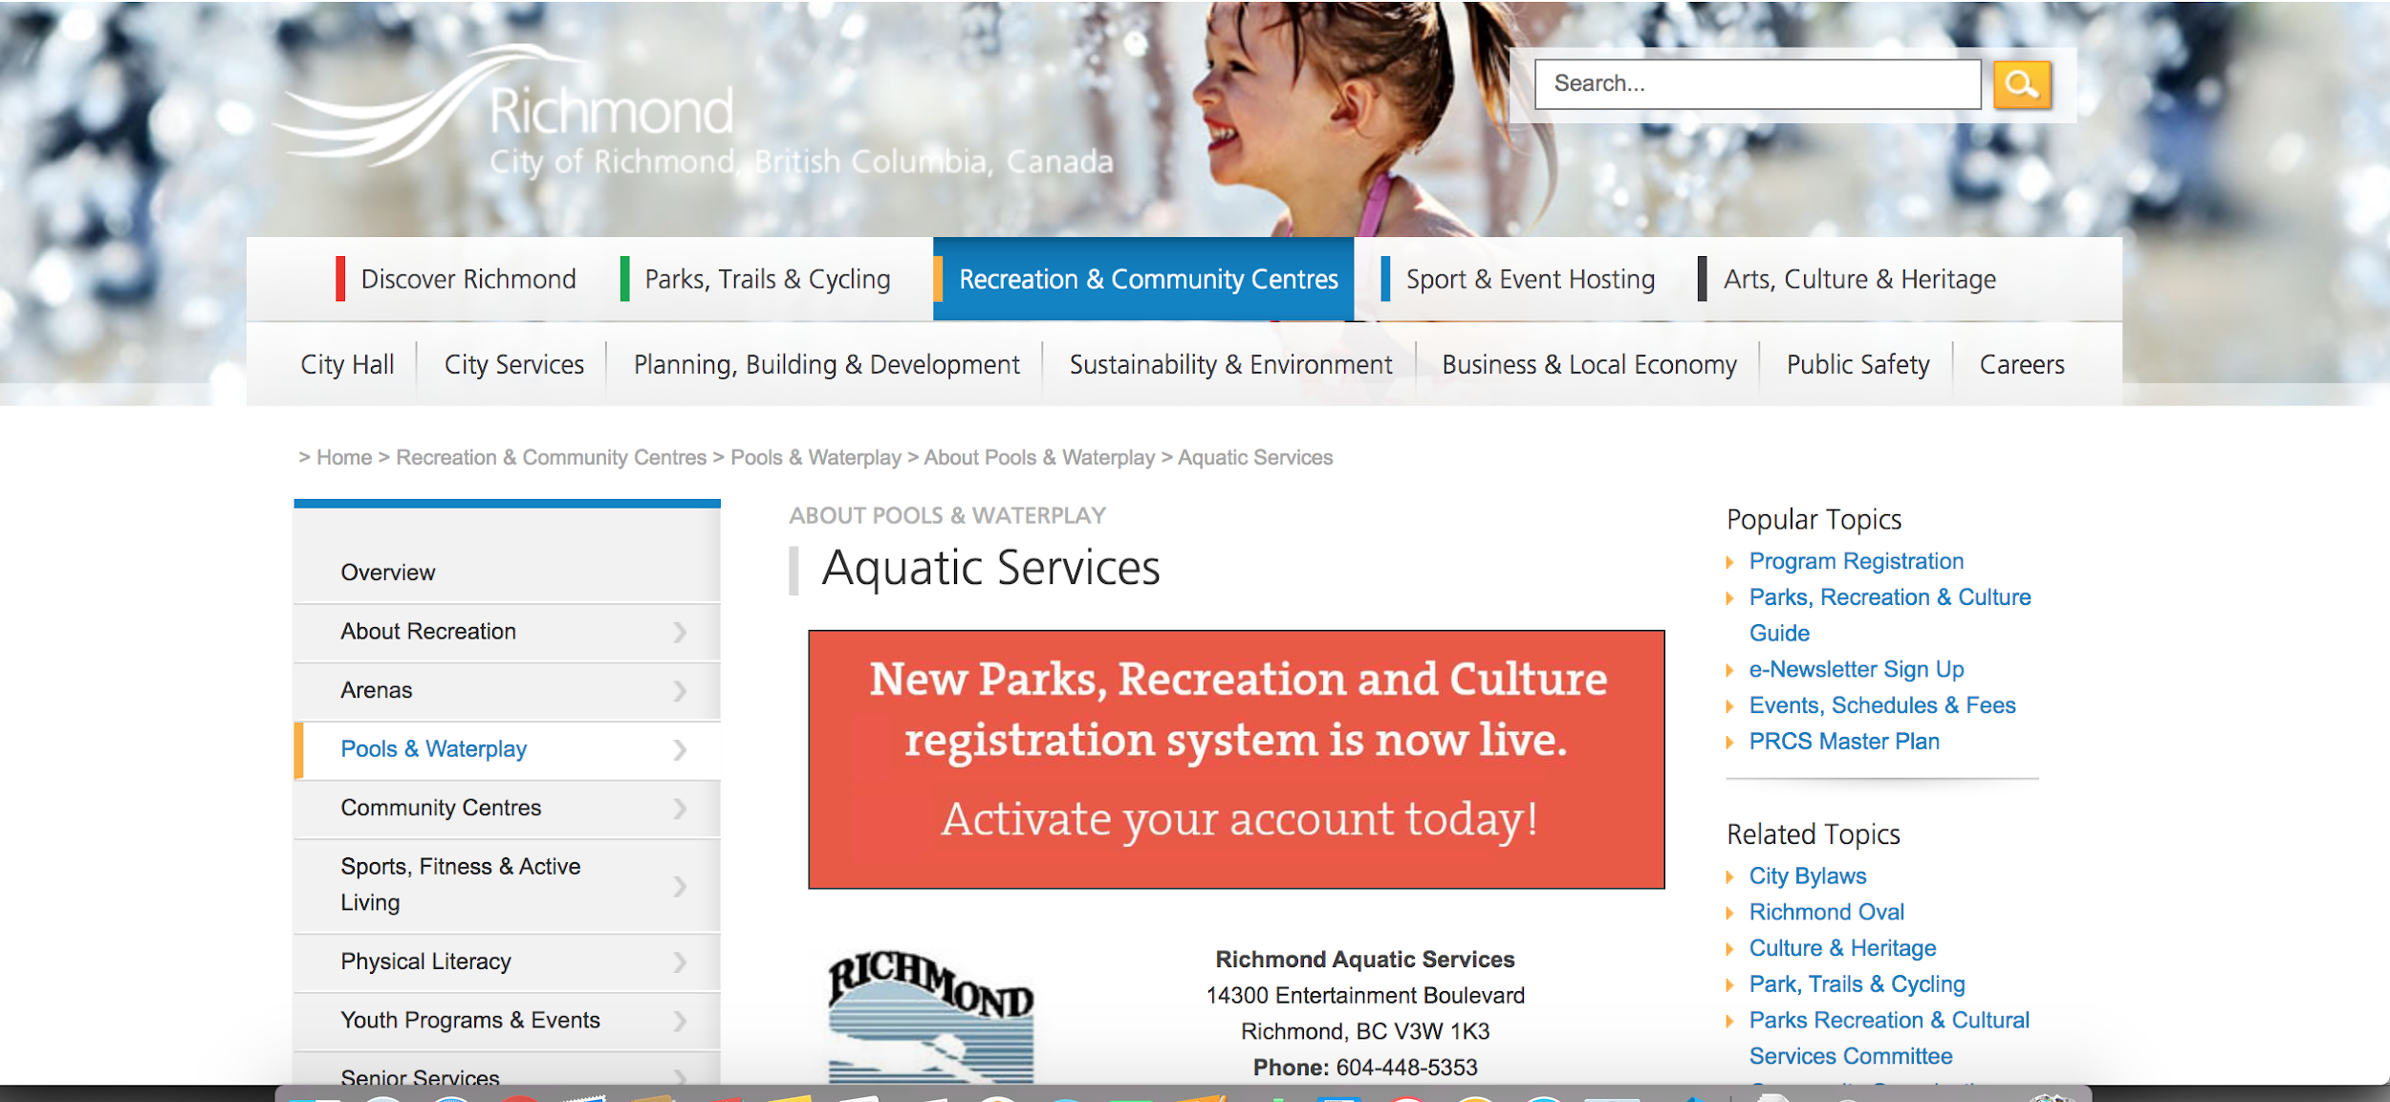
Figure 2. Current construction of the Richmond Aquatics website
- Increase of Richmond Aquatic staff members

(Still needs to be completed)

- Summary of findings

(STILL NOT COMPLETED)

- Most students and instructors of the program are aware that the program is extremely understaffed
- Most instructors feel like an added incentive will attract a lot more people to become a volunteer instructor for the program
- Instructors all agree that being understaffed means they are unable to teach the students effectively
J. Recommended solutions
- Allow volunteer instructors to skip the teaching section of the lifeguard interview process if they wish to become lifeguards in the future
- Promote the volunteer instructor position on the Richmond Aquatics website

