444 West 1st Ave

Vancouver, BC V6V 2B1

April 5th, 2017

Louise Cowin

VP Students

University of British Columbia

Vancouver BC, V4J 3J3

Dear Ms. Cowin,

Attached you will find my formal report addressing the needs of students for an increase in late night study space on the UBC campus. In creating this report I have addressed a subset of the student body and analyzed their needs for success. I believe that the proposed course of action as a result of this report will benefit all students.

The busy lives of students and taxing demands of university schedules cause students to have irregular schedules and often study late at night. At the date of submitting this report the UBC campus has only a single library open past 10:00pm on all days of the week. This library faces overcrowding issues and limited silent study space for those who choose to work individually.

This report addresses the extensive use of UBC libraries and the need for increased late-night study space. An increase in study space will be beneficial to students stress levels and academic performance. Decreasing stress in students is of utmost priority as prolonged exposure to stress can cause major health complications.

I have enjoyed creating this project for you and would be happy to answer any questions that you may have. I can be reached by my email at [edriver7@gmail.com](mailto:edriver7@gmail.com)

Sincerely,

Macintosh HD:Users:ericdriver:Downloads:1095823702472718040417.png

Eric Driver E.D.

***Libraries for Late-Night Study: A report addressing the needs of students at the University of British Columbia***

**for:**

Louise Cowin

VP Students

University of British Columbia

Vancouver, BC

**by:**

Eric Driver

English 301 Student

April 5th, 2017

***Table of Contents:***

Abstract ……………………………………………………………………………………………………. 4

Introduction ……………………………………………………………………………………………… 5-6

Methodology……………………………………………………………………………………………… 6-7

Data Section ……………………………………………………………………………………………… 8

*a) Current Library Use* ................................................................................................. 8-9

*b) Use of more space if provided* ………………………………………………………. 9

*c) Effects of Increased Space on Students* ………………………………………….. 10

*d) Type of Space Needed* ………………………………………………………………….. 11

Conclusions ………………………………………………………………………………………………. 12

Recommendations …………………………………………………………………………………….. 12-13

***Figures and tables:***

*Figure 1:* Use of library space……………………………………………………………………… 9

*Figure 2:* Effects of increased space ……………………………………………………………. 10

*Figure 3:* Preference for silent or group space …………………………………………….. 11

**Abstract**

The busy and irregular schedules of university students demand the need for equally irregular study schedules. Students require the necessary late-night spaces to complete this required studying and grant them the freedoms to work at all hours.

Current late-night study spaces are heavily used and overcrowded. They lack silent study space availability and provide limited options for different types of learners. Almost all UBC students make use of libraries to at least some extent and demand that more space be opened for them.

Ten question surveys were conducted on UBC students and data was compiled and analyzed to determine:

* Usage of current library space
* Use of more space if provided
* Effects of increased space on students
* Type of space needed

It was determined that libraries are heavily used by students and overcrowding is evident in the late hours. Students admitted to higher stress levels and decreased academic performance as a result of a lack of late-night study space. Through survey data, it was determined that the need for increased silent study space is greater than that of group study space, however an increase in both is desired by the student body.

***Introduction:***

The average University student has approximately fifteen hours of lecture per week plus or minus additional lab or tutorial time. Time spent in class encompasses only a small portion of the time dedicated to school with papers, lab write-ups, midterms, etc. taking up considerably more time outside of class hours. The busy schedules of students and tight deadlines of laborious assignments demand students to often study late into the night. The University of British Columbia Vancouver campus provides students with eight official library facilities for unrestricted use by students. Of these eight libraries only one of them is open past 10:00pm with two libraries closing before 7:00pm. With more than fifty thousand students attending UBC each year one library is not at all sufficient. This report aims to address the issue of a lack of late night study space that is available to students on the UBC campus.

Two working definitions are important for understanding the content of this report. “Study space” is defined as official UBC libraries with unrestricted student access. Meaning that any UBC student can use the space within the hours that the building is open. “Late-night” is defined as after 10:00pm. The study will be restricted to study spaces on the UBC Vancouver campus and will not address buildings with key cards or special permissions to students of a specific program.

This report serves the purpose of bringing the issue into the light of the UBC administration, in particular the VP Students Louise Cowin. This is an issue that not only increases the stress of UBC students, but may also affect their academic performance. This report will help to activate the proper mechanisms to create change on the Vancouver campus.

Data addressing the issue will be collected from students of UBC through short, anonymous, 10 question surveys. These surveys will analyze a number of topics including level of library use, level of late- night library use, stress level of students, projected use of additional late- night space, and type of space that should be added. Further research will be conducted addressing the current use of late-night study space and whether or not overcrowding issues are apparent.

Based on analysis of survey data as well as observations made of libraries on the UBC campus there is an unquestionable desire for an increase in late night study space from students. The majority of students surveyed agree that increased space would be beneficial not only to their stress levels, but also to their academic performance. High stress levels of university students can lead to both mental and physical health complications therefore stressing the importance of the cooperation of UBC administration to fulfill the desires of their student body and provide them with the resources that are needed for success.

*Methodology:*

Compilation of data was done through a ten-question survey conducted on ten UBC students distributed randomly across faculties and years of studies. Students were also selected with a variance in age and study habits (time spent studying per week). Examples of the variance within participants include a student in their seventh year of study in the pharmacy program as well as a first year student studying sociology. The only base requirement for participating in the survey was that the participant must be a UBC student enlisted in a full course load (5 courses) for the semester. Participants responded to the following list of statements, rating their agreement with each statement on a 1-5 scale:

1. I make use of the UBC campus library facilities
2. I study exclusively at UBC libraries
3. I believe that libraries in general do not have enough space for students
4. I have been kicked out of a library when it is closing
5. I would study later if libraries were open later
6. Having many study spaces open past 10pm would decrease my academic stress
7. Having study space open past 10pm would increase my grades
8. I think 1 library open past 10pm on weekdays is sufficient
9. I enjoy silent study space
10. I enjoy group work space

Additionally to these ten questions, participants were asked to rate their current stress level on a scale of 1-10 and were given adequate space to provide additional comments that they believed would be of use to the study.

Accompanying the completed surveys was research done visually by observing the level of use of Irving K. Barber learning center at 10:00pm. This was used to display the level of use of the only current late- night study space on the UBC campus.

***Data Section:***

Libraries on the UBC campus are heavily used by students and often face overcrowding issues. The research conducted on a small subset of randomly selected students suggest that a large increase in unrestricted, student- accessible study space is needed to satisfy the demands of a busy student lifestyle. Data collected addresses a number of issues:

a) *Current Library Use:*

The first objective the research was to prove that current library space is being used sufficiently by students. The conducted research shows that students are in fact using library space extensively and overcrowding of available space is evident. Figure 1a below shows the use of library space by UBC students based on collected survey data. Figure 1b shows the use of Irving K. Barber Learning Center at 10:00pm on a weeknight. As figure 1a and 1b indicate libraries are very heavily used in general and are particularly busy in the previously defined “late-night” hours. Figure 1a shows that 100% of survey participants make use of UBC library spaces to at least some extent with 70% recording a 5/5 agreement with the statement**.** Figure 1b shows no available tables on the 4th floor of the only campus library open past 10:00pm. This exemplifies the overcrowding of libraries and the need for an expansion of space.

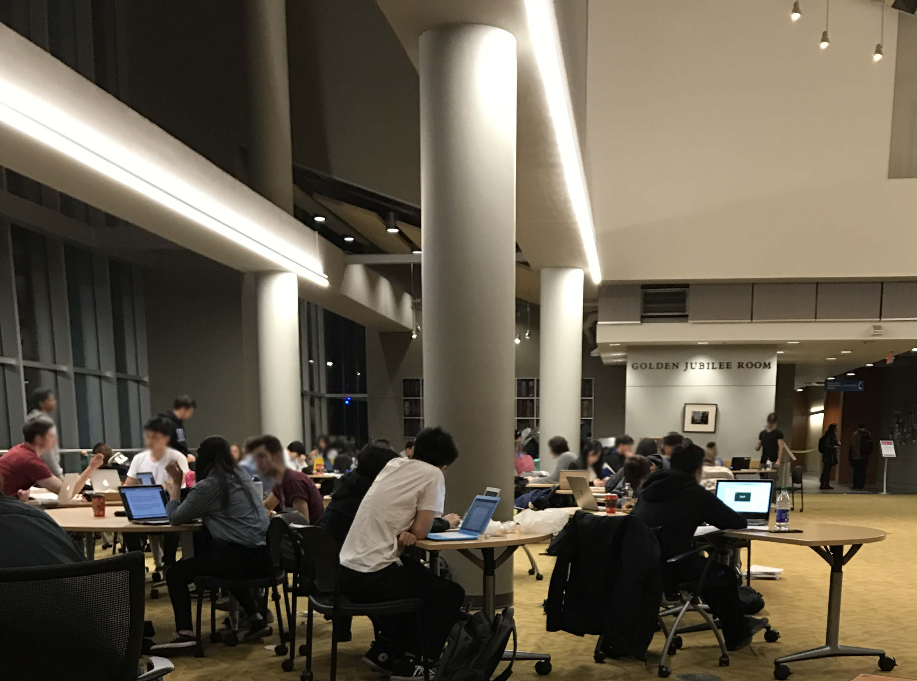

*Figure 1:* ***a***: Graph of students who stated that they make use of UBC library space. 5 indicates frequent use 1 indicates not use at all ***b***: Photo of Irving K. Barber Learning Center at 10:00pm on

March 1st, 2017.

b) *Use of More Space if Provided*

The second objective of research was to determine if students would utilize more late- night space if it were provided for them. 90% of students gave a score of 4 or higher to the statement “I would study later if libraries were open later.” This expressed desire signifies that libraries would continue to be well used by the UBC student body if they remained open later. 100% of students interviewed admitted to being kicked out of a library by security/ library staff during closing time. There is a clear need for more space and this also indicates that students are being interrupted in their studies and forced to relocate without completing tasks. Extending the hours of current libraries would resolve this issue and lead to greater productivity of students.

*c) Effects of increased space on students*

Not only would productivity of students increase with expanded late-night study space, but students also agreed that more late- night study space would decrease their overall stress due to school and increase their grades. 70% of survey participants gave a score of four or higher to a decrease in stress and an increase in their academic performance as a result of an increase in the amount of late- night study space. When asked what their current stress level is out of 10, 90% of students admitted to at least a 7 out of 10. Figure 2 (below) outlines the data collected from student surveys discussing the statistics presented.

*Figure 2:* **a:** Current level of stress as rated by survey participants. **b:** Student response of stress to increased late-night study space. **c:** Increased academic performance as a result of increase late-night study space.

d) *Type of space needed:*

The final objective of the research needed to prepare a recommendation on increases in late-night library space was to determine the type of space needed. With widely varying study habits between participants in the survey, preference for group study space and/or silent study space was determined through two survey questions. Participants were asked to rate how much they enjoyed group study space and how much they enjoyed silent study space on a scale of 1-5. These results were summed and displayed in Figure 3 below. Figure 3 shows that students have a preference for an increase in silent study space but that group study space is still desired. The limited amount of silent study space open is represented by this comment from one survey participant: “There is currently only 1 small room of silent study space open past 10pm at UBC unless you have after hours access to your faculties building.” The room that the participant is speaking of is the Nass Reading Room in the Irving K. Barber Learning Center and has a capacity of approximately 40 students. It is currently the only space on the UBC campus for students who prefer a silent study space past 10:00pm.

*Figure 3:* Survey results from participants when asked if they prefer silent study space or group study space.

***Conclusions:***

Libraries on the UBC campus are heavily used by students and suffer from overcrowding issues. Aside from regular overcrowding during the day, the University of British Columbia provides its students with a single library for late-night study with a very limited amount of silent study space available. This issue has been clearly identified and expressed through survey results obtained from a random selection of the student body. Students believe that an increase in late-night study space will give them greater flexibility in their studies, reduce their stress and even increase their academic performance. A decrease in stress on students should be the focus of UBC administration when planning campus resources as excess stress is known to cause “frequent headaches, insomnia, trouble learning new information, difficulty making decisions etc.” (American Institute of Stress)**.** Prolonged stress is detrimental to student health and must be dealt with in a serious manner.A particular need for increased late-night silent study space was identified with a subordinate need for an increase in group study space.

***Recommendations:***

In light of the data collected from students and visual observations of study space, this has become a real issue for UBC students and needs resolving. Two main recommendations are feasible to resolve this issue:

* Extend the hours of Irving K. Barber to 24/7
* Extend the hours of the Koerner Library to at least 1am.

These two recommendations will amend the main issues presented in this report. Koerner library consists mainly of silent study space, which will increase the extremely limited amount of silent study space in Irving K. Barber learning center. This would also nearly double the current capacity of late-night study space for students. Extending the hours of Irving K. Barber learning Center will allow students the flexibility to study at all hours of the day (and night) if needed and will provide both group and silent study space to do so. These two recommendations will provide students with the flexibility of study hours that they require.

***References:***

Boyd, D., Boyd, D. and Boyd, D. (2017). *Newhome*. [online] The American Institute of Stress. Available at: https://www.stress.org/ [Accessed 4 Mar. 2017].