INTRODUCTION:

The objectives of this assignment are to appreciate the importance of definitions in technical writing, understand how audience and purpose indicate the need for definition, differentiate between the levels of details in definition, and select the right level of detail according to the situation. The criteria for this assignment include choosing a complex term used in your profession and composing a parenthetical definition, a sentence definition and an expanded definition. The situation and audience I chose for this exercise is a dental hygienist explaining to her patient what a root canal procedure is. I am a dental hygienist and I encounter situations regularly where I have to explain a dental procedure to my patient. In this case, my patient was told she needs a root canal and it is my responsibility to help her understand what that means.

ROOT CANAL PROCEDURE

A root canal (removing the nerves inside the tooth) is the recommended treatment option when there is significant damage to the nerve supply of a tooth. A root canal is a treatment performed by a dentist when the nerve supply must be removed. This process involves drilling into the tooth, removing the nerve supply and filling the tooth.

What is a root canal?
“A root canal is also referred to as endodontic treatment. “Endo” is the Greek word for “inside” and “odont” is Greek for “tooth.” Endodontic treatment treats the inside of the tooth” (American Association of Endodontists, 2020, para. 1). However, the term “root canal” is more commonly used.

To better understand this procedure, lets first compare a healthy tooth versus infected in figure 1 and 2:

Figure 1. Healthy tooth (CDA, 2020). Figure 2. Infected tooth (CDA, 2020).

Why do you need a root canal?
The red tissue in these images is the pulp chamber/tissue. The pulp is the nerve supply of the tooth. If the pulp is damaged from either infection or trauma it needs to be removed or the infection can spread.
How do you know if you need a root canal?
If you have any of the following symptoms you might need a root canal:
- Persistent pain
- Chipped or cracked tooth
- Lingering sensitivity to hot or cold
- Swollen gums
- Dark discoloration of tooth
- Deep decay. (Forest Park Dental, 2018, para. 1-7)
What steps are involved?
- You will be given local anesthetic (freezing) to numb the tooth so you do not feel pain during the procedure
- The dentist drills a small hole on the biting surface of the tooth
- The decay/dead tissue is removed from the pulp and root canals
- The empty root canals are cleansed with an antibacterial (to kill the bacteria)
- Filling material (gutta percha) is placed and fills the canals and pulp chamber
- The access hole on the surface of the tooth is sealed and temporarily closed with a filling
- Later, a permanent crown (cap that covers the tooth) is placed to provide extra protection against another infection. (Largeman Dental, 2017)

Figure 3 illustrates the main steps in the root canal procedure:

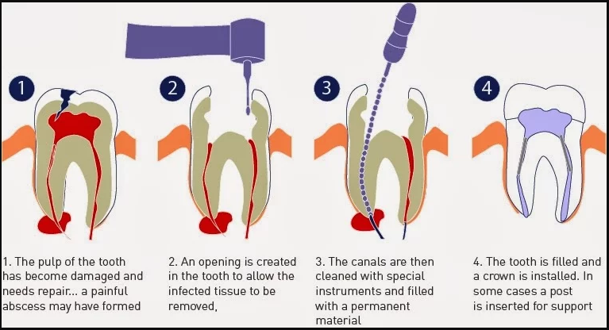
Figure 3. Root Canal Procedure. (St Lawrence Dentistry, 2020).

Conclusion:
A root canal procedure is necessary when the inside of the tooth (the nerves) have been damaged. Either by decay, trauma or a cracked tooth. If you leave the infected/damaged tooth as is and do not get a root canal there is the risk the infection will spread and cause more damage in the future.
References

American Association of Endodontists. (2020). Root Canal Explained. https://www.aae.org/patients/root-canal-treatment/what-is-a-root-canal/root-canal-explained/

CDA. (2020). Healthy tooth. Retrieved from http://www.cda-adc.ca/en/oral_health/talk/procedures/root_canal/default.asp

CDA. (2020). Infected tooth. Retrieved from http://www.cda-adc.ca/en/oral_health/talk/procedures/root_canal/default.asp
Forest Park Dental. (2018). 7 Common signs you need a root canal. https://forestparkdental.com/7-common-signs-you-need-a-root-canal/

Largeman Dental. (2017).Need a Root Canal? Here's a Step-by-Step Guide on What to Expect. https://www.largemandental.com/blog/post/need-a-root-canal-heres-a-step-by-step-guide-on-what-to-expect.html
St Lawrence Dentistry. (2020). Root Canal Procedures Can Save Teeth. https://www.stlawrencedentistry.com/root-canal-treatment/

