Casual Analysis for Improving Ergonomics
and Pain Management of the Employees
at Viewmount Dental Centre

For
Dr. Irina Smirnova
Doctor of Dental Surgery
Viewmount Dental Centre
Ottawa, Ontario

By
Erin Mungham
Technical Writing Student
University of British Columbia

December 1, 2020
272 Citiplace Drive
Ottawa, ON K2E 0A9
December 1, 2020
Dr. Irina Smirnova
Owner of Viewmount Dental Centre
Ottawa, ON K2E 7T5

Dear Dr. Smirnova:
Here is my report, Casual Analysis of Improving Ergonomics and Pain Management for the Employees at Viewmount Dental Centre. In preparing this report, I have learned a great deal about the reasons for poor ergonomics in a dental career and methods to improve and manage work-related pain. I believe my information will help other dental professionals as well. Thank you for your guidance and support throughout this process.
Working in the dental field is a highly rewarding job but also a physically demanding job. With proper ergonomics and frequent pain management techniques the dental professional can have a long and enjoyable career.
I’ve enjoyed my work on this project and would be happy to answer any questions you may have. Please phone at 613-204-5657 or email at munghame@student.ubc.ca anytime.
Sincerely,

Erin Mungham

Table of Contents
Abstract 1
Introduction 2
Data Section 3
Reasons for Poor Ergonomics 3
Time constraints. 3
Repetitive movements. 3
Lack of frequent breaks. 3
Prevalence of Musculoskeletal Diseases for Dental Professionals 4
Work-related pain. 4
Frequency of pain. 5
Impact Pain and Poor Ergonomics Has on a Dental Career 6
Reduced career longevity and productivity. 6
Ergonomically Designed Dental Equipment 7
Type of ergonomic equipment. 7
Market availability. 7
Ease of use and implementation. 7
Pain Management 8
Pain management techniques. 8
Cost of pain management techniques 9
Pros of health benefits for dental professionals. 10
Cons of health benefits for dental professionals 10
Conclusion 10
Summary of Findings 10
Interpretation of Findings 10
Recommendations 11
Works Cited 12
Appendix A: Survey Questions 13
Appendix B: Interview Questions 15

Abstract
Dental professionals need improved ergonomics and pain management in order to prevent musculoskeletal disease and increase career longevity.
The majority of dental hygienists, dentists and dental assistants will experience a high degree of joint or muscle pain throughout their career. The reason the employees at Viewmount Dental Centre have poor ergonomics and significant joint and muscle pain is because of the fast-paced work environment, no time for breaks, repetitive movements when performing procedures, and lack of medical benefits. These factors combined cause the deterioration of musculoskeletal health and reduce career longevity.
Ergonomically designed dental equipment can help relieve the muscle tension for the dental professional and improve their quality of work and life. There is a wide variety of ergonomically designed equipment that can be used in a dental office setting. This equipment is easy to use, implement and purchase.
Anyone with the ability to help improve ergonomics and pain management for dental professionals should follow these recommendations:
- Increase the number and length of breaks throughout a shift
- Implement ergonomically designed dental equipment into the office
- Consider offering the employees health benefits
- Provide monthly massage/physiotherapy/chiropractor allowances for the employees

Introduction
Poor ergonomics and physical pain will negatively impact the dental professional’s career because they will become mentally and physically exhausted. The major implications for this problem are three: first, dental professionals will have to seek alternative career opportunities; second, the business will suffer due to disability leave and trying to find replacements for employees; third, the constant pain and lack of health benefits will be destructive on the employees mental health and work productivity.
One possible solution to the problem of poor ergonomics and physical pain of the employees at Viewmount Dental Centre is to have small breaks after each appointment. Most appointments are 60 minutes and if there is a 10-minute fallow time for each appointment that will give the employee the chance to rest their muscles and stretch. Knowing that they have this extra time will also help them feel less stressed during the appointment and be able to focus on proper posture.
Dental professionals interested in improving ergonomics and pain management need answers to these questions:
- What have other dental professionals done to help with pain management?
- What products are on the market to improve ergonomics?
To help answer these questions, this report analyzes information gathered from dental professionals and literature. The analysis examines reasons for poor ergonomics, prevalence of musculoskeletal diseases for dental professionals, impact on career, ergonomically designed dental equipment and pain management options.

Data Section

Reasons for Poor Ergonomics
Dental professionals need to be able to understand the reason for poor ergonomics in order to make a change.
Time constraints. Dental appointments are often no longer than sixty minutes to provide patients with increased availability of appointments and reach office production goals. This strict time limit for appointments make the dental professional feel rushed and under pressure. A registered dental hygienist that has been working for 2.5 years stated that, “Always feeling rushed at work adds a lot of stress on us and it is hard to think about my own proper posture when I am so focused on the time” (personal interview, November 17, 2020).
Repetitive movements. A meta analysis conducted by Lietz et al. found that, “Working in the same position longer than 40 minutes significantly increased the odds of musculoskeletal pain” (2018). Specifically, for dental hygienists, they are performing the same movements for hand scaling, using ultrasonic and polishing throughout the day. One study indicated that, “An increasing number of hours of cleaning teeth increased the odds of neck pain” (Lietz et al., 2018).
Lack of frequent breaks. In most dental offices there will be a scheduled 60-minute lunch break. However, there are often no smaller breaks implemented throughout the day. A study examined in the previously mentioned meta analysis, reported that, “Having no breaks between interventions significantly increased the odds of musculoskeletal pain. Therefore, the work schedule appears to have an important influence on the prevalence of musculoskeletal diseases and pain.” (Lietz et al., 2018).

Prevalence of Musculoskeletal Diseases for Dental Professionals
Primary research includes a survey to gather information from 28 dental professionals (see Appendix A) and personal interviews with registered dental hygienist, Melanie Barbeau, and dentist, Dr. Irina Smirnova (see Appendix B). Secondary sources include publications on cost of pain management therapies, a literature review of the prevalence of musculoskeletal diseases and pain among dental professionals by Lietz et al and a literature review of a report discussing chronic musculoskeletal pain for dental hygienists by Chismark et al.
Work-related pain. A survey to collect primary data to determine the type of pain dental professionals experience shows out of the 28 participants, back pain, neck pain and wrist/hand pain are the most common with 85.7% experiencing back pain (see fig. 1).
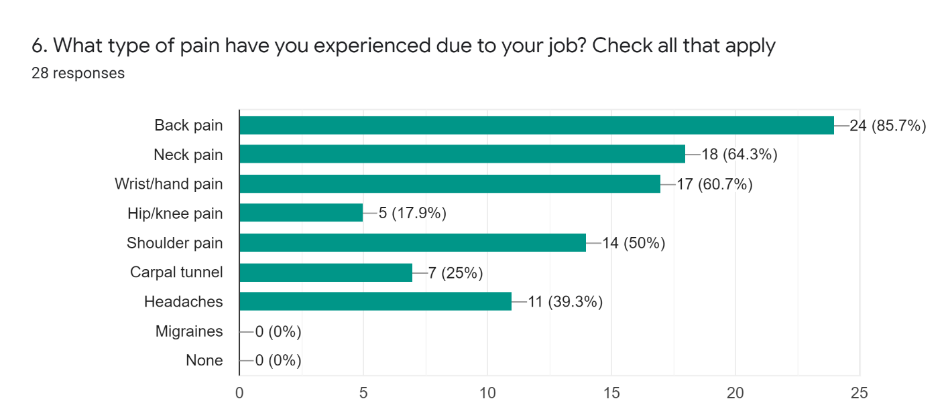
Fig. 1. Type of Pain Experienced Due to Job
This survey also shows that all of the participants experience some degree of work-related pain as 0% said they had no pain.
Frequency of pain. How often pain is experienced will have a significant effect on the dental professional’s work productivity and well-being. Figure 2 shows that 17.9% of participants experience work related pain daily, 39.3% weekly and 42.9% monthly.
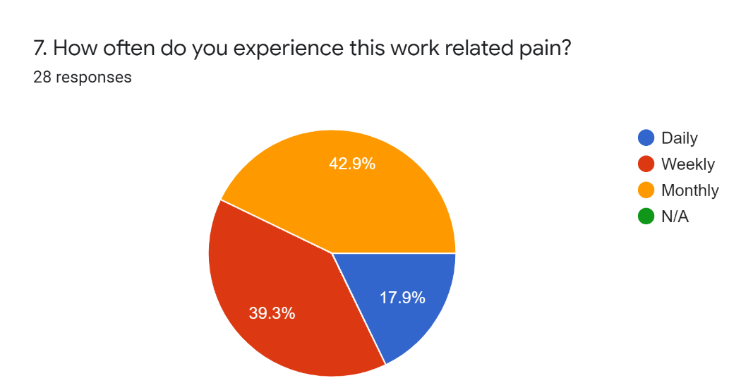
Fig. 2. Frequency of Work-Related Pain
Lietz et al. include 30 studies in their review and a meta-analysis is carried out to determine prevalence rates for musculoskeletal diseases and pain for dental professionals. This analysis states that, “In most of the studies, the prevalence rates were high (above 60%)” (Lietz et al., 2018). The annual prevalence of neck pain was between 29.1% and 84.8%, back pain in general showed annual prevalence rates from 26.7% to 57.1%, lower back pain was higher and ranged from 28.5% to 74.9% and shoulder pain had annual prevalence rates between 6.1% and 69.6% (Lietz et al., 2018).

Impact Pain and Poor Ergonomics Has on a Dental Career
Findings from primary and secondary research help to assess the impact pain and poor ergonomics have on a dental professional’s career.
Reduced career longevity and productivity. In the primary survey conducted, on average, participants work between 7-10 hours a day. The average break time ranged from just 15 minutes to 1hr. When asked, “If you work a 12-hour shift do you get more breaks than if you work an 8-hour shift” 53.6% said no. If dental professionals continue to have busy workdays with infrequent breaks and poor posture this will shorten their career. For example, it is unrealistic to expect a dental hygienist, to work a 12-hour shift with 1-hour lunch break and perform tasks as adequately if she/he worked an 8-hour shift with a 1-hour lunch break. Increasing the length and frequency of breaks will improve ergonomics which will, in turn, improve career longevity and productivity.
Chismark et al. examines a study that states, “Thirty-one percent of dental hygienists reported they work less now compared to the past as a result of musculoskeletal discomfort caused by hand and neck pain” (2011). It was also noted that, “Dental hygienists have reported work stress and burn-out caused by musculoskeletal disorders, long working hours and working without an assistant. Some have chosen to leave the profession because of their musculoskeletal pain” (Chismark et al., 2011).
These studies show the effects working long hours with minimal breaks has on the body. Over time, if poor ergonomics and work-related pain are not recognized as a risk factor for work stress and burn-out for dental professionals, their career spans will continue to shorten. This also could have a detrimental impact on dental offices from a business perspective due to employees either needing disability leave or quitting their job.

Ergonomically Designed Dental Equipment
Ergonomically designed dental equipment can help the dental professional have better posture which will reduce muscle fatigue and pain.
Type of ergonomic equipment. The following are examples of dental equipment that have helped the dental professionals that were surveyed and interviewed to reduce pain:
- Saddle stools
- Dental loupes
- Standing desks
- LED patient lights
- Lightweight and larger handled instruments
Market availability. Based on the interviews and surveys conducted, ergonomic dental equipment is widely available. For instance, several responses indicate that a saddle stool or any operator chair with ergonomic components to it would be beneficial and can be purchased from a dental supply company, a retail store or Amazon. Melanie Barbeau, RDH, says “Saddle stools help improve posture, they’re more comfortable and more lightweight than a typical operator chair. I found mine for only $100 on Amazon and it ships very fast, so it is not a long wait to receive the stool” (personal interview, November 17, 2020). With multiple different retail and dental supply companies on the market, finding ergonomically designed equipment is fast and easy.
Ease of use and implementation. Due to the simplicity of the ergonomically designed equipment previously mentioned, implementation of the product into the dental office is straightforward.

Pain Management
Finding ways to manage and reduce work-related pain will drastically improve the dental professional’s productively and career longevity.
Pain management techniques. Figure 3 identifies the pain management techniques used by the participants of the survey. The results show that even though stretching is the most common pain management technique used, seeking the help of other healthcare professionals such as chiropractor, massage therapists and physiotherapists are also of importance.
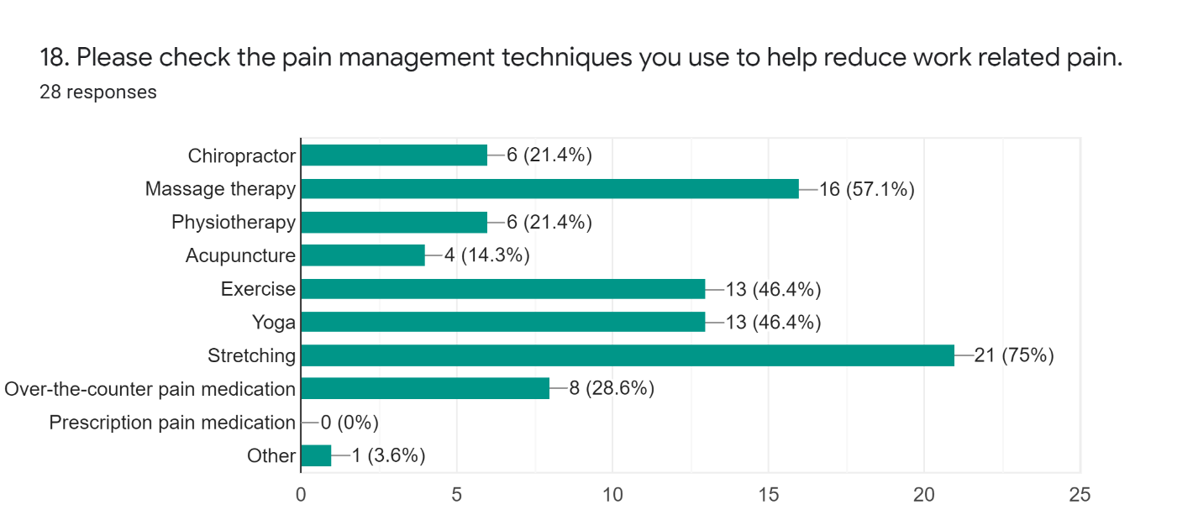
Fig. 3. Pain Management Techniques
Melanie Barbeau and Dr. Irina Smirnova both agreed that massage therapy has helped them the most in relieving pain. Ms. Barbeau even went on to say that, “Sometimes I will get this severe pain in my right shoulder that radiates to my neck and the only way it goes away is after I see a massage therapist” (personal interview, November 17, 2020). Dr. Smirnova explains, “Since starting my career, I have developed upper back and neck pain that radiates down to my arms. Massages help to improve the pain” (personal interview, November 19, 2020).
Cost of pain management techniques. Stretching is the most common pain management technique among dental professionals due to its convenience and no associated cost. However, the pain management interventions with more long-term benefits and that aid in recovery are more costly. For example, below are the average prices for pain management services in Ontario:
- 60-minute massage is $103 (RMTAO, 2020).
- 60-minute physiotherapy session is between $95-$120 (FSCO, 2019).
- Initial chiropractic visit is approximately $95 and subsequent appointments $55 (Dr. Barb, 2015).
It is uncommon for a dental professional to receive health benefits from their employer so these pain management techniques would have to be paid out-of-pocket. The high cost of these services, the frequent need for them, and the lack of medical benefits are reasons that limit the access of pain relief therapies to the dental team.
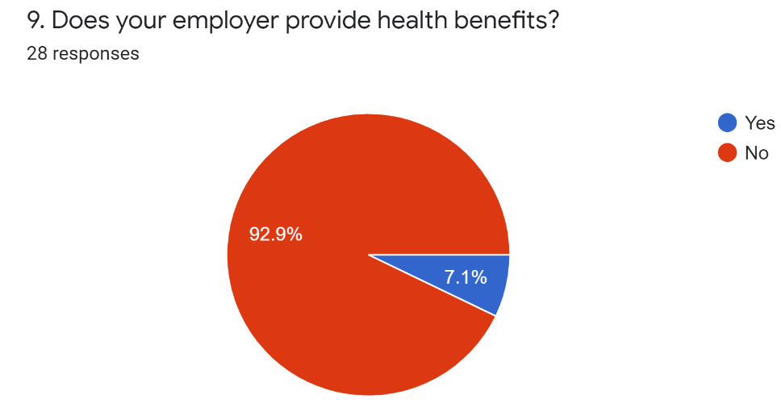
Health benefits provided from employers. If the dental team received health benefits from their employer, it would give them a higher chance of recovering from work related pain. Having health benefits could also help prevent pain from occurring or worsening as well. Figure 4 shows that 92.9% of the survey participants do not receive health benefits from their employer.

Fig. 4. Health Benefits
Ms. Barbeau stated that, “It is crazy we talk to our patients all day about how important prevention is in regard to periodontal disease, yet we can’t prevent musculoskeletal diseases for ourselves because the lack of health benefits” (personal interview, November 17, 2020).
Pros of health benefits for dental professionals. When asked during the interview process what the pros of dental professionals receiving health benefits are, Ms. Barbeau and Dr. Irina Smirnova both said to prevent and treat pain.
Cons of health benefits for dental professionals. The response for what the cons are to providing health benefits were cost related. Firstly, it would cost the employer more money to provide benefits to the employees. Secondly, the employees would receive a smaller pay cheque due to a certain amount of money going directly towards paying for the benefits.

Conclusion

Summary of Findings
Dental professionals are at high risk for developing musculoskeletal disease and facing challenging barriers to help treat and relieve the pain. The pain develops from lack of frequent breaks, time restraints, poor posture, and repetitive movements. The job requirement comes with repetitive movements and constant time constraints due to set appointment times but there are options available to improve ergonomics and alleviate work related pain.

Interpretation of Findings
The work schedule has a significant influence on reducing musculoskeletal pain for the dental team. Since the employees cannot stop doing their job specific tasks, they will need to find options they can implement to make it easier. For example, short 10-minute breaks after each appointment to stretch can make a huge difference. Also, ensuring that workdays that are 12 hours do not have the same break schedule as an 8-hour shift can help the employee with pain management.
Implementing ergonomically designed dental equipment in the office will have a great impact on the employee’s well-being and career longevity. This equipment is readily available on the market and will not put the business in a financial hardship. Equipment such as saddle stools, larger grip dental instruments, lightweight instruments, LED lights, and loupes are all examples that will help improve the dental professional’s posture which will ultimately lead to pain relief.
The best pain management options are massage therapy, physiotherapy, chiropractor, stretching, and exercise. With better access to some of these costly options by the means of health benefits, the dental professional can increase the likelihood of recovering from musculoskeletal pain.

Recommendations
If your interests and abilities match the requirements to improve ergonomics and pain management for dental professionals, consider these suggestions:
- Increase the number and length of breaks throughout a shift
- Inquire about the dental team’s interest in ergonomically designed dental equipment and initiate a plan of action to implement the equipment into the office
- Consider offering the employees health benefits to help provide them with access to pain management therapies
- Provide monthly massage/physiotherapy/chiropractor allowances for the employees if offering health benefits is not possible

Works Cited
Lietz, Janna, et al. “Prevalence and Occupational Risk Factors of Musculoskeletal Diseases and Pain Among Dental Professionals in Western Countries: A Systematic Literature Review and Meta-Analysis” PLOS ONE, vol.13, no.12, 2018, pp.1-26. DOI:10.1371/journal.pone.0208628

Chismark, Aubree, et al. “Use of Complementary and Alternative Medicine for Work-Related Pain Correlates with Career Satisfaction Among Dental Hygienists.” Journal of Dental Hygiene, vol. 85, no.4, 2011, https://go-gale-com.ezproxy.library.ubc.ca/ps/i.do?p=HRCA&u=ubcolumbia&id=GALE|A278509755&v=2.1&it=r&sid=summon
Barb. Chiropractic for Life. 2015, http://doctorbarb.com/fees/. Accessed 26 November 2020.
RMTAO. Massage Therapy Services and Fees. 2020, https://www.rmtao.com/massage-therapy/services-and-fees. Accessed 26 November 2020.

FSCO. Professional Fees Guideline- Physiotherapists. n.d. https://www.fsco.gov.on.ca/en/auto/autobulletins/archives/Documents/a-12_97-1.pdf. Accessed 26 November 2020.
Barbeau, Melanie. Personal interview. 17 November 2020.

Smirnova, Irina. Personal interview. 17 November 2020.

Appendix A: Survey Questions
Survey Introduction:
I am an undergraduate student at UBC engaged in a technical writing project. The purpose of this survey is to obtain primary data for an analysis and investigation that aims to provide recommendations for improving ergonomics and pain management for dental professionals. The final formal report will be addressed to Viewmount Dental Centre staff and other dental professionals. Together with the information available from publications, the data I gather from this survey will serve the ultimate purpose of providing recommendations for improving ergonomics, career longevity and overall well-being for dental professionals. The survey contains 15 questions, and it should take about than 5 minutes of your time. Your responses are voluntary and anonymous. Thank you, I appreciate your generous participation in my survey.
Survey questions:
- What is your job title?
________________________________________________________________________
- How long have you had this job title?
___ 0-3 years ___ 4-7 years ___ 8-10 years ___ 10-15 years ___ 15+ years
- Since you have been working in this field have you thought about alternate career opportunities?
___ yes (Please briefly describe why.) ________________________________________
___ no
- Number of employees at your office. (please check one.)
___0-4 ___5-10 ___10-15 ____15-20 ___20+
- What type of pain have you experienced due to your job?
(label by frequency: daily/weekly/monthly/never)
______ back pain _____ hip/knee pain ____none
______ neck pain _____ headaches
______ wrist/hand pain _____ migraines
______ carpel tunnel _____ shoulder pain
- Please rank the severity of physical pain you experience due to your job (from 1-10, 10 being the worst)
____
- Does your employer provide health benefits?
___ yes ___ no
- If yes, what service do you use the most often?
___ chiropractor ___ massage therapy ___ physiotherapy ___ acupuncture __n/a
- Has your office implemented any ergonomically designed equipment? Please describe.
___ yes (Please describe briefly.) ____________________________________________
___ no
- Has this ergonomically designed equipment helped with improving muscle/joint pain?
___ no ___ somewhat ___ yes ___n/a
- Please list the reasons why ergonomically designed equipment have not been introduced to your office.
___ cost
___ lack of product knowledge (which one to get)
___ unsure of where to buy it from
___ not needed
___ we do have ergonomically designed equipment
- How many hours do you work each day of the week?
Mon: ____ Tues:____ Wed:____ Thurs:____ Fri:____ Sat:____ Sun:____
- On an average shift, how many breaks do you get and how long are they?
# of breaks: ____
length of breaks: ____
no breaks: ____
- If you work a 12-hour shift do you get more breaks than if you work an 8-hour shift?
___ yes ___ no
- Please check the pain management techniques you use to help reduce work related pain:
___ chiropractor
___ massage therapy
___ physiotherapy
___ acupuncture
___ exercise
___ yoga
___ stretching
___ over-the-counter pain medication
___ prescription pain medication
___ other (please describe.) _________________________________________________

Appendix B: Interview Questions
Interview questions:
- How long have you been working as a dental professional and what is your specific job title?
- Out of the known musculoskeletal health issues that arise for dental professionals, which do you think is the most common?
- Have you experienced any physical pain since starting this career? Please explain.
- What are some of the ways you have managed physical pain since starting your career?
- What are some the factors that add stress to the staff working in a dental office?
- What are some ways to reduce stress in the workplace?
- In your opinion, why do you think most dental offices do not provide health benefits?
- What are the pros and cons of having health benefits for dental professionals?
- What are some ergonomically designed dental equipment options to implement at a dental office?
- Out of the ergonomically designed dental equipment on the market, what do you think would be the most beneficial for the dental team?

