Graphing Linear Functions and Quadratics with NetLogo (Grade 10 Exercise)
- From the File menu, open Models Library, then open the Mathematics folder and from within the Mathematics folder, open “Pursuit”.
- On the left side of the screen are sliders, switches and buttons. Try clicking on the random button and then the button labelled ‘go’. Repeat this step again. Did the same thing happen or something different?
- Spend a few minutes trying out various combinations of the buttons. Work with your partner to generate ideas about what the coloured curves are trying to show you.
- Once you have a couple of ideas, share them with two other groups and come to a consensus.

*** Pause for class discussion ***

- We have been working on linear functions and just touched on quadratic functions. Click on the tab at the top labelled “Code” – try to resist the urge to change everything! Scroll down until you see something that looks like a list of functions and their equations (like the picture below).

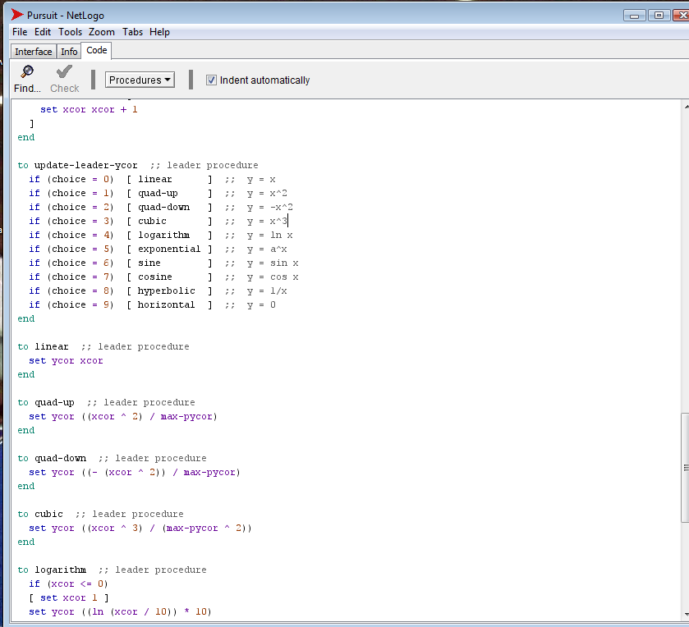

What do you notice about linear, quadratic and cubic functions? What is similar, what is different? There might be some symbols in the other functions that you aren’t familiar with, but take a look at them, too. What do they all have in common? How are they different?
- Discuss with your partner: What makes a linear function linear? How can you tell from the graph? How could you tell from the equation? Share your hypothesis with a couple of other groups and see if you can come to a consensus.

*** Pause for class discussion ***

- Farther down in the code, the actual code to graph the functions is shown. For example, the “to linear” paragraph tells the program to graph a linear function. “Set ycor xcor” means set the y-coordinate equal to the x-coordinate, or y = x. If you wanted to graph y = 0.3x + 2, you would tell the computer “set ycor (xcor * 0.3 + 2)”. There have to be spaces between the multiplication and addition signs and the numbers. Make a change and then go back to the interface tab and click on linear and hit go. Did anything change?
- How does adding or subtracting a number at the end of the equation change the graph?
- How does multiplying or dividing by a number change the graph?
- Share your results with a couple of other groups and see if you can come to a consensus.
- Once you have a consensus, go back and use screen shots/captures and records of the variables you changed with each scenario to support your theory.
- Use your new theory to graph 3 linear equations – you create the equations and graph them by hand (use a ruler!). Clearly label at least 5 points on the graph.

