Final Project
Unicode: Linguistic Diversity in Digital Writing Spaces

Marwa Kotb
ETEC540 (65B)
Text Technologies: The Changing Spaces of Reading and Writing
Introduction
The representation of the world’s writing systems has been a significant challenge in the technology world. Until the early 1990s, the English alphabet was the only standard, and only a few non-English alphabets and diacritics could be used or viewed within one’s computing system (Crystal, 2011). If there was a file of foreign words with an odd sequence of codes that weren’t recognized in the computing system (for example, if you opened a Japanese document from an American computer), the text would be completely disregarded; the user would see weird blanks, question marks, or boxes instead. This is still possible, but things have progressed significantly since the birth of Unicode (Crystal, 2011).
What is Unicode
Unicode is a world-wide character encoding standard that provides “a unique number for every character, no matter what platform, device, application, or language” (Unicode, 2017, July 24, para.7). It is “developed [and maintained] by the Unicode Consortium, a group of companies and institutions with interests in international text-encoding and computing applications” (Bigelow & Holmes, 1993, p.289).
In computer systems, characters (i.e., any significant writing unit) are stored in binary numbers. For characters representation and display, the system uses a code chart which tells, for example, the code number 68 in decimal (i.e., 0X44 in base 16 hexadecimal; U+0044 in the Unicode) represents ‘D’ (see figure 1). Having a unique pattern for each character have “eliminate[d] the problem of having to keep track of which of many different characters this specific instance of a particular bit pattern is supposed to represent.” (Gillam, 2003, “Chapter 1. Language, Computers, and Unicode”, para.23).
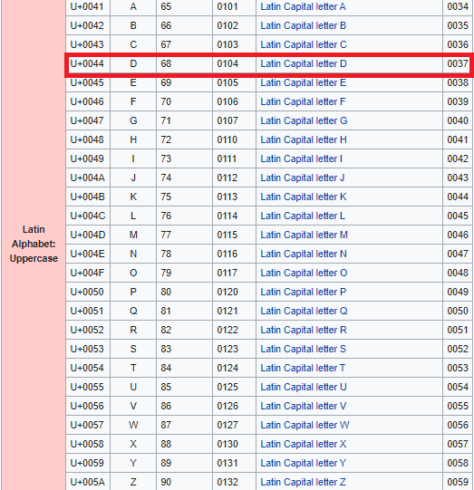
Figure 1: Web capture of Unicode Latin alphabet-upper-case (Wikipedia, 2021, March).
From telegraph to Unicode
Encoding systems had started long before the advent of the modern digital computer (Gillam, 2003). The beginning was with Samuel Morse code used to transmit messages via telegraph lines in 1837 (Gillam, 2003). The code set used two types of signals: A long “on” (i.e., dash) and a short “on” (i.e., dot) (see figure 2).
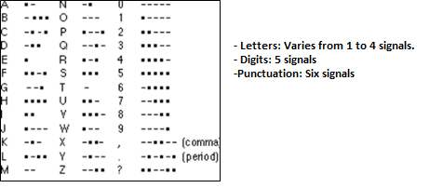
Figure 2: Subset of Morse code (Searle,2004, August 6).
The main problem of Morse code was the variant length of encoding that didn’t fit with the systematic mechanized process needed to place the characters on paper at the time (Gillam, 2003). A major step in this direction was Emile Baudot’s printing telegraph, invented in 1874; his code set was a combination of five keys (i.e., equal length), you may think of as a 5-bit code (Gillam, 2003). This means that it can afford up 32 combinations (2⁵) which were insufficient even to combine letters and digits. Thus, he created two separate sets of character encodings and assigned them different switches (i.e., control characters) to revert among them (see figure 3): The “LTRS” bank, included the upper-case letters, and a “FIGS” bank, included the ten digits and few punctuation marks and symbols (Gillam, 2003).
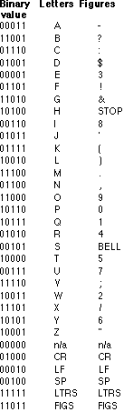
Figure 3: Baudet code set (Searle, 2004, August 6).
Until the first half of the twentieth century, many computerized and communication systems that follow relied prominently on Baudet sets (Searle, 2004, August 6). However, with the rapid development of communications and data processing technologies in the United States, there was a need for a standard character code for exchanging data and for handling the entire character set of the English language (Searle, 2004, August 6). In 1968, the American National Standards Association (ANSI) launched the well-known 7-bit American Standard Code for Information Interchange (ASCII) encoding (Searle, 2004, August 6). With its 32 control characters and 96 printing characters (see figure 4), the ASCII system was sufficient enough to fit all kinds of needs and characters in the English writing system (Searle, 2004, August 6).
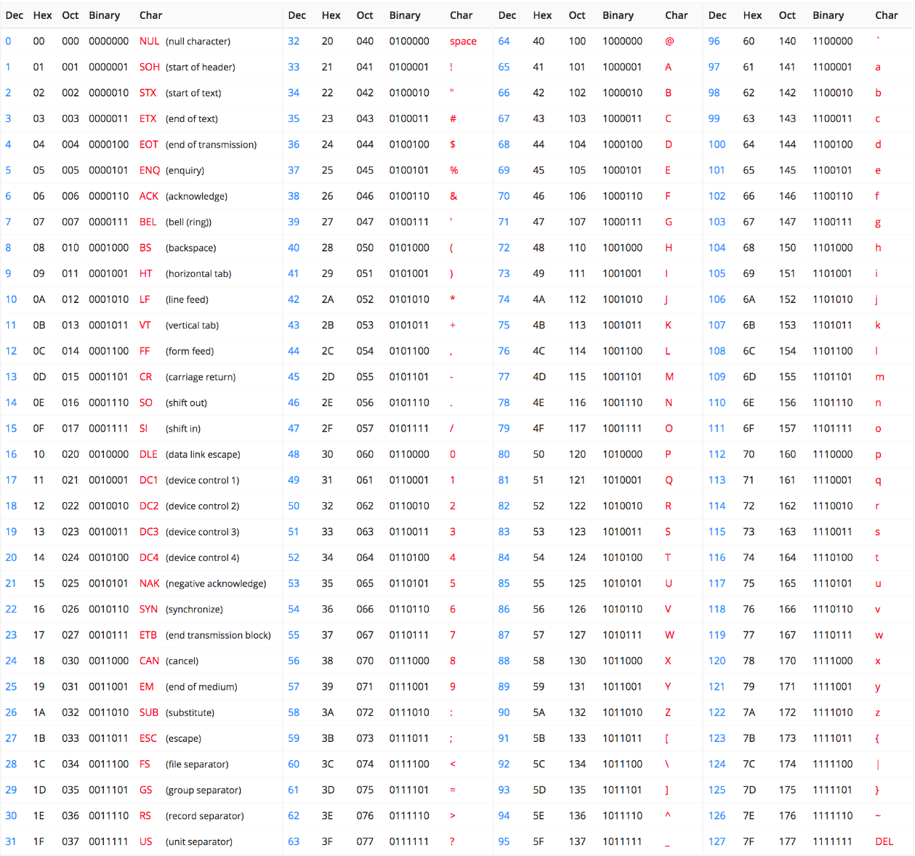
Figure 4: 7-bit ASCII code (Asciitable.xyz, 2018).
By the early 1980s, the 8-bit extended ISO encodings were implemented for several countries across the world (Gillam, 2003). In such encoding systems, the positions 0-127 were reserved for the 7-bit ASCII and the positions 128-255 (i.e., extra bit) were used for the extended character set holding specific characters of each country. For computers to retrieve the correct character on the screen, they must make sure that they were looking into the right code page (John, 2013). For instance, the code number 134 (0X86 in base 16 hexadecimal) could mean the Greek upper-case alpha with tonos (Ά) if retrieved from the code page 869 (ASCII codes, n.d.-a), or the Hebrew letter zayin (ז) if retrieved from the code page 862 (ASCII codes, n.d.-b).

Figure 5: web captures from the Greek and Hebrew extended character sets (Ascii codes, n.d.-a; Ascii codes, n.d.-b).
The 8-bit representation did not allow the extended character sets of many languages to co-exist with each other (i.e., other than English and something else) without having auxiliary data structures to keep track of the encodings used for the different pieces of the text; using a code-switching scheme was cumbersome both for the user and for the processing software (Gillam, 2003). Furthermore, this encoding system was insufficient to hold the thousands of ideographic characters of East Asian scripts (Becker, 1988). Other systems such as the 14-bit JIS (used in Japan) and BIG-5 (used in China) were utilized instead (Searle, 2004, August 6).
In the late 1980’s, Joseph Becker of Xerox PARC, along with Lee Collins and Mark Davis of Apple Computers, proposed the 16 bits standard international/ multilingual interchange encoding system unifying the world text encodings across different platforms (Unicode, 2015, March 26). The notion “Unicode” was given by Becker (1988) with the intent to suggest “unique, unified, and universal encoding” (p.3). The first version of the Unicode character set was released in June 1992. Starting with Unicode 2.0 released in July 1996, the standard was extended, adding 16 supplementary planes to the original 16-bit code space, which is now called the basic multilingual plane (BMP), thus, increasing the code space up to 1,114,112 code points (i.e., the number assigned to a character) (Piotrowski, 2012). This increase allowed the encoding of ancient scripts (such as Cuneiform, Gothic and Egyptian Hieroglyphs), besides historical characters in Latin, Cyrillic, Greek, and other extant scripts into the digital form (Piotrowski, 2012). Ever since, the extension, Unicode scheme known as UTF (Uniform Transformation Format), with its three variants UTF-8, UTF-16, UTF-32, have become the most significant standard to encode text in the global digital world. On March 2020, Unicode released its latest version, 13.0.0, which supports 154 scripts and a total of 143,859 linguistic symbols, along with a range of other representations such as Braille patterns, mathematical symbols, musical notations, emoji characters, and more (Unicode, 2020, March 10).
Design philosophies
According to Liu and Lions (1998), there are three fundamental design philosophies of the Unicode standard. Firstly, the aim toward an ideal of universality. Unicode works to encode characters that occur in a script, regardless of the number of languages that may use it; a single-language script is as important as one used for hundreds of languages (Crystal, 2011). Secondly, uniqueness, Unicode is the first encoding system that utilizes the abstract concept (the semantic unit) of the character rather than encoding the glyphs variations (Liu & Lions, 1998). For instance, in Arabic rendering, a character such as (heh) has four different shapes depending on the text’s context (see figure 6). However, the four glyph variants are represented by a single Unicode code value and it is up to text rendering process to determine the glyph per the text context (Gillam, 2003).
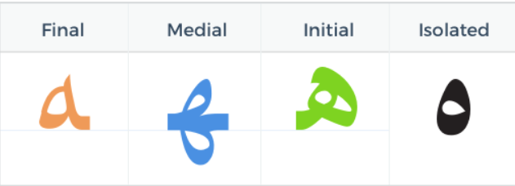
Figure 6: Web captures of the four glyphs of (heh) (Arabic Quick, n.d.).
Lastly, uniformity, Unicode works to develop a harmonization of typographic rendering; all the font characters should be displayed in a uniform width manner regardless of the encoding pattern (one-byte-alphabetic characters or four-byte-ideographic characters) (Liu & lions, 1998).
Who decides? Why does it matter?
Unicode Consortium is a non-profit organization; the membership is opened to companies, institutions, non-profit groups, and individuals. However, the membership levels vary, and each level comes with its voting right(s) and a yearly cost (Unicode, 2019a). The Unicode Consortium receive character proposals from members, users, and communities. The decision on these proposals is mainly made by the corporate ($21000) and institutional members (S10,000-$14000); both have the rights of the full vote in the technical committee (i.e., the corporate level has additional voting rights in the board and at full membership meetings) (Unicode, 2019a). The supporting members ($5000-$8750) votes count as half the full vote’s weight, and all other members may voice their opinion, but they don’t have any voting rights (Unicode, 2019a).
Since its rise, the “full” membership of the Unicode Consortium has been under the control of North American technology companies. The most recent list includes Apple, Google, Facebook, Netflix, Microsoft, SAP, and Salesforce; the only exception is Sultanate of Oman, Ministry of Awqaf, and Religious Affairs (Unicode, 2019b). The supremacy of tech-giants in Unicode has opened several allegations against the encoding decisions that they don’t concur with the proclaimed universality philosophy. John (2013) wrote that Unicode’s “focus has been on scripts used in business” (p.328); decisions are made for the reasons of economic gain rather than user or community gains. In the same vein, in the controversial topic of emoji standardization, Berard (2018) argued that classifying “emoji” as a distinct subset of text-based characters for standardization has satisfied the corporate members’ needs; it wasn’t based on their value. He asked us to consider: Who is left out in this form of a model, if those who have the money to pay for membership get to make the decisions? (Berard, 2018)
The impact of Unicode
Tracing the history of encoding standards enables us to understand that they are fundamental blocks in shaping access and communication in digital spaces; in Berard’s (2018) words, what is included and excluded in encoding systems impacts who gets to speak and how? Back in the early iterations of the Internet, English was the dominant language due to ASCII restraints (Crystal, 2011); its superiority on the web has been widely perceived as a threat to all other languages and a “killer language” to the weaker ones (Crystal, 2003; Coulmas, 2018; Taha, 2015). Several scholars contended the exclusive practice, such as Shapard (1993), who wrote about the Japanese elimination in the Internet: “Narrow vision, one-byte seven-bit ASCII biases, the assumptions about character coding that arise from them, inadequate international standards, and local solutions that disregard what international standards there are, and that pay no heed to the ramifications for others—all these are serious related problems that inhibit, rather than enhance, increased connectivity and communication” ( p. 256).
At this time, users communicating online in languages other than English needed to adapt to the ASCII environments. The European characters, for instance, were deprived of their cedilla, umlaut, stroke, etc. If there was an online resource for the Turkish scholar “Aşıksoy Gülsüm”, the attribution and citation had to change to “Asikoy Gulsum” instead (Coulmas, 2018). As we move to languages written in other alphabets like Arabic, Hebrew, Greek, and non-alphabetic scripts like Chinese, the impact of the missing representation was more visible and immense. For example, in response, trans-scripting into English alphabets (i.e., Romanization) has emerged in Computer-mediated Communication (CMC) contexts (Coulmas, 2018; Taha, 2015). In Danet and Herring (2003, November) publications about Arabish (see figure 7), Greeklish, and other trans-scripting practices, the authors regarded these adaptations as echoing threats to ideologies and cultural heritages, as well as, negatively influencing the local writing systems and spelling conventions.
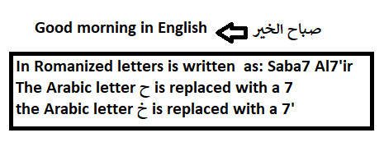
Figure 7: Arabish (Arabizi) phenomenon emerged in response to the lack of support of Arabic-scripting in the 1990’s (Taha, 2015).
Fortunately, we moved beyond the limitations of the ASCII code in some respects. Now information can be exchanged in Arabic, Chinese, and many other languages you care to write. This change is inextricably linked to the increasing proliferation and wide-spread adoption of Unicode that have enabled new linguistic varieties (see figure 8). However, it is critical to highlight that not all encoding problems have yet been solved for all software programs, not all of the world’s languages were effectively and equally represented, the growing bias in favor of English still exists in technological products, and Romanization practices have continued by those who felt that it was more suitable and facile for the modern technologies (Coulmas, 2018; Taha, 2015).
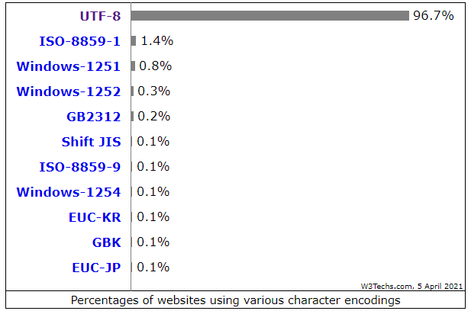
Figure 8: UTF 8 is used by 96.7% of websites known to W3tech (2020, April)
The benefits of Unicode exist in various educational fields of computer science, humanities, typography, and linguistics (Unicode, 2021, April). Several ongoing projects have been taken by a number of scholars and institutions for the revitalization and preservation of historical and minority languages in collaboration with Unicode, such as the Script Encoding Initiative (SEI) and the Missing Script Project (MSP) (Piotrowski, 2012). Even though many scripts are not yet included in Unicode and the task of harmonizing the scripts (i.e., to grant the uniformity property) is immense (SEI, n.d.; ATypI, 2018, September 25). Still, the progress brought by Unicode and linguists has allowed preserving some of the cultural and historical heritage and making it more accessible, both to students and scholars, by molding them into digital text, which can be searched and otherwise automatically processed (Piotrowski, 2012); this has opened up new possibilities for online education, study, and publication. Overall, Unicode encourages native-language education and universal literacy, helps to overcome linguistic barriers to participation, and enables embracing one’s cultural and linguistic identity throughout the learning process (SEI, n.d.).
Looking forward
Unicode standard is a technology that “brought deep-reaching changes in the republic of characters representation” (Coulmas, 2018, p.204). A sociolinguistic system, you may say, that circulates in online resources, software solutions, mobile applications, in symbolic systems such as emojis, and in educational practices. However, as noted, the Unicode standard has certain politics and uses embedded in its design—what might be called “biases” (John, 2013). And thus, computational literacy needs to go beyond its traditional view (i.e., coding literacy) and extend to encompass the political, cultural, and social apparatuses of the technology; critical literacy and critical pedagogy are essential. It is crucial to promote student’s critical thinking: How are character codes issued and by whom? Why do companies invest in full membership? How ideologies, cultural, and linguistic practices are impacted due to choices made about what characters or visual material included in Unicode? (Berard, 2018). Also, there is a need to draw students’ attention to the marginalized and the rights of those who have less access to resources due to the encoding constraints, and ensure bringing into computer science education the alternatives to the dominant technology and make room for analyses of competing, though less successful technologies, such as the TRON encoding system, as well as, the emerging encoding systems such as Noto, launched by Google to “sideline” Unicode and further the company’s dominance on global online communications (John, 2013; Coulmas, 2018).

References
Arabic Quick. (n.d.). Learn the Arabic letter Ha. Retrieved from http://arabicquick.com/learn-the-arabic-letter-ha/
ASCII codes. (n.d.-a). Code page 869 (Greek language). Retrieved from https://www.ascii-codes.com/cp869.html
ASCII codes. (n.d.-b). Code page 862 (Hebrew language). Retrieved from https://www.ascii-codes.com/cp862.html
AsciiTable.xyz. (2018). ASCII Table Online. Retrieved from https://www.asciitable.xyz/
ATypI. (2018, September 25). Johannes Bergerhausen, Morgane Pierson - The missing scripts project [Video post]. Retrieved from https://www.youtube.com/watch?v=CHh2Ww_bdyQ
Becker, J. (1988). Unicode 88. Unicode. Retrieved from https://unicode.org/history/unicode88.pdf
Berard, B. (2018). I second that emoji: The standards, structures, and social production of emoji. First Monday, 23(9). https://doi.org/10.5210/fm.v23i9.9381
Bigelow, C., & Holmes, K. (1993). The design of a Unicode font. Electronic Publishing, 6(3), 289-305. Retrieved from https://ezproxy.library.ubc.ca/login?url=https://www-proquest-com.ezproxy.library.ubc.ca/scholarly-journals/design-unicode-font/docview/57324723/se-2?accountid=14656
Coulmas, F., & ProQuest (Firm). (2018). An introduction to multilingualism: Language in a changing world (First ed.). Oxford University Press.
Crystal, D., CRKN MiL Collection, & Cambridge Core EBA eBooks Complete Collection. (2003). English as a global language (2nd ed.). Cambridge University Press. https://doi.org/10.1017/CBO9780511486999
Crystal, D., Taylor & Francis eBooks A-Z, & Ebook Central. (2011). Internet linguistics: A student guide. Routledge. https://doi.org/10.4324/9780203830901
Danet, B., & Herring, S. (2003, November). Introduction: The multilingual Internet. Journal of Computer-Mediated Communication, 9(1). https://doi.org/10.1111/j.1083-6101.2003.tb00354.x
Gillam, R., & O’Reilly for Higher Education. (2003). Unicode demystified: A practical programmer’s guide to the encoding standard. Addison-Wesley.
John, N. A. (2013). The construction of the multilingual internet: Unicode, Hebrew, and globalization. Journal of Computer-Mediated Communication, 18(3), 321-338. https://doi.org/10.1111/jcc4.12015
Piotrowski, M., Synthesis Collection Four, & ebrary, I. (2012). Natural language processing for historical texts. Morgan & Claypool. https://doi.org/10.2200/S00436ED1V01Y201207HLT017
Searle, S. (2004, August 6). A brief history of character codes in North America, Europe, and East Asia. Tron Web. Retrieved from http://tronweb.super-nova.co.jp/characcodehist.html
SEI. (n.d.). Welcome to the script encoding initiative. Berkeley University of California. Retrieved from https://linguistics.berkeley.edu/sei/
Shapard, J. (1993). Islands in the (data)stream: Language, character codes, and electronic isolation in Japan. In L. M. Harasim (Ed.), Global networks: Computers and international communication (pp.255–270). Cambridge, Mass.: MIT Press.
Taha. M. (2015). Arabizi: Is code-switching a threat to the Arabic language. The Asian Conference on Arts & Humanities. Retrieved from http://25qt511nswfi49iayd31ch80-wpengine.netdna-ssl.com/wp-content/uploads/papers/acah2015/ACAH2015_13058.pdf
Unicode (2015, March, 26). Early years of Unicode: The Unicode® standard”…begin at 0 and add the next character”. Retrieved from https://unicode.org/history/earlyyears.html
Unicode (2017, July, 24). What is Unicode? Retrieved from https://unicode.org/standard/WhatIsUnicode.html#:~:text=The%20Unicode%20Standard%20provides%20a,devices%20and%20applications%20without%20corruption.
Unicode. (2019a). Membership levels. Retrieved from https://home.unicode.org/membership/membership-levels/
Unicode. (2019b). Members. Retrieved from https://home.unicode.org/membership/members/
Unicode. (2020, March 10). Unicode® 13.0.0. Retrieved from https://unicode.org/versions/Unicode13.0.0/
Unicode. (2021, April). Students and educators. Retrieved from https://www.unicode.org/education/students.html
Wikipedia. (2021, March). List of Unicode characters. Retrieved from https://en.wikipedia.org/wiki/List_of_Unicode_characters
W3tech (2021, April). Usage statistics of character encodings for websites. Retrieved from https://w3techs.com/technologies/overview/character_encoding

