Annual Report

Financial Year
2007-08



www.ankindia.org

Regd. Office – JG-40(3GF), Khirki Extn. Malviya Nagar, Delhi – 110017.
Tel - +91-11-65641300, 09810561157.
E-mail – abhi_kishore@yahoo.com

INTRODUCTION

Ank is a not for profit organization, established in Feb. 2004. ANK is engaged in the activities of providing education, promoting ICT(Information and Communication Technology), organizing health camps etc.

Our mission is to empower the poor through knowledge, health care, education, vocational training and commitment.

We at “ANK” dream of an INDIA where every child goes to school and are given proper health care and shelter.

The thought process behind ANK is that quality education is the only vehicle that can improve the living standards of the poor people.It is the only tool that can equip them to make informed and intelligent choices about their lives and future. It is the only weapon to fight poverty and truly empower the children who will be the face of India in the times to come.

Since last three years, ANK has been working in and around South Delhi area. Our educational learning centers for out of school children are in operation in Neb Sarai, Maidan Garhi and Saidualazab areas. Our Computer training center for underprivileged kids is operational in Saidualazab. Beneficiaries of ANK include: -
800 out of school at risk vulnerable children.
120 women through Self Help Program.
400 MCD School teachers through IT training.
700 children through health camps.

Ank has a dedicated team of supervisors, trainers and community workers. We also have a network of volunteers from different backgrounds.

Programs and activities

Warriors of Light 2007

This altogether a voluntary effort by Damayanti Sharma and Mr.Pradeep Burman.Ms.Damyanti Sharma a leading artist from Delhi has been grooming 10 selected children from ANK in the field of painting. We planned to exhibit selected paintings of children. We planned one exhibition of art made by children at the Ashoka Delhi from 31ST March to 7th April 2007. Ms.Renuka Chaudhary honorable minister in govt of India inaugurated the exhibition at the Ashoka. Several other dignitaries from social and corporate world were present to grace the occasion. The opportunity provided to underprivileged children helped them to grow in confidence.

The exhibition of paintings continued from 1st April to 7th April 2007 at Tea Lounge of Ashoka Hotel,Chanakyapuri. During this period many visitors appreciated the art work done by children. Some of the paintings were sold also. All the proceeds went to the cause of educating underprivileged children. A short film was made about the children participating in the program. The film was screened during the exhibition.

The entire event was spomsored by Mr Pradip Burman of Dabur India. The most important outcome was the uplifted spirit of the participating children whose work got recognized and appreciated at such a high level.

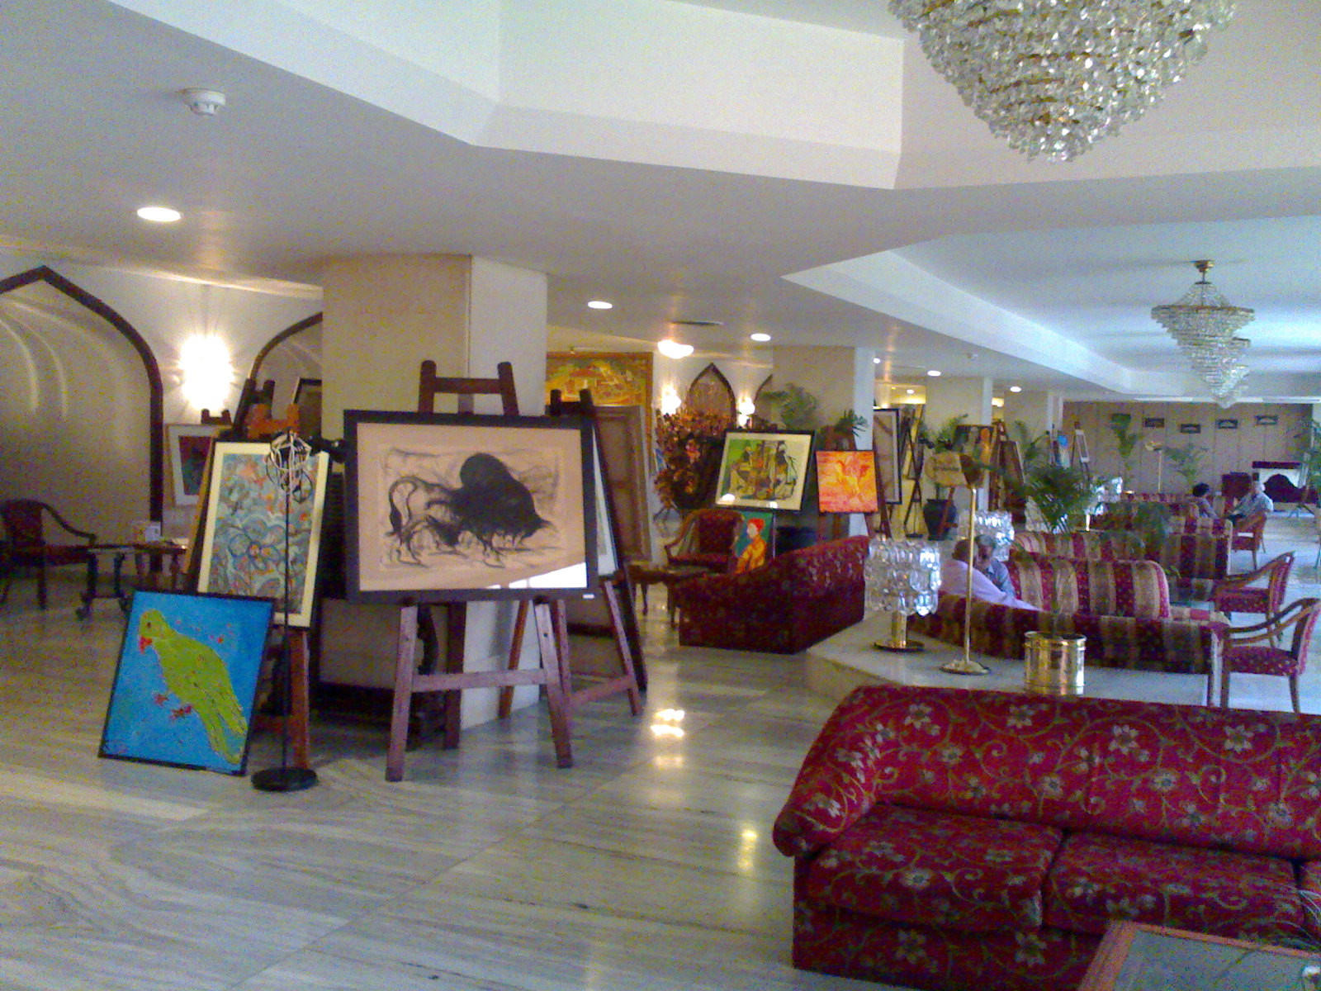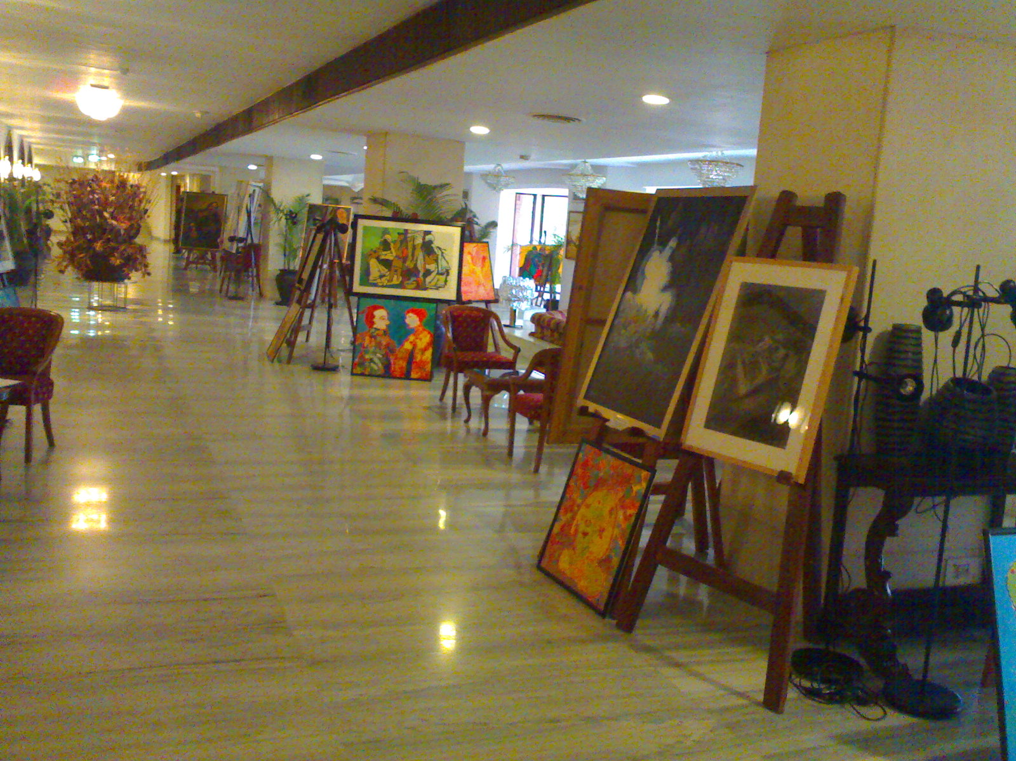

The art classes continued during the year on every Saturday. At the same time we were planning for the next year show. To provide exposure to the children towards contemporary art we organized two educational visit for the children to the National Gallery of Modern Art and Sahitya Kala Academy. The visits were organized in the month of June 2007. The children enjoyed the visit a lot. It was an opportunity for them to learn new thing and also sharpen their skill.

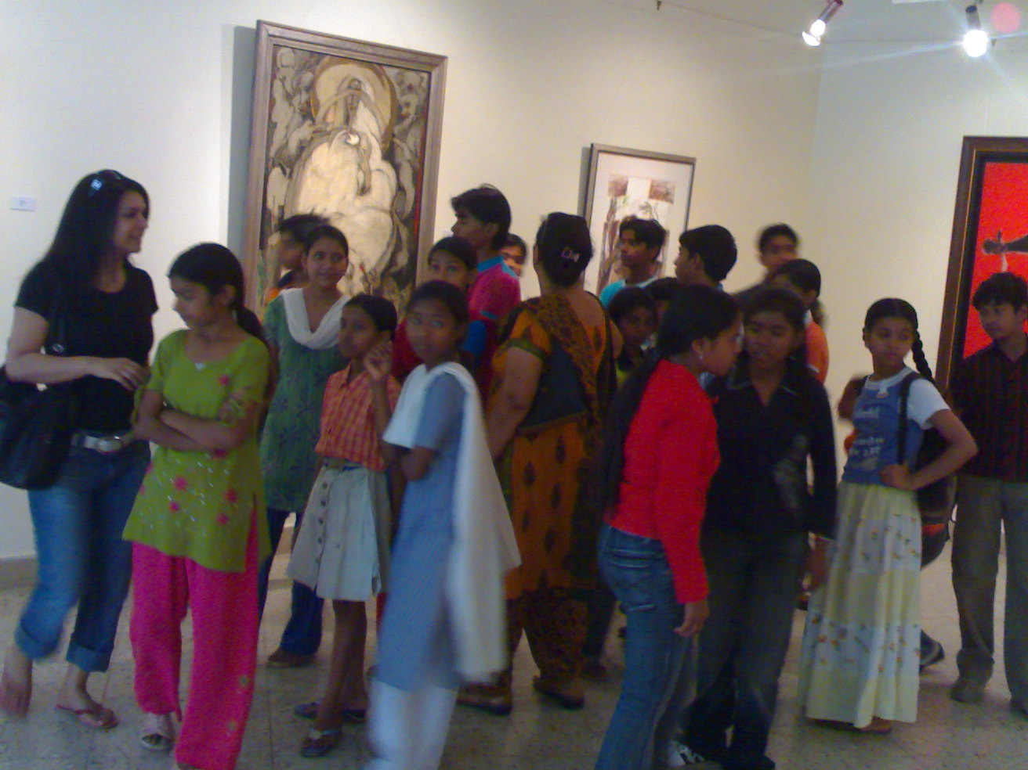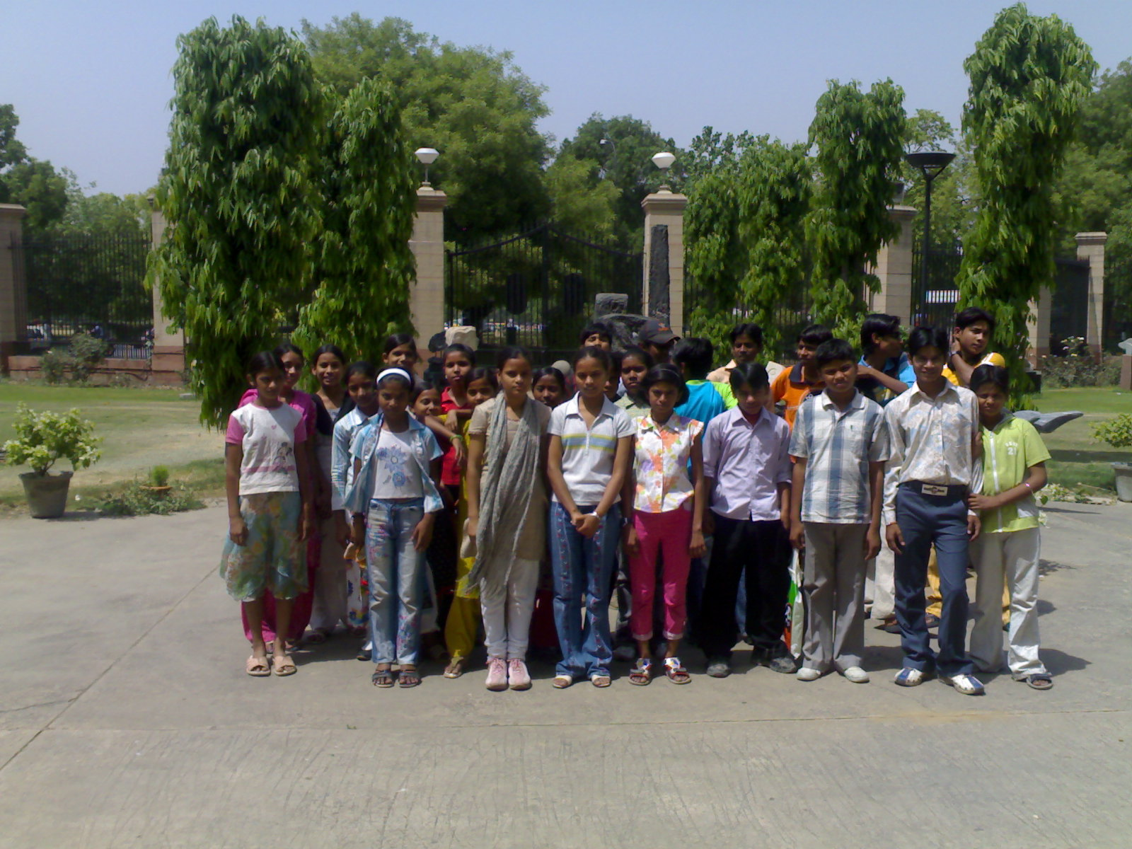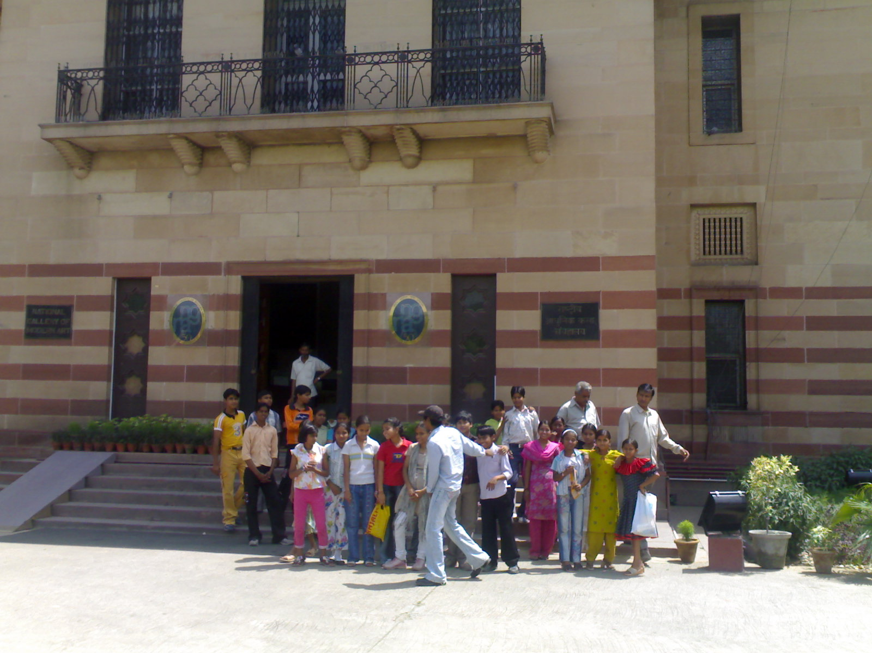

One day workshop on HIV/AIDS, Life Skills and Nutrition under adolescence development and training program.

Venue : ANK Teen Age Club,
A-12 (Basement), Saidualazab,Delhi.

Date : 29th June 2007.

No. Of Participants : 40 Children and 40 parents

One day workshop on HIV/AIDS, Life Skills and Nutrition was organized by ANK in association with Nehru Yuvak Kendra, Mehrauli at ANK’s Educational Learning Center at Saidualazab. 40 teen age children along with their parents participated in the program. The program proved to be a very good platform were the children and parents discussed issues like HIV/AIDS, Life Skills and Nutrition. The session was very interactive. Mr. Fateh Singh of NYK, Mr Onkar of NYK , Ms. Suman of ANK and Ms. Upasana of ANK conducted the workshop.

Mr. Onkar of NYK made people aware about the Delhi Civil Defence program. He discussed the issue in full detail. All the audience were very keen to learn about the Delhi Civil Defense program.

Prizes were given to participating children during the workshop. All the participating children were given some stationary as gift/ prize. Refreshments were given to all the participants including children and adults.

Painting and exhibition program under adolescence development and training program.

Venue : ANK Teen Age Club,
A-12 (Basement), Saidualazab,Delhi.

Date : 30th June 2007.

No. of Participants : 40 Children.

A painting exhibition was organized by ANK on 30th June 2007 at the teen age club, Saidualazab. 40 children participated in the program. The children made paintings on following issues :-
- HIV/AIDS awareness
- Life skills.
- Nutrition.

All the participants enjoyed the painting a lot. The children were in the age group 12 to 17 years. The children were given free stationeries and colour crayons to paint. The winners of the painting competition were given prizes. Following were the winners of the painting competition :-
  - Mamta
  - Renu.
  - Sonu.

Ms Roselynn from Canada was the chief guest at the exhibition. Other guest includes Ms. Bharti – a practicing CA, and Mr. Fateh Singh from NYK Mehrauli.

Meeting of Block Level Young Leaders

Venue : ANK,
A-12 (Basement), Saidualazab,Delhi.

Date : 30th July 2007.

No. of Participants : 35 NGO representatives

A one day meeting of Block Level Young Leaders was organized by ANK in association with Nehru Yuvak Kendra, Mehrauli. The meeting was attended by 35 representatives from different NGO’s working with Nehru Yuvak Kendra, Mehrauli, also the meeting was attended by the following NYK representatives: -

Mr. D.K.Tyagi (Deputy Director, NYK, Mehrauli)
Ms. Jitendra Kaur (Accountant, NYK, Mehrauli)
Ms. Nisha Jha (DPO, NYK, Mehrauli)
Mr. Amiya Shukla from Diabetes Foundation of India was invited as special guest.
The meeting started at 11.00AM and Mr. D.K.Tyagi chaired the proceedings. The meeting provided a very good platform to NGO representatives to interact with NYK officials and know about their programs, activities and projects. Mr. D.K.Tyagi of NYK explained in detail about the various NYK projects and activities. Ms. Jitendra Kaur and Ms. Nisha Jha also answered queries from NGO representatives.
Mr. Amiya Shukla who was special guest also delivered a small speech making an appeal to NGO’s to participate in the planned walk against Juvenile Diabetes on 25th August 2007 at Siri Fort Auditorium.

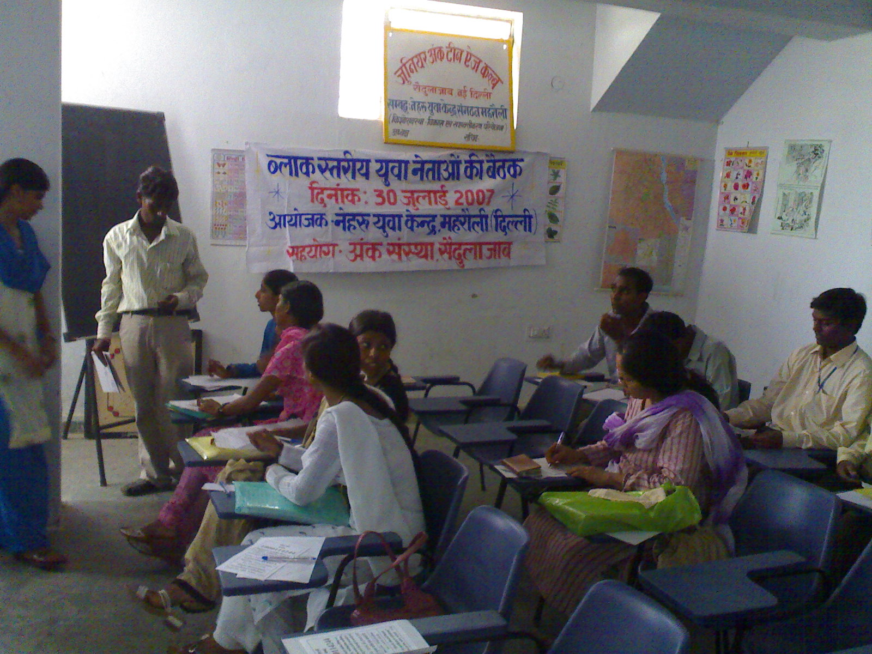
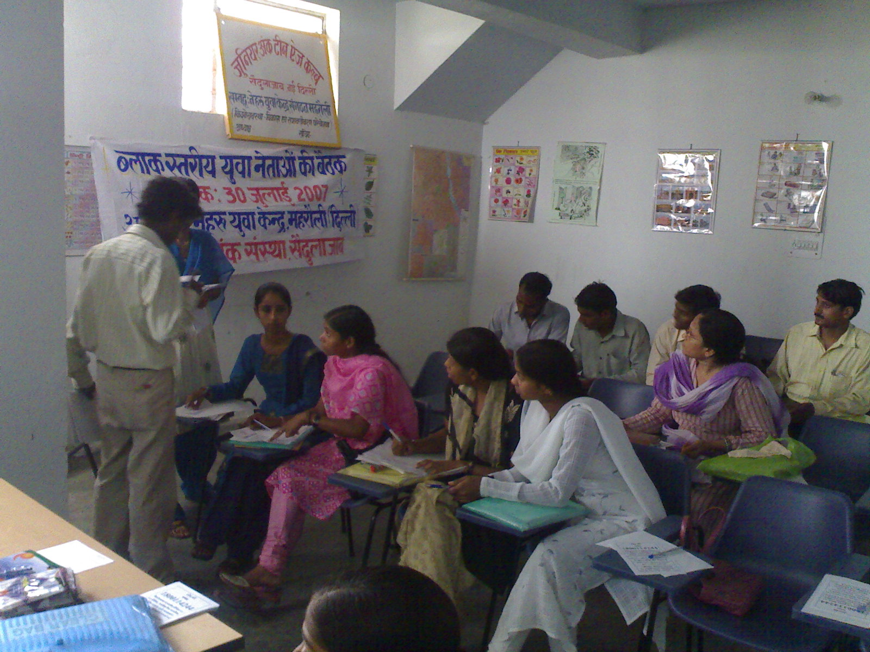

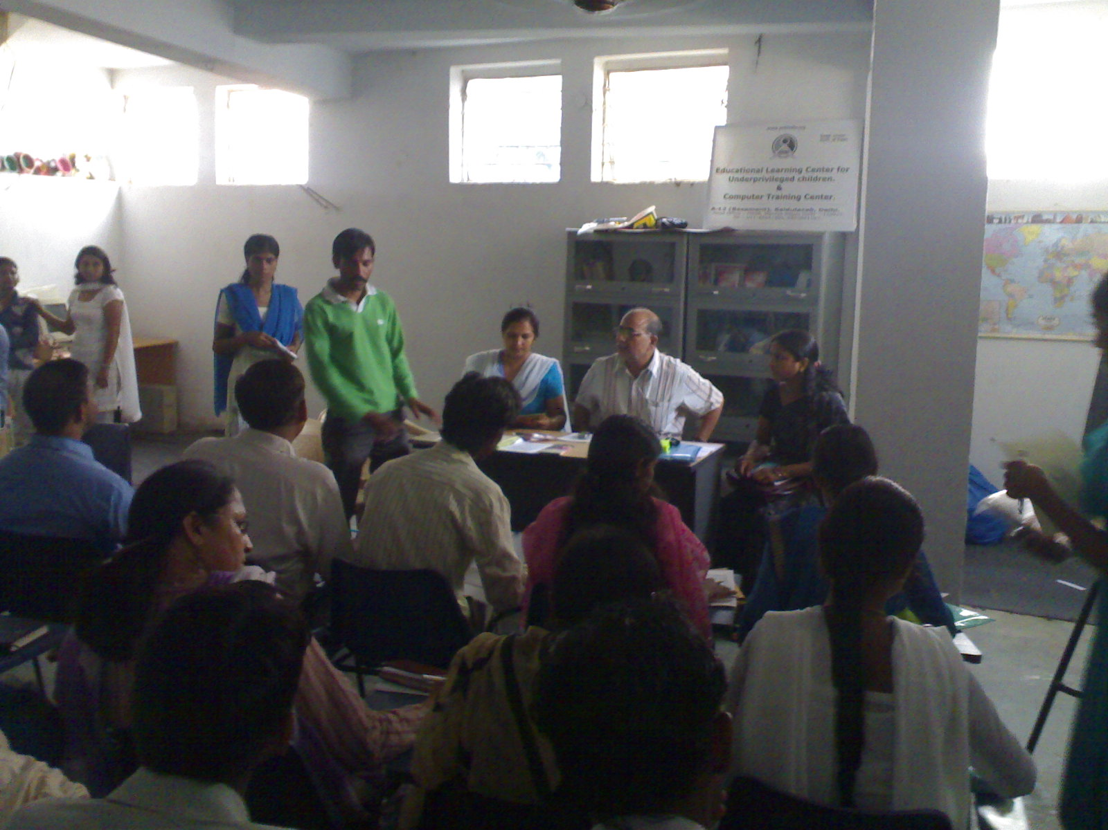
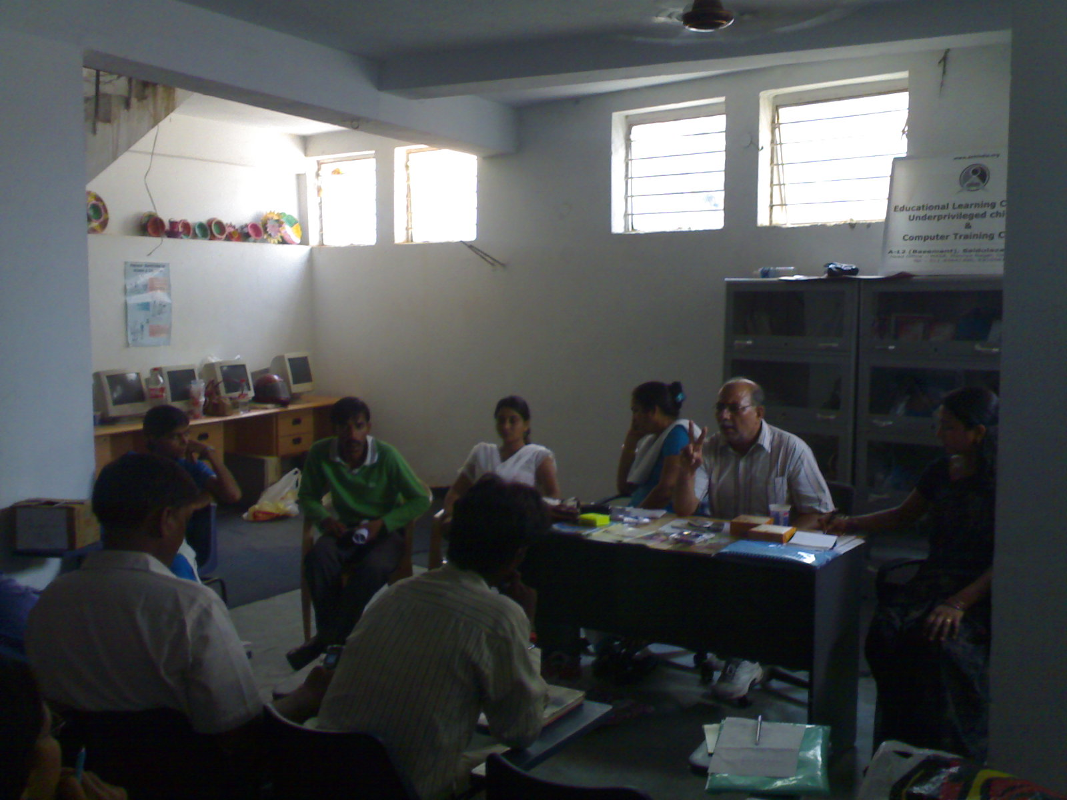
Pankh

Ank took part in the Pankh event of Diabetes Foundation of India as their NGO partner. On 25th August the Pankh got started with performance by ANK children at Siri Fort Auditorium. The bhajan sung by a group of 9 ANK children was widely appreciated. Noted bhajan singer and ANK volunteer Mr. Alok Chopra composed the bhajan. Also more than 300 ANK children took part in the walk from Dear Park to Siri Fort Auditorium. The event was organized to make people aware about juvenile diabetes.

Our association with Paankh gave us the proud privilege to be the part of a great noble cause for the benefit of innumerable lives. It gave Ank an opportunity of introduction and a platform to showcase its contribution towards the betterment of the society.
The event provided our children an opportunity par comparison, by giving them a chance to perform and showcase their talent and zeal on various grounds. The painting exhibition scheduled on 25^{th August} will put on auction some of the outstanding work done by our bright children under the guidance of Delhi’s leading artist Ms. Damayanti.. In addition to all these prized opportunities our children also take the proud privilege to inaugurate the evening cultural show by their splendid performances.

This event will surely be one of the strongest pillars in the history of Ank, in its journey towards the upliftment of underprivileged children of the society. Undoubtedly this enterprise will create waves of change with a positive impact.

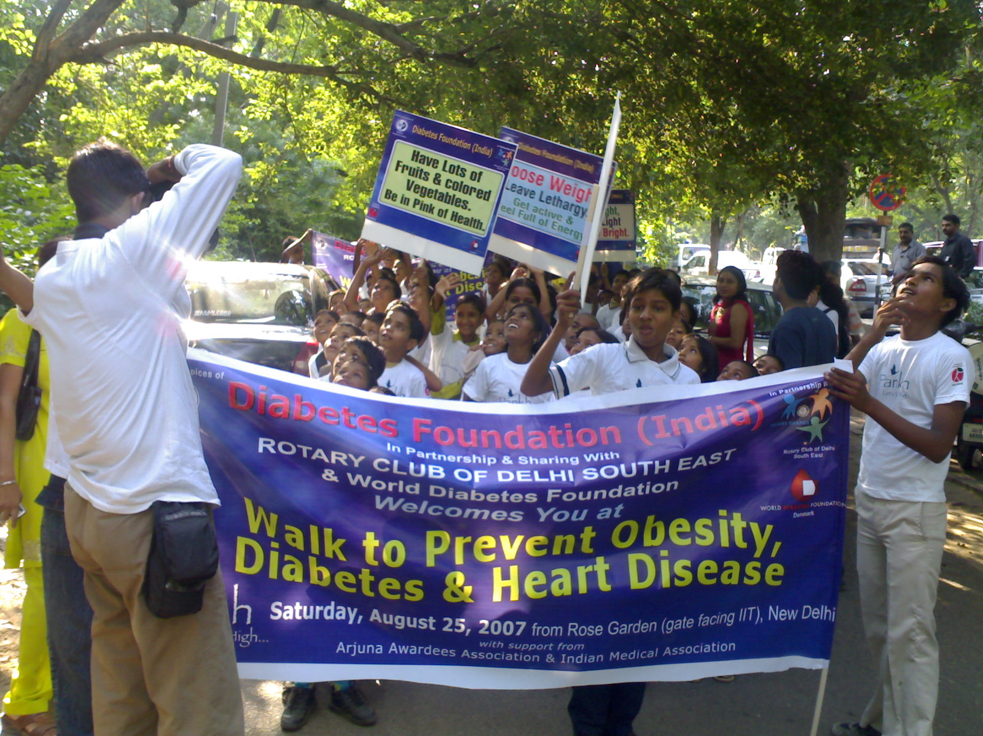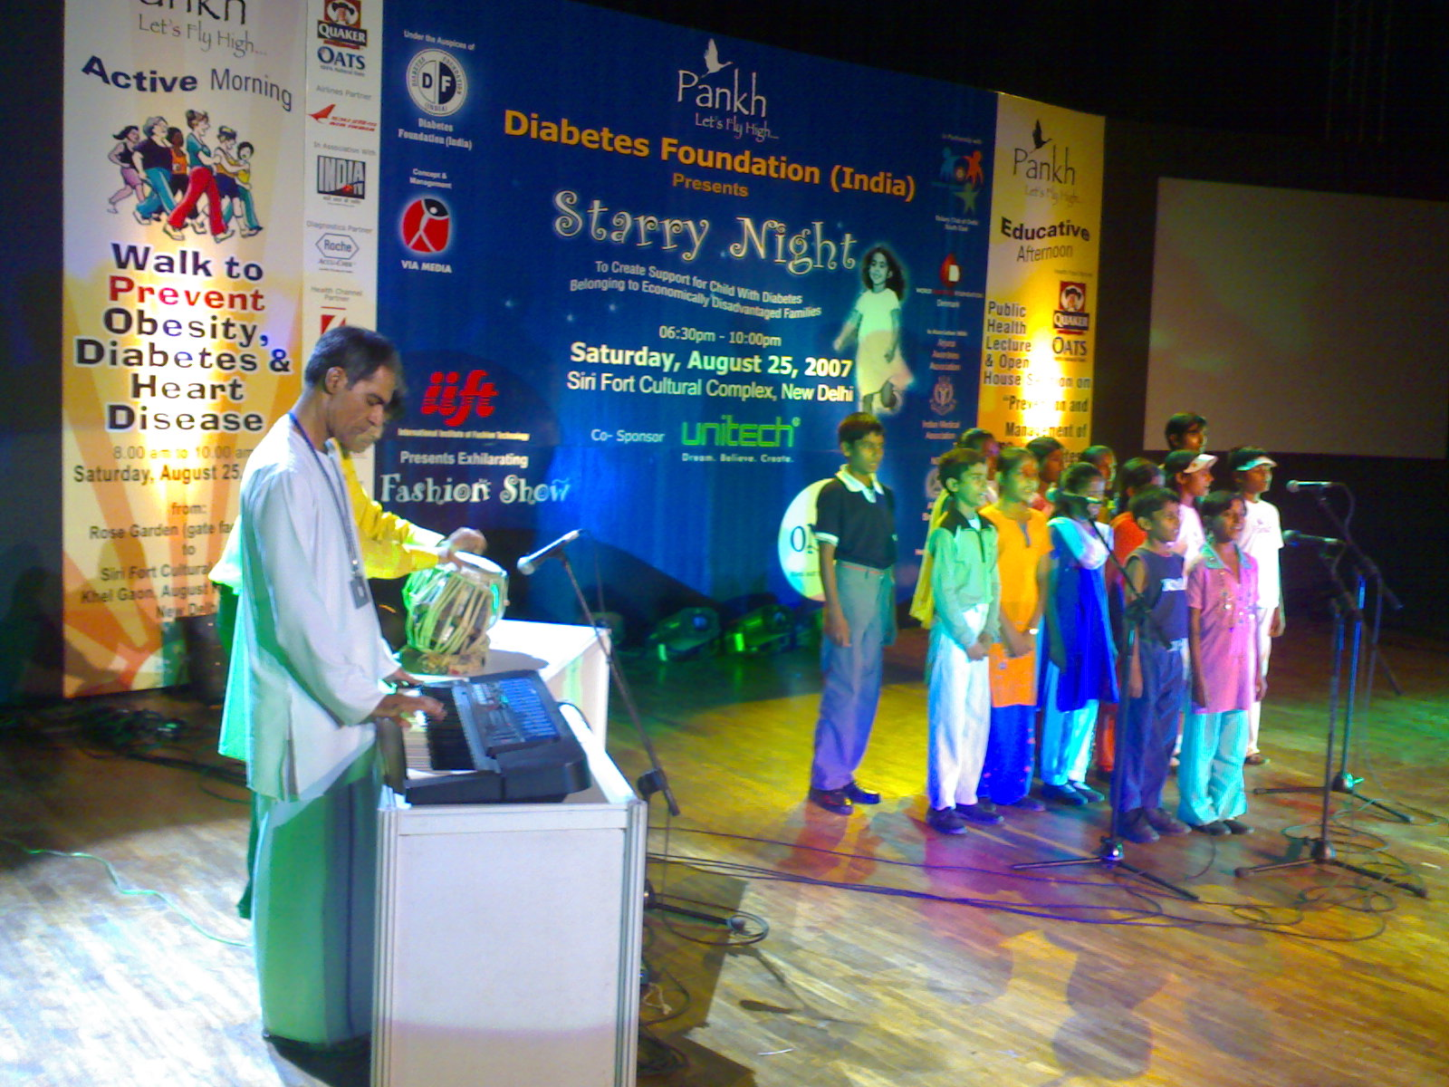

YMCA NGO Mela

Children from ANK took part in the NGO mela organized by New Delhi YMCA. Children took part in the rangoli competition, folk dance competition, Face Painting competition and pot painting competition. Jyioti from ANK won the first prize in the folk dance, Mamta won the thirg prize in rangoli competition.

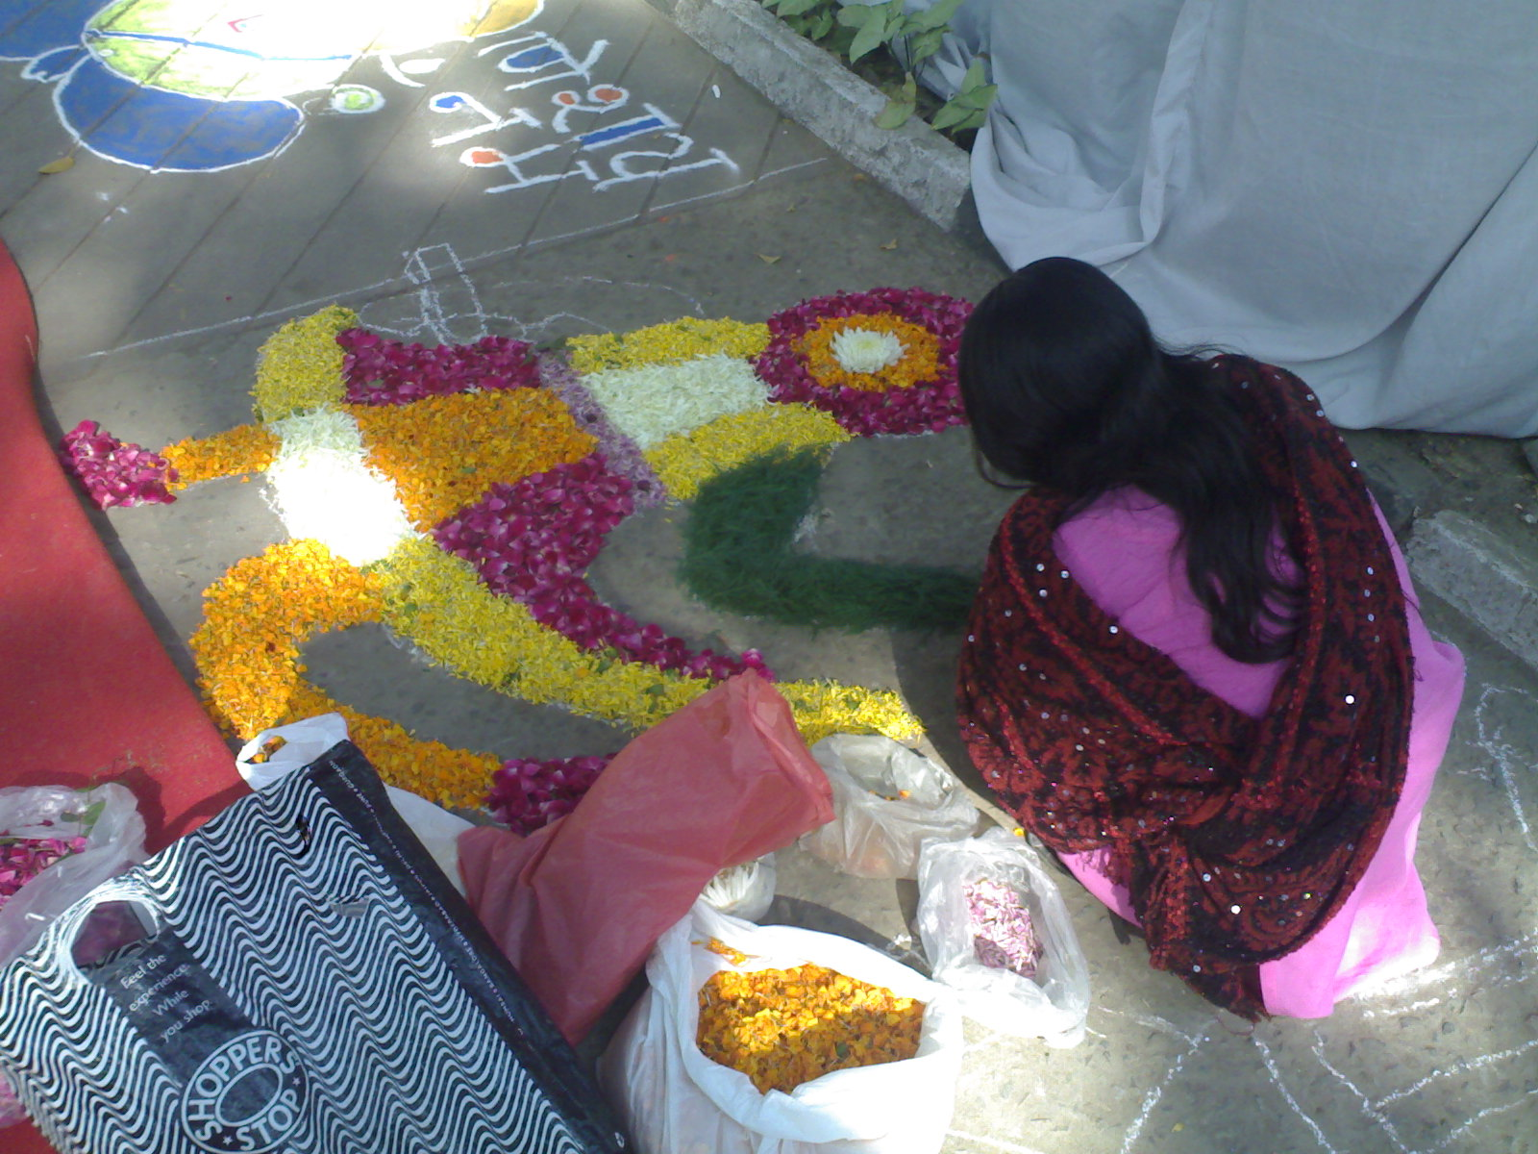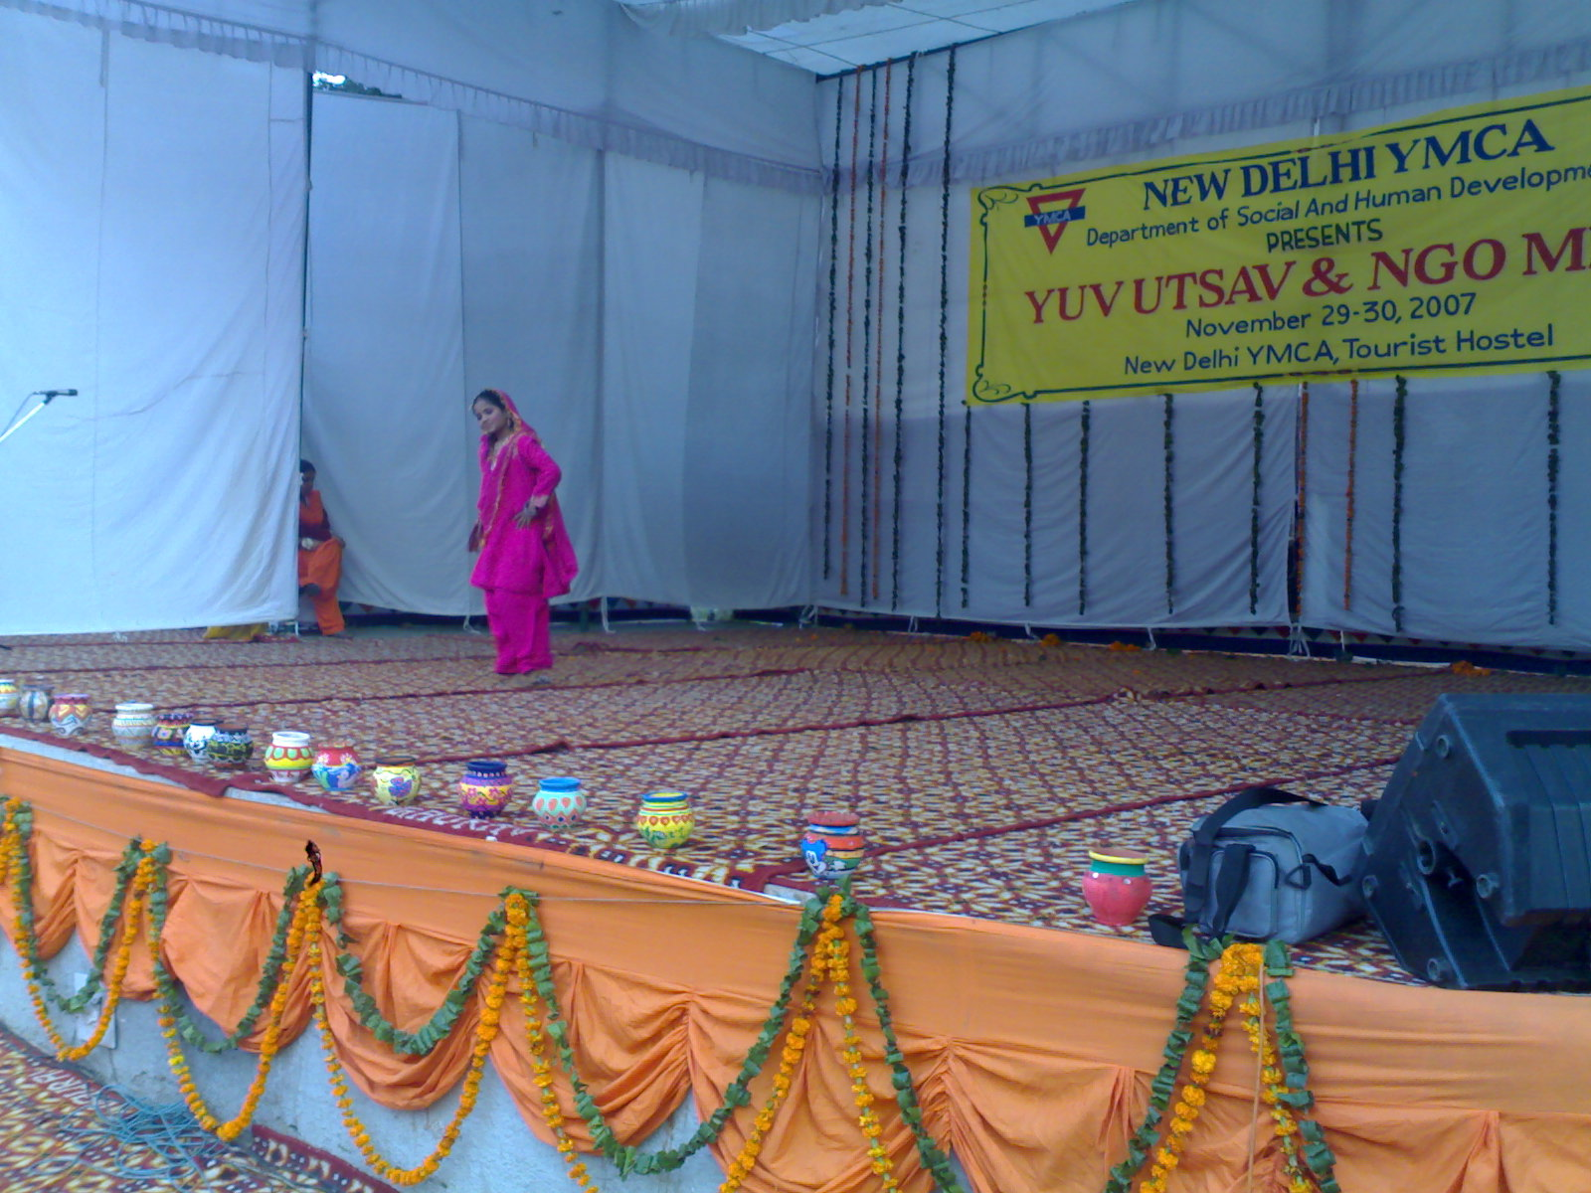

ANK’s Educational Learning Center for Underprivileged Children:

Our Learning Centers provide education to children within the age groups of 6-14 years. Though it does not impart formal learning its focus is on the age appropriate overall development of the child’s attitudes, values and behavioral patterns. The programme aims at inculcating and stimulating every child’s endeavor towards taking care of his/her environment. Due to variety of social, cultural, economic and linguistic differences, there is a fair amount of flexibility in the teaching methodologies. The children are constantly encouraged and stimulated to grow at their own pace depending on their living environment. The centers are striving to satisfy the curiosity of the child and channel it in a creative direction.
The prime objective is to attain universalisation of elementary education in the project area. The programme is envisaged, to provide the children with basic education.

All the enrolled children in the learning centers are out of school, some of them never been to any formal school while some are drop outs from formal schooling system. The parents of these children are working and they neglect the education of their children. These children are mostly first generation of learners. The main problem lies that the parents of these children do not encourage them to go to school and study. During the day when both parents go to work to earn their livelihood, these children has the freedom of roaming around in the nearby areas. The children always prefer playing rather than going to school and study. Its very difficult to bring these children to school and get them learning.

The teachers of our learning centers try very hard to bring these children to the learning centers. It involves regular meeting with the parents and motivating them to encourage their children to go to the learning centers. A regular visit to the homes of the children is done to bring them to the learning centers.

Neb Sarai Project:

The educational Learning center at Neb Sarai was started to conduct remedial classes for the children who were mainstreamed into the Government Schools of the area. A shaded classroom was constructed to provide better facility to the children. 70 underprivileged children were enrolled in the center. The children who were in need for remedial class were enrolled in the learning center.
The enrolled children were from following family backgrounds.
- Rag pickers
- Clay pot makers
- Laborers
- Housemaids etc
Emphasis was given to enroll maximum at risk girl child out of 70 enrolled children there were 48 girl child.

Saidualazab Project: -

The Saidualazab Learning Center got started in the month of May 2007 as part of our sponsorship program.

The educational Learning center at Saidulazab was started to conduct remedial classes for the children who were mainstreamed into the Government Schools of the area.

Highlights of the project
- Study chairs for the children.
- Small library of 300 books of different subjects for the children.
- Computers for the children.
- Separate toilets and drinking water facility.
- Availabity of electricity with fans and bulbs
A rented basement of 1000 sq.feet was taken on rent to provide better facility to the children. 60 underprivileged children were enrolled in the center. The children who were in need for remedial class were enrolled in the learning center.
The enrolled children were from following family backgrounds.
- Rag pickers
- Local vegetable sellers
- House maids
- Laborers etc.
In this educational learning center we placed 4 computers to be used by the children for education through multi media. We used computers as an interactive teaching aid.
The children were enrolled in such a way that they were at risk from dropping out from formal schooling system.

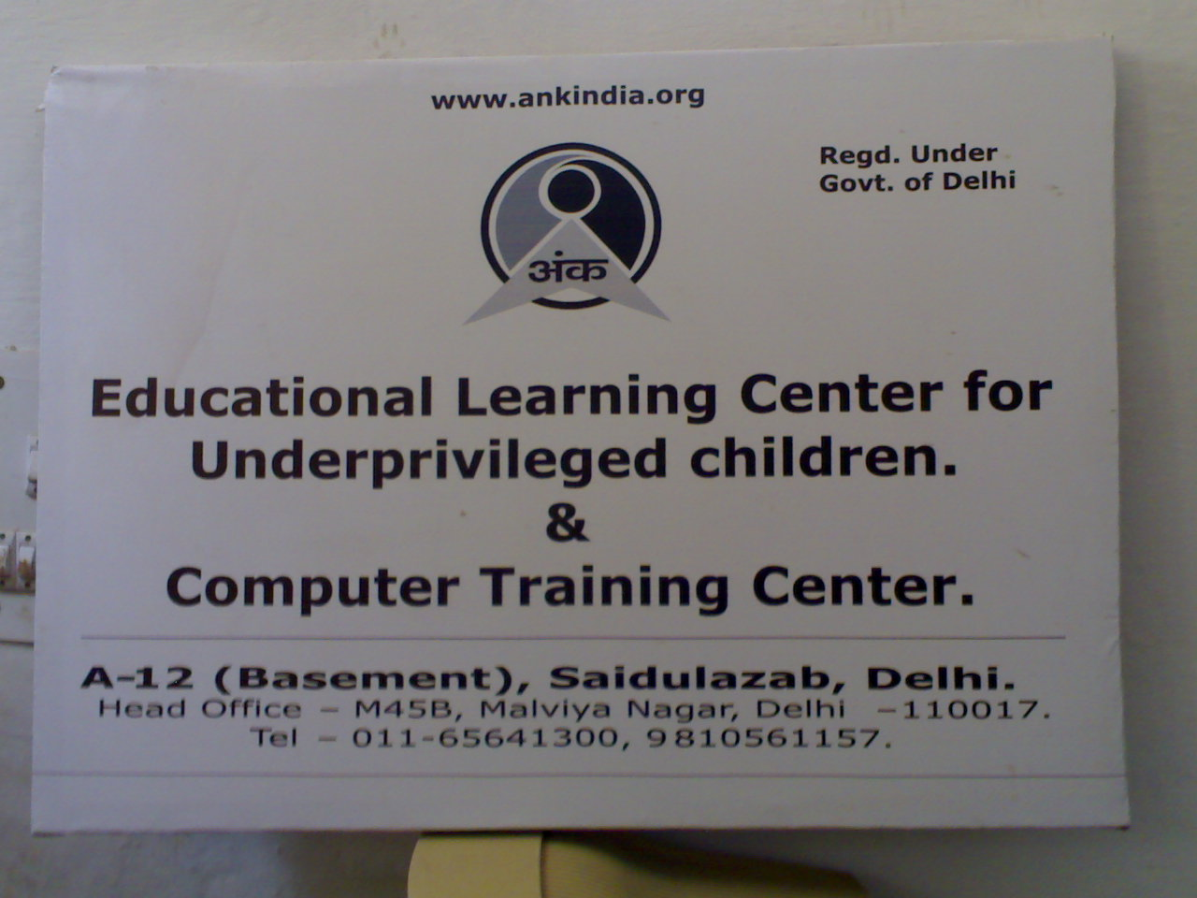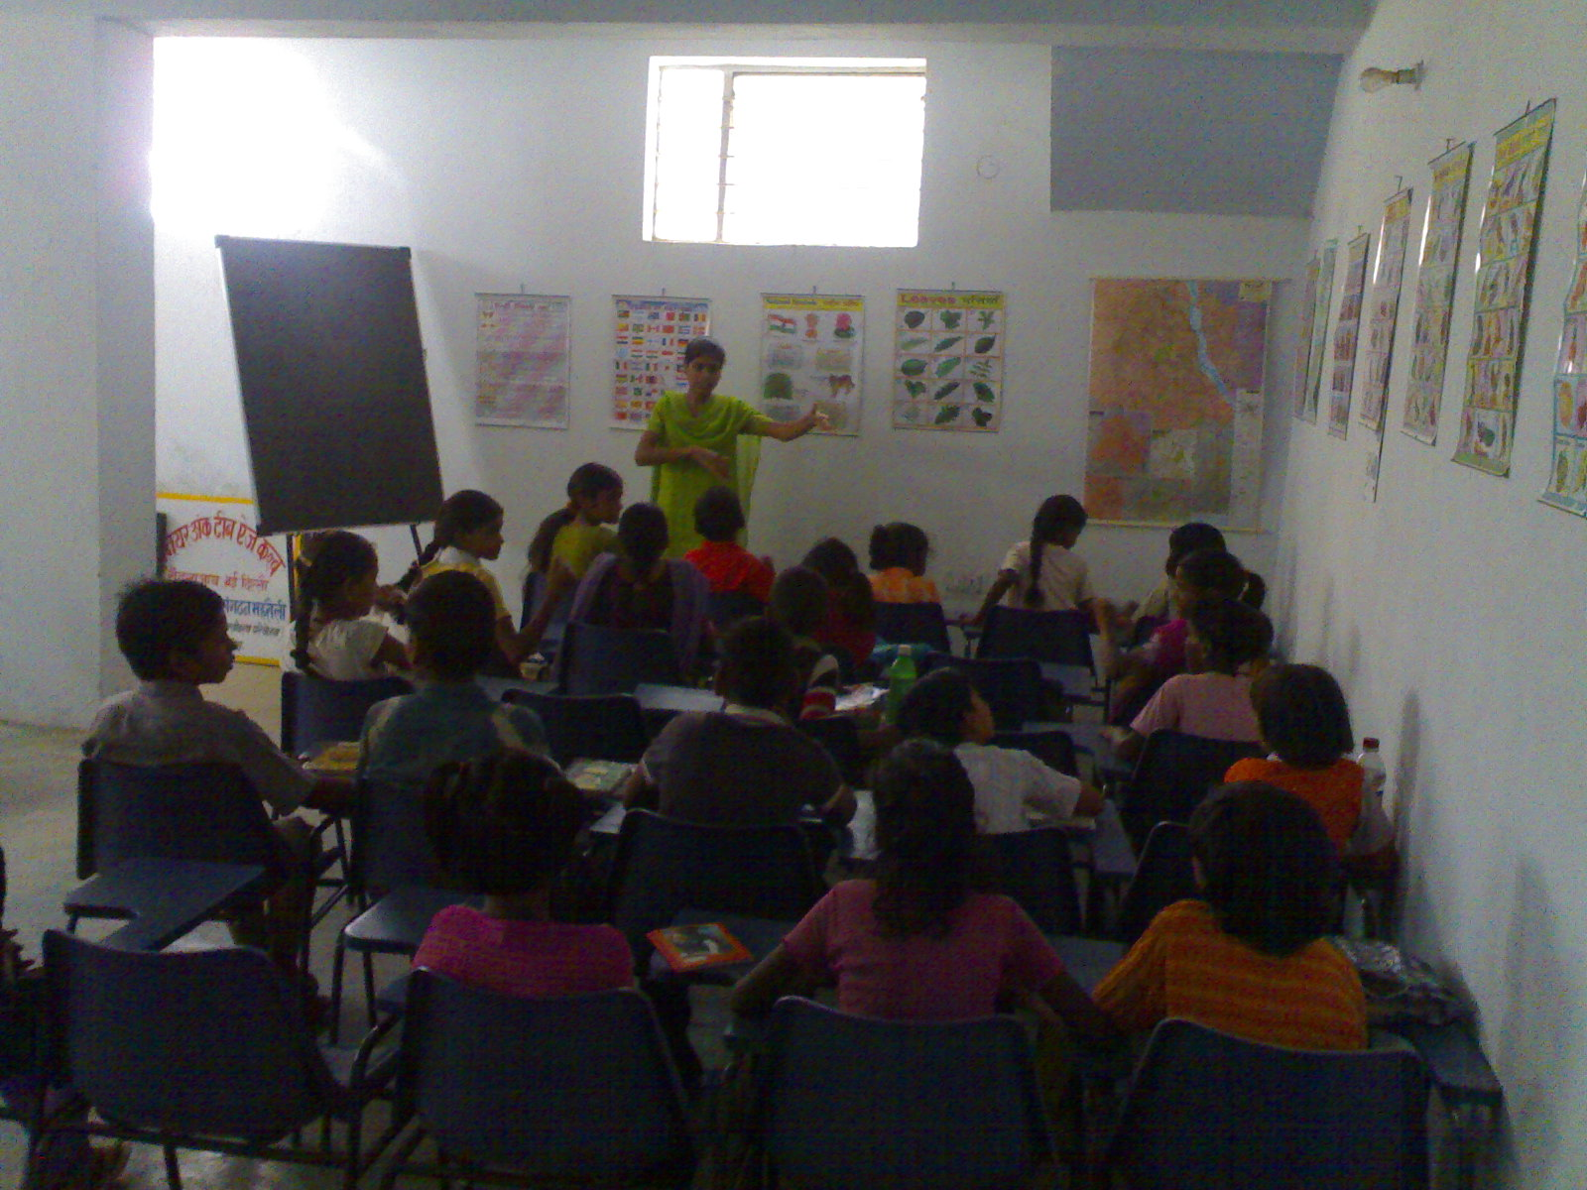

Computer Education:

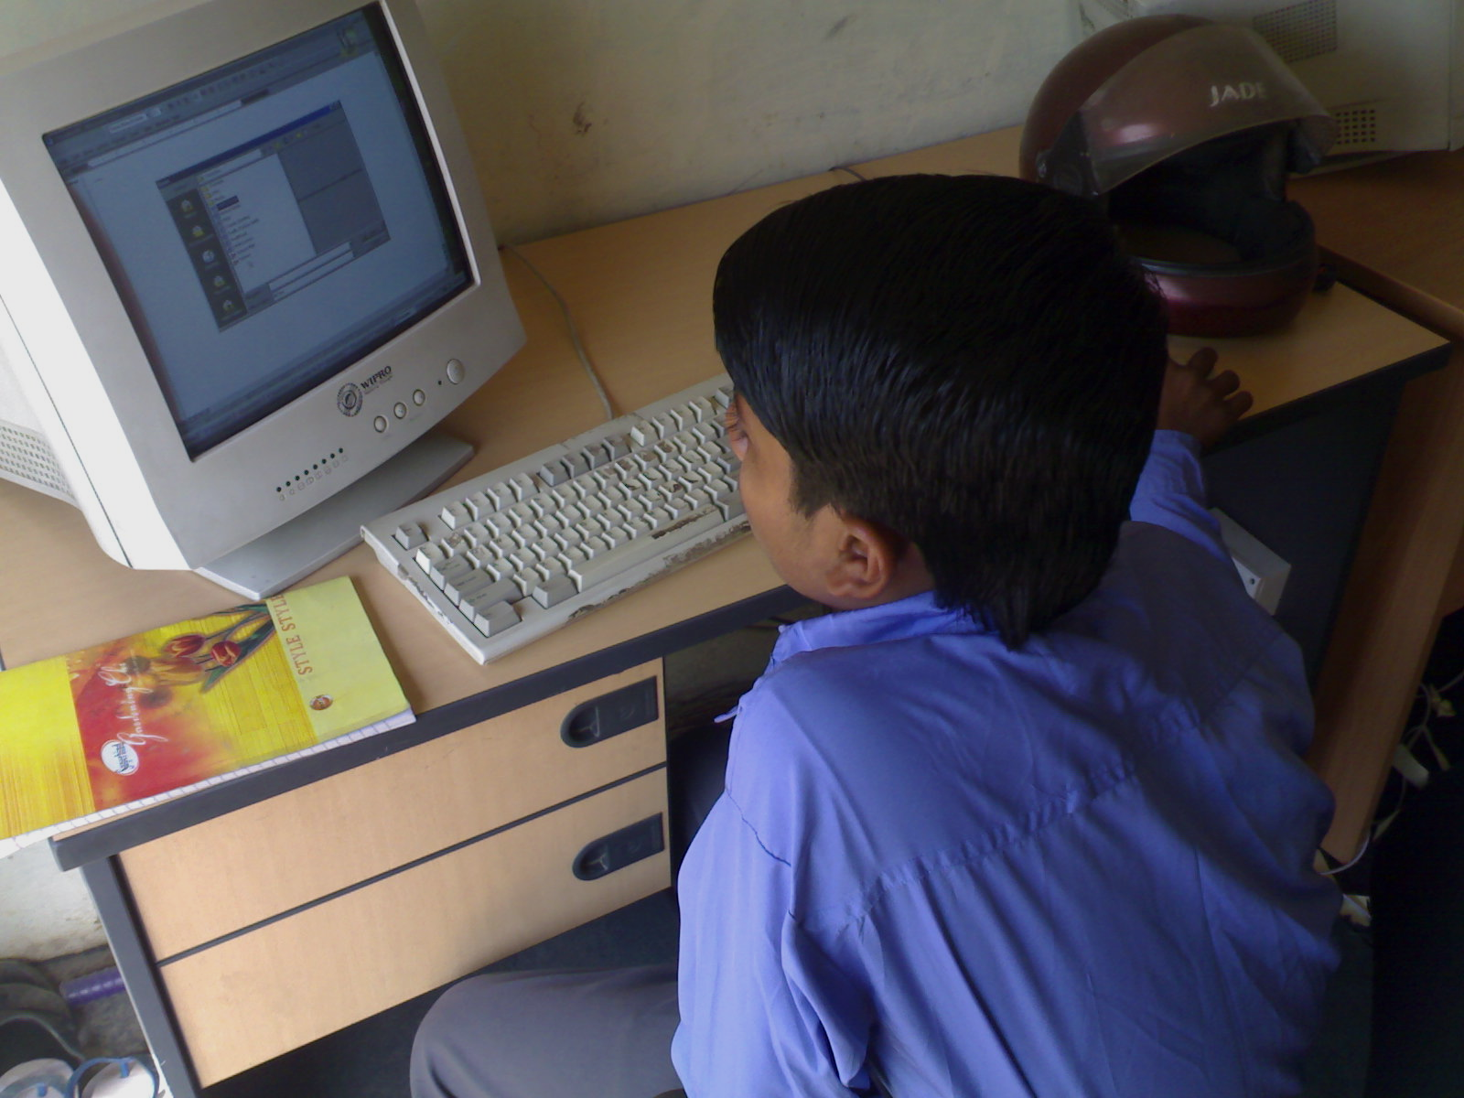
ANK lays special emphasis on Computer Education in its various learning centers. The purpose of education is to empower the children with the requisite tools to help them live a dignified life and make right decisions. Not only is education important, computer education too is critical considering the role that technology plays in our lives and is likely to play in the coming years. While no computer can replace a good teacher, it is not always possible to get good teachers for all schools, especially in the interior rural areas. This is where computer enabled education complements the teacher in the classroom. Computer also helps attract students to schools as has been said “You bring computers into schools, you bring children to schools”. By making computers available in schools at the point of delivery of education we are trying to facilitate the primary and secondary level of education. In addition to the school programme we are also using the computers for adult and vocational education and community services.
Financial Summary – for detail – refer to annexure

Total Income - 7,40,700.00
Total Expenditure - 7,31,211.00
Excess of Income
Over Expenditure - 9,489.00

Bankers of ANK
UTI Bank, Malviya Nagar Branch, Delhi.

Auditors

Gangadhara Mishra & Associates,Safdurjung Enclave, Delhi.

