**English 301 Definitions Assignment**

The purpose of this assignment is to choose a relatively complex word related in our field of profession or discipline using three forms of definitions: parenthetical, sentence and expanded. I chose the word *orthodontia* to define as I am a practicing dental hygienist who also performs orthodontic procedures. The definitions below will be informative to an adult audience with secondary education level who has an average dental knowledge.

**Parenthetical Definition:**

Elizabeth needs *orthodontia* (treatment and devices to align teeth) in order to give her a beautiful smile and boost her self-confidence.

**Sentence Definition:**

*Orthodontia* is a branch of dentistry that deals with the diagnosis, prevention and treatment of malpositioned teeth and jaw.

**Expanded Definition:**

Etymology

*Orthodontia* is derived from the Greek words *orthos* (meaning “correct” and “straight”) and *dontia* (meaning “teeth”) (en.wikipedia.org, 2015).

What is *orthodontia*?

*Orthodontia,* also known as dental braces, orthodontics and dental orthopaedics, is a branch of dentistry that specializes in the diagnosis, prevention and correction of malpositioned teeth and jaw (en.wikipedia.org, 2015). It can only be performed by a dentist or orthodontist who has undertaken special training after graduating from dental school (en.wikipedia.org, 2015).

What is the history of *orthodontia*?

The history of *orthodontia* has been associated with dentistry for more than 2000 years (en.wikipedia.org, 2015). According to the American Association of Orthodontists (AAO), archeologists have discovered ancient Greek and Etruscans (Italy) dental appliances that were used to straighten teeth (Evans, 2014). However, the concept of *orthodontia* did not start until 1728 when a French dentist named Pierre Fauchard published a book with an entire chapter devoted to *orthodontia* (Evans, 2014).The chapter focused mainly on straightening teeth which also explained how to use a device called “Bandeau” to expand the arches of the upper and lower teeth (Evans, 2014). It was not until the 1900’s that the techniques and methods used for straightening teeth was created which led way to the modern day *orthodontia* (archwired.com, n.d.)

How is *orthodontia* different from cosmetic dentistry?

Cosmetic dentistry, such as porcelain crown and bleaching, is a procedure often used to correct problems that require an immediate solution. *Orthodontia* is not only meant for cosmetic purposes but also to treat and prevent facial deformities and physical health issues related to the teeth and jaw (archwire.com, n.d.).

What are the parts used in *Orthodontia* (orthodontic parts)?

There are different devices and methods used in *orthodontia*; however, the basic parts are the ligature, archwire, metal band and brackets. A ligature is an elastic or wire that holds the archwire onto each bracket. An archwire is a long thin metal wire that is placed into each bracket to move the teeth into proper alignment. A metal band is a ring that is usually cemented on molar teeth to hold the archwire ends. The brackets are small square metals or plastics that are cemented on each tooth which hold the archwire in place. (See Figure 1)

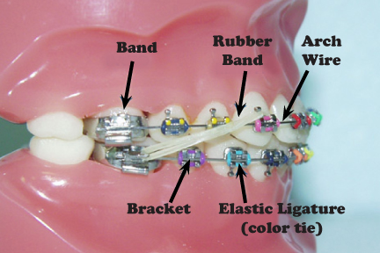

[www.carlsbadvillageortho.com](https://www.google.ca/url?sa=i&rct=j&q=&esrc=s&source=images&cd=&cad=rja&uact=8&ved=0CAYQjB1qFQoTCOTi3d6-osgCFQU3PgodbdYIwA&url=http%3A%2F%2Fwww.carlsbadvillageortho.com%2Fnew-patients%2Fcurrent-patients.html&bvm=bv.104226188,d.cWw&psig=AFQjCNE5fFjA8Cj6IdSbWBIisvVMx4Etbw&ust=1443830695949110)

Figure 1. The components of a basic orthodontics (Orthodontia)

**Works Cited**

Archwired: A Website for Adults in Braces. (n.d.). *A brief history of braces.* Retrieved from

http://www.archwired.com/HistoryofOrtho.htm

Evans, D. (2014). *The history of braces and orthodontics.* Retrieved from

http://www.davidevansdds.com/history_of_braces.php

Wikipedia. (2015). *Orthodontics.* Retrieved from https://en.wikipedia.org/wiki/Orthodontics