Causal Analysis for Improving the Overall Wellbeing of Remote Students at the Kappa Sigma Fraternity

For:
Logan Deboo
President
Kappa Sigma Fraternity- Epsilon Epsilon
Vancouver, BC

By:

Evan Ruiz
Technical Writing Student
The University of British Colmbia

Introduction

In the midst of the COVID-19 pandemic students, around the world, have made the transition to operate and are fortunate enough to continue their studies, like those in the Kappa Sigma Fraternity, are facing a whole new set of challenges. The major implications of this problem are as follows: members of Kappa Sigma are spending a majority of their time indoors; members are spending an increasingly large amount of time in a seated and or stagnant position; lastly, members are lacking any significant amount of structure within their days. With that being said, it is necessary to determine the most effective way to help members maintain physical and mental wellbeing, while operating in a remote capacity.
I propose a three-pronged solution to help students at Kappa Sigma increase their overall well being while operating in a remote capacity. Firstly, I suggest that all members create an organized, shared, schedule that lists their class times, assignment due-dates, etc. Secondly, I suggest that “study groups” be made to improve peer- support and feelings of isolation. Lastly, I suggest that morning/ evening exercise groups be created; encouraging members to leave their house, bond with other members, and stay physically healthy.

Executives of the Kappa Sigma Fraternity who aspire to improve members overall wellbeing, in the midst of remote learning, need insight into the following questions:
- How are the members of Kappa Sigma affected by remote education?
- Are their products available that increase physical wellbeing?
- What is the degree to which intermittent physical activity is beneficial?
- How does extended exposure to a screen affect mental wellbeing?

In an attempt to answer these questions, this report will analyze information gathered from members of the Kappa Sigma fraternity, as well as secondary literature. More specifically, the analysis will address members current feelings of productivity, motivation, and physical health

Data
Member Data
Executive members of the Kappa Sigma Fraternity must understand the commonalities associated with remote education, and the feelings of their own members, prior to implementing a solution that would benefit the organization, as a whole.

Decreased feelings of organization and structure. Members are, largely, feeling a lack of organization and structure in their day-to-day. More specifically, on a likert scale, 56% of members “disagreed” with the fact that they have felt organized lately; compared to 15% of members who “agreed” with the fact that they have felt organized lately. Moreover, 37% of members “disagreed” with the fact that their days have felt structured; compared to 15% of members who “agreed” that their days have felt structured (member survey, November 26, 2020).
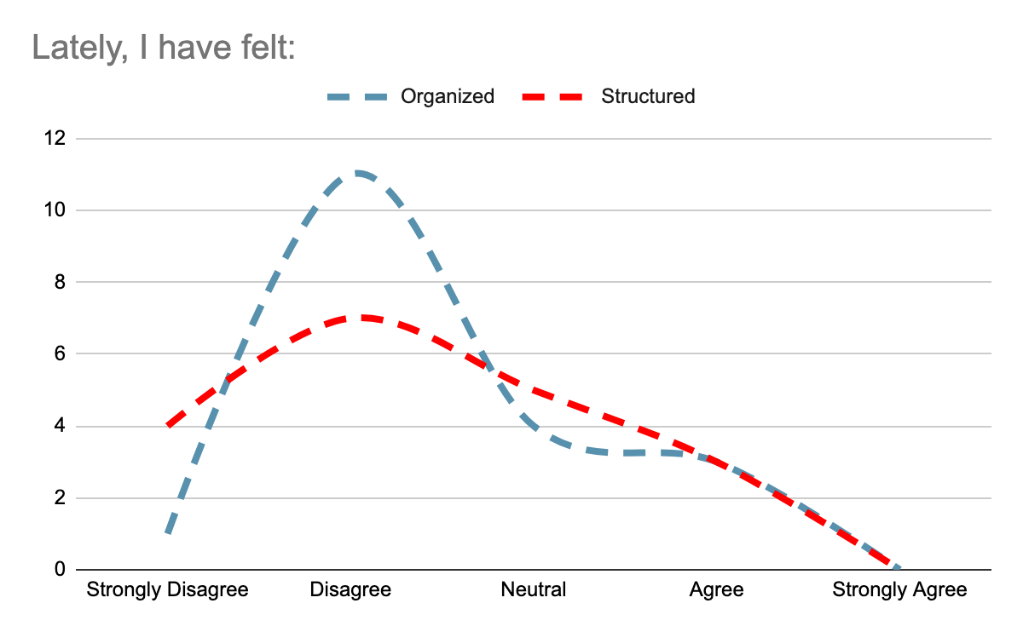

Increased feelings of Isolation. Members are experiencing a lack of connectedness with others and, as a result, are feeling increased levels of social isolation. On a Likert Scale, 52% of members “disagreed” with the fact that they are feeling connected to others. In comparison, only 5% of members “agree” that they are feeling connected to others (member survey, November 26, 2020).
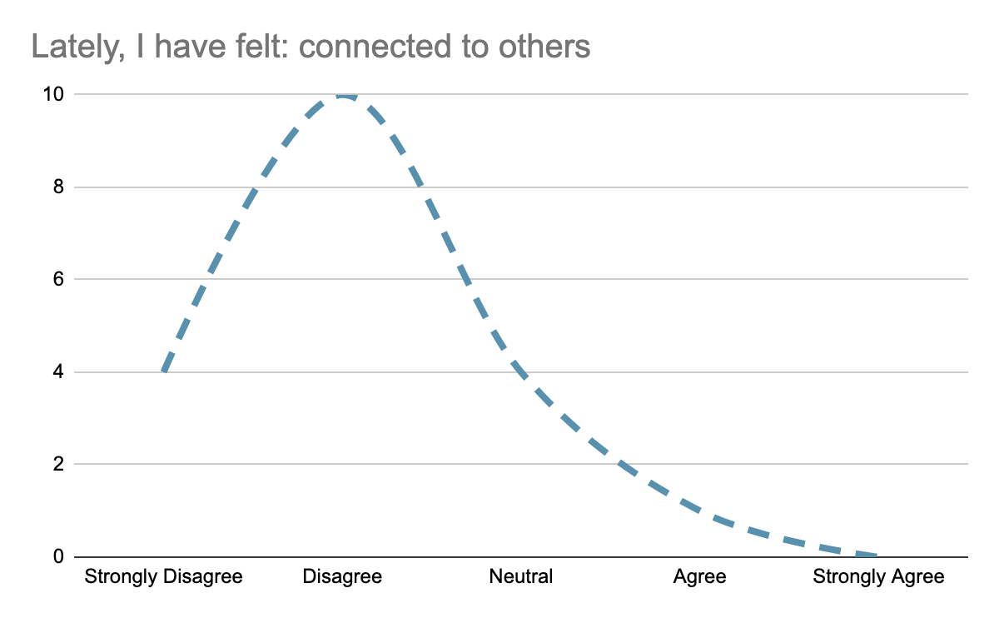

Lack of physical activity. Members are spending large amounts of time indoors and, consequently, are experiencing a lack of physical activity. More specifically, 21% of members “strongly disagreed” with the fact that they have been physically active lately; compared to 16% of members who “strongly agreed” that they have been physically active lately.

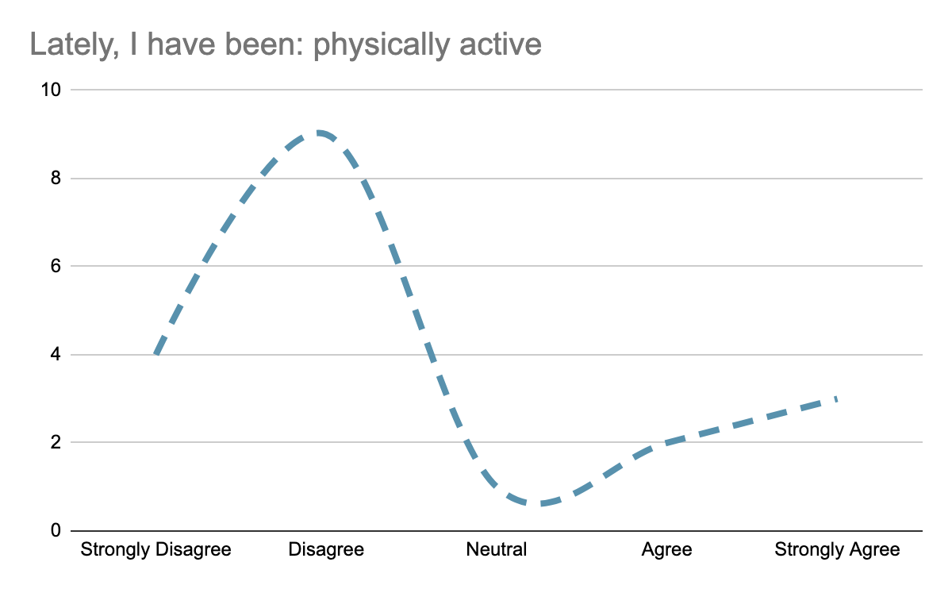

Challenges Associated with Remote Education. Remote education, and or distance education, offers a platform for students to engage with lecture material through a technological device. This system, while beneficial for some students, offers many challenges for others. These challenges include, but are not limited to, an increase in screen exposure, decrease in attention, and a decrease in social engagement.

Prolonged exposure to a screen.

Decreased Social Engagement. School, for many student, offers an opportunity to

Role that ‘Structure’ and ‘Organization” Plays in Overall Wellbeing

Benefits of Intermittent Physical Activity

