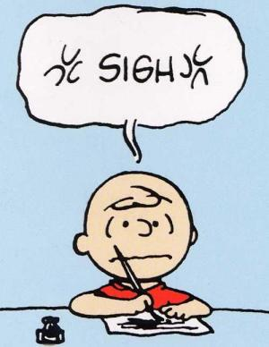**Chapter 2 Test Review Checklist**

Material covered in the test will be in pg. 70-91 of your textbook.

If you know the answers to all the questions on this checklist correctly (and can remember them), you will do well on the test.

**Although not in the textbook, nutritional charts will be included on the test:**

Can you read a nutritional chart?

Do you know where to find serving size, total fat, calories, and sodium?

How do you calculate your daily intake of fat/sodium based on the % daily value?

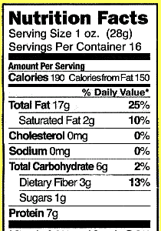**Example:**

How much fat is contained in one serving?

How many calories are contained in two servings?

How many servings can I eat before I reach my daily recommended intake of fat?

In your opinion, is this item of food healthy or unhealthy? Should I eat a lot of servings of this food?

**Circulatory System (pg. 84-89)**

Do you know what the 4 chambers of the heart are called and where they are located on a diagram?

Do you know the path of blood through the heart?

What kind of blood travels through the right atrium and right ventricle? What kind of blood travels through the left atrium and left ventricle?

What’s the biggest artery in the human body? What are the biggest veins in the human body?

Why does the left side of the heart have thicker walls?

Why is the right atrium and right ventricle on the left side of heart diagrams?

What do all veins have in common? What do all arteries have in common?

Why do arteries have thicker walls than veins? Why do veins have valves?

What are capillaries? Why are the walls in capillaries so thin? What occurs at site of capillaries in the human body?

What makes the pulmonary artery different from all other arteries? What makes the pulmonary vein different from all other veins?

**Respiratory System (pg. 90-91)**

Do you know the path of air through your respiratory system?

Can you explain how the process of gas exchange works in the alveoli? **To best answer this question, mention these terms (diffusion, concentration)**

What does the epiglottis do?

Your alveoli have very thin walls. Why is that?

How do your respiratory system and circulatory system work together?

Digestive System (pg. 70-76)

What path does food take through your digestive system?

What are the four stages of digestion?

What is the difference between mechanical digestion and chemical digestion?

What does saliva do? What does pepsin do?

What is peristalsis? Where does it occur?

What occurs at the stomach? The small intestine? The large intestine?

Why purpose do villi in the small intestine serve?