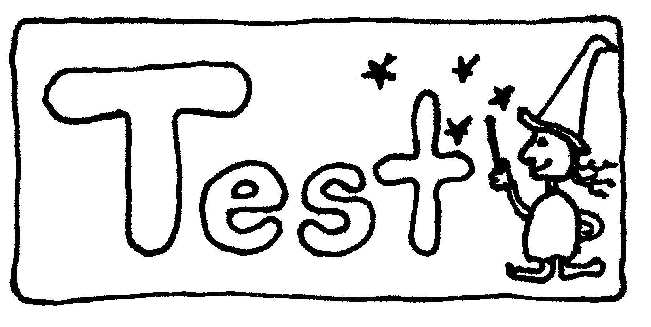**Chapter 2 Test (Maximum 50 marks)**

**Greetings grade eights! Before you start, please flip through the test to make sure there are 7 pages. Good luck!**

**PART A**

**Multiple Choice:** For each of the following questions, circle the letter of the answer that best answers the question.

1. What is the difference between inhaled air (air we breathe in) and exhaled air (air we breathe out)?
2. They are the same.
3. Inhaled air contains more oxygen.
4. Inhaled air contains more carbon dioxide.
5. Inhaled air contains less oxygen.
6. What does the epiglottis do?
7. It digests food by breaking down particles.
8. It is the site of gas exchange.
9. It blocks the trachea when you swallow so food goes down the esophagus.
10. It is the site of cellular respiration.
11. Where are the alveoli located?
12. Lungs
13. Trachea
14. Oral cavity
15. Larynx
16. What is the purpose of alveoli?
17. Reabsorbs water from food
18. Site of gas exchange
19. Supplies blood to the rest of the body
20. Prevents blood from reversing
21. Where does air first enter the respiratory system?
22. Nasal cavity
23. Pharynx
24. Epiglottis
25. Lungs
26. What are the smallest blood vessels?
27. Capillaries
28. Arteries
29. Veins
30. 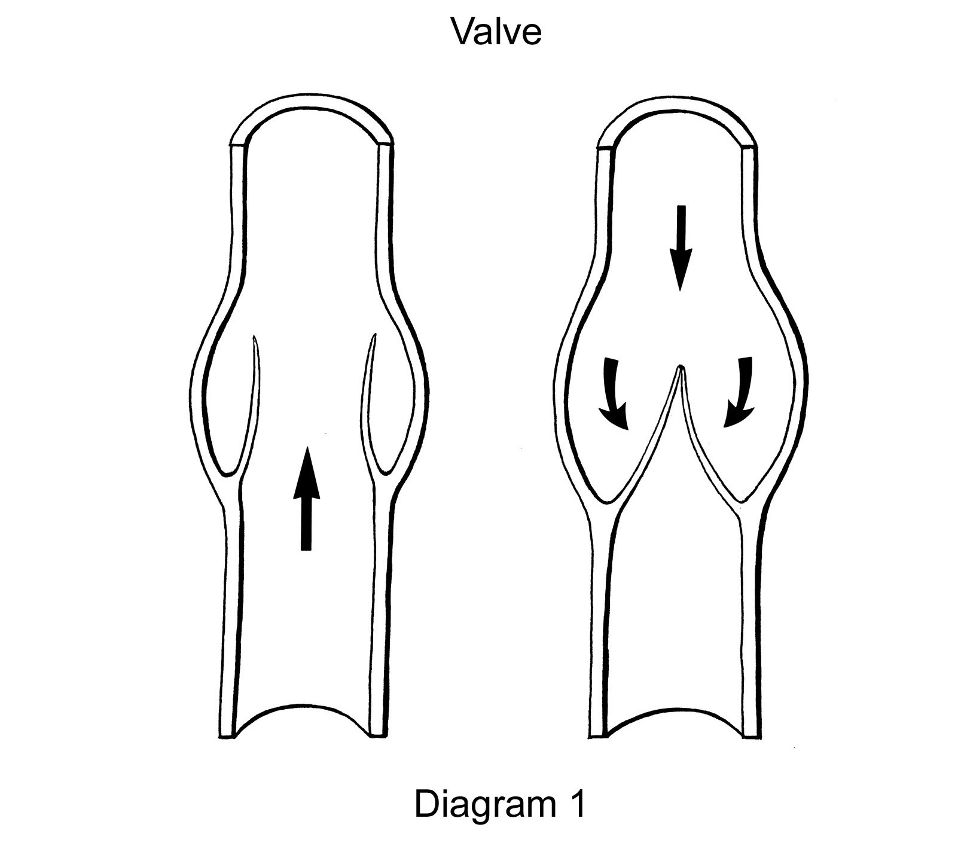Aorta
31. What kind of blood vessel to the right?
32. Capillary
33. Artery
34. Vein
35. Bronchi
36. What is the biggest artery?
37. Arteriole
38. Inferior Vena Cava
39. Superior Vena Cava
40. 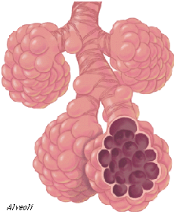Aorta
41. What structure is to the right?
42. Bronchiole
43. Alveoli
44. Bronchi
45. Pharynx
46. Why do capillaries have such thin walls?
47. So nutrients and gases have an easier time diffusing in and out.
48. So it can hold more blood.
49. To fit inside the human body.
50. To provide structural support for the circulatory system
51. The total of all chemical reactions that happen in a cell and lets the cell to carry out life functions is called...
52. Life activity
53. Metabolism
54. Cell cycle
55. Nucleus merry-go-round
56. A cell wall is found in which of the following cells?
57. Animal cells
58. Plant cells
59. Bacteria
60. All cells
61. The structures that may be observed in the cells of the sunflower but not in the cells of rabbits are ...
62. Nucleus
63. Vacuoles
64. Endoplasmic reticulum
65. Chloroplasts
66. What is true about the cell membrane?
67. It is the same as the cell wall.
68. Both plant and animal cells have a cell membrane.
69. It doesn't let any particles through.
70. It lets all particles through
71. A cell that has organelles that are **not** surrounded by membranes is known as..
72. Prokaryotic cells
73. Plant cells
74. Eukaryotic cells
75. Animal cells
76. When a chef is cooking food in the kitchen, the smell spread around into other rooms. This process is known as...
77. Cell theory
78. Expelliarmus
79. Prokaryosis
80. Diffusion
81. If you put drops of dye in a beaker of water, what do you think will happen?
82. The dye will spread throughout the water.
83. The water will freeze.
84. The dye will remain in a drop and sink.
85. The dye will get absorbed by the water.
86. A semipermeable or selectively permeable membrane means that...
87. The membrane doesn't let anything through.
88. The membrane only lets sugar through.
89. The membrane lets certain particles through but not others.
90. The membrane let's anything through.
91. What do all arteries have in common?
92. They carry deoxygenated blood
93. They carry blood away from the heart
94. They have valves
95. They have thin walls.
96. What is the path of blood through the heart?
97. Left atrium 🡺 Left ventricle 🡺 Pulmonary artery 🡺 Lungs 🡺 Pulmonary veins 🡺 Right atrium 🡺 Right ventricle 🡺 Aorta
98. Left atrium 🡺 Left ventricle 🡺 Pulmonary artery 🡺 Body 🡺 Pulmonary veins 🡺 Right atrium 🡺 Right ventricle 🡺 Lungs
99. Right atrium 🡺 Right ventricle 🡺 Lungs 🡺 Pulmonary Artery 🡺 Left atrium 🡺 Left ventricle 🡺 Inferior Vena Cava
100. Right atrium 🡺 Right ventricle 🡺 Pulmonary artery 🡺 Lungs 🡺 Pulmonary veins 🡺 Left atrium 🡺 Left ventricle 🡺 Aorta

**PART B   
True or False:** For each statement, circle True or False.

|  |  |  |
| --- | --- | --- |
| True | False | 1. Chemical digestion starts in the mouth |
| True | False | 1. An animal cell contains the same organelles as a plant cell. |
| True | False | 1. The cell theory states that cells can come from non-living material. |
| True | False | 1. A vacuole is an organelle that sorts and packages proteins. |
| True | False | 1. Ribosomes are attached to the endoplasmic reticulum. |
| True | False | 1. Plants have both mitochondria and chloroplasts. |
| True | False | 1. Both plant and animal cells contain cytoplasm. |
| True | False | 1. Photosynthesis refers to the movement of particles from an area of higher concentration to an area of lower concentration. |
| True | False | 1. A hypothesis does not have to be right. |
| True | False | 1. When cells are placed in pure distilled water, it will tend to shrink. |

**PART C**

**Short answers: Please answer in complete sentences.**

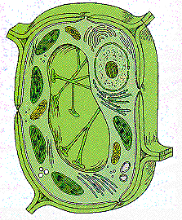

1. Is the cell to your left a plant or animal cell? Name 3 things

that led you to your conclusion. (4 marks)

2. Why is a computer not considered a living thing? Provide 2 reasons. (2 marks**)**

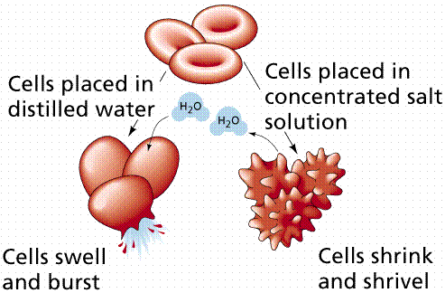

3. The diagram to your left shows red blood

cells. When red blood cells are placed in

distilled (pure) water, the cells swell and

burst. When it is placed in a concentrated

salt solution, the cells shrink.

Explain why the cells on the right shrunk and the cells on the left burst. (4 marks)

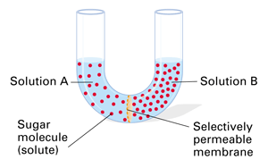4. You have set up the following apparatus. The

membrane in the middle allows water though but

not sugar. What do you expect to happen to the

water level on the two sides? Explain your

reasoning. (4 marks)

**PART D**

**Critical Thinking: The answers to these questions do not appear in your textbook. Use the knowledge you've gained and apply it to new situations.**

1. Do human cells contain chloroplasts? If not, how might our lives be different if our cells did contain chloroplasts? (2 marks)

2. Dehydration is defined as an excess loss of water and can be extremely dangerous. Explain why it is dangerous based on what you know about osmosis. (2 marks)

3. Based on what you know about diffusion, what do you think will happen if diffusion worked the opposite way? What would you see if you put 3 drops of food colouring into a beaker of water? (2 marks)

Capillaries are located throughout your body and also surround the alveoli in your lungs. However, there is one key difference between the capillaries surrounding the alveoli and the capillaries located elsewhere in your body. What is that difference? **Hint: It involves exchange of materials.**

What would happen if blood from the left side of the heart mixed with the blood from the right side of the heart? How might that affect the human body?

At high altitudes, oxygen concentration is a lot lower than oxygen concentration at sea level (vancouver). People often have suffer symptoms such as breathing difficulty, faigue, and migraines. Why might this be? **Your answer should mention the respiratory and circulatory system in some way.**