Creating a Portfolio on UBC Blogs (WordPress)
Maintaining an online portfolio helps students collect and display their coursework in an online format. Portfolios can enable reflection upon their learning in a systematic way while also allowing communication of skills and achievements with potential employers, collaborators, and other audiences. A portfolio can combine projects from one or many courses and even document projects you are doing outside of UBC.
Getting Started
- Go to https://blogs.ubc.ca/ and click on the “CWL Log-in” button to log-in with your UBC CWL username and password
- Click on “Create a Website” then create a site name (in lowercase a-z only) (this is your permanent url and cannot be changed). Try to keep your site name simple. Then create a site title which reflects you and your interests (this can be changed later on). You can allow search engines to index your site or not. These settings can be changed later.
- Find your “Dashboard”. From your “Dashboard” go to “Settings -> Reading” and select “I would like my site to be visible only to Registered network users” or choose one of the more public options if you want your site to be open to the world.
Customizing your Portfolio
- Clean House: Click on “Pages” and trash the default “Sample Page” then click on “Posts” and delete “Hello World!” so you can start with a blank slate.
- Create a page: from your “Dashboard” click “Pages” from left-side menu and create a page by clicking “Add New”. Try naming this page “Profile” and writing a short description of yourself. Let us know who you are! Click “publish” to save your changes. Your default “Home” page is set to show all the posts/projects you’re working on.
- From your “Dashboard” click “Customize Your Site”. From here you can customize almost all aspects of your portfolio, from its appearance to custom widgets.
- When selecting an Appearance simplicity can be a virtue. Start simple and choose more complicated themes as you become more comfortable with your portfolio. McKinley, Pilcrow and Twenty Twelve are all excellent, professional-looking themes. We recommend Mixfolio.
- Edit your Site Title & Tagline. Make sure to change the default tagline: this is not ‘just another UBC blog’!
- Widgets can add a lot of customization options to your site. They can also add a lot of clutter. Feel free to remove any or all of the default widgets to give your portfolio a clean, professional look.
- Remember to “save & publish” all your changes!
- For more information on how to use and customize UBC Blogs: http://wiki.ubc.ca/Documentation:UBC_Blogs/FAQ

Seven Portfolio Design Tips
- Stick to simple website design, let your work be the focus.
- Use eye-catching images - make a feature image for all your posts (this makes your blog more attractive).
- Showcase the type of work you want to do in the future.
- Make the site user friendly – can visitors find your best work using your menu and sidebar?
- Think of your audience – every post is a story, who are you telling it?
- Make your profile succinct, approachable, and about your point of view/ambitions.
- Provide links to your other professional and/or artistic online activity (GitHub, LinkedIn, SoundCloud, etc.) on your profile. Include your contact information!

Organizing your Portfolio Posts (i.e. Projects)
You should categorize your posts so that your readers can find what your posts are about. This is especially important for TAs and your instructor. Your categories can include anything you like, but every post you do for a specific course must be categorized by a unique course number category (e.g. GEOG379, GEOG310, GEOB270, etc.).
Here is information about categories and how to use them https://en.support.wordpress.com/posts/categories/
Here is a screen shot showing the process of adding a category to a post, it is just on the right hand side of the post composer (where you write your posts).
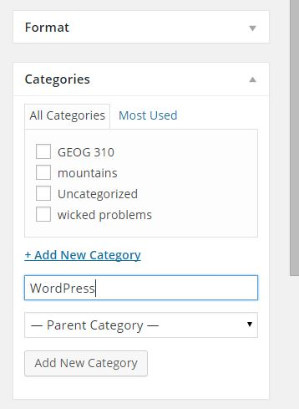
UBC Blogs Portfolio Guide by UBC Portfolio Project is licensed under a Creative Commons Attribution-ShareAlike 4.0 International License.

