EFFICIENT USAGE OF RECYCLING STATIONS AT THE UNIVERSITY OF BRITISH COLUMBIA

For: UBC Sustainability Program
Author: Eric Zhang
ENGL 301 Student

Date: March 16, 2022

Table of Contents
Letter of Transmittal….……………………………………………………………………………………………………………. 4
Abstract……………………………………………………………………………………………………………………………………. 5
Introduction……………………….….………………………………………………………………………………………………….6
Background of Sorting Station and Recycling status at UBC…………………………………….……. 6
Purpose of this Report and Identify Areas of Concern…………………………………………………….6
Potential Solutions ……………………………………………………………………………………….……………….7
Research Method……………………………………….………………………………………………………………….7
Scope of this Inquiry……………………………………………………………………….……………………………. 7
Data Section……………………………………………………………………………………………………………………………...8
Frequency of Usage………………………………………………………………………………………………………. 8
Difficulty of Usage……….………………………………………………………………………………………...........9
Effectiveness of Usage….………………………………………………………………………………………………. 9
Student Participation…………………………………………………………………………………….……………. 10
Conclusion……………………………………………………………………………………………………………………………….11
Summary of results………………………………………………………………………………….…………………. 11
Benefits of Hiring Sorting Station Employee ………………………………………………………………. 11
Suggestion for future studies……………………………………………………………………………………….12
Works Cited……………………………………………………………………………………………………………….…………. 13
Appendices……………………………………………………………………….……………………………...…………………….14
Survey Questions………………………………………………………………………………………………...………14

Figures and Tables (Draft)
Figure 1
Figure 2
Figure 3
Figure 4

Letter of Transmittal (Draft)

Abstract (Draft)

Introduction
Background of Sorting Station and Recycling status at UBC
You may have seen many garbage stations across the UBC campus where there are four different color of garbage bins. Green bin is for food scraps; Grey is for containers; Blue is for paper; and black is for garbage. While many of us, who are doing our part to protect the environment by sorting our wastes, there are many others who are still not doing their part. UBC Life Building and the AMS Nest are primary social gathering locations for UBC students. Many students eat lunch there because it is easy to access, and it is near majority of the food restaurants. These busy venues produce the most garbage out of all the recycling stations across campus. Often, the janitors were forced to separate food scrapes, plastics and paper from the black bin which consist of garbage.
Purpose of this Report and Identify Areas of Concern
The purpose of this report is to determine the current usage and satisfaction for sorting stations at UBC. In addition, we explore the opinions of the members of UBC on possible solutions. Furthermore, it provides recommendation for enhancing the proper use of sorting stations at UBC.
The major area of concern is that some students do not separate their own wastes., which defeats the purpose of recycling stations. There are two factors that contribute to this issue. One, the students are not sure which item belongs in which bin. This leads to the second factor, which is that some students are lazy. When the student is unsure which items go into which bin, they are too lazy to find out and they proceed to throw everything in the black bin.
Potential Solutions
One possible solution to this problem is to add personnel to manage some of the recycling stations. Not adding someone to every single recycling station, but the ones that receives the most garbage. For instance, the AMS Nest or the Life building. This is similar to recycling stations at local malls, where people drop off their food trays and the person at the station takes care of the rest by sorting the wastes into their respective bins.
Research Method
My Primary data source will be a survey to all the students, professors and workers who have access to the recycling stations. The survey can provide some insights and important knowledge for us to approach our solution. My secondary sources will include studies of members of UBC Sustainability and literature on benefits and motivations on recycling.
Scope
This paper investigates the following questions:
1) How often do students throw out garbage at the recycling stations.
2) Do students separate their waste and make sure they are thrown out into the right bin?
3) How much do students care about recycling?
4) What is the hard cost and soft cost of hiring personnel to manage recycling stations?

Data Section
Frequency of Usage
The participants of this study are students or staffs at the University of British Columbia who have access to the sorting stations. Table 1 shows the frequency of how often these participants access the sorting stations and sort their wastes.
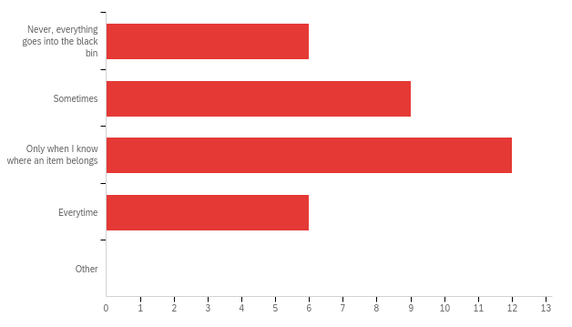
Figure 1 – Frequency of usage of sorting stations among participants
As expected, 9 out of 28 participants sometimes use the recycling station and 12 out of 28 participants only use the recycling stations when they know what kind of waste goes in which color bin. On two different extremes, 6 out of 32 who participated in the study either never uses the recycling station and throw everything into the garbage (black) bin or uses the recycling station efficiently and sort their wastes every time.

Difficulty of usage
Figure 2 shows the difficulty from the participants’ perspective when accessing the recycling stations. In other words, do the participants know what kind of wastes go into which bin.
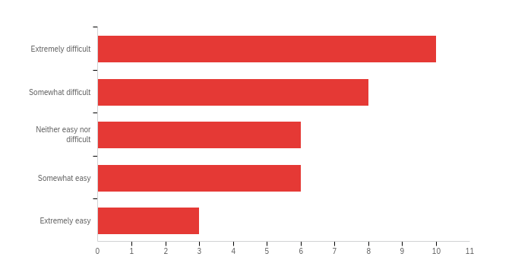
Figure 2 – Difficulty when accessing the sorting stations
Out of 33 people who participated in this study, 10 people thought the recycling stations were extremely difficult to use, and 8 people thought the sorting stations were somewhat difficulty to use. There are 6 people who were neutral about the difficulty of the sorting stations. On the other hand, only 6 people who thought that the sorting stations were somewhat easy to use. Only 3 people knew exactly which item goes into which bin.
Effectiveness of Usage
Participants were asked if they thought it would be beneficial to hire an employee to manage the recycling stations. Figure 3 shows the result of question.
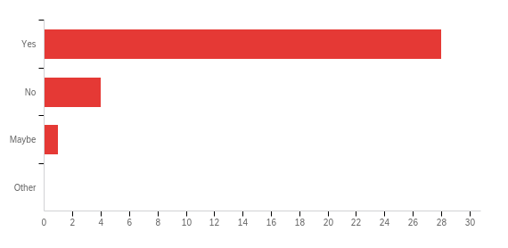
Figure 3 – Shows if the participants think it would be beneficial to hire an employee to manage the recycling stations
Majority of the participants believe it would be beneficial to add someone to do the sorting for them. Only 4 people thought it was a bad idea to hire an employee, and 1 person thought that maybe it would be beneficial to hire an employee. This way guarantees that the recycling stations are functioning efficiently.
Student Participation
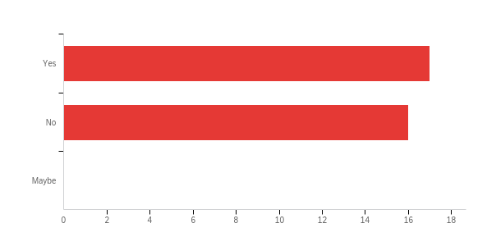
Figure 4 – Shows if the participants would be willing to work at the sorting stations
Participants were asked if they are willing to work at the sorting stations if they were being paid and the results were shown in Figure 4. We can see an even split, where 17 people would be willing to work at a sorting station and 16 people would not.
Conclusion
Summary of Results
The survey reflected participants’ thought on the current situation at the sorting stations and if they were being effective. The results have shown that majority of the participants, 24 out of 33 participants does not think the recycling stations were easy to use. As a result, 22 out of 33 participants use the different color bins when they know if an item belongs in that bin. In addition, majority of the participants, 28 out of 33 people believe it would be beneficial to add an employee at these recycling station whose responsibility is solely to sort the wastes to maximize the efficiency of the recycling bins. This is the proposed solution and survey also reflected that 52 percent of participants are willing to take on that responsibility with decent pay. That is a decent amount of interest to jump start this process.
Benefits of Hiring Sorting Station Employee
Today, it is up to the “individuals” who has the liberty of invoking their subjective judgement when to (or when not to) perform pro-environmental behaviours based on different factors underpinning such a decision-making process (Oke, 2016). However, the results have shown differently, as people are not currently using and fulfilling the purpose of recycling stations. Therefore, the sorting stations have not been used efficiently. Hiring a sorting station employee will save a lot of time and confusion from all the students. In addition, it shows the students that it is very important to recycle, which opens the possibility of individuals to recycle when they are at a self managed station. Adding an employee also creates a possible part time job position for university students. Ultimately, adding an employee ensures that the recycling stations are maintaining the purpose of recycling.
Suggestion for future studies
The main suggest for similar future studies is to increase the sample size of the participants. This survey was published on social media websites that included many students and staffs of UBC. Only 32 people participated in the survey out of 64,158 students or staffs at UBC. Larger sample size will increase the accuracy of the study.

Works Cited (draft)

Oke, A. Kruijsen, J. 2016. The Importance of Specific Recycling Information in Designing a Waste Management Scheme. MDPI. https://www.mdpi.com/2313-4321/1/2/271/htm

Appendices (draft)
Survey Questions

Q1. How often do you eat on campus per week?

a) 1 day
b) 2 days
c) 3 days
d) 4 days
e) 5+ days

Q2. How much does the sorting stations contribute to the sustainability at UBC?

a) Not at all
b) Somewhat
c) Neutral
d) Very

Q3. What is the level of difficulty when using the waste sorting stations on campus? In other words, do you know what goes in where?

a) Extremely Difficult
b) Somewhat Difficult
c) Neither Easy nor Difficult
d) Somewhat Easy
e) Extremely Easy

Q4. How often do you sort your own garbage at the sorting stations?

a) Never, everything goes into the black bin
b) Sometimes
c) Only when I know where an item belongs
d) Every time
e) Other

Q5. Do you think it would be beneficial to have someone at the stations to sort the wastes?

a) Yes
b) No
c) Maybe
d) Other

Q6. If a position to sort the waste station is available with decent pay, would you be willing to take on the position?

a) Yes
b) No
c) Maybe

