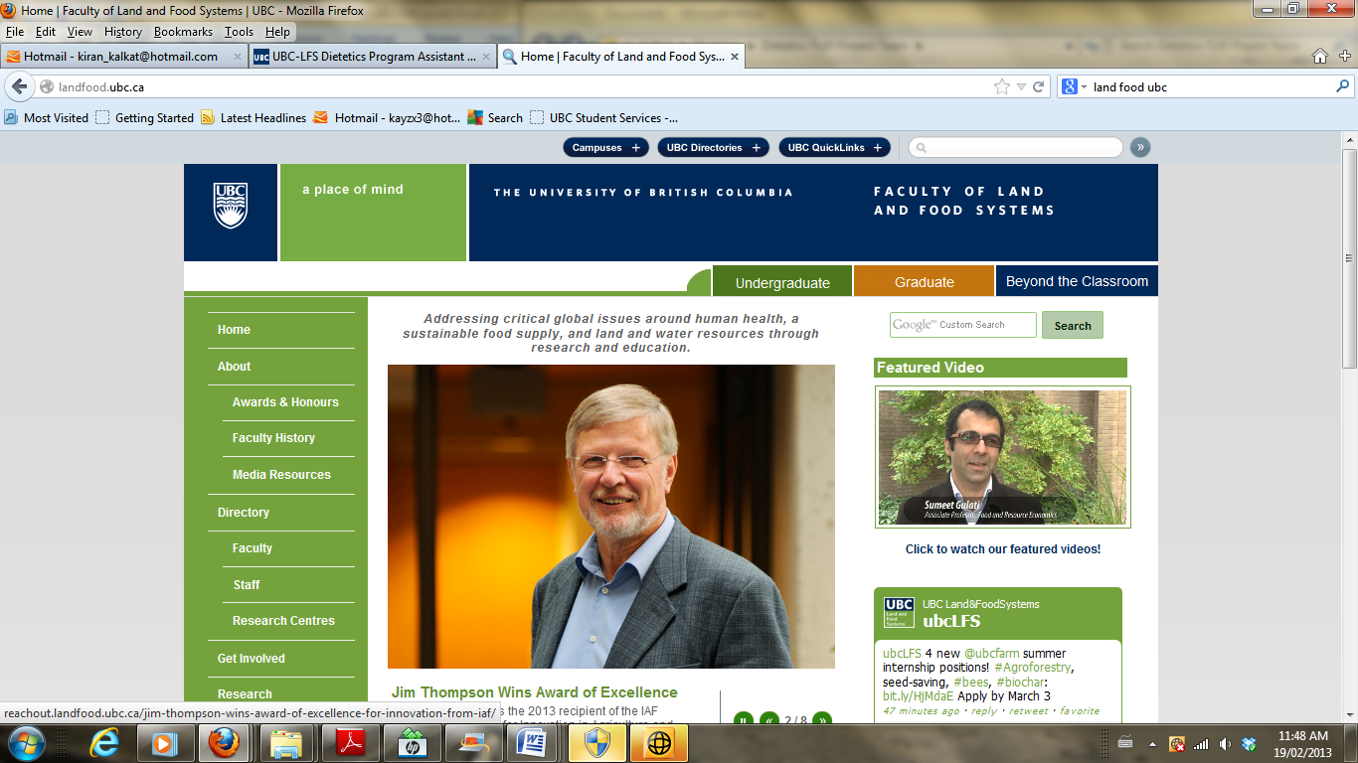

**FNH 380**

**Learning Plan Form**

|  |  |
| --- | --- |
| **REQUIRED INFORMATION** | **ENTER INFORMATION BELOW** |
| **Date:** | November 13,2018 |
| **Student Name:** | Fariba Rajabi |

To create your learning plan for the current year (**to be achieved by the end of April 2019**), establish **TWO** SMART(specific, measurable, attainable, realistic and timely) goals that align to ICDEP requirements. Choose goals that you know you will work on, as you will be asked to report on outcomes in **FNH 381** in May **2019**.

Types of goals students have pursued to date include:

* Pursue volunteer or employment activities related to specific competency areas
* Pursue strategies to enhance applied experiences related to concepts learned in courses
* Undertake self-study to enhance your knowledge related to specific competency areas
* Interview dietitians in various areas of practice to learn more about their approaches to specific aspects of the competencies
* Interview students in upper years of the program and/or new graduates to enhance your knowledge about how they have worked towards competency attainment

Note that carefully prepared goals can contribute to your development related to multiple competencies.

|  |  |  |  |  |  |  |
| --- | --- | --- | --- | --- | --- | --- |
| **SMART Goals** | **Target Date**  (no later than  **April 2019**) | **Competency Performance Indicators Impacted**  **(list number and letter)** | | | | |
| **Professional  Practice** | **Communication and Collaboration** | **Nutrition Care** | **Population and Public Health** | **Management** |
| 1. Gain knowledge on counseling principles by:  * Listening to 12 podcasts (15 minutes each) downloaded from Steps Into Excellence, an online course offered by Molly Kellogg * Toastmasters Communication pathways: 4 out of 10 lessons completed | April 30th | 1.05. 1.06, 1.08, 1.10 | 2.01, 2.03, 2.04 |  |  |  |
| 1. Gain knowledge in clinical pediatric nutrition by:  * attending [4th Annual BC Pediatric Diabetes Day](https://ubccpd.ca/pediatric-diabetes2019) on February 1st and 2nd * Job shadow a pediatric dietitian for 20 hours | April 30th | 1.3 | 2.06 d&h, | 3.01 |  |  |

|  |  |
| --- | --- |
| **FNH 380 Peer Review** | |
| **Name of peer reviewer:** | Maryam Sedaghatian |
| **Date of review:** | *November 25, 2018* |
| **Peer reviewer comments and recommendations:** | |
| 1. ***Comment on whether the student considered a range of experiences (e.g., academic, volunteer, employment, personal), and identify whether any of these areas could be enhanced.*** | |
| * + - ***Fariba has a great experience in culinary and blogging, which is an asset in dietetics profession. Sources of learning for different competencies were mentioned, with a short but informative comment related to each point. With her great experience and background, Fariba could divert her focus into achieving some managerial experiences. She could start by take a volunteer role in a food service department or apply for a food service supervisor position to gain more insight into management competency section of dietetics profession.*** | |
| 1. ***Identify any instances in which the connections between the cited experiences and dietetics competencies are unclear. Have any opportunities been missed to identify linkages between experiences and competency attainment?*** | |
| * + - ***Linkages nicely tied to each competency. I noticed in some areas the learning source is identified with “Yes” making it unclear what the actual source is. I believe mentioning the source would make it more clear as to why and how the experience is linked to the competency.*** | |
| 1. ***Are the SMART goals Specific, Measurable, Attainable, Realistic, Timely? Identify any suggestions for improvement*** | |
| * + - ***Fariba chose great SMART goals. Both goals would contribute greatly to competencies related to dietetics profession. We are both interested in improving our communication skills and Toastmaster is one of the best ways to achieve that goal. With our similar goals we can definitely support each other towards success and accomplishment.*** | |

|  |
| --- |
| **FNH 380 Student Response to Peer Review** |
| ***Comment on how peer feedback was utilized in producing the final version of your plan:*** |
|  |