

TABLE ROUTER

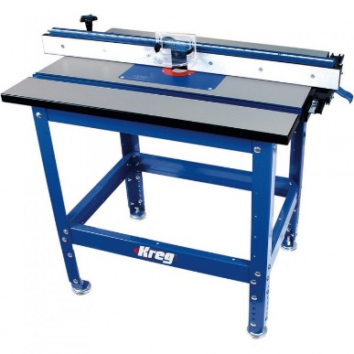

WARNING!

* Eye and ear protection required
* No loose clothing, tie back long hair
* Turn off the machine at the isolation switch
* when making any adjustments
* Install bits with at least 15mm of the shaft in the collet chuck,

any less and the bit could vibrate loose during use.

* Make sure the bit is clear of the stock before turning on
* Keep your hands and fingers at least 3” away from the bit
* Take light cuts; larger cuts can result in kickback
* ALWAYS cut against the rotation of the bit
* Use caution when cutting against the grain
* Use the fence to decrease the depth of cut.

