Name: /20
Rubric: Full back swing
Physical education Grade 10
 | Does not meet expectations | Approaching expectations | Meets expectations | Exceeds Expectations
Grip  /4 | Dominant and non-dominant hands are mixed up (dominant hand on the top, non- dominant hand on the bottom) | Non-dominant hand grips the club second  All 5 fingers of the non-dominant hand are gripping the club as if making a fist  Non dominant and dominant hand grip the club but there is space between the hands  Thumbs are wrapped around the club as if holding a baseball bat | Non-dominant and dominant hand grips the club simultaneously  Non-dominant hands last 4 fingers are producing most of the grip on the club  Non dominant and dominant hand grip the club directly below each other with no space between the hands  The thumb of the dominant hand is s centered and covers the non-dominant hands thumb | Non- dominant hand grips the club first  Non-dominant hands last 3 fingers are producing most of the grip on the club  Pinky of the dominant hand sits on top of the forefinger of the non-dominant hand  The thumb of the dominant hand is slightly off centre and covers the non-dominant hands thumb
Body mechanics  /4 | Student does not form a triangle with both shoulders and the club at the bottom of the swing or during the swing.  At the top of the swing, shoulders and hips have not turned (only the arms have moved).  Left arm is drastically bent and the axis of the spine is dramatically off centre.  At the finish, hip remain at the starting position, elbows are low, and the back foot is flat on the ground. | Student does not form a triangle with both shoulders and the club at the bottom of the swing or during the swing  At the top of the swing, shoulders have turned at least 60 degrees and, hips have turned 15 degrees  Left arm is bent and the axis of the spine is not straight.  At the finish, hips are not facing the target, elbows are low, and the back toe is only slightly pointed | Student forms a triangle with both shoulders and the club at the bottom of the swing but loses it at the start of the backswing  At the top of the swing, shoulders have turned at least 75 degrees and, hips have turned 30 degrees  Left arm is slightly bent and the axis of the spine is not centered.  At the finish, hips are almost facing the target, elbows are high, and the back toe should be pointed | Student forms a triangle with both shoulders and the club at the bottom of the swing and maintains it at the start of the backswing  At the top of the swing, shoulders have turned 90 degrees and, hips have turned 45 degrees  Left arm is straight and the axis of the spine is straight.  At the finish, hips should be facing the target, elbows are high, and the back toe should be pointed
Name: /20
Rubric: Full back swing
Physical education Grade 10

Contact with the sports object (using a 9 iron)  /4 | Ball travels 20 yards or less. | Ball is contacted and travels in excess of 20 yards | Ball is contacted and travels in excess of 50 yards | Ball is contacted and travels in excess of 100 yards
Peer and personal connection  /8 | Student has an unexcused absence for 2 or more classes during the unit | Student has an unexcused absence for 1 class. Student is late for 2 or more classes during the unit  Student provides minimal feedback to their partners on how to improve. | Student is present for every class. Student is late for 1 class during the unit.  Student provides either verbal or physical feedback but does not provide both forms of feedback | Student is present and on time for every class  Student provides both verbal and physical feedback to their partners throughout the unit

Task Description: Performing a Full back swing
Objective: For this particular unit, students will be introduced to the game of Golf, and will through a series of lessons learn how to correctly swing the golf club. In order to perform well at this task, students will need to first learn the chip shot and the half swing. Although students will be assessed on their task performance, it should also be noted that the underlying Peer and Personal connection for this unit is to “Be a great coach”. Students need to work well in pairs and need to use direction to help coach their partners whilst maintaining enthusiasm throughout each lesson during the unit. There are four criteria for success at performing this task. They are as follows: 1. Grip, 2. Body mechanics during the swing, 3. Contact with the sports object, 4. Peer and Personal connection (20 marks total).
Grip:  This section of the skill performance will focus on the correct method of gripping the golf club when performing a full back swing. One should utilize the following guide when checking for the correct grip. Students should be assessed for their grip at the beginning and the end of the full back swing. If their hands have not shifted, they have exceeded expectations (4 marks).  (For directional terms such as “left”, ensure that students who are left handed use the opposite to those stated in the illustrations) | 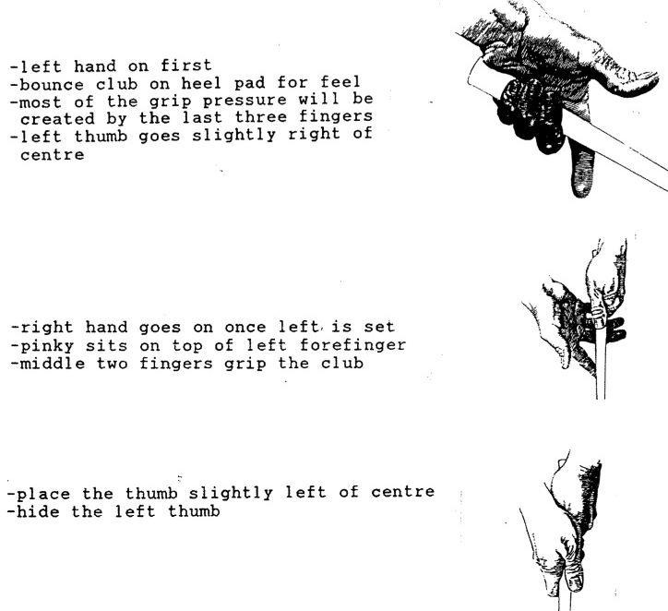
Body mechanics during the swing:
The most difficult part of the assessment is to grade the student’s actual swing. This is due to the fact that the movement is rapid and therefore very difficult to see. In order to ensure the assessment is valid, reliable, and fair, students will only be assessed at the start of the swing, the top of the swing, and at the completion of the swing. Students should be instructed to hold their finish, not only for the sake of assessment, but also to ensure their coaching partners can identify any errors during practice. Correct execution of all three phases results in full marks (4 marks). Guidelines for assessing the body mechanics during the swing are as follows:

(For directional terms such as “left”, ensure that students who are left handed use the opposite to those stated in the illustrations)

Contact with the sports object:
Assessment of the full back swing will take place at the driving range as students conclude the Golf unit. This is useful in assessing the contact with the sports object in that there are yardage markers at the driving range. In order to receive full marks, students will be required to hit the ball further than 100 yards using a 9 iron (4 marks)

Peer and personal connection:
For this particular unit, the peer and personal connection is to be a great coach. Students should be positively encouraging their partner throughout the unit and should be continuously providing their partner with feedback regarding their swing. In order to receive full marks, students should be present and on time for every class, and should provide both verbal and physical feedback to their partners throughout the unit (8 marks).

Analysis of the assessment task/ tool
Type of tool: Golf full back swing performance assessment rubric and in class formative assessment
Primary purpose: The task, the rubric, and the coach’s checklist will be used in both formative and summative assessment. The coach’s checklist will be used throughout the unit as a means to prepare students for their final assessment when they attend the driving range.
Grade and subject: Grade 10 P.E. (BC Ministry of Education, 2008)
Intended curriculum: Physical Education 8-10 Integrated Resource Package (2008)
Learning outcomes: This particular rubric focuses on 3 prescribed learning outcomes of the Grade 10 P.E. curriculum.
A4 - daily participation in moderate to vigorous physical activity to enhance fitness
B1- applies fundamental movement skills in a range of complex individual and dual activities
C4- applies leadership in a wide range of physical activity situations.
Criteria: Criteria for these learning outcomes are at the instructor’s discretion. The rubric that I have created ensures students have met the criteria. The criteria that I have created is loosely based on the preexisting criteria at Pinetree Secondary school.
Length/format: Task description (page 1-3), summative rubric (page 4-5), sample of formative assessment (page 6). The Golf unit covers 6 P.E classes including a trip to the driving range where the student’s swings will be assessed using the rubric.
Function of results: I will use the assessment to ensure participation, engagement in learning, development of leadership qualities, and as evidence of achievement of grades.
Frame of reference: Criterion-referenced according to the prescribed learning outcomes and my rubric criteria.
Marking scheme: Graded out of 20. Three of the four categories are marked out of 4 and the fourth category is marked out of 8 (see rubric). The peer and personal connection is the most important aspect of the P.E. semester and therefore is worth 40% of the student’s grade. The idea is to encourage students to be active participants not only in their own performance, but in improving their classmate’s performance.
Accommodations: In order to accommodate for students with IEP’s and ELL students, the formative assessment provides illustrations together with a checklist to ensure students understand how to correctly execute the biomechanics of the full back swing prior to being evaluated using the rubric assessment.
Relation to teaching, other assessments: This assessment relates to teaching in that the rubric provides students with summative feedback on what they have achieved during the unit as well as an understanding on how they may be assessed in future units. The formative assessment provides students with a checklist that allows them to understand how close they are to meeting the criteria of the summative rubric (with regards to the actual swing performance).
Tool description: There are two separate tools used to assess students during this unit. The formative assessment is provided to students first as it allows students to improve their performance task as they prepare for their summative assessment. The formative assessment is vital not only for the performance feedback it provides students, but also because it acts as a tool to improve the students peer and personal connection (be a great coach) grade. The summative rubric will be utilized on the final day of the unit when the students are at the driving range. The peer and personal connection section will be graded based on the duration of the unit whereas the other three categories will be assessed at the driving range in a 1 on 1 format.
High Quality Issues
Validity:
This tool will allow me to make valid inferences about a student’s ability to perform and coach a full back swing. The rubric includes clear outlines on what is expected from students with regards to the performance of the movement as well the peer and personal connection for the unit (see rubric criteria), and the rubric criteria address 3 specific prescribed learning outcomes of the physical education IRP (see learning outcomes). It is important to note that the goal of the physical education Integrated resource package is to enable all students to develop knowledge, movement skills, and positive attitudes and behaviors that contribute to a healthy and active lifestyle (BC Ministry of Education, 2008). The rubric criteria is then valid in that it does not merely focus on the ability to hit a golf ball, but rather it focuses on including how to hit a golf ball correctly and more importantly, how to teach someone else how to hit a golf ball.

Reliability:

Reliability in terms of assessment is defined as the confidence that the instructor has that the assessment process provides enough information about a students learning so that the instructor can make a sure statement about that students current understanding of the material (Manitoba Education, 2006). This assessment will allow me to make reliable inferences about student ability for two reasons. The first is that I will be collecting student’s formative assessment worksheets (see coaching checklist) and utilizing it in my final assessment of students. Secondly, students will also submit a daily self assessment score (out of 5) to be utilized in accounting for their peer and personal assessment score (see rubric). Through this method, links can be made to a student’s final grade for the unit as opposed to basing the grade strictly on a single performance.

Fairness:

Tierney claims there are six steps to fairness in the classroom setting (Tierney, 2013). This assessment is fair based on a number of these steps. The first is that the assessment is transparent. Students will be provided with a copy of the rubric prior to their assessment, and the formative “golf swing checklist” provides students with an adequate opportunity to know what they will be assessed on. The assessment always allows students an opportunity to demonstrate their learning. This pertains particularly to the fact that students will be assessed on their peer and personal connection over the course of the unit. Students will also be allowed to showcase their full back swing more than once to account for any possible errors that they may have shown if they only had one chance to swing. Finally, the tool consists of both clear summative and formative assessments (rubric, formative assignment) to make the criteria for learning clear.

Benefits and drawbacks:

This tool is beneficial to instructing a Golf unit primarily because the emphasis is on the peer and personal connection, which for this unit is to “be a great coach”. This is beneficial in that is trends away from the prototypical physical education approach that focuses exclusively on the physical performance of students.
The drawback to this tool is that it does not assess for students knowledge of the sport golf. A summative knowledge test could be designed to be utilized in tandem with this tool to assess for cognitive learning.

Works Cited
BC Ministry of Education. (2008). Physical education 8-10 Integrated resource package.
Manitoba Education. (2006). Rethinking classroom assessment with purpose in mind. Winnipeg, MB.: Manitoba Education, Citizenship and Youth, School Programs Division.
Tierney, R. D. (2013). Six strategies for fair classroom assessment. Education, Canada 53(3) , 20-23.

