Local Produce Purchasing Habits in Williams Lake
Sean Heinrichs and An Huang
May 8th, 2015

1. Introduction
While the globalization of food production has continued to distance consumers both geographically and socially from food producers and production areas, the emergence of small, local farms and urban farming movements has significantly contributed to sustainable food supply networks, which are seen as a partial solution to environmental and social challenges (Anttila, M., et al, 2013).
In an attempt to both connect our community partner, Brianna van de Wijngaard - the owner of Puddle Produce Urban Farms - with her customer base and increase the overall income of her operation, this study focuses on investigating the purchasing behaviour of Williams Lake’s residents. To gather research on this demographic, a survey was conducted which determined general trends and situated perspectives on the local food production and consumption. The data acquired from the 94 participants involved is thought to be beneficial on both a micro and macro level; aimed towards both small level producers (such as Brianna) and those in charge of city planning policy decisions. Alongside this, the research conducted in Williams Lake may also be helpful for facilitating urban farming and local food production in other towns of similar size.

2. Research Questions and Methodologies
Since the aim of this study was to explore the purchasing behaviour of the community residents in Williams Lake, it was necessary to use a quantitative approach, which offered respondents the tools to indicate their facts and views. Surveys were seen as the most appropriate method in this context to generate baseline data on the current state of consumers’ awareness of local food production, as well as the knowledge from the consumer about their purchasing behaviour, demand, and satisfaction (Jac et al. 2001).
We focused our enquiry through four questions: (i) what are the factors that go into consumers’ decision making when they are purchasing produce? (ii) where do consumers usually shop for produce? (iii) are consumers aware of local producers in Williams Lake and (iv) what are consumers’ opinions on the price and healthiness of local produce.
Besides surveying consumers at the Farmer’s Market, we also planned to carry out some of our surveys in three main supermarkets: Safeway, Save On Foods and Walmart in Williams Lake; however it turned out to be unattainable to get permission from the branch managers to conduct an in-store survey. This demographic was replaced with shoppers in the parking lot and associated side streets at random hours of the day. It was also opted to survey only community residents of Williams Lake who were purchasers of produce. As a result, we did not conduct any surveys with individuals who were not residents of Williams Lake. All respondents were aware that their survey formed part of our study.
We used a data-driven analysis in order to organize our findings, focusing on the major themes that reappeared across all the surveys. As such, we did not begin the analysis with specific questions in mind; however, we were keen to see how consumers’ view on local food production affect their purchasing behaviour and their motives on buying or not buying locally. Although our primary concern here is consumers’ awareness of Brianna’s urban farm and demand on her produce, the discussion of our study’s results draws on a bigger picture which indicates overall consumers’ awareness and demand on local food production.

3. Results & Discussion
The results of the survey determines what thought processes are involved in the purchase of produce in Williams Lake. To insure that a wide range of viewpoints were considered, numerous locations were chosen around the city. In total, 94 people were surveyed in the following locations: the supermarket, farmers market, grocery co-ops, parks and residential neighborhoods.
To pinpoint our demographics and situate the participants our first questions were on age and gender. According to the responses, 41 of the 94 people surveyed identified as male, 52 as female and 1 as other. The age of respondents ranged from 18 to 65 and older, with the majority occurring in the latter. This was not considered a surprising result, or due to this age bracket being more willing to talk with us but rather that it agrees with the 2011 census data situating the mean age of citizens in Williams Lake at an age of 41.2 (Statistics Canada, 2012).
The next set of questions was aimed at determining thought processes involved in consumer decision making when purchasing local produce. As shown in Figure 1 a total of 92 respondents were allowed to choose multiple answers. The overall data shows that the majority
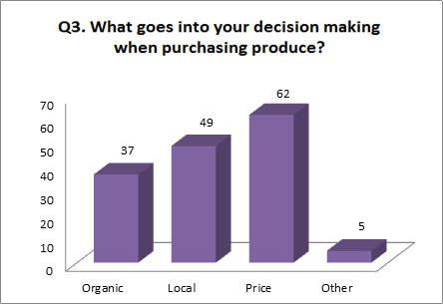
Figure 1: Sean Heinrichs and An Huang. “Local produce purchasing habits in Williams Lake.” Survey. 8 May 2015.

of citizens in Williams Lake feel that price was a more important determiner when purchasing produce than local or organic. The other in this category came from five informal interviews where participants said the following factors were important in their decision making: quality, country of origin, brand names and appearance.
When comparing surveys conducted near supermarkets to those at farmers markets, it was found that this trend was not ubiquitous. Instead, local becomes the primary factor in their decision making, however it is still closely followed by price. This suggests that those shopping at supermarket chains do so mainly because of the reduced price associated with produce at those locations. However, we were also told from many participants near grocery store locations that this was in combination with the convenience associated with grocery stores and that local food was only available for so many seasons of the year.
The following question in the survey examined which locations shoppers prefered when purchasing produce. Unfortunately, this ranking question did not always work as intended, with many of the respondents answering the question incorrectly. Instead of providing a rank from 1-5, a checkmark was issued for the most preferred location, while unpreferred locations were left blank, thus making a large amounts of these responses invalid. However, after looking at the invalid responses in more detail it was found that the majority of people checked Supermarkets as their only answer. When taking these into account, the results are drastically changes as the preference for Supermarkets/Retail near doubles, increasing its first choice from 23 to 43 (note the * in Figure 2). This data agrees with the previous data, indicating that supermarkets are preferred due to their year round availability, price and convenience.
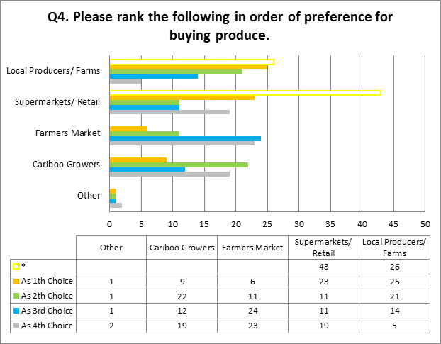
Figure 2: Sean Heinrichs and An Huang. “Local produce purchasing habits in Williams Lake.” Survey. 8 May 2015.
Question 5 and 6 were aimed at determining which local producers consumers were aware of, and how much was spent there every month. It was found that 60% of participants were aware of at least one local producer, however many were unable to recall which ones they knew. The following are the local producers which respondents could identify (in order of most well known to least well known): Puddle Produce Urban Farms, Mackin Creek Farm, Soda Creek Sweet Corn, Roads End Veggie Company, Empire Valley Premium Beef, and Springhouse Gardens. The following local producers were named just once: Fraser Bench Farms, Potato House, Rodear Meats, Spokin Lake Meats, Meldrum Creek Ranch, Hall's Organics, Rolph Stock Ranch, Whiskey Creek Acres and Frank's Plants. As far as the amount of money spent weekly at these locations it was seen (refer to Figure 3) that the majority of consumers did not spend more than $30 every month.
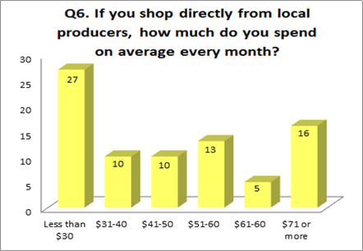
Figure 3: Sean Heinrichs and An Huang. “Local produce purchasing habits in Williams Lake.” Survey. 8 May 2015.
The final set of questions were used to determine whether participants felt that local food was too expensive, healthier and if they grew their own vegetables (see Figures below). When examining the trends in question 8 it was found that over 30% of survey participants felt that local food was too expensive. This suggests that a third of consumers can not fit local food into their budget. However, most participants did note that they believed local food was healthier and would choose to purchase it if it wasn’t for the fact that the supermarket was a cheaper and more convenient place to purchase food. Many participants also noted that one way to eat locally, while not suffering from the increased price was by growing food of their own. Surprisingly, over half of our respondents said they grew their own fruits and vegetables.
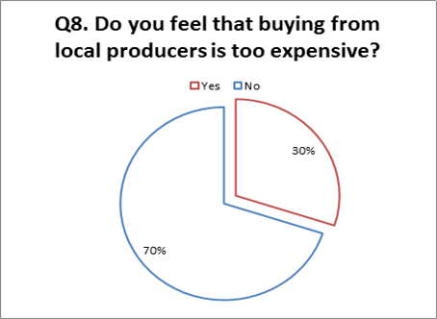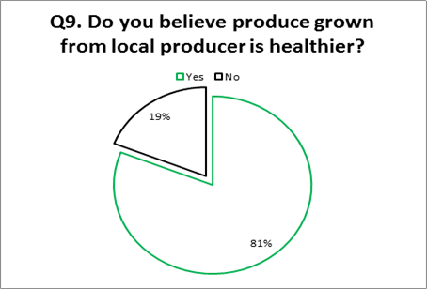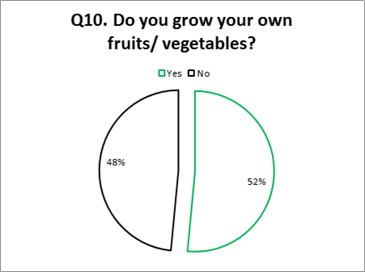
Figure 4, 5 & 6: Sean Heinrichs and An Huang. “Local produce purchasing habits in Williams Lake.” Survey. 8 May 2015.
4. Conclusion
In this study, we found that there was definitely a demand in Williams Lake for more local food. Participants were aware of local producers, and believed their food to be healthier, but the large majority were unable to consume these products due to budgetary constraints. Alongside price, another determinant was that local food is not always available due to its seasonal availability. As for long portions of the year consumers have little to no choice but to shop at supermarkets.
While this study acknowledges that success in urban farming is not always determined by financial gains, it is still realized as playing a primary role in business decisions. Unfortunately for small urban farmers such as Brianna, the price war against local food and supermarkets is seemingly an impossible task to win outright. Alongside this, reducing the price of goods to untap a wider share of the market could leave these small companies even more economically constrained, as many lack the capital required for expansion and seasonal staff. When it comes to providing for consumers that would purchase local food all year round, there are once again economic impediments. Both the costs of the permits required and the materials restricts the ability for small urban farmers to create long-term crop producing spaces.
With all of these factors in mind, the equation of increasing sales is both something that can be affected directly from the farmer, and from policy planners. Providing subsidies to local growers, or even working in conjunction to create community greenhouses could be an interesting step in becoming a more sustainable city. On top of it was noted by a great number of participants in the survey who usually buy from local producers that it would be great if local produces could create strategic alliances and cooperate with each other to increase the variety of products in the CSA Program and to offer customized produce box according to CSA members’ family size. Since Brianna is initiating her CSA program this year, further study on the demand of her CSA clients on produce can be helpful.

References
Jac Smit, Joe Nasr, and Annu Ratta. Urban Agriculture: Food, Jobs and Sustainable Cities. 2001 Edition. New York, N.Y: United Nations Development Programme. Jac Smith. Web. 6 Feb. 2015.
Anttila, M., et al. “Consuming Nostalgia? The Appreciation Of Authenticity In Local Food Production” (2013) 37 International Journal of Consumer.
Statistics Canada. 2012. Williams Lake, British Columbia (Code 5941009) and Cariboo, British Columbia (Code 5941) (table). Census Profile. 2011 Census. Statistics Canada Catalogue no. 98-316-XWE. Ottawa. Released October 24, 2012. http://www12.statcan.gc.ca/census-recensement/2011/dp-pd/prof/index.cfm?Lang=E
(accessed May 15, 2015)

