Week 6: TIMELINE TASK, activity outline.

Using the TimeGlider application: http://timeglider.com

Develop a timeline of significant events and transitions as they relate to Williams Lake as your research field site and community research partner.

You may use the following questions as a guide:
- Who lives and has lived in Williams Lake?
- What are the key moments that have altered and impacted the demographic makeup of Williams Lake?
- Are there important treaties or legislation that mark changes in the titles and rights to land, water, or other resources?
- Are there important moments or transitions that you can mark, that denote environmental evolution, adaption, development? Are there particular bio/eco/logical, animal, or human actors that are important to identify?
- etc….

In thinking about these key moments, periods, transitions, etc. keep in mind the question: Are these moments singular, iterative, and/or continuous? You can find ways to demonstrate this with your timeline, by colour coding, denoting that something is ongoing by lengthening the “event” dates, layering events, or through descriptive annotations. Be creative!

Each group will present their timeline to the class (brief, 5 mins per group), and there will be opportunities to add and change timelines after all groups have shared their timelines. They can then be loaded onto your group blogs. It is expected that many groups will present similar information, however, it is likely that based on your particular interest or research partners you will also include specific details most relevant to your research partner’s stake in Williams Lake.

Over the course of the term you may wish to add/change your timeline, as you discover more and more about the site. This timeline may prove useful too at the time of project completion, when you want to establish the context for your research, and how you identified your research questions, priorities and the connectivity of various aspects/issues identified in Williams Lake.

On the following page is a set of basic instructions, outlining how to use TimeGlider to start developing your Williams Lake Timeline.

USING TIMEGLIDER, STEP-BY-STEP

- Go to http://timeglider.com/ and click on “start a timeline it’s free”

- Students can sign up an account with TimeGlider for free. You can use your student email address to create an account, or a non-UBC email address will also work. It may also be worth making up a new email account that you can use as a group -- this will mean that you can have a log in that each group member can use to access the timeline from different locations if you need to work on this while apart.
.
- Now that you’re logged in, you can get working on your timeline.
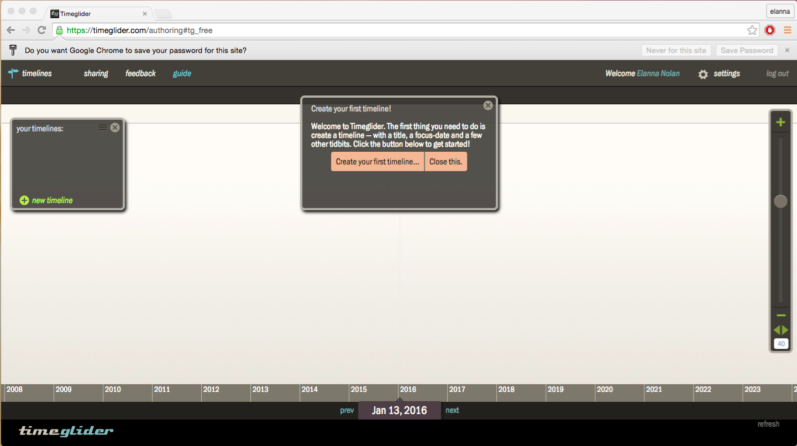

- Start by creating a new timeline -- you’ll be prompted to do so by the dialogue box. 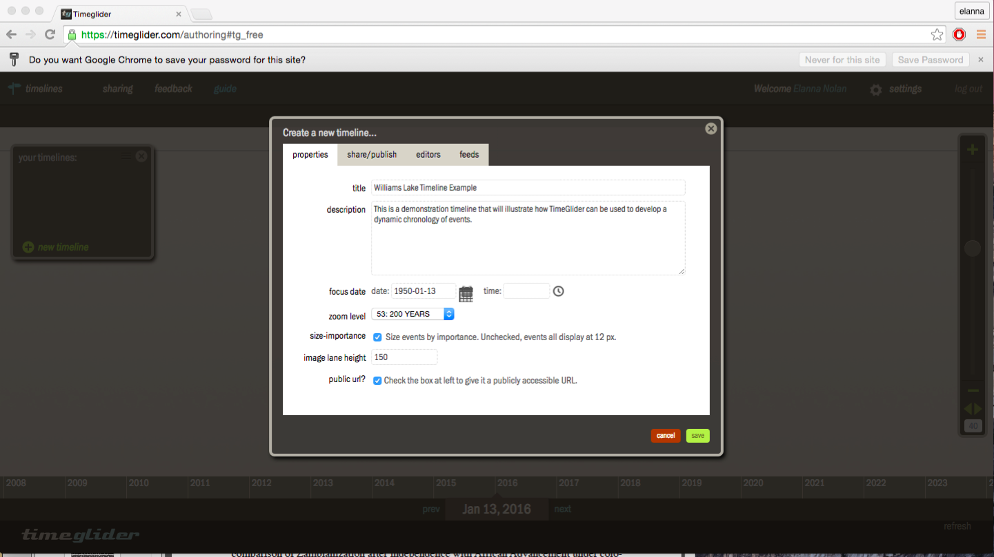
Give your timeline a title, description, choose a “focus date” (this will create a centre-point which will be in the centre of your browser when anyone opens up your timeline), a zoom level (this will format the spectrum of time shown in the browser window, i.e. the x axis), and click the tick-box to elect to have your timeline display via a public URL (this will allow your fellow students to view your timeline, as well as allowing you as a group to access your timeline if you’re working on it in different locations).

- Now that you have the scope of your timeline set up, to start adding events to your timeline you can either click on the “Create an event…” button shown in the dialogue box, or you can double click on a stage (i.e. the timeline screen) to add an event. Enter dates (you can select various date displays), choose a degree of importance (this will elevate or lower the event on the vertical spectrum of your timeline), and add any description text, image, or audio-visual content that you think would make your timeline more interesting, useful, or informative.
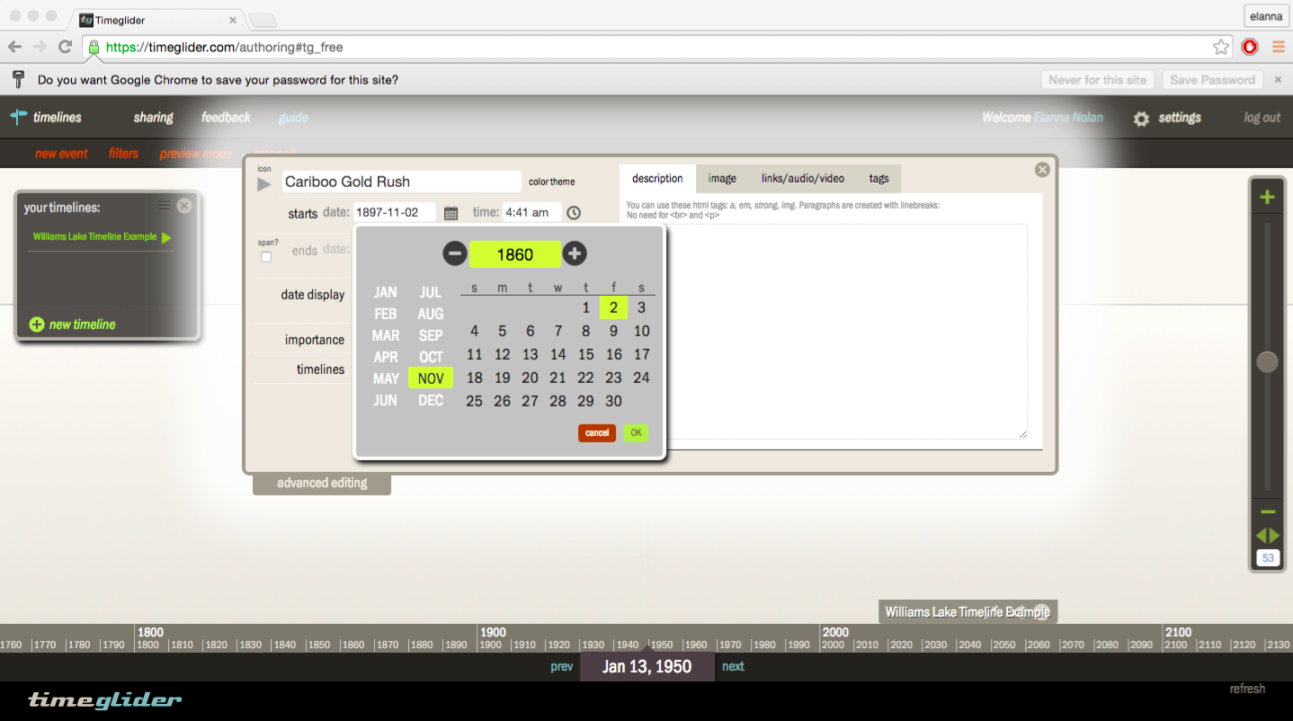

- Continue to add events to your timeline. You can zoom in and out on your timeline using the scroll panel on the right side of your screen, as you need to.
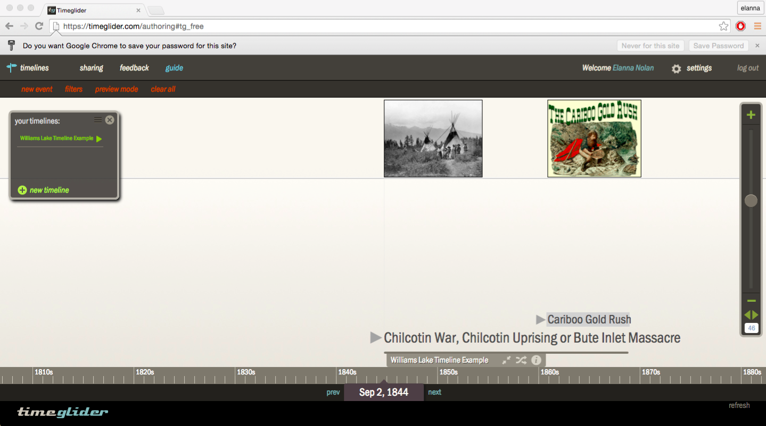

- You can use the “preview mode”, by clicking on the button in the top banner, at any time to view your timeline as it will look in its own URL page. Once you have populated your timeline with events, click on “sharing” in the top left corner of your browser. You will see a dialogue box pop up. You need to select your Williams Lake timeline title from the drop down box, and you will be given a public URL. You can then set the format of the public timeline by adjusting the minimum and maximum zoom levels. Once you click “done” you will then be able to circulate your URL, and access your timeline from anywhere.
