Cervical cancer screening- PAP test

In Canada, it is recommended for all women aged 25-70 to have a PAP test every 3 years.

***Why?***

This test is done to detect early changes in the cervix, which could lead to cancer.

Treatment is simpler if changes are detected early.

***Where is the cervix?***

The cervix is the opening of the uterus, located at the end of the vagina.

It’s the part of the uterus that opens when giving birth.

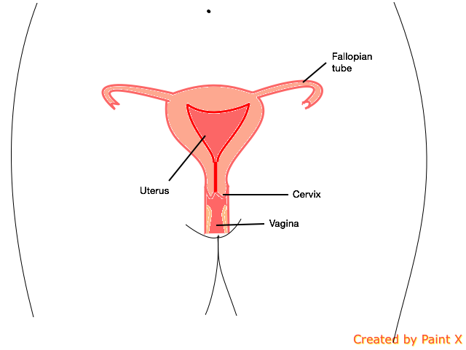

***How is the cervix seen?***

The doctor or nurse inserts an instrument called “speculum” into the vagina .

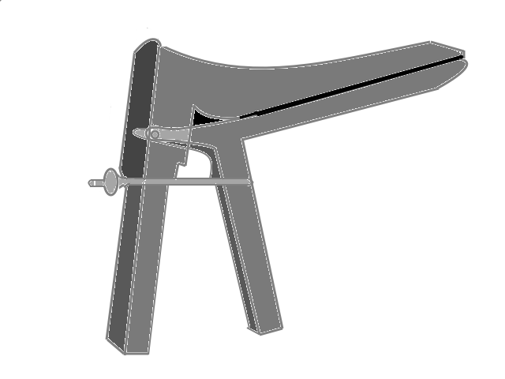

The speculum is then slightly opened to see the cervix.

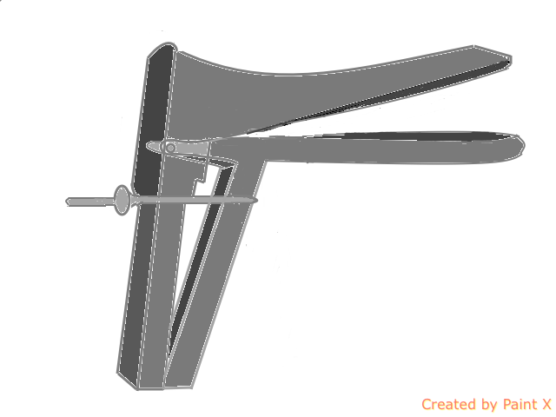

A speculum can either be metal or plastic.

Different sizes exist, but the part inserted usually has a width of about 2 fingers (2-3 cm)

***How is the PAP test done?***

The doctor or nurse will hand you a gown or drape. You will then be asked to remove your pants and underwear, but may keep on your shirt.

You will then lie on your back on the examining table with your feet in stirrups.

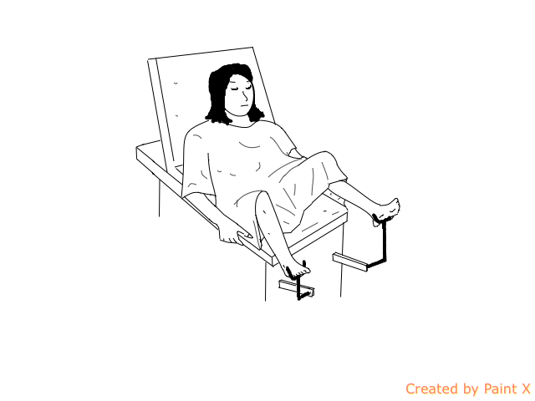

The doctor or nurse will sit on a stool by the foot of the bed.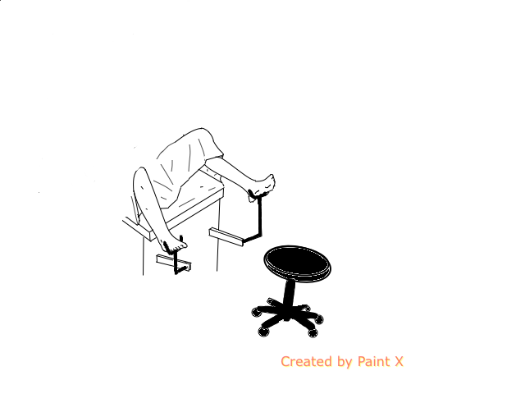

To begin the exam, the nurse or doctor will gently insert the speculum in the vagina.

Side view

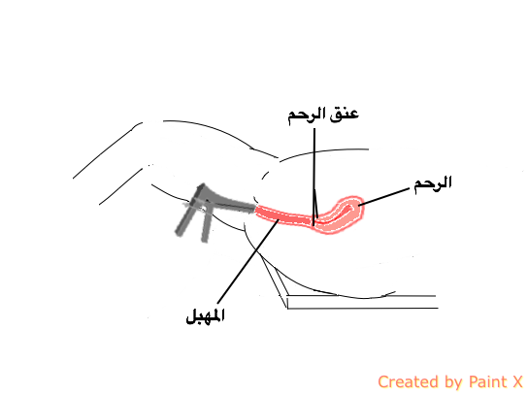

Front view

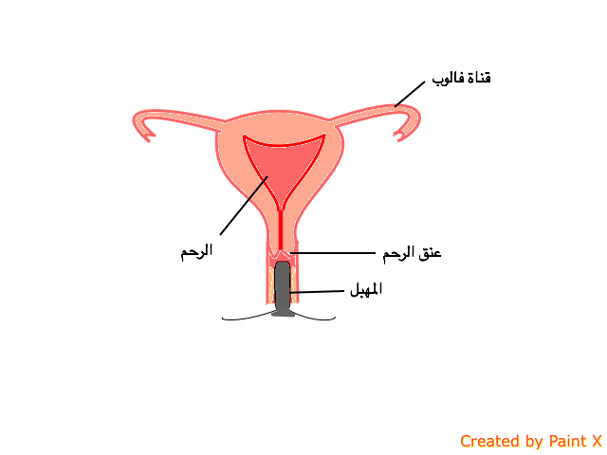

The speculum is then opened to visualise the cervix.

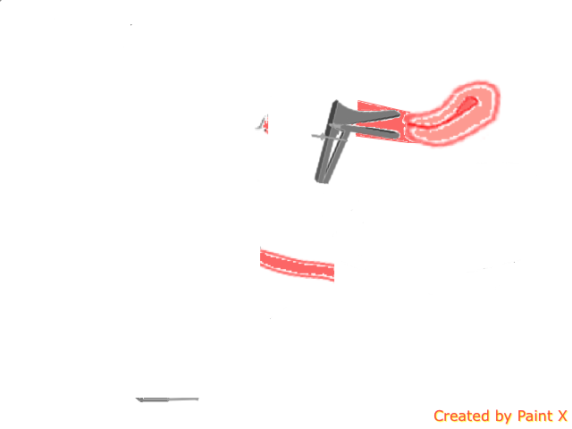

Note that only the thin blades of the speculum are inserted, and not the whole instrument.

This the front view of the cervix, how the examiner sees it.



Once the speculum is inserted, a wooden or plastic instrument is used to reach the cervix.

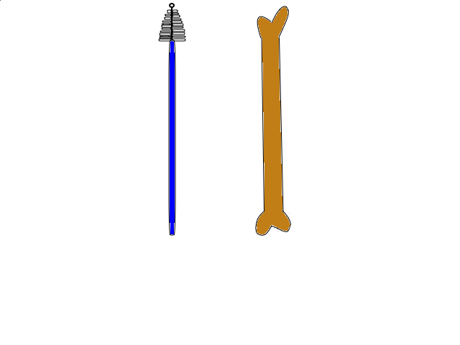

It is passed through the speculum to collect samples.

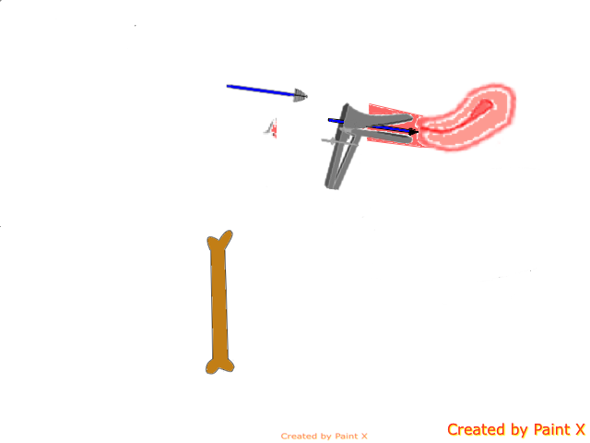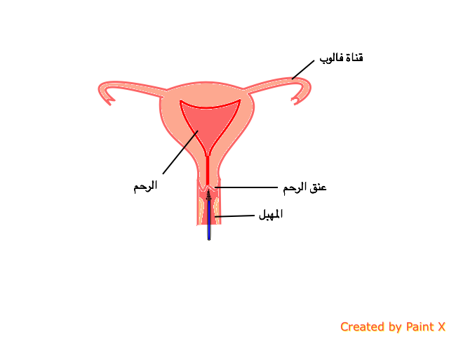

The samples are collected by simply wiping the cervix surface without cutting or injuring it.

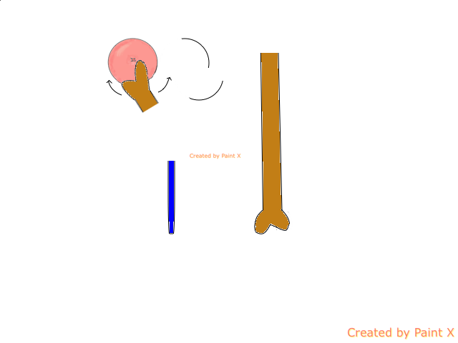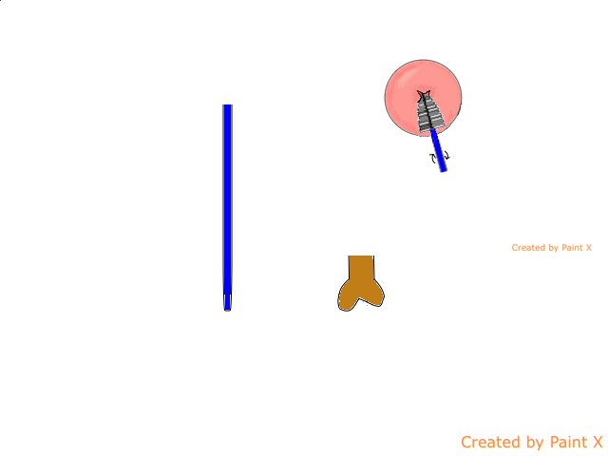

Once this is done, the instrument and speculum are removed.

In total, the speculum stays inserted for about 1-2 minutes.

The samples collected by the instrument are then wiped on a slide, and sent to the laboratory. Professionals look at the slide under the microscope.

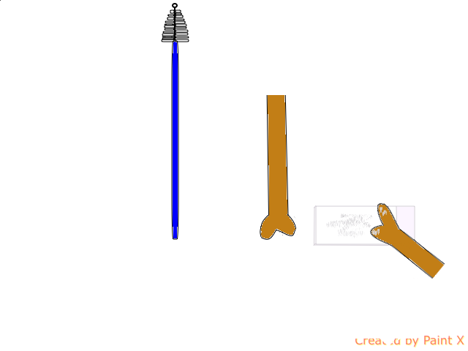

Results are usually available 4 to 6 weeks after the exam.

***Is the test painful?***

Inserting the speculum may cause some discomfort. To limit this, gel can be applied at the tip of the speculum. Relaxing also helps insert the instrument with less discomfort.

***How should I prepare for the test?***

Ensure to not apply vaginal medication the day of the exam, and that a tampon isn’t in place.

Taking samples from the cervix may cause slight spotting. It is therefore recommended to bring a sanitary pad.

***Is this mandatory?***

No.

This test is recommended, but you should not feel forced to have it done against your will.

Also note that usually a female health-care worker does the test. If only a male physician/nurse is available, you may request having a female chaperone with you in the room, or have your appointment changed to when a female can be available.