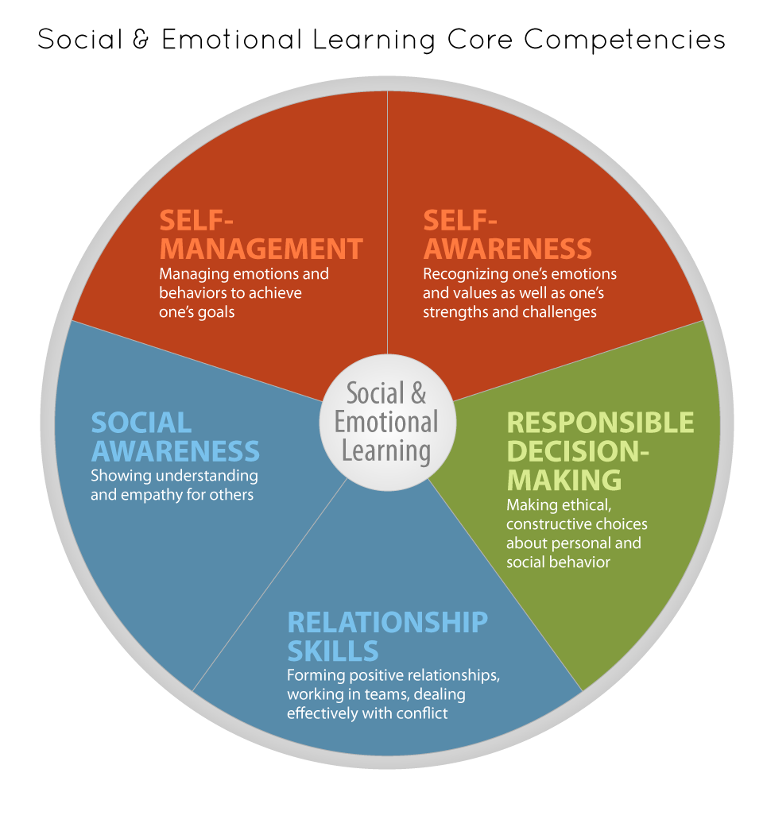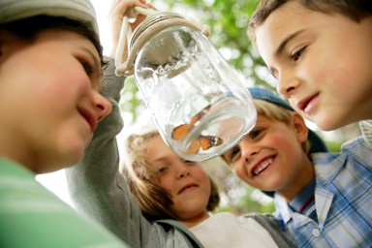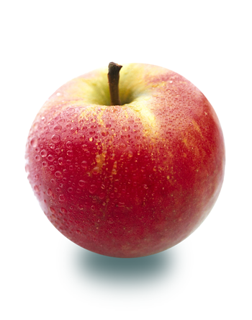 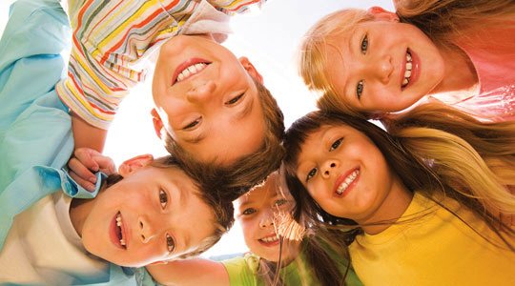

According to the Collaborative for Academic, Social and Emotional Learning (CASEL), the goal of SEL is to foster the development of five interrelated sets of cognitive, affective, and behavioral competencies: self-awareness, self-management, social awareness, relationship skills, and responsible decision making.

### **SEL Competencies**

* Discipline Strategies
* Cooperative Learning
* Emotional Literacy
* Moral Education/Social reasoning discussions
* Social problem solving training
* Conflict resolution programs
* Anti-bullying initiatives
* Promoting positive relationships

### How to foster SEL in Schools

SEL is the process of developing the skills and competencies related to recognizing and managing emotions, developing care and concern for others, establishing positive relationships, making responsible decisions, setting and achieving positive goals, and handling challenging situations constructively.1

**What is Social and Emotional Learning?**

CASEL 2013

When Heart Meets Mind:

Social and Emotional Learning in Schools

In classrooms where SEL programs have been implemented, students show:

* Increase in the development of social and emotional skills
* Improvement of attitude about self and others
* Decrease in emotional distress (internalizing and externalizing behaviors)
* Improvement in academic achievement 2

## **Student** **Outcomes**

Participation in SEL programs have also been shown to produce long-term benefits:

* Students who received a universal SEL intervention in elementary school demonstrated better educational and academic attainment, emotional and mental well-being as adults, than those who did not receive the intervention. 3

SEL skills in adolescence predicts later success:

* Social connectedness in adolescence, compared with academic success, is a stronger pathway to adult well-being (adult well-being is defined as positive emotional functioning, sense of coherence, social engagement and character values) 4

*1. Zins, J. (Ed.). (2004). Building academic success on social and emotional learning: What does the research say. Teachers College Press*

*2 & 6. Durlak, J. A., Weissberg, R. P., Dymnicki, A. B., Taylor, R. D., & Schellinger, K.B. (2011). The impact of enhancing students’ social and emotional learning: A meta‐analysis of school‐based universal interventions. Child development, 82(1), 405-432.*

*3. Hawkins, J. D., Kosterman, R., Catalano, R. F., Hill, K. G., & Abbott, R. D. (2008). Effects of social development intervention in childhood 15 years later. Archives of pediatrics & adolescent medicine, 162(12), 1133.*

*4. Olsson, C. A., McGee, R., Nada-Raja, S., & Williams, S. M. (2012). A 32-year longitudinal study of child and adolescent pathways to well-being in adulthood. Journal of happiness studies, 1-15.*

*5 & 7. Reyes, M. R., Brackett, M. A., Rivers, S. E., White, M., & Salovey, P. (2012). Classroom emotional climate, student engagement, and academic achievement. Journal of educational psychology, 104(3), 700*

*8. Johnson, D. W., & Johnson, R. T. (1999). Making cooperative learning work. Theory into practice, 38(2), 67-73*

Schools and classrooms where SEL programs have been implemented show:

* improvement of students’ attitudes towards school
* decrease in conduct problems and aggressive behavior
* increase in prosocial behaviours 6
* more positive relationships with peers and teachers
* increase in student engagement and motivation 7

**School and Classroom Climate**

**Teacher Outcomes**

Teachers with higher social and emotional competencies tend to:

* + Have more positive feelings about teaching and are more satisfied with their work
  + Experience less burnout
  + Are better able to manage the stress associated with teaching5

# Benefits of SEL: What the research says

## How to foster SEL in schools

#### **Cooperative Learning**

**Necessary Ingredients for Cooperative Learning**

* Positive interdependence
* Face-to-face interaction
* Individual accountability
* Social skills training
* Group self evaluation practices

# **Some strategies for fostering SEL**

*(Conversation Peace, Fraser Community Justice Initiatives, 2006)*

## **Restorative Action**

**Restorative Approaches to Discipline**

## **Punitive Discipline**

* Focus is on accountability, healing, reparation
* Harm is defined in terms of people hurt and relationships damaged
* Justice means understanding, dialogue and reparation, achieved when people take responsibility for their actions, relationships are healed and harm repaired
* Action is determined by all parties together
* Response determined by perpetrators, victim and community working together to find solutions that promote repair, reconciliation and reassurance.
* Focus is on punishment
* Harm is defined in terms of broken rules and guilt
* Justice means proving who is right and who is wrong and is achieved when those found guilty are punished
* Action directed by authorities to person who caused harm
* Response by authority who determines blame and administers punishment to the person who caused harm

**VS**

|  |  |  |
| --- | --- | --- |
| Competitive | Individualistic | Cooperative |
| * Students work against each other to achieve a goal that only one or a few can attain. * Students can attain their goal if & only if others do not attain them. * Value communicated: Success depends on beating out others | * Students work by them-selves to master material that is individualized (mastery learning) * One student’s goal attainment unrelated to goal attainment of others * Value communicated: success depends only on own efforts | * Students work together and help each other learn the material assigned * A student can attain his/her goals only if other students also attain them * Value communicated: Success depends on joint efforts to achieve mutual goals |

##### **Types of Learning Structures 8**

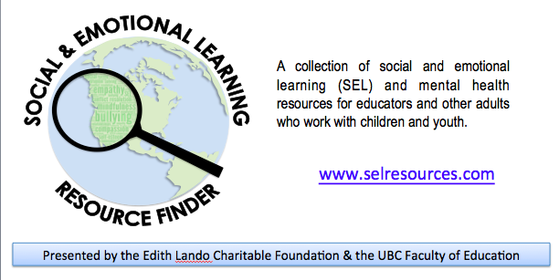

* Collaborative for Academic and Social and Emotional Learning (CASEL) [www.casel.org](http://www.casel.org)
* Edutopia- What works in public education, George Lucas Foundation [www.edutopia.org](http://www.edutopia.org/)
* Find Youth Info - Resources and effective programs to help youth-serving organizations [www.findyoutinfo.gov](http://www.findyouthinfo.gov/)
* What Works (Character Education), US Dept of Education Institute for Education Science [www.ties.ed.gov/nceewwc/](http://www.ties.ed.gov/nceewwc/)
* Centre for Social and Emotional Education [www.csee.net](http://www.csee.net/)
* Developmental Studies Center (Caring School Communities Project) [www.devstu.org](http://www.devstu.org/)
* Teach Safe Schools [www.teachsafeschools.org](http://www.teachsafeschools.org/)
* Educators for Social Responsibility (ESR) [www.esrnational.org/home.htm](http://www.esrnational.org/home.htm)
* Promoting Relationships and Eliminating Violence Network (PREVNet) [www.prevnet.ca](http://www.prevnet.ca/)
* Education.com - Online Magazine for parents and teachers –see special issue on bullying [www.education.com](http://www.education.com/)
* Promoting Alternative Thinking Strategies http://www.channing-bete.com/prevention-programs/paths/paths.html
* Second Step www.cfchildren.org/second-step.aspx
* Restitution http://www.realrestitution.com/
* RULER Approach to Emotional Literacy [www.therulerapproach.org](http://www.therulerapproach.org)
* Conversation Peace http://www.cjibc.org/conversation_peace

# Tips for Teachers

# Resources

* Greet students by name as they enter the classroom, creating a welcoming environment
* Take a personal interest in all students
* Smile often; show kindness and warmth to your students and colleagues
* Focus on all students’ positive qualities and acknowledge their efforts and contributions
* Co-construct a set of expected norms of behavior (code of conduct, classroom charter, etc.) so that students understand how to treat each other with respect
* During discussion and activities, offer students the right to pass to honour different learning styles
* Offer students options to promote a sense of autonomy and competence in the learning process
* Encourage students to discuss solutions rather than blame others
* Model SEL behaviours of respect, caring, self-control and fair decision-making
* Admit when you don’t know something; model authenticity and vulnerability
* Participate in professional development opportunities to hone your own social-emotional skills

**Handout prepared by M.Miller, A.Low & S.Hymel, UBC, with support from the Jacqueline Farquhar Endowment fund (2013-2015).**