Proposal for a Tobacco Free Campus
at North Island College’s Comox Valley Campus

for
John Bowman – President and CEO
North Island College
Courtenay, British Columbia

and
Carissa Wilson – College Relations North Island Student Union
North Island College
Courtenay, British Columbia

by
Glen Kavaliunas
UBC English 301 Student

July 30, 2020

Table of Contents
- ABSTRACT . . . . . . . . . . . . . . . . . . . . . . . . . . . . . . . . . . . . . . . . . . . . . . . . . . . . . . . . . 4
- INTRODUCTION . . . . . . . . . . . . . . . . . . . . . . . . . . . . . . . . . . . . . . . . . . . . . . . . . . . . 5
- Purpose of this report . . . . . . . . . . . . . . . . . . . . . . . . . . . . . . . . . . . . . . . . . . . . . . . . . . 5
- Audience for this report . . . . . . . . . . . . . . . . . . . . . . . . . . . . . . . . . . . . . . . . . . . . . . . . 6
- Background on tobacco health risks . . . . . . . . . . . . . . . . . . . . . . . . . . . . . . . . . . . . . . 6
- Description of current tobacco policy at North Island College (NIC) . . . . . . . . . . . . . 7
- Impact of current tobacco policy at NIC . . . . . . . . . . . . . . . . . . . . . . . . . . . . . . . . . . . .8
- Tyee building designated smoking area . . . . . . . . . . . . . . . . . . . . . . . . . . . 8
- Portable Village designated smoking area . . . . . . . . . . . . . . . . . . . . . . . . . 9
- Proposed solution . . . . . . . . . . . . . . . . . . . . . . . . . . . . . . . . . . . . . . . . . . . . . . . . . . . . 10
- METHODS . . . . . . . . . . . . . . . . . . . . . . . . . . . . . . . . . . . . . . . . . . . . . . . . . . . . . . . . 10
- Scope . . . . . . . . . . . . . . . . . . . . . . . . . . . . . . . . . . . . . . . . . . . . . . . . . . . . . . . . . . 11
- DATA SECTION . . . . . . . . . . . . . . . . . . . . . . . . . . . . . . . . . . . . . . . . . . . . . . . . . . . . 11
- Location of Designated Smoking Areas at NIC Courtenay . . . . . . . . . . . . . . . . . 11
- Interview Summaries . . . . . . . . . . . . . . . . . . . . . . . . . . . . . . . . . . . . . . . . . . . . . . 12
- Survey Summaries . . . . . . . . . . . . . . . . . . . . . . . . . . . . . . . . . . . . . . . . . . . . . . . . 13
- NIC students and staff . . . . . . . . . . . . . . . . . . . . . . . . . . . . . . . . . . . . . . . . . . 13
- Beaufort Children’s Society Staff and Parents . . . . . . . . . . . . . . . . . . . . . . . 16
- Conflicting interest regarding study . . . . . . . . . . . . . . . . . . . . . . . . . . . . . . . . . . . 18
- CONCLUSION . . . . . . . . . . . . . . . . . . . . . . . . . . . . . . . . . . . . . . . . . . . . . . . . . . . . . 18
- Summary of Findings . . . . . . . . . . . . . . . . . . . . . . . . . . . . . . . . . . . . . . . . . . . . . . 18
- Recommendations Based on Findings . . . . . . . . . . . . . . . . . . . . . . . . . . . . . . . . . 18
- APPRENDIX A: Survey to North Island College Students . . . . . . . . . . . . . . . . . . . 20
- APPENDIX B: Survey to Beaufort Childcare Parents and Staff . . . . . . . . . . . . . . . . 23
- APPENDIX C: Interview Questions . . . . . . . . . . . . . . . . . . . . . . . . . . . . . . . . . . . . . 26
- APENDIX D: Interview - Colin Fowler – NIC VP Finance and Facilities . . . . . . . . 28
- APPENDIX E: Interview - Echo Hope - Director of the NIC Student Society . . . . . 30
- APPENDIX F: Interview - Carissa Wilson – NIC Student Union - Organiser, College Relations & Services Coordinator . . . . . . . . . . . . . . . . . . . . . . . . . . . . . . . . . . . . . . . 32
- REFERENCES . . . . . . . . . . . . . . . . . . . . . . . . . . . . . . . . . . . . . . . . . . . . . . . . . . . . . 33

FIGURES AND TABLES
Figure 1: Tyee Building designated smoking area and proximity to Beaufort Children’s Society play space . . . . . . . . . . . . . . . . . . . . . . . . . . . . . . . . . . . . . . . . . . . . . . . . . . . . . . . . . . . . . . . . . . . . 9
Figure 2: Portable Village designated smoking area and entrances and exits . . . . . . . . . . . . . . . . 9
Figure 3: Break down of survey response to areas of second-hand smoke exposure . . . . . . . . . 12
Figure 4: Do you smoke? . . . . . . . . . . . . . . . . . . . . . . . . . . . . . . . . . . . . . . . . . . . . . . . . . . . . . . . 14
Figure 5: Do you wish to quit smoking? . . . . . . . . . . . . . . . . . . . . . . . . . . . . . . . . . . . . . . . . . . . 14
Figure 6: Would removing designated smoking areas help you quit smoking? . . . . . . . . . . . . . 14 Figure 7: Smoking Cessation support . . . . . . . . . . . . . . . . . . . . . . . . . . . . . . . . . . . . . . . . . . . . . 15
Figure 8: How many designated smoking areas are essential? . . . . . . . . . . . . . . . . . . . . . . . . . . 15
Figure 9: Location of exposure to second-hand smoke . . . . . . . . . . . . . . . . . . . . . . . . . . . . . . . . 17

Abstract
To be written later

INTRODUCTION
North Island College (NIC) is located on Vancouver Island, British Columbia, with their main campus located in Courtenay. At the Courtenay campus, NIC has three designated smoking areas. These are located outside of main buildings. The designated smoking area outside of the main entrance of Tyee building and one at the entrance to Portable Village are problematic. While these designated smoking areas are legally the specified distance from the entrances, it only takes a little wind to carry to smoke to the doorway.
The designated smoking area for students from the Tyee building at NIC is dangerously close to Beaufort Children Society’s daycare outdoor play space. This same designated smoking area is also directly outside of the bookstore and the cafeteria.
With the health-related conditions and problems associated with the use of tobacco (including smoking, chewing and vaping), it is irresponsible for a college to support this unhealthy habit in their students. By having a designated smoking area, NIC is supporting the exposure of young children to this behavior and second-hand smoke, as well as NIC students and staff. An education should not come with second-hand smoke exposure.

Purpose of this Report
The purpose of the report is to highlight the health risk posed to students and staff, as well as the children at Beaufort Childcare Society, through the exposure to second-hand smoke at the Courtenay NIC campus. The location of the current designated smoking areas at Portable Village and the Tyee building are the main areas of concern. The smoking areas are the legal distance from the entrance to buildings, but being at front entrances to buildings, students and staff must walk through smoke to go to class, the bookstore or the cafeteria. The designated smoking areas are roofed structures, which hold the smoke down. If there is a slight wind, the smoke carries outside of the designated smoking area to surrounding areas.

This report and its findings are timely as North Island College is in the planning phase of a large expansion which could see an increase in tobacco use. This would be an ideal time to move towards a tobacco free campus.

Audience for this Report
The findings of the formal report on Tobacco at NIC will be presented to the President and CEO of NIC, John Bowman, and College Relations North Island Student Union, Carissa Wilson, and other interested parties. Both of the named individuals represent groups responsible for the health of students and staff at NIC. Additionally, the report will be shared with the Executive director of Beaufort Children’s Society, Amanda Peters, who has a vested interest in the location of the designated smoking area at the Tyee building and the impact on the children at Beaufort Children’s Society.

Background on Tobacco Health Risks
Society is aware of the negative health affects of smoking and second-hand smoke. Unfortunately, smoke is not selective and even non-smokers exposed to second-hand smoke risk diseases and disabilities. The Center for Disease Control states, “Smoking causes cancer, heart disease, stroke, lung diseases, diabetes, and chronic obstructive pulmonary disease (COPD), which includes emphysema and chronic bronchitis. Smoking also increases risk for tuberculosis, certain eye diseases, and problems of the immune system, including rheumatoid arthritis.” (Centers for Disease Control Health Effects)
While the effects of smoking are well known, “Second-hand smoke exposure [still] contributes to approximately 41,000 deaths among non-smoking adults and 400 deaths in infants each year.” (Centers for Disease Control Health Effects). This is an alarming number as second-hand smoke exposure can be out of the control of non-smokers as is the case of students at NIC. “Second-hand smoke causes stroke, lung cancer, and coronary heart disease in adults.” (Centers for Disease Control Health Effects) The second-hand smoke exposure of children at Beaufort Children’s Society’s daycare is concerning because “Children who are exposed to second-hand smoke are at increased risk for sudden infant death syndrome, acute respiratory infections, middle ear disease, more severe asthma, respiratory symptoms, and slowed lung growth.” (Centers for Disease Control Health Effects) This exposure over the four years they are at the daycare can have lasting repercussions throughout their life, impacting their health and costing taxpayers thousands of dollars in medical expenses.

Description of the Current Tobacco Policy at NIC
Currently NIC is a smoke free campus other than in designated smoking areas, as explained in the North Island College handbook of policies and procedures, “Smoking, including e-cigarettes, is permitted in designated areas only” (Policy & Procedures Manual - North Island College). According to VP Fowler, NIC requires five designated smoking areas for the population and layout of the college. (interview July 22, 2020), but currently there are only three designated smoking areas on NIC Courtenay campus.

Impact of Current Tobacco Policy at NIC
The health and welfare of students, staff at NIC and the infants and toddlers at Beaufort Children’s Center is of utmost importance. Specifically, the negative health impacts of first and second-hand smoke. Although North Island College has made some steps toward reducing exposure to second-hand smoke on campus, the designated smoking areas do little to protect to non-smokers. Some students start using tobacco products to make friends and others continue out of convenience or to help reduce stress, yet all students and staff are exposed to it as a result. Investigating the use of tobacco on campus and the impact on students is vital, especially with the increase in vaping and the unknown health results.

Tyee Building Designated Smoking Area
In order to enter the Tyee building main door to attend classes or go to the cafeteria/ bookstore, students must walk through the second-hand smoke from the designated smoking area. Another concern with the location of the Tyee building smoking area is the proximity to the Beaufort Childcare outdoor play space. This proximity means children ages eighteen months to five years old are exposed to second-hand smoke daily and witness the unhealthy activity of college students. On many occasions the staff of Beaufort Children’s Society have commented on the smoke blowing over to the play yard, and the children have asked why the air smells like candy when the vape smoke blows over the play area.

This same designated smoking area for the Tyee building forces any student who needs to buy textbooks or food to walk through the smoke to get to their destination. This is consistent across campus at the main entrance of all buildings.
Fig. 1 Tyee Building designated smoking area
and proximity to Beaufort Children’s Society play space

Portable Village Smoking Area
The designated smoking area in the area known as Portable Village is the other troublesome area. There are about ten portables together in a group with a ramp system connecting them. There are two staircases up to this area, one at either end. The entrance/it closest to the rest of the campus leads directly into the designated smoking are for this section of campus. This means everyone entering/exiting leaving Portable Village by the main entrance/exit is exposed to second-hand smoke.
Fig. 2 Portable Village designated smoking area and entrances and exits
Proposed Solution
A solution for the second-hand smoke from the Tyee building would be to move the smoking area to the other side of building and away from the main entrance. This would mean smoking, or inhaling second-hand smoke, would once again be a choice for students. Moving the designated smoking area away from the daycare would also reduce the children’s exposure to second-hand smoke.

The full solution is for North Island College to become a tobacco free campus. This would limit the number of students who start smoking due to stress or to build friendships, and it would eliminate the exposure of other staff and students to second-hand smoke. “Comprehensive smoke-free campus policies make it easier for people to resist and quit smoking and can have a tremendous impact on the health of an entire campus community!” (Smoke-Free Campuses) An additional benefit for North Island College would be a possible reduction in medical and employee and family assistance expenses. “Everyone deserves to breathe clean air where they live, work, study, and play. Tobacco-free policies decrease costs for schools without impacting enrollment.” (Smoke-Free Campuses)

METHODS
Primary data sources will include consultations with Amanda Peters – Executive Coordinator of Beaufort Children’s Society and interviews with John Bowman - president of NIC, Colin Fowler – NIC VP Finance and Facilities, Echo Hope – Comox Valley Director of NIC Student Union, and Carissa Wilson – NIC Student Union - Organiser, College Relations & Services Coordinator. I will explore the appetite from students for North Island College to become a tobacco free campus, as the smoke is not healthy for any student. Primary research will be rounded out with surveys to current NIC students.

Secondary sources include publications on the effects of second-hand smoke on young children, and a review of North Island College’s smoking policy. The Tobacco Free Campus movement is also a valuable resource. (Tobacco Free Campus Guide, 2011)

Scope
To assess the feasibility of moving to a tobacco free college campus, the following questions will guide the research:
- What are the rights of non-smoking students and their unwelcome exposure to second-hand smoke?
- What smoking cessation programs are available to NIC students and staff?
- How does second-hand smoke affect young children below the age of three year?
- How can a smoke free campus help to reduce tobacco use among NIC students?

DATA SECTION
Location of designated smoking areas
NIC currently has five designated smoking areas. The locations are: Komox Hall, Trades building, Tyee building, Portable Village, and Discovery Hall. The survey and interviews indicated the only the designated smoking areas at Tyee building and Portable Village are a major source and concern for second-hand smoke.

Fig. 3: Break down of survey response to areas of second-hand smoke exposure

Interview Summaries
To gather critical information regarding second-hand smoke and tobacco use at NIC Comox Valley campus three pivotal people were interviewed:
- Colin Fowler – Vice President Finances and Facilities
- Echo Hope - Director of the North Island College Student Society
- Carissa Wilson - North Island College Student Union - Organiser, College Relations & Services Coordinator

All interviewed parties agreed that the designated smoking area by Tyee building is a concern due to both the proximity to the main entrance to Tyee and the proximity to the outdoor play space at Beaufort Childcare Society daycare. There seem to be no support, outside of MSP, for students who wish to stop smoking or using tobacco, but NIC employees do have support both financially and emotionally through the employee family assistance program. There was a divide in the number of smoking areas required for NIC. The VP stated that five designated smoking areas were required, but both student union representatives stated that one or zero designated smoking areas were required.

Survey Summaries
Two surveys were conducted. One survey was presented to parents and staff of Beaufort Children’s Society daycare. The other survey was presented to students and staff at NIC. Survey responses in the second set were minimal as no on-campus courses are currently operating, all staff are working from home, and students are on summer vacation. As a result, the information is not necessarily representative of the full NIC Comox Valley student body.

Student and Staff Survey
Students and staff were asked to complete this survey online. Due to limited access to staff and student emails and many people eon summer holidays there were only ten respondents. To make decisions based on this data many more students and staff need to be surveyed.

When students and staff were asked if they smoke forty percent said yes, while sixty percent said no (Fig. 3). The next question asked if they would like to quit. Of the forty percent who indicated they smoke, seventy-five percent said they would like to quit (Fig. 4). Looking at it another way, that means out of the ten people surveyed, only four smoke and three of those four want to quit.
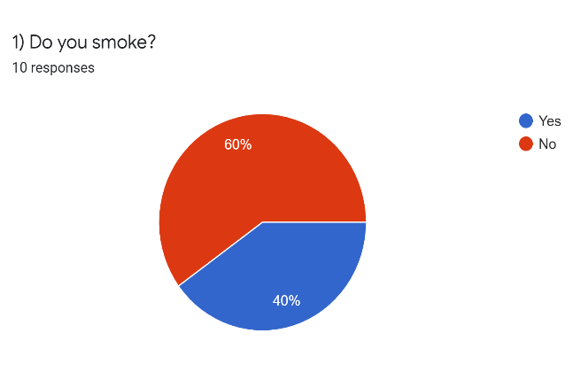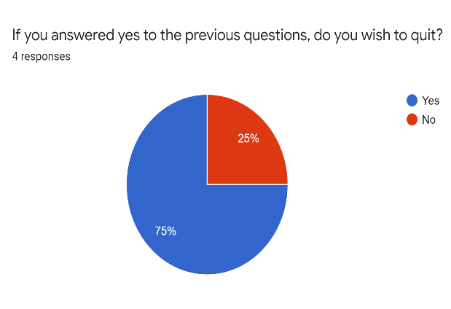
Fig. 4: Do you smoke? Fig. 5: Do you wish to quit smoking?

When asked if the removal of the designated smoking areas would help students and staff quit smoking the responses were completely split (but there were only three responses). (Fig. 6)
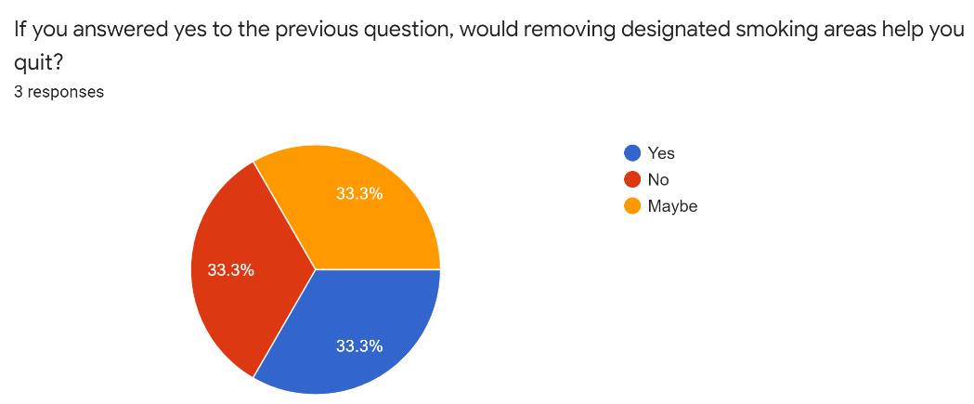
Fig. 6: Would removing designated smoking areas help you quit smoking?

The number of students and staff who are interested in quitting smoking was high, yet smoking cessation help / programs were sparse or unknown. Students have few options. MSP will assist with the cost and they can call the nurses hotline (811) for emotional assistance and advice. Staff have the support of the North Island College Employee and Family Assistance program as well as extended medical benefits. (See Fig.7)
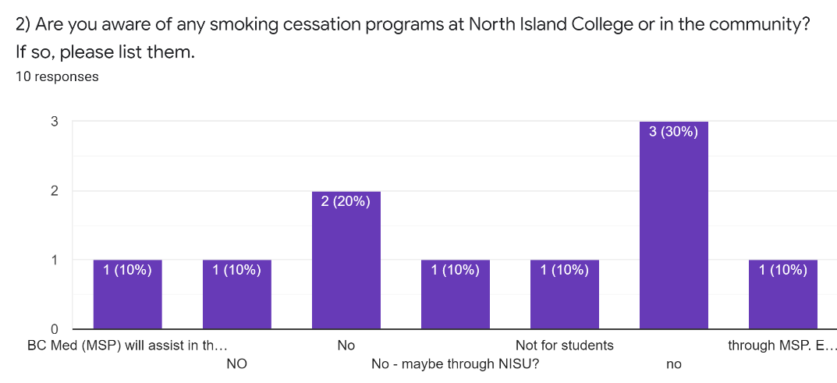
Fig. 7: Smoking Cessation support

When looking at the possibility of going to a completely tobacco free campus, forty percent of the students surveyed said no designated smoking areas were essential at NIC. Ten percent of student said five or more designated smoking areas were needed, while another ten percent said only one designated smoking area was essential. The last forty percent said two or three smoking areas were essential. NIC would need to do more research, but according to those polled the number of designated smoking areas could be reduced from five to three or fewer.
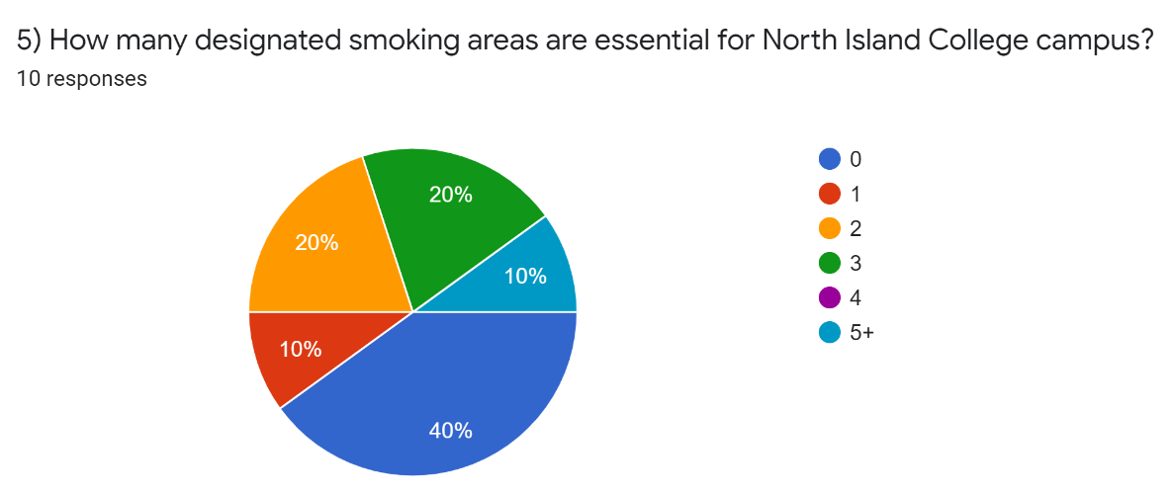
Fig. 8: How many designated smoking areas are essential?

Of those surveyed, eighty percent said they had heard of Beaufort Children’s Center, but of those surveyed sixty percent of respondents said they were concerned about the proximity of the designated smoking area at Tyee to the childcare outdoor play space.

The other comments and suggestions coming from the survey included:

“If there is going to be designated smoking areas, they should be away from the primary buildings. The area by the Village is also terribly placed.” (anonymous)

“i believe it would be unfair to remove the ability to smoke on campus. when i attended that is how i destressed and i know many others did as well. You could place smoke pits in a way that they will not be in the way, or bother others.” (anonymous)

“Smoking areas should be moved away from buildings and prime public areas” (anonymous)

Beaufort Staff and Parent Survey
Of the eleven people who responded to the Beaufort Parent and Staff Survey, sixty-four percent indicated that they were also student or staff at NIC. This group indicated that eighty-two percent of them have be exposed to second-hand smoke when performing their day-to-day activities at NIC. Sixty-four percent of respondents indicated this happened “often”. The main areas of exposure indicated were outside the Tyee building, Portable Village, and at Beaufort Children’s Center play area. (see fig. 9)

Fig. 9: Location of exposure to second-hand smoke
When asked if the location of the smoking area at the Tyee building and the proximity to the childcare outdoor play space was a concern, one hundred percent of the respondents answered yes. These thoughts were also reflected in the respondents’ final comments.
“I do not believe that there is any room for a smoking area so close to where the children play. This is especially the case when we are outside all day during this COVID 19 pandemic.” (anonymous)
“The smoke can travel easily into the children's play yard from the smoking area. It doesn't happen too regularly (it seems there are fewer people who smoke these days) but it is certainly noticeable everytime someone is smoking.” (anonymous)
“To be honest, I have not though about the designated area and the close proximity to the outdoor Humming bird play space. Due to the impacts of Covid19 and the percentage the Humming bird room children and staff are outside now the designated smoking area is more concerning.” (anonymous)
“There should be no smoking in NIC property.” (anonymous)
“I would like to see the smoking pit by the daycare moved to another location we as educators smell it way to often and I’ve had toddlers ask me why it smells like candy outside when they are breathing in the vape smoke.” (anonymous)
“I am surprised of the location and how close it is to the daycare.” (anonymous)
“I work with children ages 18 months -3 years of age and we have had cigarette smoke almost daily when classes are running” (anonymous)
“Consider time limitations to the smoking site near Beaufort; i.e.: smoking allowed evenings, weekends, stats.” (anonymous)
“move smoke areas away from entrances and outdoor spaces enjoyed by all” (anonymous)

Conflicting Interest Regarding Study
Criticism from students who use tobacco is a conflicting interest. Some saw a threat to smoking on campus, instead of multiple options. There are no other apparent conflicting issues in this study.

CONCLUSION
Summary of Findings
Second-hand smoke exposure is an issue for staff, students and Beaufort Children’s Society parents and staff as indicated in surveys and interviews. The most problematic areas are the designated smoking area at the Tyee building, especially as it pertains to Beaufort Children’s Society outdoor play area, and the designated smoking area outside Portable Village.

Most students and staff who indicated they use tobacco were interested in quitting. Smoking cessation help is available for NIC employees, but students do not currently have access to a program to aid in smoking cessation outside of MSP or 811, the nurse’s hotline.

Recommendations Based on Findings
Centered on the findings of this study the following actions are recommended:
- Based on the interviews and surveys conducted, NIC and North Island Student Union should take on a more in-depth survey of students as, due to COVID online class delivery and summertime, the one conducted for this project did not generate enough responses to represent the student voice.
- A smoking cessation program or support be made available to NIC students.
- Designated smoking areas be located away from main entrances to make exposure to second-hand smoke an option.
- The designated smoking area at Tyee building be moved to an area at the back of the building. (*I have learned since starting this project that for the 2020-21 school year the designated smoking area at the Tyee building has been moved to the back of the building. The old smoking area has become a bike lock-up area. This limits the impact on students and staff and removes the exposure to second-hand smoke on the children at Beaufort Childcare from this location.)
- The designated smoking area a Portable Village be moved to the other side of the back-parking lot.
- NIC should become a tobacco free campus if a further student survey shows support.

Appendix A
Tobacco Free Campus at NIC (student and staff survey)
I am a North Island College student registered in the Business Administration degree program and I am currently registered in a technical writing course at the University of British Columbia. We are currently working on a technical writing project. The purpose of this interview is to collect primary data that will be used to analyze and provide recommendations to reduce or eliminate second-hand smoke exposure for students and staff at North Island College, as well as the infants and toddlers at Beaufort Children’s Society. The goal of this inquiry is to provide a safe environment for students, staff and children on the North Island College Campus. The formal report will be presented to the President of North Island College, the director of the North Island College Student Society, the Executive Director of Beaufort Children Society and the Faculty Chair - Department of Early Childhood Care. The data collected from this survey will serve to identify hurdles and roadblocks to becoming a tobacco free campus.
Ultimately the data will be used to present recommendations to minimize second-hand smoke exposure on North Island College campus. The valuable information you provide will be used for analysis in proposing these recommendations.
The survey consists of 8 questions and it will take approximately 10 minutes to complete. Your responses are voluntary and anonymous but are greatly appreciated. Thank you for participation.

  - Do you smoke?
    - Yes
    - No

If you answered yes to the previous questions, do you wish to quit?
- Yes
- No

If you answered yes to the previous question, would removing designated smoking areas help you quit?
- Yes
- No
- Maybe

  - Are you aware of any smoking cessation programs at North Island College or in the community? If so, please list them.

  - Have you been exposed to second-hand smoke will performing your day to day activities at North Island College?
    - Yes
    - No
If you answered yes to the previous question, where did the exposure occur?

  - Would you say that this occurs rarely, sometimes, or often?
    - Rarely
    - Often
    - Sometimes

  - How many designated smoking areas are essential for North Island College campus?
    - 0
    - 1
    - 2
    - 3
    - 4
    - 5+

  - Are you familiar with Beaufort Children’s Center?
    - Yes
    - No

  - Is the location of the designated smoking area for the Tyee building and the proximity to the Childcare play space a concern for you? (see map below)
- Yes
- No

North Island College Campus map pointing out the Tyee building designated smoking area's proximity to Beaufort Children's Center outdoor play space.
- Do you have any comments or suggestions that you would like to share regarding tobacco use at North Island College?

Appendix B: Tobacco Free Campus at NIC (Beaufort Children’s Society staff and parent survey)
I am a North Island College student registered in the Business Administration degree program and I am currently registered in a technical writing course at the University of British Columbia. We are currently working on a technical writing project. The purpose of this survey is to collect primary data that will be used to analyze and provide recommendations to reduce or eliminate second-hand smoke exposure for students and staff at North Island College, as well as the infants and toddlers at Beaufort Children’s Society. The goal of this inquiry is to provide a safe environment for students, staff and children on the North Island College Campus. The formal report will be presented to the President of North Island College, the director of the North Island College Student Society, the Executive Director of Beaufort Children Society and the Faculty Chair - Department of Early Childhood Care. The data collected from this survey will serve to identify hurdles and roadblocks to becoming a tobacco free campus.
Ultimately the data will be used to present recommendations to minimize second-hand smoke exposure on North Island College campus. The valuable information you provide will be used for analysis in proposing these recommendations.
The survey consists of 6 questions and it will take approximately 10 minutes to complete. Your responses are voluntary and anonymous, but greatly appreciated. Thank you in advance for your participation.

- Are you a student or staff at North Island College?
- Yes
- No

- Do you know where the designated smoking areas are at North Island College - Comox Valley campus?
- Yes
- No

- Have you been exposed to second-hand smoke will performing your day to day activities at North Island College or Beaufort Children's Society?
- Yes
- No
If you answered yes to the previous question, where did the exposure occur?

- Would you say that this occurs rarely, sometimes, or often?
    - Rarely
    - Often
    - Sometimes

- Is the location of the designated smoking area for the Tyee building and the proximity to the Childcare outdoor play space concern for you? (see map below)
- Yes
- No
North Island College Campus map pointing out the Tyee building designated smoking area's proximity to Beaufort Children's Center outdoor play space.
- Do you have any comments or suggestions that you would like to share regarding tobacco use at North Island College?

Appendix C: Tobacco Free Campus at NIC – Comox Valley Campus - Interview Questionnaire
I am a North Island College student registered in the Business Administration degree program at the Comox Valley campus and I am currently registered in a technical writing course at the University of British Columbia. We are currently working on a technical writing project. The purpose of this interview is to collect primary data that will be used to analyze and provide recommendations to reduce or eliminate second-hand smoke exposure for students and staff at North Island College – Comox Valley campus, as well as the infants and toddlers at Beaufort Children’s Society located on the Comox Valley campus of North Island College. The goal of this inquiry is to provide a safe environment for students, staff, and children on the North Island College Campus. The formal report will be presented to the President of North Island College, the director of the North Island College Student Society – Comox Valley, the Executive Director of Beaufort Children Society and the Faculty Chair - Department of Early Childhood Care. The data collected from this interview will serve to identify hurdles and roadblocks to becoming a tobacco free campus.
Ultimately the data will be used to present recommendations to minimize second-hand smoke exposure on North Island College Comox Valley campus. The valuable information you provide will be used for analysis in proposing these recommendations.
The interview consists of 8 questions and it will take approximately 10 minutes to complete. Your responses are voluntary and greatly appreciated. Thank you for participating.

- How many designated smoking areas are essential for North Island College campus?

0 1 3 5 8 10+

- How were the current designated smoking areas chosen?
________________________________________________________________________

- Does NIC offer students and staff smoking cessation programs? If so, please list them.

Yes No
______________________________________________________________________________
- Have you been exposed to second-hand smoke will performing your day to day activities at North Island College? Yes No

Where did this occur?
______________________________________________________________________________
- If you answered yes to the previous question, would you say that this occurs rarely, sometimes, or often?

Rarely Sometimes Often

- Are you familiar with Beaufort Children’s Center? Yes No

- Is the location of the designated smoking area and the proximity to the Childcare play space a concern? Yes No

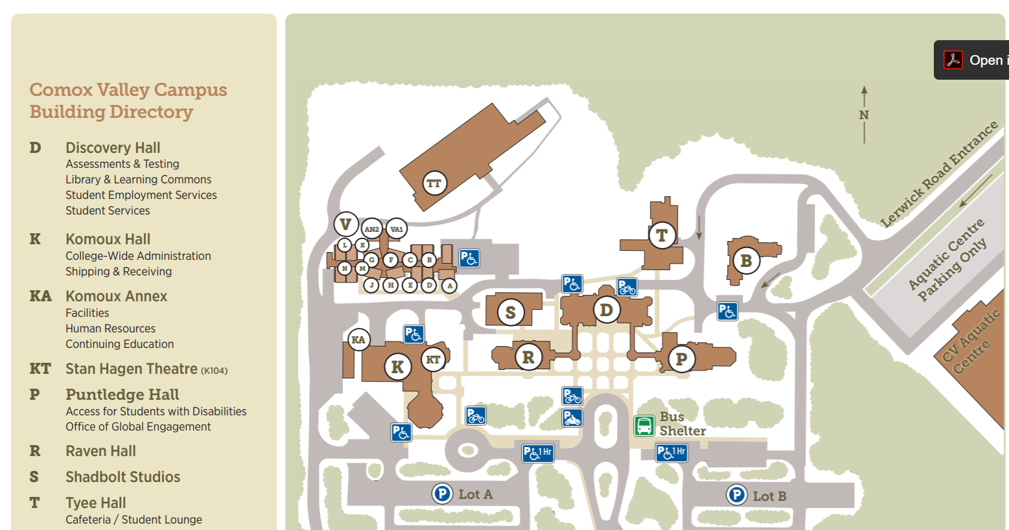
Beaufort children’s Society play space

Designated smoking area

- Do you have any comments or suggestions that you would like to share regarding tobacco use at North Island College?

If you think of any recommendations going forward please feel free to share them by emailing NICtobaccofree@gmail.com. The email account will be checked daily and all comments will remain anonymous.

Appendix D: Interview - Colin Fowler – NIC VP Finance and Facilities
Tobacco Free Campus at North Island College – Comox Valley Campus
I am a North Island College student registered in the Business Administration degree program at the Comox Valley campus and I am currently registered in a technical writing course at the University of British Columbia. We are currently working on a technical writing project. The purpose of this interview is to collect primary data that will be used to analyze and provide recommendations to reduce or eliminate second-hand smoke exposure for students and staff at North Island College – Comox Valley campus, as well as the infants and toddlers at Beaufort Children’s Society located on the Comox Valley campus of North Island College. The goal of this inquiry is to provide a safe environment for students, staff, and children on the North Island College Campus. The formal report will be presented to the President of North Island College, the director of the North Island College Student Society – Comox Valley, the Executive Director of Beaufort Children Society and the Faculty Chair - Department of Early Childhood Care. The data collected from this interview will serve to identify hurdles and roadblocks to becoming a tobacco free campus.
Ultimately the data will be used to present recommendations to minimize second-hand smoke exposure on North Island College Comox Valley campus. The valuable information you provide will be used for analysis in proposing these recommendations.
The interview consists of 8 questions and it will take approximately 10 minutes to complete. Your responses are voluntary and greatly appreciated. Thank you for participating.

- How many designated smoking areas are essential for North Island College campus?

0 1 3 5 8 10+

- How were the current designated smoking areas chosen?
I am not aware of the selection criteria selected, but I believe it related to proximity to main buildings, but far enough away from classrooms or offices to not be an issue. The College has significant space constraints, so I believe there was limited options.

- Does NIC offer students and staff smoking cessation programs? If so, please list them.

Yes No
NIC’s Employee Family Assistance program through Homewood Health offers a smoking cessation program. I’m not aware of a similar program for students. NISU could answer this question.________
- Have you been exposed to second-hand smoke will performing your day to day activities at North Island College? Yes No

Where did this occur?
________________________________________________________
- If you answered yes to the previous question, would you say that this occurs rarely, sometimes, or often?

Rarely Sometimes Often

- Are you familiar with Beaufort Children’s Center? Yes No

- Is the location of the designated smoking area and the proximity to the Childcare play space a concern? Yes No

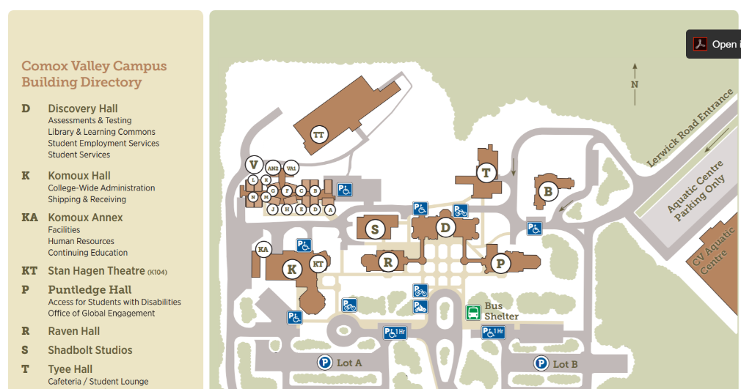
Beaufort children’s Society play space

Designated smoking area

- Do you have any comments or suggestions that you would like to share regarding tobacco use at North Island College?

If you think of any recommendations going forward please feel free to share them by emailing NICtobaccofree@gmail.com. The email account will be checked daily and all comments will remain anonymous.

APPENDIX E: Interview - Echo Hope - Director of the NIC Student Society
Tobacco Free Campus at North Island College – Comox Valley Campus
I am a North Island College student registered in the Business Administration degree program at the Comox Valley campus and I am currently registered in a technical writing course at the University of British Columbia. We are currently working on a technical writing project. The purpose of this interview is to collect primary data that will be used to analyze and provide recommendations to reduce or eliminate second-hand smoke exposure for students and staff at North Island College – Comox Valley campus, as well as the infants and toddlers at Beaufort Children’s Society located on the Comox Valley campus of North Island College. The goal of this inquiry is to provide a safe environment for students, staff, and children on the North Island College Campus. The formal report will be presented to the President of North Island College, the director of the North Island College Student Society – Comox Valley, the Executive Director of Beaufort Children Society and the Faculty Chair - Department of Early Childhood Care. The data collected from this interview will serve to identify hurdles and roadblocks to becoming a tobacco free campus.
Ultimately the data will be used to present recommendations to minimize second-hand smoke exposure on North Island College Comox Valley campus. The valuable information you provide will be used for analysis in proposing these recommendations.
The interview consists of 8 questions and it will take approximately 10 minutes to complete. Your responses are voluntary and greatly appreciated. Thank you for participating.

- How many designated smoking areas are essential for North Island College campus?
One of these
0 1 3 5 8 10+

- How were the current designated smoking areas chosen?

__I don’t personally know. I’ve asked the other board members and will send you another email containing the information if I find out._________________________

- Does NIC offer students and staff smoking cessation programs? If so, please list them.

Yes No
__Same as question 2, though I haven’t seen any myself.______________________________
- Have you been exposed to second-hand smoke will performing your day to day activities at North Island College? Yes No

Where did this occur?
____At both smoking areas_______________________________________________________
- If you answered yes to the previous question, would you say that this occurs rarely, sometimes, or often?

Rarely Sometimes Often

- Are you familiar with Beaufort Children’s Center? Yes No

- Is the location of the designated smoking area and the proximity to the Childcare play space a concern? Yes No

Beaufort children’s Society play space

Designated smoking area

- Do you have any comments or suggestions that you would like to share regarding tobacco use at North Island College?
I think you make some very valid and excellent points. I’m sure NISU would be willing to support and work with you if you’d like to see some change regarding the designated smoking areas. I believe they should either be moved away from the pathways where other students are walking or removed completely off campus.
If you think of any recommendations going forward please feel free to share them by emailing NICtobaccofree@gmail.com. The email account will be checked daily and all comments will remain anonymous.

APPENDIX F: Carissa Wilson Interview – North Island College Student Union - Organiser, College Relations & Services Coordinator

Hello Glenn,

Thank you for this work.

I believe no designated smoking areas are essential for NIC Campuses.

The current areas were chosen by Facilities, and were meant to provide accessible access to smoking

Great to ask the institution about smoking cessation programs. My understanding is there is currently no specific support beyond directing a student to 811 nursing support

Yes, I am regularly exposed to second-hand smoke while at NIC, in part to the proximity of my office to the former Tyee smoking area. The front smoking area has been turned into a bike rack and a smoking area was made at the back of the building. This is to support the accessible access to the building not having to pass through the smoking area. The smoking at the rear of the building also moves it further from Beaufort Children’s’ play area.

I am very familiar with the Centre

The previous smoking area was of high concern, the new one for 2020 is better, overall, I believe the time has come for NIC campuses to be smoke free.

Smoking on the Campbell River campus is also currently a concern, talking with students about smoking has turned into a source of contention. Preparing current students for an evolving work force that is becoming less and less smoking friendly is due diligence for our students.

I am happy to speak further about the history of talks with NIC, if you are interested.

REFERENCES
Fowler, Colin. Personal interview. 22 July 2020.
“Health Effects.” Centers for Disease Control and Prevention, Centers for Disease Control and Prevention, 28 Apr. 2020, www.cdc.gov/tobacco/basic_information/health_effects/index.htm.
Hope, Echo. Personal interview. 16 July 2020.
“Policy & Procedures Manual - North Island College.” North Island College, Executive Vice President Academic & COO, 12 May 2018, www.nic.bc.ca/pdf/policy-3-06-community-code-of-academic-pers-and-prof-conduct.pdf.
“Smoke-Free Campuses.” Smoke Free Campus, Simcoe Muskoka District Health Unit, 2019, smokefreecampus.ca/.
“Tobacco Free Campus Guide.” Non-Smokers’ Rights Association & Smoking and Health Action Foundation, 2011, https://nsra-adnf.ca/wp-content/uploads/2011/05/tobacco_free_campus_guide_web_finalb.pdf.
“University and Colleges 100% Smoke Free Campuses in Canada: National Report.” Canadian Cancer Society, 14 September 2018, https://www.cancer.ca/~/media/cancer.ca/CW/for%20media/Media%20releases/2018/University-college-100-percent-smoke-free-campus-national-report-2018-09-14.pdf?la=en.
Wilson, Carissa. Personal Interview. 29 July 2020.

