Bibliographie Annotée
Human Factors International. (2013). Crafting fun user experiences: A method to facilitate
flow. Retrieved from https://web.cs.wpi.edu~gogo/courses/imgd5100/papers/
FlowQuestionnaire.pdf
Mots clefs:
Flow experience, conditions of flow experience, flow loop model, enjoyment, intrinsic motivation, challenge
Objectif de l’article:
The objective of this paper is to present the Flow Condition questionnaire, and to present the conditions for flow experience according to Owen Schaffer, Lead Usability Analyst at Human Factors International.
Résumé:
This paper is presented as an interview with Owen Schaffer, Lead Usability Analyst at Human Factors International. Owen studied directly under Mihály Csikszentmihalyi, renowned psychologist and creator of the concept of flow experience. Schaffer summarizes Csíkszentmihályi’s concept of ‘flow’ as a state where the learner is completely absorbed in an activity and not aware of distractions around him. When in a state of flow, the individual is not experiencing any anxiety nor thoughts of what others may think. There is “focused concentration” (Human Factors International, 2013, p. 4) and the activity itself becomes a rewarding experience.
Schaffer succinctly lists the necessary conditions for a flow experience:
- High perceived challenges
- High perceived skills
- Knowing what to do
- Knowing how to do it
- Knowing how well you are doing
- Knowing where to go (where navigation is involved)
- Freedom from distractions
(Human Factors International, 2013, p. 4)
There are several factors that apply directly to motivating learners in a classroom situation. Firstly is the concept of challenges and skill level. In order for flow, there must be a challenge within the activity, but the structure of the activity itself is not a struggle. The student knows what they have to do and knows that they have the necessary skills. The challenge comes with applying the skills they have to a slightly higher level in order to advance. This, as Schaffer points out, is the basis behind the success of video games and engaging interactive websites. Also necessary in this concept is that of skill level. The student has to feel that he has the skills necessary to achieve. If the task seems too far above the skills level, they will not have the perseverance to work through the activity.
Secondly is the concept of feedback. Immediate feedback is a necessary component in flow, as the learning needs to know how they are doing with the skill progression. With no feedback as to progress, motivation fades away. Thirdly is the concept of distractions. Distractions prevent the learner from reaching the state of complete concentration required for flow.
Schaffer also discusses the concepts of relaxation, control, and arousal. Relaxation involves no challenge, and will become boring even though it is a happy, stress-free state. Control is still stress free, as the tasks do not stretch the skill level. Arousal is the state where the tasks are difficult and require working above skill level. This is very stressful. Creating an activity that allows for flow experience must move between these states, not staying in one too long.
The iterative loop set out by Schaffer is perfect for an educational setting.

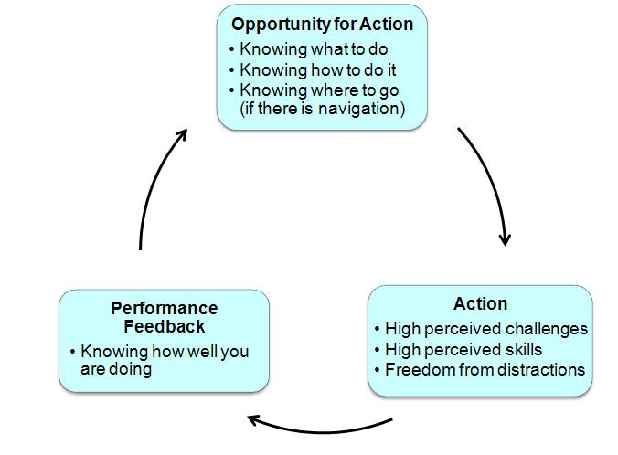
Figure 1. Flow Loop model (HSI, 2013, p.7)

. An activity that allows students to enter into a state of flow must involves all of these elements. Throughout the time period, there must be time spent in relaxation and time spent in arousal. Control is a state that may be omitted depending upon the situation. The Flow Loop model clearly shows the need for precise, complete instructions and immediate feedback. Activities but be carefully designed to avoid distractions and to present as challenging but not far above skill level.
Méthodologie:
This paper is presented as an interview with Owen Schaffer, Lead Usability Analyst at Human Factors International. There is no indication as to who wrote the paper, but the result is a concise summary of the conditions of flow experience according to Dr. Schaffer who completed his Ph.D. under Mihály Csikszentmihalyi, the psychologist who developed Flow Theory. The paper takes the form of a concept overview or ‘mini lesson’.
Pertinence pour les objectifs d’études que vous avez choisis:

My topic of study is that of motivation boys in secondary school French immersion. While I continue to read research done directly with boys in French immersion as a focus, I believe that there is a need to step outside of that frame of reference to look more widely at the concepts of learning and motivation. All research so far has said the same thing – boys need to be motivated. But no research that I have read uncovers how to design activities and classrooms that will promote such motivation. As I plan to frame my presentation with Csíkszentmihályi’s theory of intrinsic motivation through flow experience, it follows that I need to investigate this concept further. I chose this specific paper for two reasons: firstly, the flow loop model lends itself perfectly to the design of good classroom activities. Secondly, this paper uses the flow loop model through examples of internet web design and gaming design. According to my experience as a senior teacher, these are the areas that interest adolescent boys the most. As I further my research I am beginning to see parallels between these two areas, and I believe that the material presented m Dr. Schaffer will be extremely useful to mu project.

References
Csikszentmihalyi, M. (1990). Literacy and intrinsic motivation. Daedalus, 119, 115-140. Retrieved from https://msu.edu~dwong/CEP991/CEP991Resources/Csikszentmihalyi-Lit&Mot.pdf
Human Factors International. (2013). Crafting fun user experiences: A method to facilitate flow. Retrieved from https://web.cs.wpi.edu~gogo/courses/imgd5100/papers/
FlowQuestionnaire.pdf

