Attrition in British Columbia

**Canadian Parents for French BC & Yukon. (2004). *Addressing attrition in French immersion*. Retrieved from https://bc-yk.cpf.ca/wp-content/blogs.dir/1/files/Addressing-Attrition-in-French-Immersion.pdf**

**Mots clés:**

Attrition in French immersion programs, boys in French immersion, secondary school attrition, lack of variety in course load, other programs

**Objectif de l’article:**

This report outlines attrition in secondary school French immersion programs between 1999 and 2005 in British Columbia.

**Résumé**

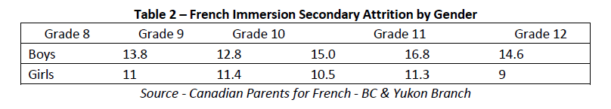There is concern about attrition in secondary school French immersion programs. This report notes that attrition rates for high school boys is higher than that of girls. The data shows the following average attrition rates:

* End of grade 8: 13.8%
* End of grade 9: 12.8%
* End of grade 10: 15.0 %

The CPF researchers attribute much of this attrition to lack of access to programs (bussing and rural communities) and economic factors involving families moving from area to area. Also noted is information from research citing work load in French immersion, lack of variety in the course programming, lower marks in French immersion, and students having to choose between French immersion and a desired different program. A lack of post-secondary options in French is also a factor.

Nancy Taylor, CPF-BC & Yukon and former President of CPF Saanich, gives a list of interventions taking place in school district #63 Saanich. These are all interventions at the district recruitment level, not at the classroom level.

**Méthodologie:**

This report is a compilation of information gathered by the CPF team. There is no information on the process nor the names of the team other than Nancy Taylor, CPF-BC & Yukon.

**Pertinence pour les objectifs d’études que vous avez choisis:**

For my presentation I want to start with British Columbia general information that opens the discussion of boys being dissatisfied with the program. With the project drawing near, I envision an introduction that begins with what this report says and then use its focus on program interventions to lead into my interest in why the boys have a higher attrition rate. Then I will bridge into the difficulties that boys have in French Immersion and my motivation for investigating how to make French classes more enjoyable for boys, in hopes that they will become confident, motivated language learners.

References

Canadian Parents for French BC & Yukon. (2004). *Addressing Attrition in French Immersion*. Retrieved from https://bc-yk.cpf.ca/wp-content/blogs.dir/1/files/Addressing-Attrition-in-French-Immersion.pdf