**Proposal to Increase Oral Health Education for UBC Medical Students**

For: Dr. Torsten Nielsen  
MD/PhD Program Director   
University of British Columbia  
 Faculty of Medicine

By: Gabriella Meroli Assad, Technical Writing Student   
July 2021

**Table of Contents**  
 I. ABSTRACT………………………………………………………………………….

1. INTRODUCTION……………………………………………………………………
2. Description and background………………………………………………………….
3. Statement of the current problem…………………………………………………….
4. Purpose of the report and intended audience…………………………………………
5. Scope of inquiry………………………………………………………………………
6. Study limitations………………………………………………………………………
7. DATA SECTION…………………………………………………….……………….
8. Based on primary research; survey results   
    findings……………………………………………………………………………   
    interpretation of findings………………………………………………………….
9. Based on secondary research; from internet databases  
    findings……………………………………………………………………………   
    interpretation of findings………………………………………………………….
10. CONCLUSION……………………………………………………………………..
11. Summary and overall synthesis of findings…………………………………………
12. Recommendations…………………………………………………………………..
13. Works Cited…………………………………………………………………………

**Figures and Tables**

Figure 1……………..

Table 1……………….

Figure 2…………….

Table 2.……………

**I. ABSTRACT**

XXX………………..

**II. INTRODUCTION  
A. Description and Background**

Oral health is essential to overall health. Many oral health related problems are preventable through educating patients and providing regular, professional care. Oral health is much more than just healthy teeth; it encompasses other anatomical structures such as gums, bones, ligaments, muscles, glands and nerves. Oral health also can affect basic human functions which interfere with one’s self-image and sense of well-being. The abovementioned anatomical structures are responsible for allowing one to speak, smile, masticate, smell and taste. Many systemic conditions can be related to poor oral health and some systemic conditions can impair or reduce optimal oral health.

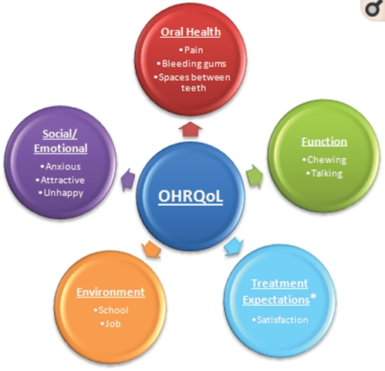  
Figure 1: Dimensions compromising oral-health related quality of life (OHRQoL).

It is critical for health professionals to be aware of medical diseases that can be affected by oral health and vise versa. Comprehensive and competent care requires this knowledge. This report will emphasize the need for physicians to harness the skills for early detection of abnormalities to prevent incurable diseases and increase patient’s quality of life.

**B. Current Problem**

Oral diseases are largely preventable when regular home care and professional maintenance is rendered. Access to essential dental services is a growing concern in many countries, including in Canada. This major public health issue is leading to an increase in poor oral health and thus general health, alike. With many individuals not seeking regular dental care for various reasons, when dental care is sought, it tends to only be when there is a problem and dental pain is imminent. Due to this ongoing shortcoming, preventable solutions are sometimes no longer an option. This generates a vast population of patients seeking treatment by their medical doctor rather than dentists. Patients also end up in emergency rooms due to untreated dental problems, this is problematic as emergency settings are to be reserved for life threatening injuries and accidents. The main issue surrounding patients seeking oral health care in a medical setting is that doctors are not equipped with dental equipment.

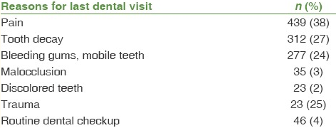

Table 1: Distribution of data according to primary reasons for last dental visit (n=1155)

Medical doctors are knowledgeable on a multitude of health issues but do not specialize in preventative dentistry. Many dental issues, when treated or prevented appropriately, can avoid a visit to the emergency room. Therefore, avoiding emergency visits can increase favorable dental prognoses. With health care treatment options constantly evolving and more holistic approaches being elected, having medical professionals calibrated on common dental practices and preventions is advantageous for all. Due to the comprehensive learning involved in the UBC medical program, limited time is given to teaching oral health and prevention. Because medical doctors are often the first point of contact for individuals seeking care, this can result in dentists being left out of the equation.

**C. Purpose of the report and intended audience**

The purpose of this report is to present a possible solution to increasing and providing more of a broad scope of oral health education to UBC medical students. One possible solution to the problem is to have dental students share their knowledge and expertise with medical students. Dental students can be assigned a teaching project on oral health, oral health-related issues, and basic intra and extra oral examination measures. This can be presented to medical students over a single day seminar, outside of regular teaching hours. The program will be opportunistic and involve clinical (hands-on) practice. With the strong link between oral health and overall health, it is crucial for medical students to receive adequate dental related education. Medical doctors therefore will be better equipped to appropriately triage their patients and encourage the importance of regular dental visits to prevent detrimental health problems.

Dr. Torsten Nielsen is the MD/PhD UBC Program Director who aims to maintain excellence of the program and grow it further. He would ideally be the reader of the Formal Report however if he is unable to do so, the plan is to inquire with The Dean, UBC Faculty of Medicine Vice-President, Health, Dr. Dermot Kelleher. Some of Dr. Kelleher’s commitments are academic leadership and research excellence.

**D. Scope of inquiry**

*Primary research:* A survey has been developed and circulated to measure the feasibility of incorporating changes to the quantity and quality of oral health education for medical students. Insight on the current oral health education was gathered and participants shared whether they believed they could benefit from additional knowledge in this arena. The information was collected whilst maintaining participants confidentiality and autonomy. The survey results were used as primary data for this Formal Report.

*Secondary research:* Internet databases have been scanned in search of the oral-systemic link and the related rise of dental visits to the emergency room because of patients not seeking regular dental care.

**E. Study Limitations**

Study limitations derive from an inadequate sample size <10 survey participants. The results were synthesized and considered in this Formal Report. Secondary research has been used throughout the report to strengthen the proposed idea as to why UBC medical students would benefit from a one-day seminar on oral health, preventative dentistry and fostering skills to complete oral exams.

**III. Data Section**

1. According to the survey results, UBC medical students believe the time spent on learning about oral health and dentistry to be unsatisfactory. One student indicated that <6 hours of teaching time is devoted to oral health and dentistry, the remaining five students were unsure of the time allotted to this learning module. Based on the graph found below, most of the students who participated in this survey have indicated that there should be more time allotted to learning about these essential topics. Albeit a small sample size, this is indicative of students who would willing to learn more about oral health and dentistry to better serve the population by fostering comprehensive care.

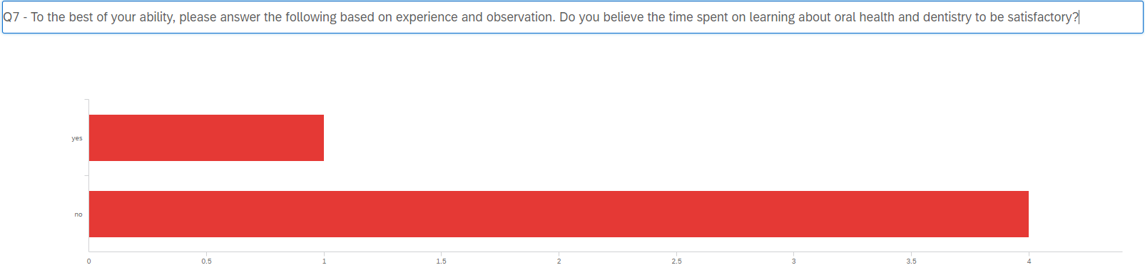

Figure 3: Survey question on “do you believe the time spent learning about oral health and dentistry to be satisfactory?”

1. According to secondary research, the reasons for not visiting a dentist were alarming and underpin the need to focus on preventative dentistry and educating patients to avoid irreversible oral disease which can impact general health. Among people who had a history of never visiting the dentist, the reasons most frequently documented in a study conducted in 2018 presented an elevated level lacking oral health knowledge (30%). The other primitive reason for never seeking dental care was because the dental problem was not severe enough to require professional attention.

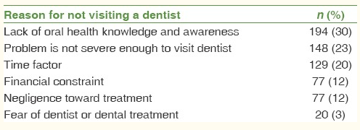

Table 2: Data of “non-visitors” according to reasons for not seeking dental care. (n=645)

This table is representative of the critical focus that must be placed on oral health education for patients to be equipped with the necessary knowledge on how to obtain optimal oral health. If individuals gain awareness on the link between oral health and overall health, they may begin to seek dental care more regularly, or at the very least spend more time on oral home care techniques.

**Conclusion**

I have been involved in a compressed teaching curriculum on oral health for medical students at the University of Ottawa. During the experience, it dawned on me that the students were only given one short day to understand the importance of oral health and preventative screening. Further, the volunteer experience from various dental programs and organizations alongside the ten years of professional practice accrued will bolster this research process. As a dental hygienist, I believe that the education on this subject should be slightly expanded on, though awareness of the intensive medical program is considered and will be respected throughout the research process and the formal report.

Evidence-informed research has made it indisputable that there is a powerful relation between oral health and overall health. With this knowledge, highlighting the importance of preventative dentistry and holistic approaches to reduce unfavorable circumstances among individuals is fundamental. Seemingly,additional oral health education would be valuable to UBC medical students. With your approval I will begin the research process.

**Findings**

Overall, the survey results have indicated that most students suggest the time allotted to oral health education to be inadequate. They do believe that some essential oral health material is shared however it appears as though going further in depth with this information would be necessary to understand the importance and true possible correlations between oral health and overall health.

**Recommendations**

If you are interested in supporting a single-day seminar on oral health and dentistry for UBC medical students, please consider this Formal Report. Dental students are highly knowledgeable and familiar with oral examinations, and they are comfortable with distinguishing between normal findings or anomalies. If dental students are provided with an opportunity to develop a module on oral health and preventative dentistry, they would be able to share this paramount information with UBC medical students. This would give both groups of students an experience to learn from each other, to network and collaborate inter-professionally.

**Works Cited**

1. <https://www.ncbi.nlm.nih.gov/books/NBK219661/>
2. <https://www.ncbi.nlm.nih.gov/books/NBK219661/>
3. <https://www.ncbi.nlm.nih.gov/pmc/articles/PMC6088817/>

NOTES:

1. Challenges associated with expanding the oral health educational module
2. Why medical students must be calibrated on oral health practices and preventions   
    a. holistic and preventative treatments   
    b. knowing when to refer   
    c. being aware of how to treat  
    d. when a dental issue becomes irreversible
3. Why increase the level of oral health education among UBC medical student   
    a. to improve overall wellness   
    b. to ensure comprehensive treatment is rendered   
    c. to provide individuals with all options to make informed decisions