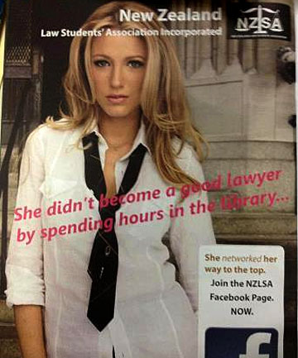

Advertisement Featuring Blake Lively retrieved from: http://www.stuff.co.nz/life-style/life/8017140/Law-school-magazine-blasted-for-sexist-ad
Even in the 21st century many advertisements are still filled with themes and messages of misogyny, the sexual objectification of women, and the reinforcement of traditional gender roles. Ads are created to pull the reader in with interest to create a sense of want by the consumers in order to sell a product, and unfortunately, sex sells. Many ads treat women as sexual objects that are expected use their sensuality in order to satisfy men and to gain power or status. Even small brands and associations are using the sexualisation tactics exploited by large corporations in order to drive consumers to buy their product because, in part, it is successful.
Instead of ads showing more progressive modern attitudes emerging within the world, many are still showing reflections of past patriarchal views where women are considered below men and that women are not business savvy, women do not belong in traditionally male jobs, and that women could not obtain a “mans” job without misleading a man. The New Zealand Law Students Association Ad is no different, depicting a blast from the past with its misogynistic view of women.
This Ad depicts Blake Lively wearing a seductive look in an unbuttoned dress shirt and loose tie accompanied by the words “She didn’t become a good lawyer by spending hours in the library…” The swirly pink cursive leaves a blaring message for any females reading this: you do not become a professional lawyer through hard work and determination, you can only achieve this title on a man’s terms by yielding to and pleasing a man. The Ad then goes on to convey its actual selling message in the bottom corner “She networked her way to the top” suggesting that it’s not how hard a women works, but who she knows and can manipulate sexually that helps her succeed in the business world. This ad suggests that the woman in the ad “networked” her way through men in the company by pleasing or tricking them because a beautiful blonde lady could not become a powerful lawyer by working hard, she must have cheated her way to the top.
This ad not only highly sexualizes women, suggesting that they will do anything in order to gain power or status, but it also sends a second message: that if women do not use sexual means or trickery to gain power or status there is no way that they could have done it with their own abilities. This reinforces the ideal that women are inferior to men and have no right to be in a man’s profession, and if they are there, they are not there by their own intelligence and perseverance. The NZLSA team that created this ad claim that it was satirical and funny and they meant no harm, but I have a feeling that most people are not in on the joke (Cuming, November 30th, 2012).

Photo of Blake Lively retrieved from: http://www.fashionizelife.com/2012/07/latest-look-blake-lively.html
NZSLA Logo Photo retrieved from: http://www.stuff.co.nz/life-style/life/8017140/Law-school-magazine-blasted-for-sexist-ad

In order to “culturally jam” the NZLSA ad to show a more positive message I changed the messages written on the magazine ad and placed the actor Blake Lively in a more professional pose and attire. I wrote that she “did become a good lawyer by spending hours in the library” because women do have the ability and determination to work hard to become good lawyers just like any other man. Women are not meant to be play dolls or sexualized objects for men in higher up business jobs. A woman can bring diversity and new ideas to a profession; broadening the spectrum of a company because of the unique views she can bring from her experiences. I decided to place her in a red suit because red represents power and strength, showing that she got to where she is on her own term. I also changed the writing related to networking to involve the choice and action being taken by the women herself to give empowerment.
Appropriate networking through school and people in business world can be an asset in obtaining a job, but doing it through professional means on her own terms is the way this ad should have portrayed networking, not by oppressed and highly sexualized means. If networking and hard work are considered skills that will help anyone obtain a dream job, then a women is able use these skills just as well as a man without “cheating” her way to the top.

References

Cuming, A. (2012, Nov 30th). Law school magazine blasted for sexist ad. Retrieved from http://www.stuff.co.nz/life-style/life/8017140/Law-school-magazine-blasted-for-sexist-ad
New Zealand Law Students’ Association Incorporated. (2012). Advertisement Photo. Retrieved from http://www.stuff.co.nz/life-style/life/8017140/Law-school-magazine-blasted-for-sexist-ad
Flame Flynet. (2012, June 27th) Blake Lively Red Carpet Photo. Retrieved from http://www.fashionizelife.com/2012/07/latest-look-blake-lively.html

