Stephanie Erickson
GRSJ 300
Culture Jamming Assignment

Original Copy of Ad-
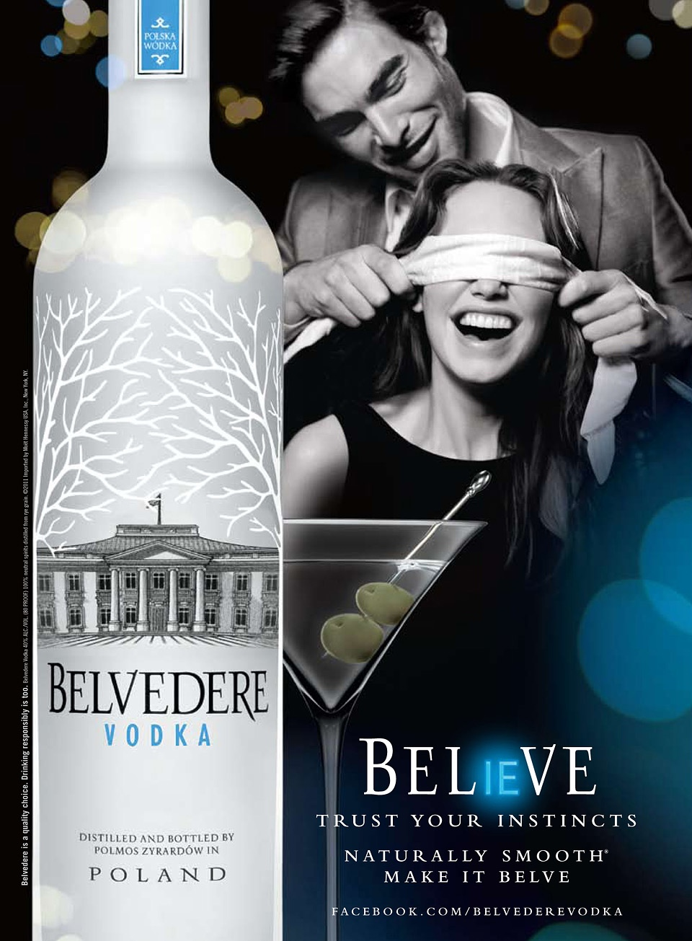
Analysis of Original Ad-
This ad represents a Polish rye-vodka brand, Belvedere. The ad uses the similarity of their brand name to construct a play-on-words with the English word, believe. This demonstrates that the ad is targeting English-speakers, and in all likelihood, by extension, westerners. The ad consists of three main parts: the image of the bottle of Vodka, arguably most importantly, the image of the man standing behind the woman holding a blindfold over her eyes, and the text. The design of the Vodka bottle could be examined as its own advertisement because of the marketing on the label and could thus be deconstructed to reveal its own social messaging. The logo here is a design of the Polish presidential palace in Warsaw. This imaging connects notions of national pride and patriotism to the product. Even if the consumer didn’t know the exact significance of the image, the house appears wealthy and powerful, visibly similar in design to the White House in the United States. Specifically for North Americans, this connection would signify ultimate political power. This is one demonstration of power and dominance the overall advertisement includes to sell its product. Also, the dim lighting and the James Bond-style martini image construct, works to further create an atmosphere of wealth and status associated with the ad. The image of the man blindfolding the woman implies a sense of control, masculine dominance, and, thanks to Fifty Shades of Grey, BDSM sexuality. Keeping in mind that the physical product this ad is selling, it is clear that the ad is implying to consumers that their brand of alcohol is not only sexy, but also results in the power to put women in a position of submission. The ad signifies rape culture and furthermore, the text in the ad, “trust your instincts” paired with the alcoholic product, a state-altering substance, implies that impairment, and ‘going with the flow’ in situations involving alcohol is something to be desired. However, knowing that many cases of sexual assault are linked to alcohol consumption, this connection further adds to the ad’s sexually abusive nature.

Jammed version of the ad-
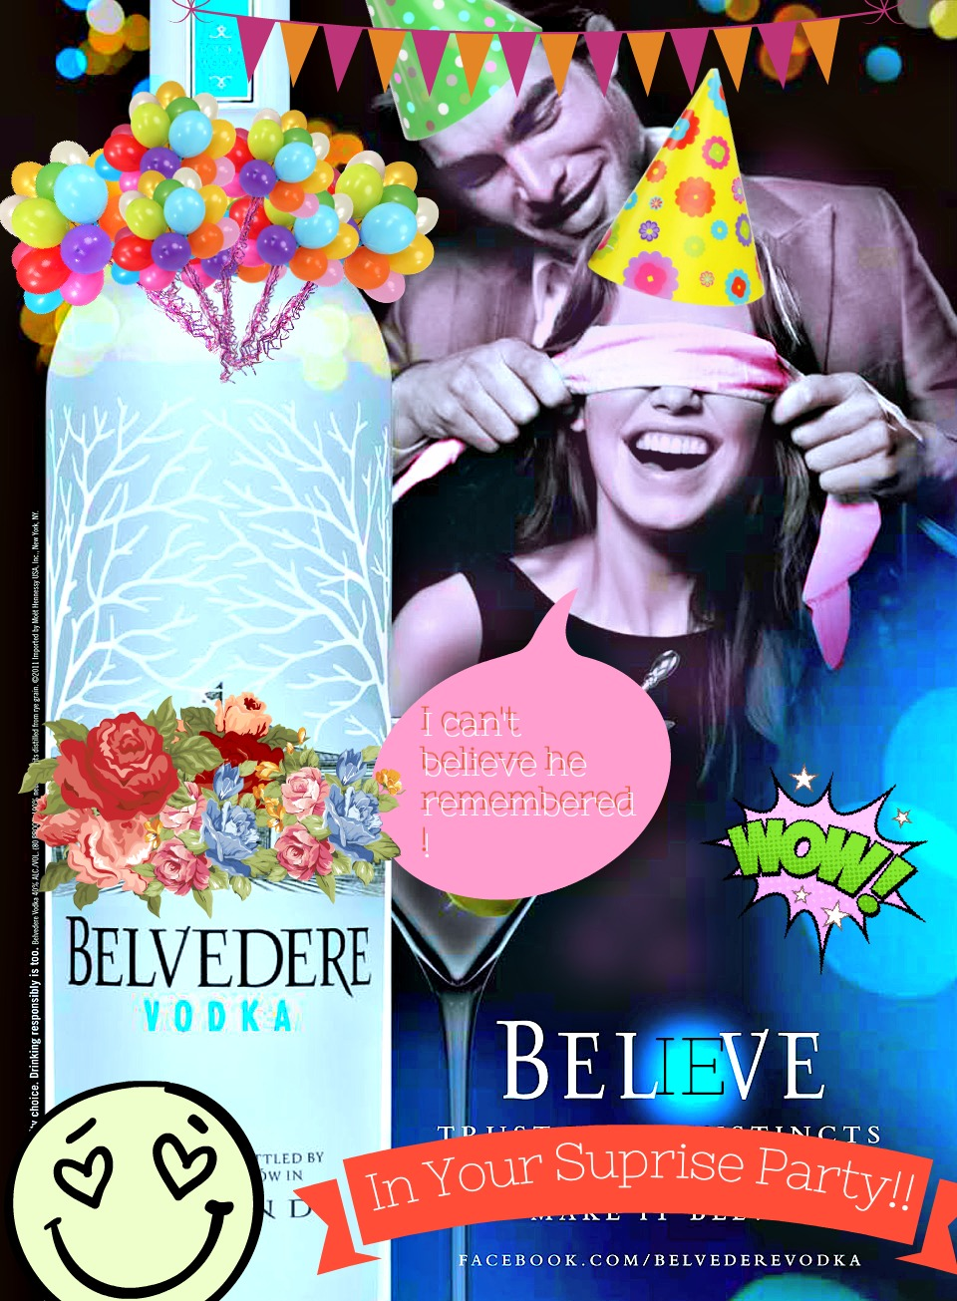
Analysis of Jamming philosophy-
In my culture-jammed version of the Belvedere Vodka ad, I wanted to redirect the way consumers view the actors in the ad. The original ad attempted to sell consumers on the excitement of sexual control. In terms of social messaging, this is as unoriginal as saying, “sex sells.” Originally, where there were some heavy sexual and controlling connotations, I tried to reframe the people in the ad in a different situation, thereby changing the context of the characters’ relationship. Now, instead of the characters being in a sexually controlling relationship, one has planned a surprise party for the other. This takes away the masculine dominance and substitutes caring and consideration into the relationship, while maintaining the excitement in the atmosphere of the ad. The original ad used a controlling sexual atmosphere to illicit a level of excitement from its viewers, however I tried to show how that feeling of excitement can come from a variety of different situations, such as a surprise party. I added party decorations to create this atmosphere, as well as changed out the text. Where originally the text used the play on words with believe and “Belev” to read as something like “believe in what you cannot see,” and “trust your instincts,” it now says “believe in your surprise party,” which is meant to be hopeful and exciting in comparison to dangerous and risky. I covered up the image on the label too, because it was a symbol of masculine power and dominance in Poland. I also brightened the colour scheme and added colour to the characters to take away some of the black and white tension from the original ad. Overall, I tried to take sexual dominance out of the ad and replace it with something fun.

